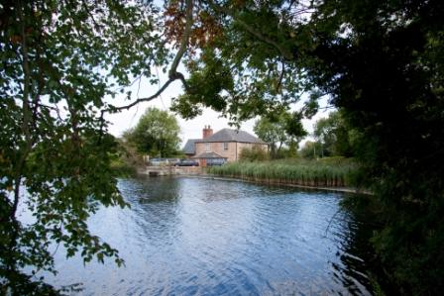**Cuckney Church of England Primary**

**School Lane**

**Cuckney**

**Mansfield**

**Notts NG20 9NB**

[**office@cuckney.notts.sch.uk**](mailto:office@cuckney.notts.sch.uk)

**Telephone: 01623 842223**

**Fax: 01623 845391**

**Headteacher: Mrs L C Crossland BSc Hons QTS / NPQH**

Dream, Believe, Achieve.

‘Nothing will be impossible with God’ Luke 1:37

Thank you for expressing an interest in our vacancy and we hope you feel inspired to apply for the position of class teacher.

THE SCHOOL AND ITS LOCALITY

The village of Cuckney is a fifteen-minute drive from the towns of Worksop and Mansfield on the A60. It is about 5 miles from Junction 30 of the M1 and about 25 miles from the cities of Nottingham and Sheffield. Most of the properties in the village are Victorian or earlier and the surrounding area is rural and extremely attractive, with Sherwood Forest, Creswell Crags and the Peak district of Derbyshire within easy reach.

The main school building is a Grade II listed water mill which dates from the 18th century. It was converted into a school in the first half of the 19th century. Later alterations and improvements have resulted in a picturesque working environment consisting of five large classrooms and a kitchen. A further classroom and the hall are housed in the new building completed in 2007.

There is a large playing field adjacent and the school which has a large attractive playground which many pupils use with parents after school. The school used lottery funding to update the garden area to create an outdoor classroom and learning environment; work continues on this area through the ‘Forest schools’ project. These features, together with the adjacent wooded area, stream and mill dam, give it enviable environmental educational advantages.

The present staffing consists of a Head Teacher, 4 full time FTE teachers, 4 full-time Teaching Assistants.

Our current roll is 128. The catchment area is sparsely populated and 80% of our pupils come by choice from outside the catchment area. High standards have consistently been achieved and the school also has a very good reputation for its provision for pupils with Special Needs.

The most recent OFSTED in June 2024 judged the school to be good overall with outstanding Early Years, alongside our most recent SIAMS inspection in April 2023 also judged to be good.