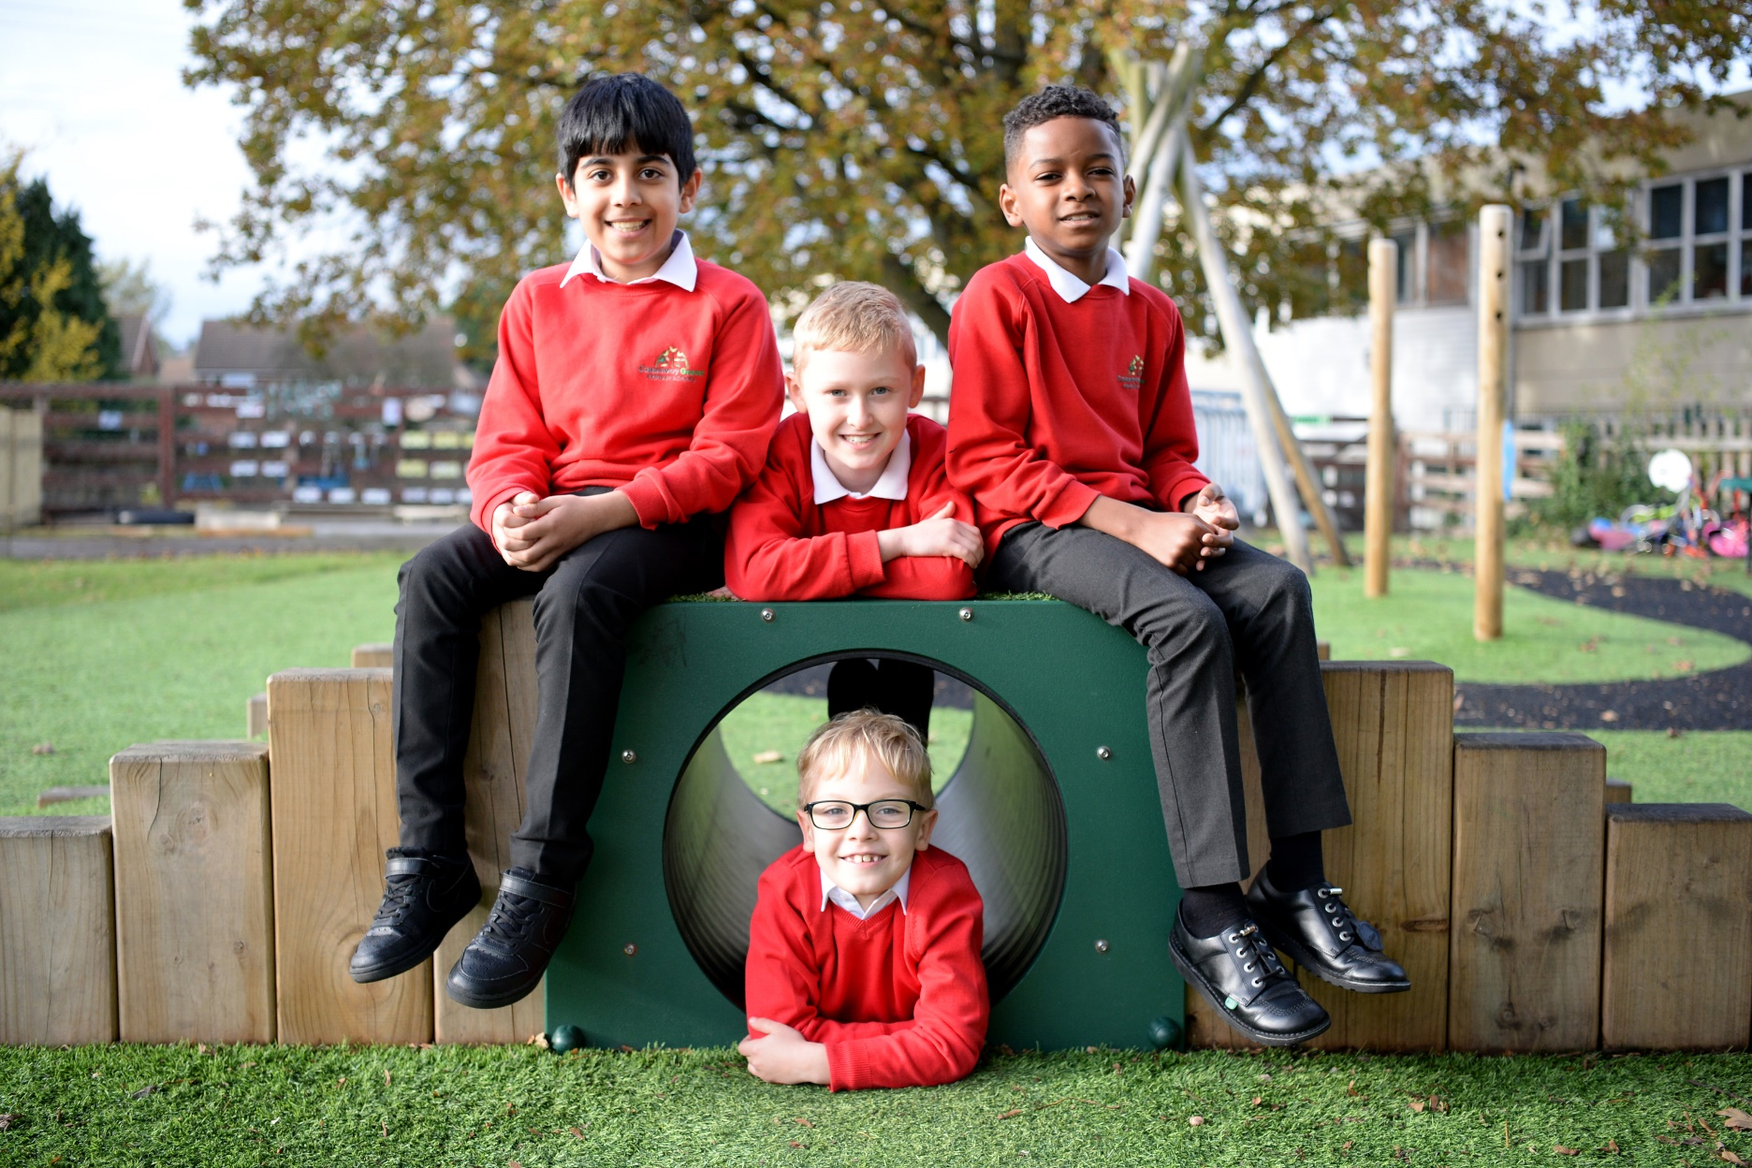
Welcome to Causeway green
PRIMARY SCHOOL

Recruitment Pack

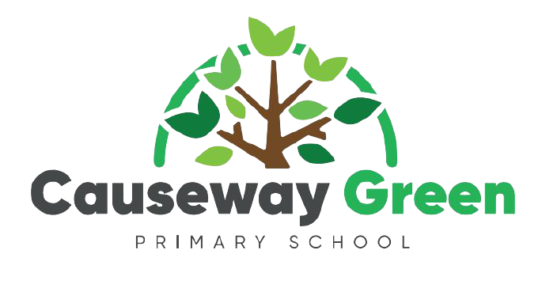

Message from the Headteacher

Thank you for showing an interest in applying for the Deputy Headteacher position at our school. The post is available due to the successful promotion of our current Deputy Headteacher.
On behalf of the children, staff and governors, I would like to welcome you to Causeway Green. I feel proud and privileged to work at a school where staff, governors and parents work hard to ensure that the children reach their full academic and personal potential in a caring, safe and creative environment where everyone is valued.

We put the children at the heart of all we do with a rich and broad curriculum and an ethos that builds self-esteem and confidence. Our team all share the same relentless drive and determination to make Causeway Green an outstanding school.

“Developing lifelong skills and aspirations to meet the challenges of the future”

School Overview
Our Ethos
Causeway Green is a dynamic and harmonious school. Our curriculum supports our children to be happy and self-confident individuals with strong morals and a ‘can do’ attitude, who are encouraged to aspire for success, aim for excellence and achieve their full potential.
Our Vision
Our vision is for Causeway Green to be an excellent school, where outstanding practice, equality and well-being are at the heart of all that we do.
Aims of our school
The school:
- Recognises that each child is unique.
- Encourages a positive self-image in each child with a love of learning and a desire to always do their best.

- Provides opportunities for the child's social, moral, spiritual, intellectual, physical and creative development.

- Involves children in developing understanding, co-operation and cultural awareness and instils a sense of justice, respect and fair play.

- Works alongside parents and the wider community to develop and extend the concepts, skills, positive attitudes, independence and knowledge necessary for every child's continuing education and their future

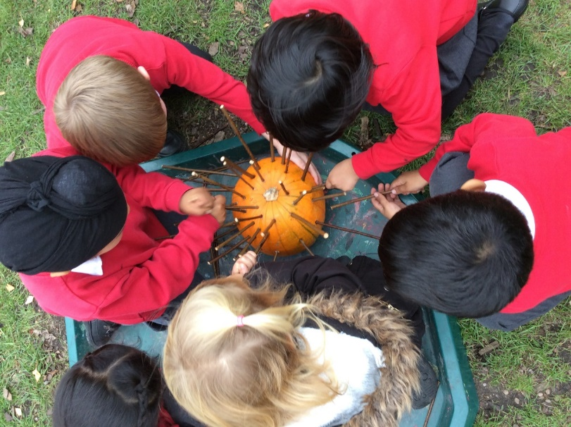

An introduction to Causeway Green

Causeway Green Primary is a co-educational two form entry school for ages 3-11. We have approximately 450 pupils on roll.

We teach the National Curriculum 2014 and recognise the importance of the core subjects, particularly English, Mathematics and Science as part of a broad and balanced curriculum.

With approximately 80 staff members, we believe in working together as a team with the children at the centre of all we do.

Key School Information
Type of school | Sandwell Local Authority
Age range | 3-11
Location | Penncricket Lane, Oldbury, West Midlands
Number of teaching staff | 71 (teachers, support, cleaners, site staff, office staff)
Number of children on roll | 448
Average class size | 30
Attendance Sept 20 to July 21 | 96.2%
% of children with SEN | 22%
% of children on FSM | 26%
% of children with EAL | 32%
% of PP pupils | 26%
2019 KS2 results | Reading 59%  Writing 78%  Maths 80%  SPaG 81%  Science 83%
Latest Ofsted report | https://reports.ofsted.gov.uk/provider/21/103983

Ofsted said our ‘school continues to be good’

“There has been a positive impact on the school with a clear vision for the school’s development. You are determined that every pupil is given the best opportunities to succeed at Causeway Green.

Pupils achieve well because teaching is strong and provides pupils with many interesting and challenging learning opportunities. Outcomes for pupils are consistently at or above those seen nationally at the end of key stage 2.

You are rightly developing the roles of staff so that they can led subjects and other areas of the school’s work effectively. The training opportunities provided for staff to enable them to develop effective leadership skills are proving to be successful.

You are acutely aware of your responsibilities to keep children safe and give pupils’ well-being the utmost priority”.

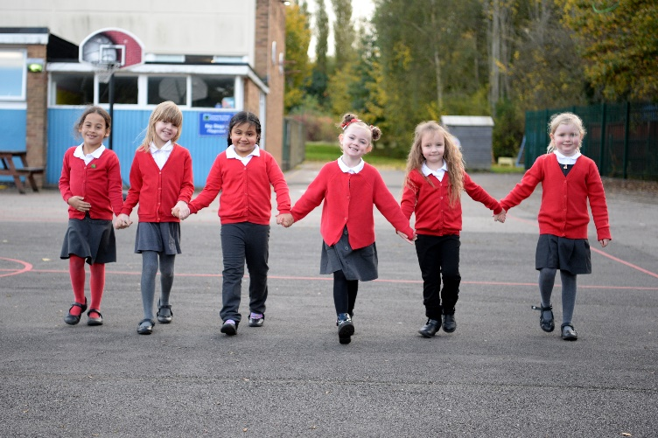

‘As a result of strong relationships between staff and pupils, pupils’ attitudes to learning are consistently positive and they are ready to learn’ Ofsted 2017

An Overview of our creative curriculum

At Causeway Green we enjoy a creative cross-curricular learning experience. We progressively build on skills, develop knowledge and understanding of the world through key concepts whilst following the national curriculum.

Each teacher has a responsibility for a subject and ensures expert knowledge is taught fluently in school through appropriate discussions, building on previous lessons and using termly assessments. This them helps the pupils embed the skills and concepts they have learnt in their long-term memory.

By talking to pupils, looking in their books, attending stunning starts or fantastic finishes and becoming immersed in our classroom environments you will be able to witness first-hand how our curriculum forms the core of school life.

Within each subject led topic, every year’s teaching is informed by several discrete key concepts, aimed at maximising pupil’s individual ability to transfer knowledge across the curriculum. Quality texts based on the topic enhance the children’s understanding and enjoyment. The optimum combination of the skills, knowledge and key concepts taught on a daily basis enables pupils to fulfil their potential, make excellent progress and develop their life long skills and aspirations to meet the challenges of the future. Using the retrieval booklet created by the curriculum working party, we check children’s understanding and are making progress over time, retrieving key concepts and knowledge taught in previous years.

Curriculum Rationale:

Strong relationships between our staff, pupils and parents has resulted in us having a holistic understanding of our children. This enables us to teach the knowledge within the national curriculum in a highly engaging way which:

- Is broad and balanced
- Builds on prior learning
- Promotes a love of language and literacy
- Embeds basic skills
- Develops transferable skills
- Celebrates individual strengths
- Develops links between subjects and the world we live in
- Prepares pupils for a happy, healthy, fulfilling future in modern Britain

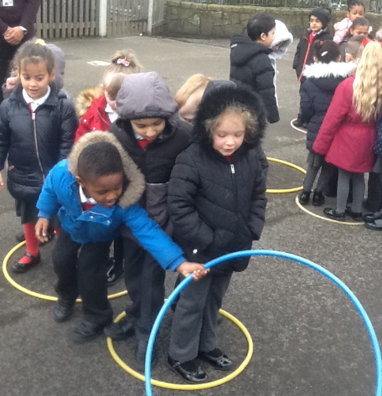
The learning journey through each topic:

Before each topic begins, the children should be involved in a ‘KWL’ or a concept map which is to be displayed in the classroom to ascertain what they know already and what they would like to find out. This gives pupils the opportunity to contribute to the planning for the topic, thus ensuring they have ownership of their learning. The results of the review lesson should feature on the display for the new topic along with pupil interest board.

Newsletters are sent out to families to inform them about the upcoming topics. This enables pupils and their families to begin engaging with the topic through, for example, visiting a library or museum or looking for appropriate artefacts and objects at home.

Each topic begins with a stunning start which hooks the children’s imagination and engages them with the topic content at this initial stage. Now, Press, Play can be used to support the delivery of the curriculum through a virtual, audio experience immersing children within the topic they are studying.

The topic is planned to lead towards a fantastic finish in which pupils can demonstrate what they have learnt. The exit point should be shared with the children from the outset so that they have a sense of what the whole class (and year group) is working towards. Exit points can take a variety of forms but could include a performance for parents or another year group, an exhibition or a challenge designed as an opportunity to apply new skills.

Reading at Causeway Green

At Causeway Green, we aim to develop the habit of reading, for both pleasure and information. It is our hope that all our pupils will strive to be, the very best they can be. It is our intention to nurture well-read, insightful, knowledgeable and inquisitive readers by immersing our pupils with a high-quality texts and experiences.

Intent
Reading lies at the heart of the curriculum. We are dedicated to enabling our pupils to become lifelong learners and we believe reading is key for success. At Causeway Green, we aim to teach the skills our pupils need to access, understand and enjoy different texts, as well as the ability to decode words.

Implementation
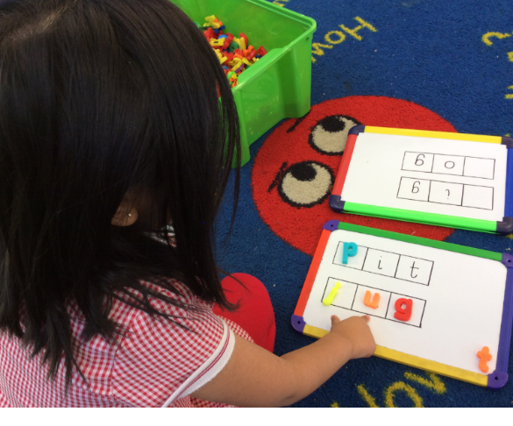
Here, we ensure that our pupils hear, listen, experience and are immersed in a variety of texts which are read and recited aloud. Specific sessions are used to teach and apply the skills of prediction, summarising, inference, retrieval of information, analysis and clarification of the author's choice of vocabulary and performance of the written word.

Impact
Through the teaching of systematic phonics, our pupils will become fluent and confident word readers by the end of KS1. By the time pupils leave Causeway, they are competent readers who can recommend books to their peers, have a thirst for reading a range of genres and can engage in thoughtful discussions about books, text and authors.

We pride ourselves on the consistent approach to teaching and learning that can be observed across all phases of school. This is achieved through our commitment timely and specific CPD and quality first teaching on a daily basis. Expectations of staff and pupils are high, resulting in good or outstanding progress in all phases. These strategies are consistently used throughout school and it is the expectation of leadership that all lessons will include a variety of these to enable learners to reach their full potential. Active learning is essential in all aspects of the lesson. All staff use the same terminology so that learners develop a knowledge and understanding of the different ways they learn.

Writing Curriculum

Learning to write is one of the most important things that a child at primary school will learn. Children use their writing in almost all other subjects of the curriculum. Good writing also gives children a voice to share their ideas with the world. At Causeway Green, we prioritise writing as a key skill, underpinning our curriculum, teaching children a range of skills to support them to meet the challenges of the future.

Teachers plan clear learning journeys to include:
- Read
- RIP
- Rehearse
- SPAG
- Spelling
- Write
- Edit

Maths Curriculum

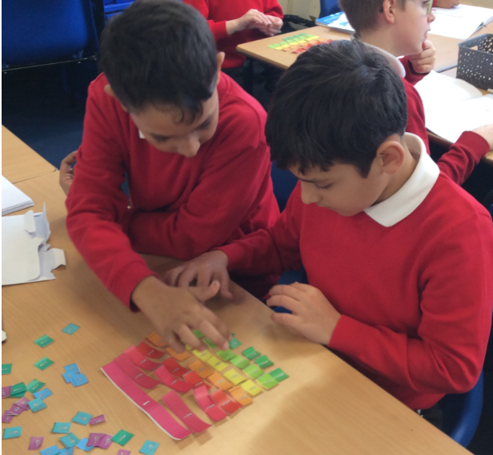
At Causeway Green, we strive for our pupils to achieve and be challenged, embedding these skills through the Mastery Maths Approach. Through a range of strategies, pupils are taught how to manipulate mathematical skills and strategies in a range of methods including; concrete, pictorial and abstract. These elements are taught, modelled and practised by both staff and pupils. Our school follows White Rose for mastery approaches which incorporates a range of applications to embed children’s knowledge and understanding through varied fluency, reasoning and problem solving.

Commando Joe Curriculum
We are excited that we have invested in the Commando Joe’s curriculum. This outstanding curriculum is broad and exciting and provides a great foundation on which all children will get the chance to achieve, be resilient, tolerate others and make great choices for life.

The aim is to provide a character learning journey that can be personalised to the needs of children, whatever their background or need – encouraging our children to think critically and develop a mindset that thrives on looking at themselves and others from different perspectives.

The RESPECT framework supports the “whole school approach” with staff being able to help children to develop these behaviour traits within a number of exciting topics based on amazing characters and aspects of their life stories.

RESPECT focuses on:
R – Resilience
E – Empathy
S – Self Awareness
P – Positivity
E – Excellent
C – Communication
T – Team work

We feel that this curriculum is vital as they become ready for the next stage of their learning.

Safeguarding

At Causeway, we understand safeguarding and promoting the welfare of children is everyone’s responsibility. Everyone who comes into contact with children and their families has a role to play.

We are committed to safeguarding our children and expect all staff, volunteers and visitors to share this commitment. Adults in school take all welfare concerns seriously and encourage our children to talk to us about anything that may worry them.

What we do in school
- Ensure all staff and volunteers have DBS clearance and training to identify abuse and what to do if they are concerned
- Have a safeguarding team who are available to discuss and respond to concerns
- Have a family support team who are happy to talk to parents and families about any worries and offer support where needed
- Listen and work with parents if we are concerned about a child (sometimes we may not be able to discuss our concerns with parents and our safeguarding policy, which you can find on our website)
- Help children learn about keeping themselves safe including lessons on anti-bullying, e-safety, healthy relationships, healthy eating, road safety

What our pupils, parents and staff have to say about us….

What our staff say | What our parents say | What our pupils say
- 100% of staff are proud to be a member of the school  - 100% believed that pupils felt safe at this school  - 100% said leaders use professional development to encourage, challenge and support teacher’s improvement  - 94% believed that leaders have created a climate in which teachers are trusted to take risks and innovate in ways that are right for the pupils  - 100% said the school is well led and managed | - “The school have dealt with my needs very well”  - “The school are good, polite and respectful”  - “The teachers are doing an amazing job”  - “The school has done well in such unforeseen circumstances due to the Covid pandemic”  - “My daughters are really happy at school. The staff always go the extra mile for the children”  - “I have always felt the staff to be very approachable and helpful at Causeway | - 100% said that they feel safe when they are at school  - 100% said they think school encourages them to look after their physical, emotional and mental health  - 100% said that school encourages them to respect people from other backgrounds and to treat everyone equally  - 99% would recommend us to a friend moving to the area

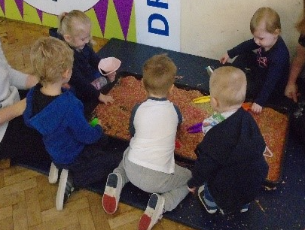
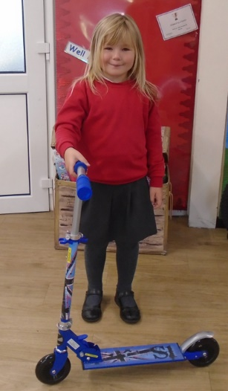
Campfire days, attendance winners, Little Sprouts playgroup, Bikeability, Good to be Green parties, healthy eating workshops, science experiments, World Book day, Causeway has Talent, Magic breakfast…

”

