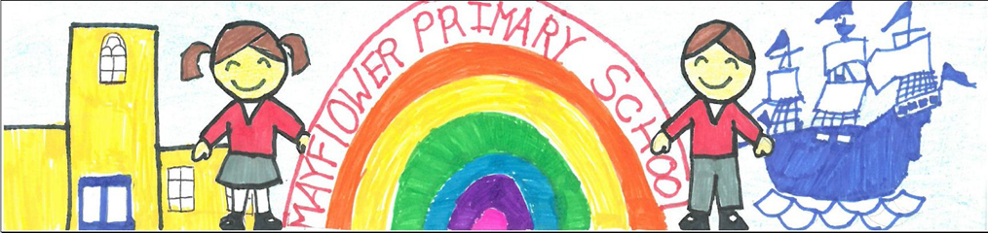

Job Description

Post: Deputy Head Teacher

Responsible To: The Head Teacher and Governing Body

OVERALL RESPONSIBILITIES - The duties outlined in this job description are in addition to those covered by the latest School Teachers' Pay and Conditions Document. With your agreement, these may be modified by the Head Teacher, to reflect changes over time and anticipate amendments to the job according to the school’s needs and the strengths of the successful candidate. They will be commensurate with the salary and job title. The Deputy Head Teacher will play a significant role under the overall direction of the Head Teacher in:

    - Formulating the aims and objectives of the school and managing staff and resources to that end
    - Assisting the Head Teacher in determining general school policy and managing its implementation
    - Personally supporting, following and implementing school policies and procedures as currently set out in the school’s policy file and/or assist in establishing new policies as well as monitoring progress towards their achievement
- Assisting the Head Teacher in managing the school on a day-to-day basis
- Deputising for the Head Teacher in the event of absence or other urgent business.
- Making a leading contribution to the school’s monitoring and review processes for pupils’ attainment and learning/teaching.
- Making a leading contribution to the development of the general school ethos and its mission statement
- Using Leadership and Management time effectively for these purposes
- Undertaking the duties to the extent required by the Head Teacher or the Governing Body and the professional duties of the Head Teacher in the event of his absence from the school
- Teaching pupils in the primary age range 3 – 11 years and by example, providing an exemplar model as a classroom practitioner
- Having a key role in the implementation of teacher appraisal
- To manage, and have a vision for, the development of hardware and software provision for all aspects of the school, including those outside of the curriculum

SECTION 1 – DUTIES

Teaching and Learning

- Carry out teaching duties in accordance with the school's schemes of work and National Curriculum
- Liaise with colleagues to deliver units of work in a collaborative way
- Work with teaching assistants, SENDCo and subject specialists
- Set targets for pupil attainment levels
- Demonstrate exemplary practice

Assessing and Reporting

- Record pupils’ work and maintain lesson evaluations
- Provide pupils and parents with feedback and targets, as required
- Provide assessment reports to monitor student progress making these available to colleagues and others as required/appropriate
- Liaise with parents and attend consultation evenings
- Work within the Code of Practice relating to Special Educational Needs

Leadership and Management

- Support and deputise for the Head Teacher
- Understand issues relating to the organisation, ordering and funding of resources
- On a day-to-day basis, line-manage and lead staff, both teaching and non-teaching
- Organise the deployment of support staff across the school to ensure effective use of resources
- Deploy staff effectively in order to give everyone a good work/life balance
- Be responsible for the preparation, evaluation and updating of the school’s timetable and rotas
- Support and uphold the school's policies on behaviour, discipline and bullying
- Plan and lead school assemblies, with a specific emphasis on celebrating pupils’ achievements
- Provide support to the Assistant Head Teacher, Curriculum Management Team, and dedicated subject specialists, as required
- Manage the budgets for negotiated/agreed subjects and areas
- Undertake responsibility for staff development activities
- Under direction from the Head Teacher, assist in the interview and appointment of new members of staff
- To manage the role of the ICT Technician
- To be responsible for the role of the ‘Young Consultants’ within the school
- To oversee the work of the Creativity Council, and support in the delivery of agreed programmes across the school

Standards and quality assurance

- Support the aims and ethos of the school and contribute to a clear vision for overall effectiveness by initiating and managing change and improvement to develop the organisation and staff
- Act as a lead member of the Governors’ working groups
- Assist in the organisation and implementation of assessment, whole school data analysis, and target setting
- Develop and monitor the curriculum across the whole school
- Oversee the curriculum and its effectiveness in meeting the needs of all pupils
- Set a good example to pupils and staff in terms of dress, punctuality and attendance
- Be a supportive presence at after school events by attending and participating in parents’ evenings, performances, FOM events etc
- Support and uphold the school’s policy on behaviour, discipline and anti-bullying
- Organise and participate in staff training and attend team meetings
- Develop links with community members and external agencies, governors, Las, and neighbouring schools
- Be confident in the use of modern technologies, maintaining high levels of ICT competency and keeping abreast with future developments

Health and Safety

- Undergo First Aid at Work training and update courses
- Assist in the design and delivery of health and safety policies and practices
- To be aware of the responsibility for personal Health, Safety and Welfare and that of others who may be affected by your actions or inactions
- Co-operate with and represent the Head Teacher and Governors on all issues to do with Health, Safety & Welfare
- Supported by the Head Teacher, to be the school’s Designated Safeguarding Lead (DSL)

Continuing Professional Development – Personal

- In conjunction with the Head Teacher, take responsibility for personal professional development, keeping up to date with research and developments in teaching pedagogy and changes to the school’s curriculum
- Undertake any necessary professional development as identified in the School Improvement Plan taking full advantage of any relevant training and development available
- Maintain a professional portfolio of evidence to support the teacher appraisal process including the incorporation of targets related to leadership, evaluating and improving own practice
- Effectively manage own time when dealing with the wide range of day-to-day and long term demands of the post

Continuing Professional Development – Staff

- To organise and take a leading role in the provision of high quality professional development for all staff through the development and maintenance of an effective appraisal programme, making use of, where appropriate, other sources of expertise, e.g. LAs, Learning Partners, external training agencies, etc
- In the absence of the Head Teacher, to consider the expectations and needs of other members of staff, and in particular ensure that new appointees, trainees and NQTs are appropriately inducted, monitored, supported and assessed in relation to the Teachers’ Standards and those of the school, e.g. by the incorporation of targets related to professional development, quality of teaching and pupil progress

Whilst every effort has been made to explain the main duties and responsibilities of the post, each individual task undertaken may not be specifically identified.

The Deputy Head is expected to comply with any reasonable request from the Head Teacher to undertake work of a similar level that is not specified in this Job Description.

The duties identified may be amended at any time following discussion between the Head Teacher and the Deputy Head and will be reviewed annually. This will form part of the appraisal cycle, which will support the Deputy Head Teacher to develop wider competencies against the National Standards of Excellence for Head Teachers.

Signed: ______________________________ (post-holder)

Date: ______________________________

Signed: ______________________________ (Head Teacher)

Date: ______________________________

