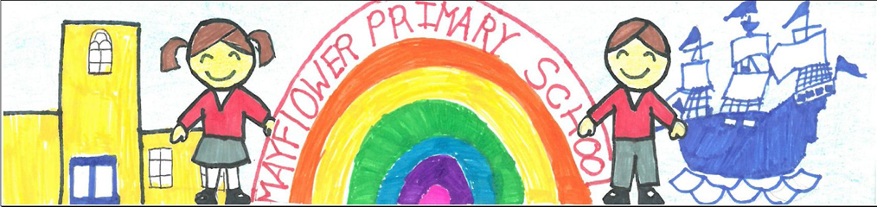

How to Apply

The following guidelines are designed to help you submit a job application in line with our requirements. Please ensure that you comply with the instructions below. If you do not, we may not be able to short-list you.

If you require clarification or have any questions regarding the application process, please contact Mr. Luke Whitney on 0116 2737504 or via the following email address:

- lwhitney@mayflower.leicester.sch.uk

Application Form and Covering Letter

Please complete all the sections of the form in full, giving as much detail as possible. Once completed, you must sign and date the application form to confirm that the information and any attachments are correct. Please note that CVs will not be accepted. For this post, you will also be required to complete a covering letter that addresses all of the essential characteristics for the role, as detailed in the Person Specification. Uploading via eTeach will also be acceptable.

Equal Opportunities Monitoring

Please ensure that you have completed the Equal Opportunities Monitoring form and submit either as an attachment, or as an enclosure along with your application form and covering letter. The deadline for applications is Midday on Monday 9th March 2026.

Short-Listing

Short-listing will take place on Wednesday 11th March 2026. A Short-Listing Panel will score each application against the essential characteristics for the role, as detailed in the Person Specification. The principles of Safer Recruitment will also be applied, in-line with national guidance and KCSIE 2025. The Short-Listing Panel will ensure that all candidates called for interview are notified by email, and details of the interview day will be provided at the time. Our hope is that this will give candidates the maximum amount of time to prepare for what will be a challenging progression of tasks and activities. Unsuccessful candidates will be notified online via the eTeach portal.

References

In-line with Safer Recruitment guidance, references will be requested consequent to short-listing and prior to the interviews. Candidates are reminded that they will be required to provide the names and contact details for 2 referees, one of which must be your existing employer. In the unlikely event of us not receiving references before the interviews, any offer of employment will be conditional on us receiving a satisfactory response from the named referee.

Interviews

The first interview day will take place on Monday 16th March 2026, and will consist of a range of tasks that will allow the Interviewing Panel to make a full assessment against the essential criteria for the post, as disclosed within the Person Specification. The nature of the day will be confirmed in the written confirmation that will be provided to any candidate who has been short-listed.

At the end of Day 1, the Interviewing Panel will short-list again, on the basis of the information that has been collected during the day. Unsuccessful candidates will be offered a debrief, and successful candidates will be carried forward to Day 2, on Tuesday 17th March 2026. Details of the final tasks will be disclosed to short-listed candidates as part of communication from the Interviewing Panel, consequent to short-listing, and this will be sent by email soon after telephone confirmation from the Chair of the Panel.

Candidates who are invited for interview will be required to provide proof of their eligibility to work in the UK by producing verifiable documents. Candidates will also be required to bring some photo ID with them on the day of the interview e.g. valid passport, driving license or identity card.

An offer of appointment will not be confirmed until we have received confirmation of your fitness for employment, an enhanced Disclosure & Barring Service check and confirmation of your right to work in the UK. Teachers will be required to provide proof of their qualifications (degree certificate(s), QTS etc).

Applicants with Additional Needs

Mayflower Primary School welcomes applications from candidates with additional needs. If you require any adjustments to enable you to attend the interview, please ensure that you have provided this information on your application form. If you are called for interview, please discuss any adjustments you may require to carry out the duties of the role with the Interviewing Panel so that the appropriate arrangements and any adjustments can be made if necessary. (Under the Equality Act, a disability is defined as a physical or mental impairment which has a substantial and long-term adverse effect on a person’s ability to carry out normal day-to-day activities).

