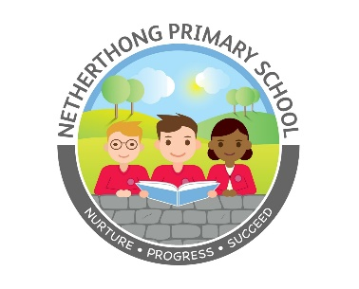
Deputy Headship
NETHERTHONG PRIMARY SCHOOL
School Street, Netherthong
Huddersfield,HD9 3EB
Tel: 01484 222487

Ref:
DEPUTY HEAD TEACHER
Salary: L5 – L9
Start September 2021

Following the promotion of the current post holder, the Governors wish to appoint an inspirational Deputy Head Teacher with exceptional leadership qualities who will continue to build on the strengths of the school with passion and vision.

Netherthong Primary School is a vibrant and friendly community school in a stunning village setting above Holmfirth. We have a single form entry with 218 pupils and are a truly outstanding school by any measure, including our December 2012 OFSTED. We strive for the highest academic achievement possible for each and every child, and provide a hugely diverse range of curriculum and extra-curriculum activities.

Our new Deputy Head Teacher will:

- Embrace our values, ethos and creativity.
- Be an outstanding classroom practitioner who can teach effectively across the primary range.
- Be an exemplary practitioner who is committed to playing a key role alongside the headteacher in the leadership and management of the school.
- Be an innovative and creative leader who can support, motivate and inspire others.
- Be a leader who can respond positively to change.
- Commit to the development of all our staff.
- Promote the school within the wider community, and engage in partnership with parents and carers.
- Act as SENDCo for the school.

In return we can offer you:

- Children who are enthusiastic, well behaved and positive in their approach to learning.
- An exciting opportunity to support the development of our outstanding school.
- Strong and loyal support from ambitious and committed Governors.
- A cohesive team of driven and highly dedicated staff.

This is likely to be a non-teaching role in the first year. However, this will be subject to an annual review of the school budget. Some teaching will be required for cover.

If you share the vision, drive, passion and creativity needed to take our wonderful school onto even greater success, we would really love to hear from you.

We are committed to safeguarding and promoting the welfare of children and young people and expect all staff and volunteers to share this commitment. All staff are subject to an enhanced DBS check. A conviction may not exclude candidates from appointment but will be considered as part of the recruitment process.

Applicants are encouraged to visit the school website http://netherthongprimary.co.uk. If you require any further information please contact school on 01484 681950 or via our email office@netherthongprimary.co.uk office@netherthongprimary.co.uk. Visits to the school are welcome.

To view job details and apply go to http://jobs.kirklees.gov.uk

Completed applications should be returned to the Head Teacher by 12 noon on Friday 9th April 2021.

Please email completed forms to recruitment@netherthongprimary.co.uk

Closing date for applications: Friday 9th April.

Interviews will take place w/c 19th April.

