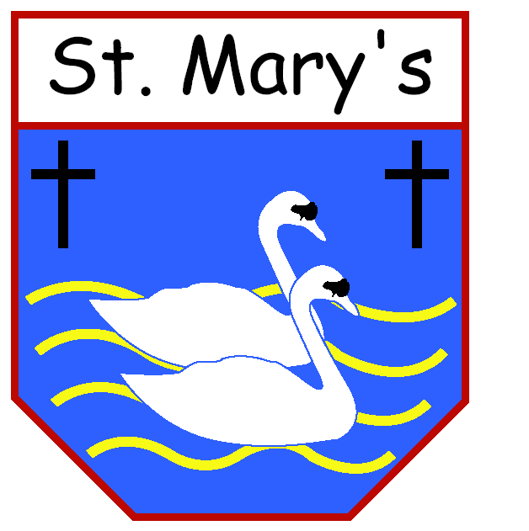 St. Mary’s Catholic Primary School, Harrington
Holden Road
Salterbeck
Workington
Cumbria CA14 5LN
Telephone: 01946 830433
Headteacher: Mrs D Douglas
Email: admin@stmarys-harrington.cumbria.sch.uk
Website: www.stmarys-harrington.cumbria.sch.uk

Dear Applicant,
Thank you for showing interest in the position of Deputy Headteacher of St Mary’s Catholic Primary School.
The Governing Body is looking for an inspirational and determined leader who will take our school from strength to strength. Our most recent Ofsted inspection in November 2022 recognised the significant work and achievements of the current leadership team. We are looking for someone build on these strong foundations and further develop these strengths. Can you create an environment where learning is fun? Can you demonstrate how to identify a possible weakness and turn it into a strength? Can you work collaboratively with other local primary schools, sharing best practice and expertise?
Our school has an ethos of love and the teachings of Christ in the Gospels. This is at the centre of who we are and all we do. These beliefs and values are fundamental and are taught through the curriculum by a very supportive, forward thinking, and innovative staff. We strive for every child to reach their full potential in everything they do, irrespective of wealth or poverty. Each child is equal in God’s eyes.
The first thing that I noticed when I became a Governor at St Mary’s was the happy and joyous children that we are blessed with at our school. Their smiles can literally melt a hardened heart. Every time I visit a classroom, they are polite and friendly with a willingness to share what they are doing. Our children want the very best Headteacher.
Our with school has very a strong relationship with the local diocesan priests and is strongly supported by them. Visits to our school are regular and we celebrate Mass in school as well as the local church. We are actively involved in parochial events and would want this to continue.
If you are interested in the post, I would encourage you to contact the school on 01946 830433 to book an appointment and see for yourself what we have to offer.
Details of how to apply for this post can be downloaded from the school’s website: https://www.stmarys-harrington.cumbria.sch.uk/topic/about-us
I look forward to receiving your application.
Paul Glaister
Chair of Governors

