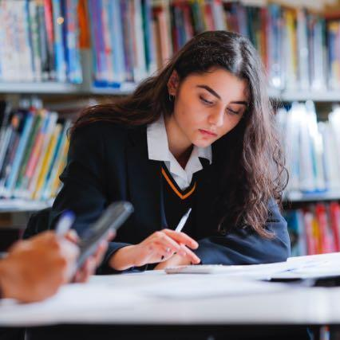
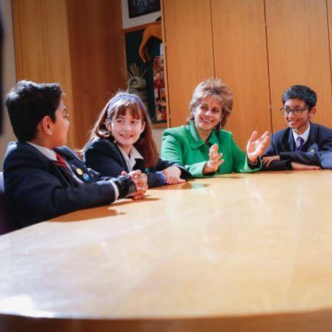

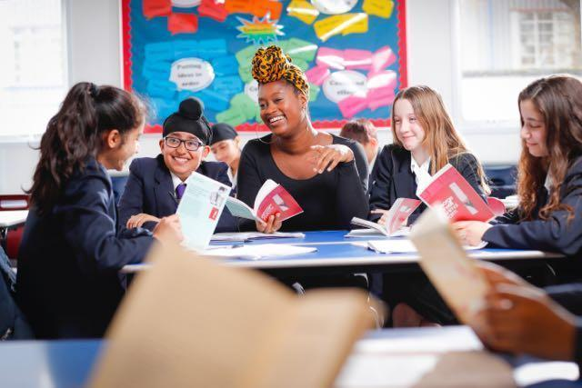
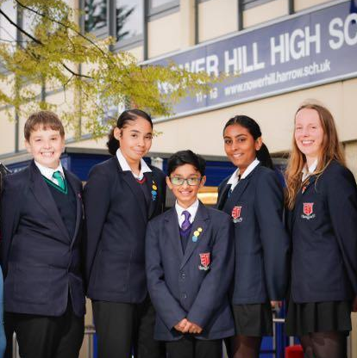

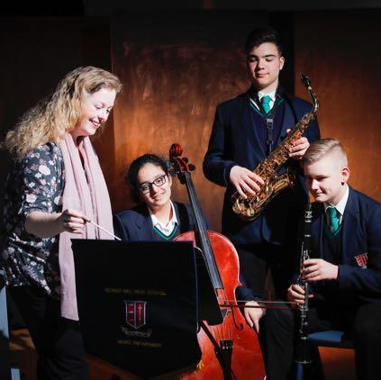

New Parents’ and Carers’ Handbook
2021-2022

Nower Hill High School
New Parents’ and Carers’ Handbook 2021-2022

Contents | Page
Welcome to Nower Hill High School | 3
The Nower Hill High School Learning Journey | 4
Background and History | 5
Nower Hill High School Governing Board | 6
Joining the School – Keeping in Touch and Working Together | 7
SIMS Parent App | 7
Attendance Policy | 8-9
Children Entitled to Free School Meals | 10
Clubs and Activities | 10
Design and Technology | 11
Equipment | 11
Home / School Agreement | 12
Home / School Diaries | 13
Links with Primary Schools | 13
Lockers for Year 7 Students | 14
G-Suite and Satchel | 15
Medical Services | 15
Mobile Phones and other Electronic Equipment | 15
In Touch | 15
ParentPay | 16
Cashless Catering Service | 16-17
Parents and Friends of Nower Hill High School | 18
Policies | 19
Printing Costs | 19
School Council | 19
The School Day | 20
The School Environment | 20
School Trips and Other Off Site Activities | 21
Security | 22
Service to the Community | 22
School House System | 23
Specific Medical Needs | 23
Sustainable Travel to School | 23
Teaching and Learning | 23
Term Time Dates | 23
School Uniform | 24-26
Physical Education Kit | 27
Dress Code for 6th Form | 28
Uniform Stockists | 29
Leadership and Management Roles 2021-2022 | 30
Key Contacts 2021-2022 | 31
Planning Your Route to School | 32
Welcome to Nower Hill High School

Dear Parents and Carers

It is an absolute pleasure to welcome you and your child to the Nower Hill family; thank you for trusting us with your child’s education for the next 7 years. As educators, we never forget what a privilege it is to shape a young person’s life and prepare them for a successful future; everyone within the Nower Hill community has a deep commitment to this responsibility and will go above and beyond to ensure that working in partnership with you, your son or daughter leaves here well qualified for the next stage of their life. The past year has been difficult for all of us, and it gives me great pleasure to look ahead with you now to a very positive future for your child.

Most importantly, we want our students to enjoy their time with us. We are a hard working school, but we are also a very happy school and it is important to us that young people maintain a good balance of academic and enrichment activities. We want our students to achieve as highly as they possibly can, but at the same time, it is essential that they maintain good physical and emotional health and can look back at their time at Nower Hill with great warmth and fondness.

Your children join Nower Hill following an exceptional time for schools, in which we have seen the majority of students working from home for some of the year, returning to schools where daily life looks very different to how it once did. Please be assured that we will fully support your child to ensure they have a happy and successful transition to Nower Hill and that everyone will be in the same situation. A fresh start is actually just what they need and to help them envisage a bright, positive future full of opportunities, our ‘Nower Hill Learning Journey’ (on page 4) will show them the exciting pathway they will follow; the goals they need to work towards and achieve; and the success which will be theirs at the end of the journey. Please do read through the Learning Journey with your child, helping them to visualise that positivity and success and encouraging them to make the most of all the enriching experiences and opportunities which Nower Hill has to offer.

We are a school with very high standards and with that, comes the highest expectations of students at all times, both in terms of their academic efforts and their behaviour. Our sustained high standards have attracted a number of national awards and we are proud to have been able to maintain a rich, balanced curriculum, supported by a wide-ranging programme of extra-curricular activities, which continues to allow our children to excel in a variety of disciplines and in a holistic manner. We are very proud of our school, but we are never complacent and constantly evaluate and tweak what we do, in order to be an even better school next year.

Our school’s values will not have escaped your notice. We are a truly comprehensive school and welcome children from all backgrounds, regardless of academic ability; we will help them to grow into the best version of themselves they can possibly be. All that we ask in return is that you as their parents and carers support us in this endeavour and together with us, embed the values of: impeccable manners, excellent behaviour, smartness of appearance, articulacy, hard work and most importantly, kindness. Some people call this character education, but we just call it good parenting!

As we start this journey together, we encourage you to be involved in every aspect of your child’s education at Nower Hill. We will do all we can to support, nurture and encourage your son or daughter and in return, ask for your active partnership in order that your child achieves as highly as they possibly can; it is only when school and home work effectively together that this can be achieved.

As someone who has lived in this community all of my life, it is a great privilege to help shape the successful future lives of the young people within it, by being the Headteacher of this wonderful school. I do hope that your children will enjoy coming to school each day as much as I do, and that they will fully immerse themselves in all that Nower Hill has to offer. I very much look forward to the pleasure of getting to know both them and you over the next 7 years.

Yours faithfully
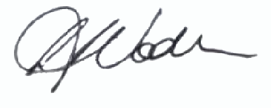
Louise Voden,

Headteacher
The Nower Hill High School Learning Journey
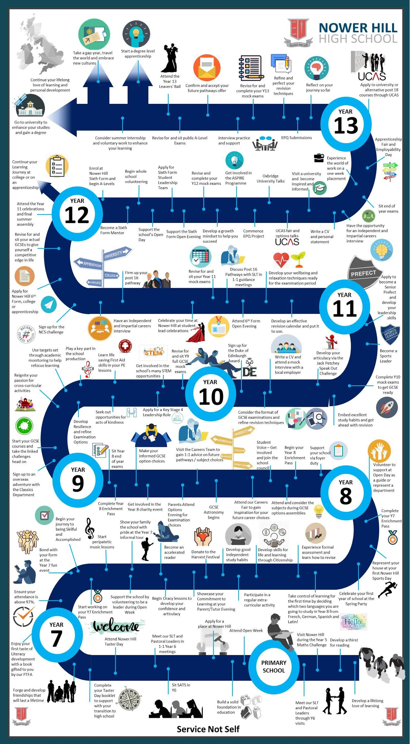
Background and History
The school, then known as Headstone Council School, started life on April 8th 1929 under the headship of Mr C.J Boyden and 6 teachers. At the cost of £15,000 the red brick building in Pinner Road had been newly built to educate 292 five to fourteen year olds (average class size of 50). The school soon expanded to meet the ever growing number of children resident in the rapidly expanding North Harrow and Pinner (Pinner grew from a population of 9,462 in 1921 to 24,500 in 1931), with class sizes reaching the sixties and never less than the fifties. The Second World War interrupted the education of many young people. Many of the male teachers were called up for military service and the playing field was dug up for trenches and air raid shelters. The children attended on only every 3rd day and lessons were constantly disrupted by air raid sirens (1227 alerts in total). The girls were expected to have knitting with them at all times to occupy them during their frequent visits to the air raid shelters. The threat was very real; among many bombs landing in the vicinity, in 1944 a V2 rocket landed in the cemetery behind the school. School uniform was first introduced in 1946 and the navy blue blazer remains to this day.

In the late 1950s a new school building was planned which opened in the early 1960s. Another block was added in 1972 and further buildings were taken into use in 1978. Nower Hill High School came into existence on 1st September 1974. 1993/94 saw the start of a £2.75 million development programme, which included a new 13 classroom block and the Gristwood Centre housing Music, Dance and Drama studios, a fitness suite and the sports hall. More recently, new Science laboratories have been added and a new teaching block. Every teaching room has an interactive whiteboard and sets of tablet computers are available to all faculties for use in the classroom. There are also 7 discrete ICT rooms and iMac suites in the Media and Music classrooms. The school has also enjoyed numerous structural improvements including new doors, windows, roofs, toilets and central heating system.

The school first admitted 6th Form students in September 2006 and in September 2009 we moved into our £4 million 6th Form extension, housing excellent facilities for our large 6th Form. As we welcomed Year 7 into the school in September 2010 for the first time since it had become Nower Hill High School, our facilities were further enhanced by the addition of additional teaching rooms, Science laboratories (giving us a total of 16) and a 13 classroom English teaching block. More recently, the school has benefitted from a newly designed front of school along George V Avenue and earlier this year, we completed our new sports changing rooms. We are now a school of 2000 students.

Much has changed in the last 92 years, but we are pleased to say that the sentiment expressed in the words written by the very first Headteacher in his school log, dated May 24th 1929, remain true to this day. Mr Boyden wrote “I would like to place on record the excellent work of the staff and the exceedingly successful results of their efforts”. We are a forward looking and innovative school, rooted in the timeless qualities and traditions of excellent schools.

Throughout its 92 year history, the school has only had 8 Headteachers:

Mr C.J. Boyden (1929-43)
Mr A.W. Manson (1943-63)
Mr E.J.R. Dey (1963-69)
Mr F.R.H. Gristwood (1969-83)
Mr S.P. Hensby (1983-99)
Mr H. Freed (2000-2013)
Mr C.J. Livesey (2013-2019)
Ms L. Voden (2019 to date)
Nower Hill High School Governing Board
The school's Governing Board consists of parent governors, member governors, co-opted governors and staff governors. Governors serve for a term of four years. We are currently in the process of recruiting parent and staff governors and we hope that new parents will be willing to get involved. Nominations and applications can be emailed to …

Member Appointed Governors
Mrs M Weerasekera (Chair of Governors)
Mr H Freed (Vice Chair of Governors)
Ms L Voden (Headteacher)
Mrs A Chowdhry
Ms K Jeram
Mrs D La Rue
Ms S Syed

Parent Governors
Mr K Bhogal

Staff Governor
Ms M Berry

Member of the Academy Trust
Mr P Lawder
Ms M Manderson
Mr R McKerracher
Mr S Nattrass

Ofsted Outstanding
As an outstanding school, we were exempt from routine inspection, however at our last inspection, May 2012, Nower Hill High School was judged to be outstanding in all five categories:

Achievement of Students - Outstanding
Quality of Teaching - Outstanding
Behaviour and Safety of Students - Outstanding
Leadership and Management - Outstanding
Overall Effectiveness - Outstanding

You can find the Inspection Report on our website: www.nowerhill.org.uk/ofsted

Joining the School – Keeping in Touch and Working Together
When a new student joins us at Nower Hill, they are beginning an important new stage in their life.
We aim to work in partnership with our parents and carers to the benefit of your children, our students. Within this partnership there may be times when you wish or need to contact the school rather than through the home/school diary. As a large school, it is important that we provide the best possible service for parents and students by using our staff efficiently. At your child's primary school, you may well have become used to discussing a wide range of matters with the Headteacher. At Nower Hill we have a large, well-qualified staff and we would ask you to consider which person is best placed to deal with an issue. To help you decide, a summary of the main responsibilities of various staff are as follows:

Form Tutor
The Form Tutor should be the first point of contact for both students and parents, as they will know your child best. The Form Tutor sees his/her Form for registration every morning and is the teacher who has a personal and direct responsibility for all members of their Form. Form Tutors will usually remain with their Tutor Group from Years 7 to 11.

Class Teacher
For queries related to a particular subject you can contact the relevant class teacher.

Year Co-ordinator
There are two Year Co-ordinators per Year Group who each have responsibility for 162 students and a team of 6 Form Tutors. The Year Co-ordinator is responsible for the oversight of their group of Forms and their Form Tutors.

Curriculum Leader
The curriculum areas within the school are divided into 10 Faculties, each led by the Curriculum Leader. The Curriculum Leader has general oversight of the subject areas within the Faculty.

Assistant Headteachers
There is an Assistant Headteacher for each Key Stage. If you are unable to resolve an issue with the members of staff listed above, then please contact the relevant Assistant Headteacher for your Key Stage.

If you wish to see a teacher, please remember that in normal circumstances teachers have classes and duties for the vast majority of the school day. The expected practice is to telephone the school to agree to a mutually convenient appointment. This provides an opportunity for information to be gathered, as required, and to meet in a more relaxed and positive way. If a message is left with reception, teaching staff will endeavour to return a telephone call to you within 48 hours. We appreciate that there will be occasions when issues arise which require urgent attention. Nevertheless, we must insist, in the best interests of all concerned, that the procedure outlined above is followed. Please note, all visitors to our school must enter via the main reception at all times.

SIMS Parent App
Communication is fundamental to us at Nower Hill and we encourage a strong working partnership with our families. To help facilitate this, we are promoting the use of the SIMS Parent App, which will also enhance the communication link between school and home. This will enable you to keep a close eye on how your child is progressing in school. Details will be sent to you via letter regarding instructions for setting up the application. Once activated, you will then be able to monitor your child’s attendance, achievement and behaviour points and view their timetable, which is a useful resource to have.
Attendance Policy
Nower Hill High School promotes good school attendance and punctuality for every child. Regular and punctual attendance at school is both a legal requirement and essential for students to maximise their educational opportunities. School attendance is also a component of safeguarding children.

Our weekly attendance target is 96% plus for each student in each year group; Nower Hill High School considers this to be a satisfactory level of attendance for students. Please be aware that an attendance record of 90% means that a child has missed half a day every week. This is four weeks over a school year and over five school years, becomes half a school year missed. The DfE guidelines class attendance below 90% as persistent absence and parents and carers should note that the Local Authority may use its legal powers in cases of persistent absence to improve school attendance.

We ask that you inform the school if your child is unwell or unable to attend school. Please ring the main school number 0208 863 0877 by 8.15am on the day of absence and choose the option to leave a message to report your child’s absence. It is very helpful if you speak slowly and clearly when leaving your message. Alternatively you may email attendance@nowerhill.harrow.sch.uk. If no notification is received, we are required to check the reason for absence; therefore you will be contacted by the school.

If your child has a medical appointment and will arrive at school later than 9:30am, we also ask for a message to be left informing us, as we need to ensure that our students are safe. Please note that students will need to be collected by a parent/carer for any appointments during school hours. With regards to medical appointments, we ask for your support in making appointments before or after school whenever possible.

Punctuality is also extremely important at Nower Hill. Students are expected to be in school for registration by 8:40am. Those who are late without a valid reason will be expected to attend a detention at break time on the same day. Persistent latecomers will receive a longer detention and possible further sanctions. Please refer to the Student Support Guidance for full details of our attendance and punctuality procedures.

Legal Enforcement by Harrow Local Authority
As part of promoting good attendance and punctuality, Harrow Local Authority will use its legal powers to enforce school attendance where this becomes problematic, including powers to prosecute parents who fail to comply with a School Attendance Order (Section 443 of the Education Act 1996) or fail to ensure their child’s regular attendance at school (Section 444 of the Education Act 1996). In addition, the Local Authority will impose Penalty Notices as an alternative to prosecution on parents for unauthorised absence; these may also be issued where parents allow their children to be present in a public place during school hours without reasonable justification.

The Education (Penalty Notices) Regulations 2007 and the Harrow Code of Conduct for issuing penalty notices sets out the details of how the penalty notice scheme operates. Harrow Council will also conduct Pre Court Panel meetings in accordance with the Police and Criminal Evidence (PACE) Act 1984. The Harrow Attendance Guidance and Resources (pack) provides a clear outline of the process for escalating cases for legal action which is called Attendance Intervention Model (AIM).

If your child has an unauthorised absence, such as taking holidays in term time, recurring lateness or persistent absence for any reason other than certified illness, the school will refer the matter to the London Borough of Harrow for consideration of a Penalty Notice and/or Prosecution in the Magistrates’ Court, leading to a criminal record, a maximum fine of £2,500 and/or up to 3 months’ imprisonment.

Absence in Term Time
Absence in term time will only be authorised for exceptional circumstances. Parents/carers should contact the Attendance Officer to discuss the matter well in advance of the expected absence and before a booking is made. All requests will be considered on an individual basis in accordance with school policy. A Leave of Absence form will need to be completed for our records. Repeat requests will be identified and challenged. Please note this includes primary school records of attendance as well, and in the case of travelling due to exceptional circumstances, your travel documents will be required as evidence. If you take your child out of school without permission or if your child is away for longer than the time agreed by the Headteacher, this absence will be registered as unauthorised. Sanctions can be imposed including:

- Your child could lose their school place.
- You could face a penalty fine.
- You could be subject to legal action by the Local Authority that could result in a fine of up to £2,500.
- 6th Form students whose attendance falls below 90% or who have a very poor punctuality record may be asked to pay for their public examination entries. Poor attendance may also affect entry to Year 13 or university.
- Poor attendance and punctuality will always be reflected in any personal reference given by the school.
- Referral to Children’s Services.
Religious Observance
After taking advice from SACRE (Standing Advisory Council for Religious Education), the school has limited the number of religious days that may be taken as an authorised absence, to a maximum of 3 days per school year. Please note that these may not be taken consecutively. One day will be authorised for each religious festival. Any additional requests must be submitted in writing to the Attendance Officer. Parents/carers must telephone the school to advise us when their child is absent due to religious observance.

We ask parents/carers for their support in:
- Encouraging their child to attend school regularly and punctually and to appreciate both the legal and social importance of good attendance and punctuality.
- Informing the school on the first morning of any absence by 8.15am, indicating the cause and likely duration of the absence.
- Contacting the Attendance Officer promptly whenever their child seems unwilling or disinclined to attend school.
- Making every attempt to arrange dental and medical appointments outside the school hours. Please note that parents will be expected to collect their child from the school if they are to attend a dental or medical appointment during school time, or if they are going home sick.
- Supporting our Attendance Policy at all times.
- We value a positive home/school partnership with all families. Please be aware that if we are unable to contact you by phone, email or letter, we are obliged to inform Children’s Services as a duty of care.
Children Entitled to Free School Meals
The borough has a policy to support children in serious need. Any parent or carer who believes they maybe entitled to support should visit http://www.harrow.gov.uk/freeschoolmeals to find out information on eligibility and apply at http://pps.lgfl.org.uk
You only have to apply once for the duration your child is at the same school. When your child moves school, you will need to update your child’s details against their new school at: http://pps.lgfl.org.uk .

If you qualify, your child’s school will receive funding and you can choose the free school meals. For further information or assistance with completing the application, please contact Student Services at the School on 020 8863 0877 and select option 2.

Clubs and Activities
Numerous clubs and societies operate during lunchtime and after school. Some examples of the activities which are offered are: The Duke of Edinburgh Award, STEM, school orchestra, basketball, art, debating, classics, cricket, football, choir, astronomy, dance, science and coding clubs. Students are encouraged to take part to widen their interests, further their skills and meet a range of other children with similar interests. Many of our 6th Form students help teachers in the running of after school clubs and prove to be excellent role models for the younger children.

Educational excursions are a feature of school life and have included: ski trips; cultural visits to Italy, Spain, China and America; and outdoor pursuits in the Peak District and Hertfordshire. There are also frequent and varied day trips, including field study days, museum and theatre visits.

In accordance with DfE guidance where visits or on site activities are undertaken during the school day, there must be no compulsory charge to cover the costs involved. Accordingly, we invite parents to make contributions on the understanding that if not enough parents are prepared to do so, then the activity may have to be cancelled. (We are delighted that we have not yet had to cancel any such activity and we look forward to continuing to provide these excellent opportunities). A summary of the extra-curricular offer may be found on our website and will be updated termly.

Design and Technology
Under recent education law, the school is required to provide your child with materials, books, instruments and other equipment, which the school feels appropriate for his or her education during school hours.

Previously it was usual, in the case of practical subjects such as Design and Technology, to ask students to bring into school for the particular design and technology lesson, products for food tastings, fabrics for textile work or to pay for the cost of resistant materials provided by school. In these practical subjects, the school allows students to take the finished item home at the end of the lesson or course. Due to the nature of these materials being expensive and difficult to source, the school now provides the students with the above mentioned items, to ensure all pupils have the opportunity to produce quality products and to support busy parents and carers who may find it difficult to find the time to source all of the necessary equipment.

You will appreciate that there could be considerable strain on the school’s budget as a consequence of any change to these arrangements. Therefore, we ask if you would be prepared to continue the previous arrangement, by making a contribution of £15 for the items that your child will complete in Year 7. Please note that this contribution will not cover all items that will be used over the course of the year.

Payment for this must be made via ParentPay. If you require a reminder of your username and password, e-mail ParentPay@nowerhill.harrow.sch.uk.

Equipment
We recommend that all students have with them a sturdy plastic folder or zip-lock wallet in which to keep exercise books and homework completed on paper to ensure their necessary protection whilst in their school bag. These are available for purchase from Student Services in school. All students will be required to be equipped with the following:

- Compulsory Premier Backpack
- Pencil Case
- Several pens (blue and black)
- 1 purple pen
- Several pencils - HB and 2B
- Eraser and sharpener
- Ruler
- Colouring pencils
- An adhesive glue stick
- A pack of multi-coloured highlighters
- Scientific calculator
- Water bottle
- Reading book

PLEASE NOTE, SCISSORS MAY NOT BE BROUGHT ONTO THE SCHOOL SITE AND COMPASSES MAY ONLY BE USED IN MATHS AND SCIENCE LESSONS AND SHOULD BE KEPT SECURELY IN SCHOOL BAGS.

Home/School Agreement
Nower Hill is a thriving and successful school which provides high quality teaching and learning, a rich, balanced curriculum, outstanding student support and a wide programme of extra-curricular activities.

We are a school which values and celebrates the successes of our students. A stimulating, encouraging, caring and disciplined environment ensures that every child in our care can achieve his or her potential.

We have the highest expectations of our students. We are endeavouring to have a school where the students are nothing less than the most well-mannered, most articulate, best behaved, hardest working, smartest and kindest students there can be. We encourage you to be involved in every aspect of your child’s education at Nower Hill and value your active partnership in order to achieve the highest standards for our children.

- The Parents/Carers
I/We will:
- ensure that my/our child arrives at school on time, correctly and smartly dressed as well as properly equipped
- ensure that my/our child does not miss lessons through unnecessary absence, including taking holidays during term time
- let the school know about any concerns or problems that might affect my/our child’s wellbeing
- acknowledge that I/we have a clear role in ensuring my/our child is well behaved at school, and therefore will fully support the school’s policies and guidelines to ensure best behaviour at all times
- support my/our child in homework and other opportunities for learning
- monitor my child’s use of the internet and social networking sites
- attend parents’/carers’ evenings and meetings about my/our child’s progress as required
- facilitate communication by signing up to In Touch and providing one or more e-mail addresses and mobile phone numbers; keeping the school updated with regard to any changes to contact details
- conduct myself/ourselves in a mature, respectful and polite manner at all times when on the school site or in communication with members of staff
2. The Student
I will:
- ensure that I am well-mannered, hardworking, smartly dressed, articulate, kind and behaving extremely well at all times when in school uniform and/or representing the school
- behave with courtesy, respect and consideration for the local community before and after school
- attend school regularly and punctually
- bring all the equipment I need every day
- wear the correct school uniform, and be extremely smart in appearance, including on the way to and from school
- work extremely hard and ensure I complete all my class work and homework with an excellent level of effort
- be helpful to others wherever I can
- respect others’ opinions and points of view
- apologise when I have done something wrong
- keep the school free from litter and graffiti and treat other people’s property with care
- go about the school in a calm and orderly manner
- not bring the name of the school into disrepute
- follow the school rules and treat others with respect at all times
3. The School is committed to:
- having very high expectations of students in relation to their behaviour, their appearance, their manners and the need for hard work
- providing a calm and orderly environment in which we can all work and succeed
- treating all students and their parents/carers with respect at all times
- letting parents/carers know of any concerns in relation to the work or behaviour of their child
- sending home regular tracking reports
- encouraging and supporting parents/carers to use the SIMS Parent App to enable regular monitoring of conduct points, punctuality and attendance
- setting and marking/monitoring homework in accordance with school policy
- arranging parents’/carers’ consultation evenings
- keeping parents/carers informed about school activities through regular letters home and meetings
- correcting children’s speech when appropriate to improve their articulacy
- applying the ‘Ladder of Consequence and Reward’ fairly and consistently at all times
- contacting parents/carers if there is an on-going problem with attendance, punctuality, progress or equipment
It is expected that all parents/carers and students agree to and sign the Home School Agreement at their pre-admission meeting and at the start of each year in the student diary.

Home School Diaries
These are supplied to all students. Diaries are used for the following purposes:
- For students to record their homework, although we predominantly use Satchel for this;
- For students to remind or notify parents of any extra-curricular clubs or detentions;
- To provide a medium for communication between parents/carers and teachers.

Form Tutors sign the diaries weekly and we ask that parents do the same.
Diaries will need to be replaced if they are lost, damaged or defaced. The cost of a new diary is £3.00.

Links with Primary Schools
Many of the new students joining Nower Hill in Year 7 come from primary schools within our local community. Transition procedures between primary and high school are successful and well established, featuring a pre-admission meeting with a member of the Senior Leadership Team; parent information evenings; a student induction day and close liaison throughout the year between Nower Hill and primary schools. Curriculum representatives work with our primary schools in Harrow, aiming to provide continuity within the curriculum. The close relationship between Nower Hill and its primary schools guarantees a sense of belonging and a continuity of education to all students, allowing the transfer at 11+ to be made with the minimum cause for concern to both students and parents/carers.
Lockers for Year 7 Students
There are 20 lockers in each form room available to hire on a first come, first served basis. The terms for receiving a locker are as follows:

- Upon payment of £15 for one year the student will have use of the locker in their form room. Lockers will be allocated within the first two weeks of term.

- Payment via ParentPay to be received by Wednesday 1st September. Payments received after this date will result in a delay to the issue of lockers.

- Students must provide and be responsible for his/her own padlock. If lost, or if the keys are lost, the student must be responsible for replacement and any cost incurred by the school. This may include a replacement padlock if bolt cutters have to be used. For this reason, we recommend that either a combination padlock, or a padlock with at least 2 keys (with one key kept in a safe place at home), is purchased. A suitable sturdy padlock can be purchased through the school for £5.00. If you wish to purchase the padlock from us, please edit the payment amount to £20 on ParentPay.

- The fee paid for the locker will not be refundable under any circumstances.

- The rules for use of a locker:

a) Access - Only between the following times:
8.30 am to 9.10 am
12.50 pm to 1.00 pm
3.15 pm to 3.30 pm

b) Maintenance. Each student is responsible for keeping his or her locker clean and tidy inside and out.

c) Cleanliness. At the end of the Academic year, or when there is a change of form base, the locker must be emptied and left in a clean and fit state for another student to use.

d) School’s Rights. The school reserves the right to withdraw the use of a locker if it is abused or the above rules are broken. In this event, there will be no refund of monies. It is permissible to share a locker but the original user is responsible for its upkeep and the school will not be involved in any disputes between users. The school will not be responsible for any items if they are stolen or damaged. The school has the right to search a student’s locker without their permission for any suspected prohibited item.

e) Consent Box. A consent box will appear on ParentPay and must be ticked before proceeding to pay. Ticking this box implies that you agree to our terms and conditions set out above and rules of use.

G-Suite and Satchel (previously known as Show My Homework)
G-Suite is an online platform consisting of apps; these include Drive, Classrooms, Google Meet and Sites. Students will use sites to access a wide range of resources, links to useful websites and learning activities organised by faculty and department. Google classrooms will be used to retrieve and submit work online, Google meet is used to deliver online learning where necessary and all students will have their own personal drive where they can store all their electronic documents, allowing access in or out of school.

Homework details can be accessed by students and parent/carers via the online platform, ‘Satchel – previously known as show my homework’. Parents and students can also download the Satchel:one app to their phone, which will send notification reminders of homework which are due for submission.

Medical Services
In common with all Harrow schools, we work closely with the borough's medical services. These may include immunisation programmes, meetings with the health advisor and the school nurse. In addition, the school has its own medical and welfare team. The medical and welfare room is open 08.30-15.30 and staffed by our welfare assistant during these times. We also have a qualified Paediatric nurse who works 10.00-14.00 four days a week. If your child has a medical issue that may affect them during the school day, please contact the school nurse to discuss. You may need to complete an individual care plan. Please ensure your child has the correct in date medications in school should they be required. Please note that it is the responsibility of parents to ensure that they provide in date medications for their children.

Mobile Phones and other Electronic Equipment
Whilst we understand that parents/carers may wish to allow their child to carry a mobile phone, particularly as this may be the first time that they are travelling to school on their own, they are not allowed to be seen, heard or used during school time. If they are seen or heard on school premises they will be confiscated and you will be notified by letter and required to come and collect it the following day. Students will also have the option to call parents/carers at the time of confiscation so families are aware of the situation for safeguarding purposes. Our rules surrounding mobile phone use in school has ensured that our students are able to learn and enjoy their leisure time without the distractions of mobile devices. Students must ensure that when they come onto the school site, their phones are turned off and safely kept in their bags. In addition, earphones, Air Pods and all other personal electronic equipment are not permitted in school and we would urge parents/carers to support us in this. Please be aware that if mobile phones and other electronic equipment are brought into school and lost or stolen, the school cannot accept responsibility and will not spend time investigating.

InTouch
All large scale distributed letters (e.g. by class, Year group or whole school) will be sent out by ‘InTouch’. Individual letters will continue to be sent by post. Please ensure that you complete the email box on the data collection form to ensure you receive electronic copies of letters. If you do not have email, then please state this on the data collection form and we will continue to send out all correspondence by post. Our school messages will be sent from the email address messages@parentmail.co.uk. Please make sure you add this address to your email address book in order to prevent messages being blocked by your spam/junk filters.

ParentPay
In an attempt to remove all cash and cheques from school we are asking all parents to only use our e-payment system (see below – Cashless Catering Service) to pay for lunch, printing, trips, lockers, music lessons and ad-hoc payments. This process is facilitated by ParentPay. ParentPay offers you the freedom to make payments whenever and wherever you like, 24 hours a day, 7 days a week, safe in the knowledge that the technology used is of the highest internet security available.

Parents/carers will be given a secure online account, activated using a unique username and password, and will be prompted to change these and to keep them safe and secure. If you have two or more children at the same school, or already have a ParentPay account at another school, it is possible to merge the accounts to create one set of login details for all children.

Making a payment is straightforward and ParentPay holds an electronic record of your payments to view at a later date; no card details are stored in any part of the system. Once you have activated your account, you can make online payments straight away.
Please visit www.parentpay.com, click on the ‘Login’ button and enter your username and password, which will be provided in this pack.

Cashless Catering Service
Nower Hill High School operates a cashless system for the catering service. The system offers many advantages to parents and students, as it enables the school to deliver an efficient, fast service and to provide wholesome, healthy and enjoyable meals at the lowest cost.

What is a Cashless System?
At the heart of the cashless system there is a computer controlled by I.M.P.A.C.T. Software. This allows the system to: recognise each individual student; hold individual cash balances; record cash spent and cash received; record where money is spent, on what food, on any specific date and time of day. Should the student have a specific food allergy, or be a diagnosed diabetic, this medical information can be coded into the system, preventing foods with allergy ingredients from being served to a particular student, by automatically locking out relevant buttons on the keyboard.

How are students recognised by the system?
Each student will have their fingerprint registered which will then be translated to an Alpha Numeric number. The image is then discarded. This will enter them into the system programme and identify them by a number.

How is this then used to obtain a school meal?
The student simply places their finger on a scanner at the point of sale; a display will show the server the student’s name, class and current cash balance held within the system. The selected food items will be entered into the system from an itemised keyboard while the amount spent and the new cash balance will show on the display.

We have adapted our systems this year due to Covid restrictions; students are required to remember a 4 digit pin code to identify themselves, which has been used successfully. We shall be monitoring the situation to determine when we will revert back to fingerprint scanning and we will ensure that we keep our parents and carers informed of any changes.

How will the student be able to check what the current cash balance is held in the system at any one time?
A Remote Display at the point of sale will show the new cash balance when the food service is finished. There is also a machine outside Student Services where students will be able to check their balance by using their finger print. They are able to access this before and after school, as well as during breaks. It is good practice to encourage secondary age children to regularly check their balance on their account. Should they be short on any given day they can contact home by using the student services telephone (at a 10p cost) to request a top up from home. However, we cannot guarantee the length of time taken for top ups to become ‘live’ on a child’s account, and for this reason, we encourage families to have a regular top-up system and to speak to their child regarding budgeting.

Children entitled to free school meals
Their accounts will automatically be credited with their daily entitlement. The system works exactly the same for all students whether they pay or have a free school meal. All students have their own account to use in exactly the same way. The amount allocated for the free school meal will be entered into the system by the software daily and is accessible at lunchtime only, for a hot meal or a sandwich and a drink.

The system will then allow on a daily basis the required cash amount for each individual student to be allotted to their current cash balance. However, any under spend or missed lunch will be identified by the system and will not be added to the next day’s balance.

They can also add extra cash on to their balance in the system using one of the two payment methods as described below.

Will we be able to have any information on how the system is being used?
Reports can be obtained from the system, giving comprehensive information on all aspects of use for each individual student, as well as each day’s service. These reports can be for a specific day or between any dates you wish; they will be dated and timed to the minute and can be obtained from ISS.

Data Handling
Certain data will be held on the system to enable accurate operation. This will include your child’s name, class, photo, account balance and whether they are receiving free school meals. This data will be handled under the guidelines of the Data Protection Act and only used by parties directly involved with the implementation of the system.

Ways in which to credit your child’s account:
1. Making secure payments online using your credit or debit card
Our caterers, ISS, have subscribed to ParentPay.

2. Paying by cash at a PayPoint
PayPoint payments are recorded by ParentPay and can be seen by logging into your ParentPay account and viewing your payment history online. The nearest PayPoint stores to school are:
MFG Ten Pin Station Road, North Harrow, HA2 6AE 0.30 miles away
Instanbul Express 63 Station Road, North Harrow, HA2 7SR 0.41 miles away
Harrow Superstore 83 Station Road, North Harrow, HA2 7SW 0.44 miles away
Sparkk Ltd 183 Marsh Road, HA5 5PB 0.71 miles away
Tesco Express Pinner Road, Harrow, HA1 4HS 0.70 miles away
Please notify the School Office if you wish to use the PayPoint facility.

Parents and Friends of Nower Hill High School
This association was established in 1983 and has a long history of working alongside the school community. Our aim is to develop and improve the already excellent relationships that exist between students, parents/carers and teachers. The school is more than a place of learning; it is a warm, caring, nurturing community where all are valued and encouraged to play a role. Parents/carers who take an active role, no matter how small within the PTFA, help to build on this.

The committee structure is as follows:

Chairperson Mrs Bijal Bavishi
Treasurer Mrs Ljiljana Marinkovic
Honorary President Ms Louise Voden
Minute Secretary Mrs Helen Massingham
Vice-Chairperson Mr George Nagle

The Parents, Teachers and Friends Committee, which has gone from strength to strength, aims to organise an event once a term, such as Quiz Suppers and the Year 7 Spring Disco - there is something for all the family to enjoy. In addition, they provide refreshments at the many evening events throughout the school year. Thanks to the support of the parents/carers, students, teachers and friends, this year they have contributed over £2,000 to the school community, raised over several fundraising events. By sending your son/daughter to Nower Hill High School, you become part of the PTFA and your involvement is welcomed at every level. Remember you get out what you put in - this is true of every community. The Parents, Teachers and Friends Committee look forward to meeting you.

Further details of how you can become involved in the PTFA will be provided in September for Year 7 Parents and Carers.

We hope to see you at the PTFA quiz night which will be held in the Autumn Term.

Policies
Please see the school website for details of up to date policies.

Student Support Guidance contains:
Anti - Bullying Policy School Rules
Attendance Policy School Uniform
Behaviour Policy Searching Procedure
Student Reward Policy The Nower Hill Way
Home School Agreement

These policies are available for parents to view on the school’s website and from the school office. All new families joining us at the start of Year 7 or as a mid-year admission receive their own copy of the Student Support Guidance. Parents/carers and students in all year groups are also made aware of any changes within the Student Support Guidance annually.

Appropriate discipline at home
We ask all parents and carers to familiarise themselves with our Ladder of Consequences and Rewards and the appropriate sanctions and rewards for various behaviours. At home, you might also like to mirror the consistency used in school around behaviour to give your child really clear boundaries; this will inevitably be very helpful to us in school and supports us to work together in the best interests of your child. Please note that a parent or carer no longer has the legal right to inflict moderate physical punishment on his or her child, and should a child disclose to us that they have been physically punished, we are obliged to make a referral to Harrow Children’s Services. We therefore respectfully suggest that if punishment at home is necessary, you consider the removal of privileges, ‘time out’ or allow children to experience natural consequences which they can reflect on and learn from. Having clear and simple rules, being an excellent role model and being sure to praise good behaviours are also very effective strategies.

Printing Costs
Students are able to print homework at school but a small charge is applied for printing costs (A4 black and white 1p, A4 colour 15p, A3 colour 25p). This is payable in advance via ParentPay and a minimum £5 charge is applied.

School Council
The Senior Student Team, led by the Head Boy and Girl, are a 6th Form team who meet weekly to discuss 6th Form and whole school issues. They meet termly with the Prefect Team, led by the Head Prefects from Year 11 and also support the work of the School Council.

The School Council consists of elected members from Years 7-11. It is an energetic body which meets with relevant staff, receives a wide spectrum of student opinion, and makes recommendations regarding the working of the school. The council representatives have the lead role in communicating ideas and attend half termly council meetings with their Year Co-ordinators. Several members of our Student Leadership Team are on the Harrow Youth Council. Here they voice their opinions to a Borough and London-wide audience. Over the year we invite a number of guest speakers to talk to the Student Leadership Team, including the British Legion, Harrow Road Safety Officer, TFL, Transport Police, Metropolitan Police Safer Neighbourhood Team, St Luke’s Hospice and Age Concern. The Student Leadership Team often represents the school at events in school and in the local community.

School Day
The normal daily timetable is:

8.45 - 9.10am Registration/Assembly
9.10 - 10.00am Period 1
10.00 - 10.50am Period 2
10.50 - 11.10am BREAK
11.10 - 12.00 noon Period 3
12.00 - 12.50pm Period 4
12.50 - 1.35pm LUNCH
1.35 - 2.25pm Period 5
2.25 - 3.15pm Period 6
3.15pm END OF SCHOOL

Other than in the case of emergencies, parents will be informed, in advance, of any changes to the school timetable. We ask that all students arrive at school by 8.40am at the latest to ensure a prompt start to Registration. Please note that the Dining Centre is available for breakfast from 8am for students, although the school site opens to students at 7.55am. The library is open from 8am for students to use before school and closes at 5pm apart from Fridays, when the library closes at 4.30pm.

The School Environment
We are very fortunate at Nower Hill to have a superb school environment and we ask that all members of the school community accept responsibility for keeping it clean and litter free. We ask parents/carers for their support in fostering in their children a responsible attitude towards disposing of litter and respecting the environment. In addition, please note that we are a ‘chewing gum free’ school and do not allow gum at all on the site.

We are also actively trying to reduce our plastic waste so we would be grateful for any support from parents/carers, for example by providing your child with a reusable water bottle rather than purchasing single use water bottles daily.

School Trips and Other Off-Site Activities
There is a form within your admission documentation for school trips and other off-site activities. Please complete this in full and return it to the school. This gives consent:
- To take part in routine and local off site activities and
- To be given first aid or urgent medical treatment during any school trip or activity.

Please note the following important information before signing the form.
The trips and activities covered by this consent include:
- All off-site sporting fixtures whether during or outside of the school day.
- All arts/music events, or events where the students have been chosen to represent the school, that take place at other local schools or venues, whether during or outside of the school day.
- You will be informed when these are taking place but you will not be expected to complete a permission slip each time. You will, however, be required to inform us in writing if you do not want your child to participate in a particular activity.
- It will still be necessary to gain your consent each time if a trip involves adventurous activities or travel to venues that are further afield including major cities and landmarks.

Behaviour Expected on school trips
Taking other people’s children on excursions is a considerable responsibility. A visit may take many weeks, even months of planning, with much correspondence involving the organisers in a great deal of work.

At Nower Hill, we value and enjoy offering our students the opportunity to take part in enriching trips and off site activities each year. As a school however, we are responsible for the safety of all participants on a school trip and consequently, we have the highest behaviour expectations of all the students. In order to qualify for a school trip, all students in each Year Group must not exceed ten disruptive behaviour points over the 13 school week period immediately prior to applying to participate in the trip. This includes inappropriate and/or dangerous behaviour, refusal to follow instructions, defiance and rudeness towards staff (this list is non exhaustive; please refer to behaviours outlined in the Ladder of Consequences). If a student is banned from a school trip, parents / carers will be notified via letter and informed that a trip ban will be in place for the duration of a 13 school week period. After this point, the trip ban will be lifted if good behaviour has been maintained.

It is important to note that as per the Ladder of Consequences, any student may also receive a trip ban for individual behaviours at the C5 to C7 level which suggests they may be a health and safety risk on the trip. Once a student has been accepted onto a trip, the school also reserves the right to withdraw them for any behavioural reasons that may arise which suggest they would be a health and safety risk, and in such circumstances, the school is not obliged to refund any monies already paid. Please therefore speak to your child about the importance of behaving well in school and in the local community to maximise their chances of taking part in our extensive trips and off site provision.
During a visit, students must obey the following rules:
- Follow instructions given by the trip organisers at all times
- Follow the activities that have been planned for the party and not attempt to opt out or do something different
- Avoid noisy, over-excited or attention-seeking behaviour
- Show consideration and courtesy towards members of the public, officials or other guests
- No cigarettes, alcohol or drugs may be consumed or bought as presents (Children are not allowed to bring them through Customs)
- NEVER go off alone

Security
We have a legal obligation to ensure that Nower Hill is as safe and secure an environment for your children as possible. It is therefore imperative that all visitors to the school report to Reception in the Main Foyer of the George V Avenue entrance. You are asked to co-operate by doing this even if your visit is likely to be brief. Visitors will be asked to sign in and out of the school, wear a visitor’s pass and be accompanied at all times by a member of staff whilst on site. Our closed circuit television system (CCTV) is fully operational and all visitors to the school are likely to be recorded.

In order to comply with the Data Protection Act 1998 and General Data Protection Regulation (GDPR), we need permission before we can photograph or make any recordings of your children.

We need to ascertain:
- If we may use your child’s photograph in any printed publications that we produce for promotional purposes and
- If we may use your child’s image on a video or DVD recording or on a website

In either event, no surnames will be used.

In order to give us permission for these activities, please sign the photography consent form. Once you have given in the form, if you would like to change your decision, please let us know.

Please note that websites can be seen throughout the world, and not just in the United Kingdom, where UK law applies.

Service to the Community
‘Service not self’ is the school motto, a motto which is vibrant and alive in the way we serve our community. At Nower Hill we strive to live by our motto. Over the last school year we raised approximately £8,500 through our termly mufti-days and numerous charity events. Charity is a major strength at this school and a driving force behind our ‘active citizenship’ activities. Every student is expected to rise to the challenge and do something for others. In addition, we work hard to support our local community and have enjoyed facilitating activities such as the Christmas lunch for the residents of Betjamin Close and Milmans Day Centre, daffodils for the elderly and a harvest collection which is distributed to the old and vulnerable within the area.

Our students play important community roles beyond the school. As members of the Harrow Student Advisory Group, they meet with other students from across the Borough to discuss issues.

School House System
The School House system consists of 6 Houses: Bannister, Franklin, Gandhi, King, Nightingale and Shabazz. Each house represents people who have such virtues that we wish to emulate as the “Nower Hill Way”. All students at Nower Hill will belong to a school House. Each House consists of 13 Tutor Groups and there are approximately 325 students in each House. The House system facilitates vertical interaction between all year groups. Conduct points, to be known as House points, are totalled and summarised each week. Half termly House competitions are rewarded by House points. The winners of the House competitions will receive a winners House shield or cup to be presented at the House Assemblies. By having competition between Houses and collaboration within a House, we hope to build upon the excellent community cohesion and improve interaction and communication between all year groups.

Specific Medical Needs
As you are aware, guidelines are issued to schools regarding the school’s responsibility for ensuring student welfare with regard to meeting their medical needs whilst at school. Therefore, we require you to please complete the Medical Information and Consent Form before your child commences at Nower Hill.

If your child has a medical issue that may affect them during the school day, please contact the school nurse to discuss. Please ensure your child has the correct in date medications in school should they be required. You may need to complete an individual care plan which can be obtained from the school nurse.

Sustainable Travel to School
A large number of our students live within a short distance from Nower Hill and so the vast majority of our students are able to walk to school. The local area is well served by local transport. Recent traffic management measures and the installation of a zebra crossing outside the school make getting to school safer. We strongly urge all students to walk to school, cycle if competent to do so or use public transport if necessary. There are many benefits to walking and cycling to school: independence and street awareness to mention just two, which are very important in the maturity of our young students. We have regular cycle training programmes and excellent cycle parking facilities. Please see the sustainable travel to school map attached and plan the route that best suits you.

Teaching and Learning
Up to date information on teaching and learning, standards, homework and assessment at the different stages of your child’s education and much more can be found on the school website. You are able to see curriculum maps for each subject in each year group in documents available on the subject information page. These curriculum maps also allow you to see the assessment that takes place in each subject. Comprehensive information about the 6th Form can also be found on the school website.

Term Time Dates
Term dates can be found on the school website http://www.nowerhill.org.uk/termdates
School Uniform

Year 7 Green | Year 8 Blue | Year 9 Yellow | Year 10 Purple | Year 11 Red
Please note that this colour coding will stay with the student as they move up the school, so you will not have to buy new colours each year. Full uniform must be worn at all times, including on the way to and from school. Students are required to wear their House badge on the left lapel of their blazer or jumper.

Girls
Blazer | Navy girls’ blazer with school crest (sleeves should not be rolled up).
White blouse | Long or short sleeves with a revere collar (sleeves should not be rolled up).
Skirt | Black Henley style in length sizes 18”/20”/22” only to sit on or just above the knee.  Skirts must not be rolled up and no PE shorts to be worn underneath.
Trousers | Black full length standard school style (Skinny fit/cropped/fashion trousers are not permitted despite being marketed by some shops as school trousers).
Jumper | Navy long sleeve jumper with school crest and coloured stripe, worn outside of trousers/skirt (sleeves should not be rolled up).
Black shoes | No plimsolls, canvas, trainers, steel toe caps or boots (except with permission during severe weather). Laces must be black.  Black leather trainers or look-alike trainers are NOT permitted.  (Please see illustrations on website for suitable footwear).
Tights/socks | No leggings or footless tights. Plain dark or natural tights with skirts or black socks with trousers. White or black ankle socks are permitted in the summer, but coloured, fluffy, frilled and knee high socks are not permitted at all. Tights with deliberate holes are not permitted.
School bag | A school bag is available from stockists: Premier backpack navy only with school logo.
Girls Summer Term Only (Optional)
Coloured Nower Hill polo shirt | Please note that if anything is to be worn over the polo shirt, it must be the blazer. Students may wear the jumper in addition to, but not in place of the blazer. Coats/jackets may not be worn in place of the blazer/jumper.
Top coat – winter or inclement weather only; conventional outdoor coat suitable for school. No extremes of design or colour.  Open to bottom (not to be worn inside) | No t-shirts/undershirts that can be seen under blouse.  No signs or slogans except brand names.  No denim/leather/leather look.  No caps, balaclavas, bandanas or any headwear other than headscarves.  No badges apart from school badges.  Headscarves/scarves/hair bands navy blue or black or plain white in the summer (not associated with political groups or sports teams).  Woollen hat if required in winter only.  No tracksuit tops/body warmers.  Belts must be plain black with a small buckle. No large buckles allowed.
Hoodies are not permitted in school at all | No hoods of coats may be worn up inside the school  Please note students may not wear coats in place of jumpers/blazers, only in addition to them.

Boys
Blazer | Navy blazer with school crest (sleeves should not be rolled up).
White shirt | Long or short sleeves - Top button must be fastened (sleeves should not be rolled up).
Coloured Tie | With school crest to be worn in winter - fastened properly to top of shirt collar.
Trousers | Black full length standard school style – (Skinny fit/cropped/fashion trousers are not permitted, despite being marketed by some shops as school trousers) No PE shorts to be worn underneath.
Jumper | Navy long sleeve jumper with school crest and coloured stripe, worn outside of trousers (sleeves should not be rolled up).
Black shoes | No plimsolls, canvas, trainers, steel toe caps or boots (except with permission during severe weather) Laces must be black.  Black leather trainers or look-alike trainers are NOT permitted.  (Please see illustrations on website for suitable footwear).
Socks | Black plain socks only.
School bag | A school bag is available from stockists: Premier backpack navy only with school logo.
Boys Summer Term Only (Optional)
Coloured Nower Hill polo shirt | Please note that if anything is to be worn over the polo shirt, it must be the blazer. Students may wear the jumper in addition to, but not in place of the blazer. Coats/jackets may not be worn in place of the blazer/jumper.
Top coat – winter or inclement weather only; conventional outdoor coat suitable for school. No extremes of design or colour.  Open to bottom (not to be worn inside) | No t-shirts/undershirts that can be seen under shirt  No signs or slogans except brand names  No denim/leather/leather look  No caps, balaclavas, bandanas or headwear other than turbans.  No badges apart from school badges  Woollen hat if required in winter only  No tracksuit tops/body warmers  Belts must be plain black with a small buckle. No large buckles allowed.
Hoodies are not permitted in school at all. | No hoods of coats may be worn up inside the school.  Please note students may not wear coats in place of blazers or jumpers, only in addition to them.

Uniform
Students must always wear their uniform immaculately when representing the school or on school premises. Students who come to school in the incorrect uniform will be sent to the uniform store in Student Services to change. Students who have a written note from home will also be required to go to Student Services to change. Students who repeatedly wear incorrect uniform will receive a sanction. Parents/carers may also be contacted to bring correct items into school to ensure their child is wearing the correct attire. We expect parents and carers to support our uniform policy at all times; parents will be required to meet with Year Co-ordinators if their child is persistently failing to adhere to the uniform policy. Please note that if uniform is borrowed and not returned, parents/carers will be charged via ParentPay.

Student Services hold a stock of freshly laundered, good quality blazers. In environmental interests, we encourage our families to exchange their child’s blazer once it has been outgrown. Either send your child to student services which a note requesting an exchange or contact Students Services on ss@nowerhill.harrow.sch.uk.

Any student in Year 7 to 11 coming to school without the regulation school bag will be expected to use a Nower Hill drawstring bag for the day.

Please note that Muslim students who wish to wear hijabs are welcome to do so, provided that the fabric is plain and navy blue or black or plain white in the summer. We do not however allow garments which cover the face or whole body. Headscarves may be worn for PE but they should be secure and easily removable in an emergency. Press studs, ‘poppers’ or similar fastenings should be used to secure the headscarf.

All female students have the option to wear the regulation skirt or trousers. The wearing of trousers will ensure that legs are sufficiently covered to the ankle and will give our students the opportunity to dress in an appropriately modest fashion, to fit with expected religious codes of practice, whilst maintaining Nower Hill’s expectations in regards to uniform.

Mufti dress must be respectable and appropriate for school – we do not allow students to wear any garment which exposes the chest or midriff, shorts above the knee or ripped jeans of any kind.

The school will always be prepared to advise, in confidence, where parents have financial difficulties in respect of purchasing uniform. Please contact Student Services at school.

Uniform Grant
If your child is joining the school in Year 7 and is eligible for free school meals, you will be entitled to apply for a clothing grant of £25 towards the cost of your child’s uniform. For further information or assistance with completing the application, please contact Student Services at the school.

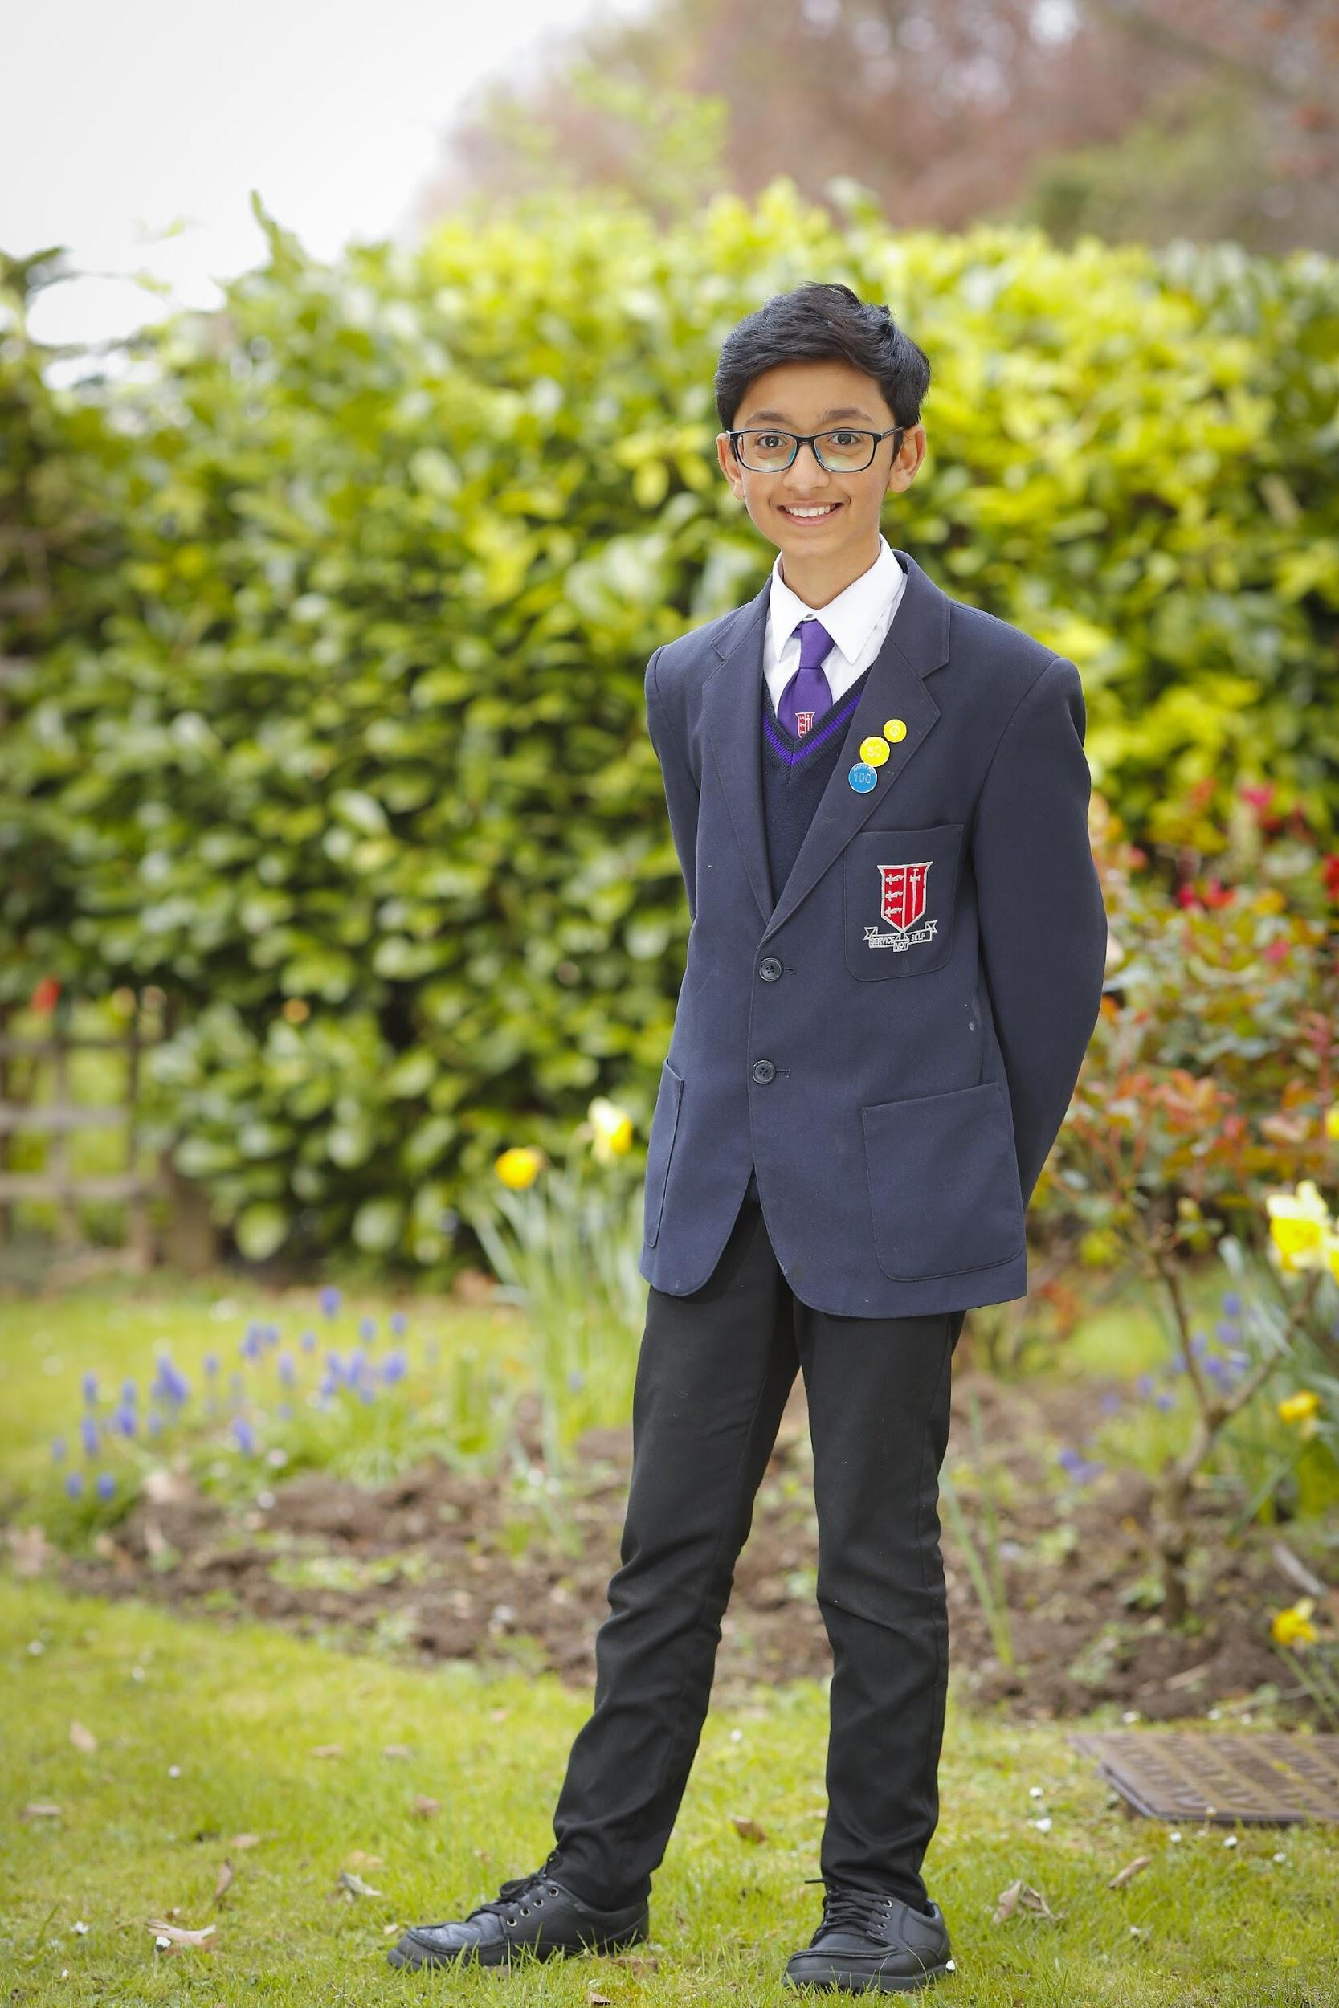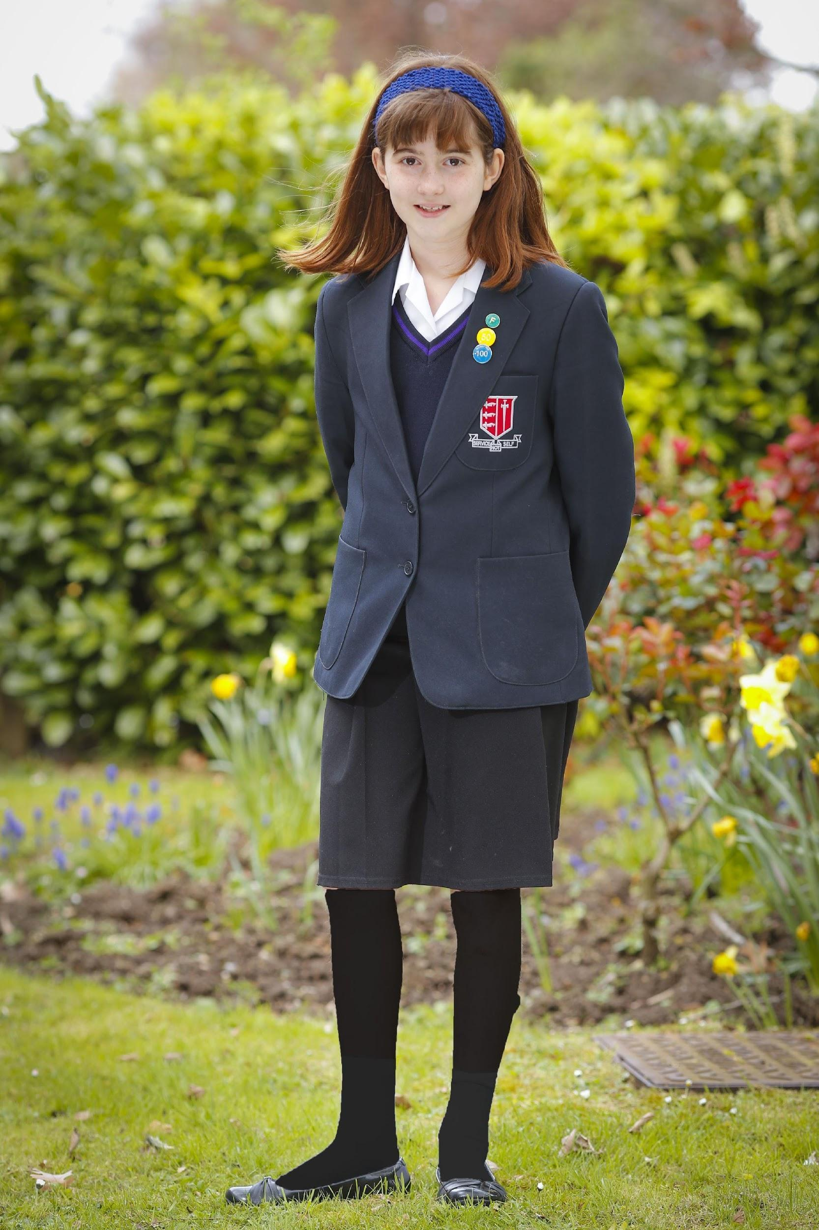
Physical Education Kit
All students are required to have the correct PE kit for all practical lessons. Failure to do so will result in the student having to wear a kit provided by the school. Refusal to wear this will result in disciplinary sanctions.

Students will be required to wear their PE kit during all lessons even if unable to participate due to an injury or parental note. In such circumstances, students will be given an active role in the lesson so they are still able to participate in the learning.

Compulsory PE Kit for Girls and Boys

PE kit bag | Embroidered with Nower Hill PE logo.
Short-sleeved polo shirt, navy blue/scarlet/ white | Embroidered with Nower Hill PE logo.
Shorts, navy blue/scarlet/white | Embroidered with Nower Hill PE logo.
Sweatshirt with ¼ zip, navy blue/scarlet/white | Embroidered with Nower Hill PE logo.
Tracksuit trousers, navy blue/white | Embroidered with Nower Hill PE logo.
Navy blue football socks with scarlet & white trim
White sports socks
Football boots | Moulded studded boots which can be used on grass and all-weather surface.
Non-marking sole trainers | Required when indoor activities are timetabled.
Long socks | Essential in the winter for all outdoor activities for safety and hygiene reasons. Short white socks may be worn for indoor lessons and are essential for trampolining.
Optional for Girls & Boys:

Panelled Rain Jacket with ¼ zip, navy blue/scarlet/white | Embroidered with Nower Hill PE logo.

Highly Recommended
It is highly recommended for health and safety reasons that all students have shin pads and gum shields for football, lacrosse and rugby lessons. These items are compulsory when representing the school in any competitive school fixture.
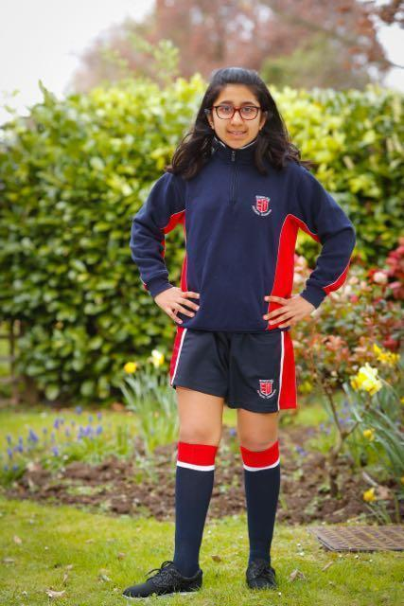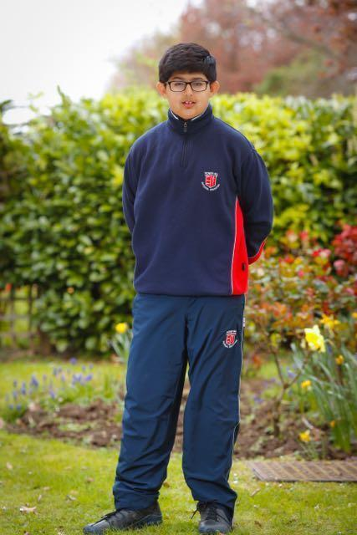

Dress Code for the 6th Form

The current 6th Form dress code at Nower Hill allows for individuality. However, 6th Formers are role models for the entire school and as such it is vital that they dress smartly and appropriately.

For Safeguarding reasons, students must have their ID badges on display at all times within the school.

Please note that the following are not permitted under any circumstances:

- Jeans with any rips or holes.
- Trousers or jeans worn in such a way as to expose underwear.
- Revealing clothing that exposes the chest, midriff or buttocks.
- Vests or tops with spaghetti straps.
- Clothing with offensive slogans and politically extreme/offensive statements.
- Indiscreet facial piercings, for example eyebrow bars. Please discuss with Head of Year before having any piercings.
- All headwear and hats. Headwear and hats must be removed on entering the 6th Form gate (with the exception of scarves worn for religious reasons) or they will be confiscated.
- Excessively short shorts/skirts that do not reach at least mid-thigh.
- ‘Short’ shorts or skirts and tights / long socks.
- Leggings/tights worn without a top/tunic that extends to the thigh back and front.
- Tights with large holes/deliberately made holes.
- Hoods should not be worn up indoors. Students who persistently wear their hood up indoors will have their hoodie/jacket confiscated.
- Coats must be taken off in lessons and assemblies at the discretion of the teacher.
- Tattoos are illegal for children under the age of 18 years of age. 6th Form students over the age of 18 who have a tattoo should ensure at all times they are not visible whilst on the school site.
- All types of earphones and headphones are not to be seen outside of the 6th Form area. Failure to comply will result in confiscation.

Students who persistently fail to comply with the Dress Code will be sent home to change.
Stockists – for school uniform including summer shirts, PE Kits and bags

Kevins Schoolwear  104 Marsh Road  Pinner, HA5 5NA  020 8866 7208  www.kevins-schoolwear.co.uk | Pullens  48 Church Road  Stanmore, HA7 4AH  020 8954 3850  www.uniform4kids.com | Pullens  52 High Street  Northwood, HA61BL  01923 840050  www.uniform4kids.com
Angels  363 Rayners Lane  Pinner, HA5 5EN  020 8866 9972  www.angelsuniforms.co.uk | Teenywear  325 High Road  Harrow, HA3 5EQ  020 8863 3892  www.teenywear.co.uk

The school bag:
PREMIER BACKPACK (navy only) with school logo. This bag is ONLY available at the Nower Hill High School uniform stockists named above. Please note the portfolio style bag is no longer available.

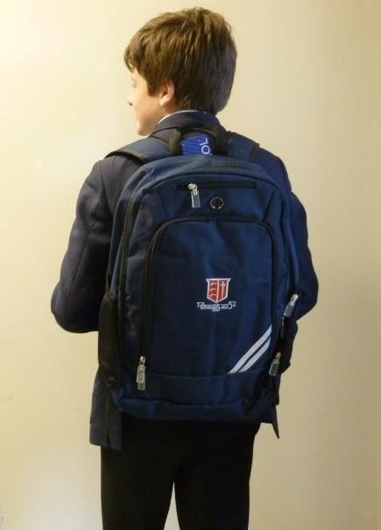

Leadership and Management Roles 2021-2022

Headteacher Louise Voden

Deputy Headteachers Neil Hardy Janine Sabbagh
Teaching & Learning / Student Support
Achievements & Standards Designated Safeguarding Lead

Assistant Headteachers Fiona Ward Caroline Cox
Assistant Headteacher Assistant Headteacher
Student Support Student Support
Key Stage 3 Key Stage 4

Colin Carter Lucy Kitchen
Assistant Headteacher Assistant Headteacher
Key Stage 5 Inclusion / SENCO

George Nagle Cathie Serrao
Assistant Headteacher Assistant Headteacher
Community Teaching & Learning

Julie Wilkinson Zoe Watson
Assistant Headteacher Associate Assistant Headteacher
Professional Development Early Career Development
and Staff Wellbeing

Year Co-ordinators
Year 7 Co-ordinators Richard Ahern and Joel Suthesh
Year 8 Co-ordinators Sajid Latif and Lyall Sahadow
Year 9 Co-ordinators Miriam Berry and Georgia Hawley
Year 10 Co-ordinators Michael Gallop and Nadine Lewis
Year 11 Co-ordinators Zara Mainwaring and Ian Parker
Year 12 Co-ordinator & Deputy Head of 6th Form Sarah Cullum
Year 13 Co-ordinator Jessica Abbots

Curriculum Leaders
Arts Jon Butterworth
Design & Technology Sarah Francis
English Chris Want
Humanities Taira Chaudhry
ICT & Computer Science Satwinder Wilks
Inclusion Lucy Kitchen
Linguistic & Cultural Studies Tara Atkinson
Mathematics Stuart Preston
Science Zoe Watson
Social & Economic Studies Emily Dodd
Sports Studies Samantha Sheppard

Key Contacts 2021-2022

Attendance Julia Blanshard / Gae Adams

Parent Pay Finance Department

Reception Tracey Davies

Student Services Rashmi Kripalani

School Nurse Kelly Quinn

Site Supervisor Joe Cleary

School Contact Details Nower Hill High School
George V Avenue
Pinner HA5 5RP
Telephone: 020 8863 0877
Email: admin@nowerhill.harrow.sch.uk

Harrow Education Department P.O. Box 22
Civic Centre
Harrow
Middlesex HA1 2UW
Telephone: 020 8863 5611 (General Enquiries)
Email: education@harrow.gov.uk

Harrow Admissions department:
Telephone: 020 8901 2697
Email: schooladmissions@harrow.gov.uk

Planning your Route to School

A map can also be found on our school website http://www.nowerhill.org.uk/Map.pdf

Nower Hill High School
George V Avenue,
Pinner,
Middlesex HA5 5RP

