

**WALTHAMSTOW SCHOOL FOR GIRLS**

***“NEGLECT NOT THE GIFT THAT IS IN THEE”***

Candidate Information Pack



**Information for applicants for the post of**

**Deputy Headteacher**

**Required for January 2022**

Contents of Applicant Pack

* Welcome letter from Helen Marriott – Headteacher
* Brief history of Walthamstow School for Girls
* Walthamstow School for Girls G.R.E.E.N. vision
* What staff value about our school
* Job description and Person Specification
* SIP 2021-2024 (Draft introduction)
* NELTSH aims and objectives
* NELSTH latest newsletter
* Staff Benefits

Candidates are encouraged to visit the school website for additional information:

[www.wsfg.waltham.sch.uk](http://www.wsfg.waltham.sch.uk)

Tours of the school will be available, with an opportunity to meet with Helen Marriott.

Please contact Mandy Madhani, Human Resources Manager, on 0208 509 9447 for further information.

# 

Welcome letter from Helen Marriott, Headteacher

# August 2021

Dear Applicant

I am delighted that you are considering applying for the role of Deputy Headteacher at Walthamstow School for Girls. As the newly-appointed Headteacher in January this year, I consider it a privilege to lead staff and students in this exceptional school where we are passionate about education being a vehicle for promoting equality for all and where our mission is to empower young women to become leaders of the future. Our designation as a Teaching School Hub in February has given us the opportunity to work collaboratively with leaders and practitioners throughout Haringey, Redbridge and Waltham Forest to improve the life chances of young people in 239 schools across our area. There could not be a more exciting time to join the students and staff at WSfG!

The promotion of our current Deputy to a Headship, as well our Teaching School Hub designation, has enabled us to create a unique role for someone to become both Deputy Head and Hub Director. We are looking for an exceptional candidate who has the skills and experience to balance these dual roles, knowing that they will enjoy the challenge of this ‘once in a career’ position. You will be able to see from the job description below exactly what this entails. There is ample support in both elements of the role, from internal teams of senior leaders and from the Hub team and administrator.

Although we are an Outstanding school with exceptional outcomes, there is a real appetite for change amongst staff and leaders and therefore a great deal of potential for the right candidate to make a considerable impact. The new school SIP, developed initially with middle leaders and then with a wider range of stakeholders, demonstrates our commitment to staff and student wellbeing, devolved leadership and creating robust systems, founded on evidence-informed practice. I have included a summary below so that you have a ‘flavour’ of how our key priorities will be developed over the next few years.

Having read the candidate information, I hope that you feel excited by both the role itself and the chance to be part of WSfG at a pivotal moment in its development. I understand that, particularly because of the unique nature of the role, prospective candidates will have questions and may wish to visit. I would be delighted to meet with you and would be proud to show you round our wonderful school.

I look forward to hearing from you.

Helen Marriott

Headteacher MA NPQH



**History**

In January 1890, a circular stated that a “school for girls” was to be opened in Walthamstow. Miss Hewett was appointed as the first Headmistress and remained until she retired in 1924. There were 49 girls, whose ages ranged from 7-16 years. At this time there were only five teachers, two of whom were graduates.

Our original building was in West Avenue Road and when student numbers grew the school moved to Church Hill House, where a church now stands. It was in September 1913 that 243 girls came to the present building with the Greek Amphitheatre being added in the 1920s. In January 2010 our most recent refurbishment and rebuilding work was completed as part of the Building Schools for the Future Programme. This work has given us the unique blend of traditional and state of the art facilities that we currently enjoy at our school.

**Our school in 2021**

Walthamstow School for Girls is a high achieving, oversubscribed, diverse and inclusive school which is regularly in the top 10% nationally for progress, significantly above the national average in all key indicators at Key Stage 4, and is at the centre of the vibrant local community of Waltham Forest (the 2019 and first London Borough of Culture). Our most recent results can be found on our website.

We have an ambition to become ‘world class’ and a commitment to work with other professionals both locally, nationally and internationally, through our Erasmus links. We won the national High Aspiration Award for the progress made by disadvantaged students in 2015 and have won SSAT Achievement and Progress awards annually since 2014.

We have been awarded the SSAT Exceptional Education standard twice; in 2017, for *Leadership through Moral Purpose*, and, in 2018, for *Systems: use of assessment, data, policies* *and monitoring to support teaching and learning.* We were awarded Teaching School and National Support School Status in July 2017. In June 2018, following a Section 8 inspection, we were awarded an ‘outstanding’ judgement in all categories.

*“Middle Leaders are exceptional and collaborate well to share best practice. They drive their teams with energy and enthusiasm. They share the strong moral purpose of the Headteacher to ensure that no pupil is left behind. As a result, outcomes for pupils are outstanding, giving them essential life chances.” Ofsted 2018.*

**Students and staff**

Every one of our 900 students is valued equally as an individual with different gifts and talents, reflecting our commitment to the school motto “Neglect not the gift that is in thee”. We offer strong pastoral support and regular monitoring, target setting and dialogue with students and parents/carers.

Our school is characterised by its sense of community and ‘family’, the commitment of staff to the welfare and progress of students and its inclusive and diverse nature. Our students are a delight: ambitious and hard-working, they embrace the full range of opportunities offered to them both during and beyond the school day. This is highlighted not only by our exceptional examination results but also by the maturity of the girls, their sense of responsibility, community and fun.

One of the school’s strengths is the quality of the staff we are able to attract and retain. Our teachers ensure lessons are stimulating and challenging. Students work with enthusiasm and interest in classrooms where there is a calm atmosphere suitable for learning. The broad and balanced curriculum ensures that all students are extremely well equipped to continue their education.

**Our environment**

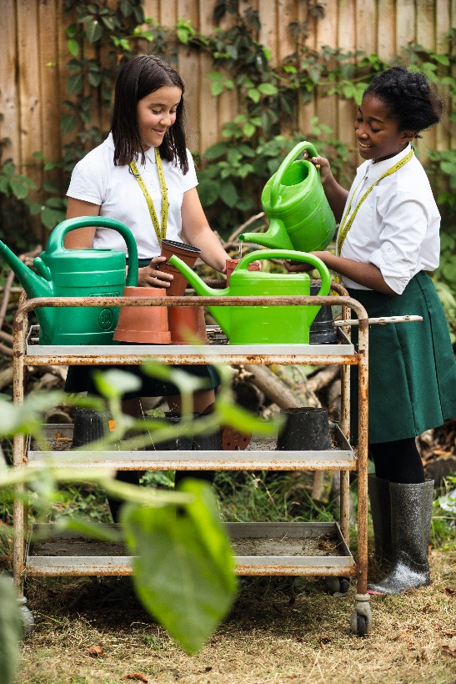We offer excellent facilities to both staff and students. Our acclaimed architect designed buildings and facilities make a stunning learning and working environment. Our £18 million rebuild project, completed in 2010, dramatically extended and enhanced our accommodation. We have state-of-the-art facilities in science, technology and performing arts, as well as a fantastic dining hall, two assembly halls and social areas.

Visitors often comment on the beautiful school grounds and are surprised to find them in an East London comprehensive school! We are fortunate to benefit from both a listed building and an architect designed site, surrounded by lawns and trees. We also have a Greek amphitheatre and an allotment where students to learn how to grow fruit and vegetables, some of which are then used by our chef.

The school is well-served by transport connections, being just ten minutes’ walk away from Walthamstow Central tube and rail station and five minutes’ walk from the popular Walthamstow ‘village’, creative and restaurant quarter. We pride ourselves on working hard to retain our role as an important part of the local community. Examples of this commitment can be seen in our weekly *Greensheets*. Our staff are inclusive and friendly, with regular social and wellbeing events as well as charity fundraising.

**Educating and empowering young women**

Our role is to empower young women become leaders of the future: confident and articulate, but also critical thinkers. Through a range of activities and opportunities, students are helped to develop their leadership qualities, their sense of community and global responsibility as citizens of the world in line with our G.R.E.E.N. values.



Our G.R.E.E.N. Vision

**The G.R.E.E.N. values**

| https://www.wsfg.waltham.sch.uk/_site/data/files/images/values/C52FA90503F596A26EE2DC7FE1E19642.png | The value **GROWTH**is based on the work by Carol Dweck on growth mindset.  Having a growth mindset encourages the belief that we can all improve at whatever we put our minds to with practice and perseverance.  It encourages learning, effort and stickability.  It also promotes the importance of reflection and criticism as tools to move us forward. |
| --- | --- |
| https://www.wsfg.waltham.sch.uk/_site/data/files/images/values/3FEE02382FB6B8CCE94E0DF659218767.png | The value **RESILIENCE** represents the notion that, on any learning journey, there will be obstacles.  With **RESILIENCE**and perseverance, these obstacles can be overcome and the final goal more rewarding.  The key is not to be fearful of these obstacles and to accept that mistakes and challenges are an important part of learning.  The learning line is an effective symbol for resilience and for assessment for learning. |
| https://www.wsfg.waltham.sch.uk/_site/data/files/images/values/38C6CD54B28E286D9A8410BF39911E01.png | The value **ENERGY**is the centre of our vision.  It encourages focus and enthusiasm from everyone.  This **ENERGY** could be represented in the attitude of students as well as in staff morale, parent and governor involvement.  It promotes positivity and supports all of the other G.R.E.E.N. values. |
| https://www.wsfg.waltham.sch.uk/_site/data/files/images/values/BC7D9BD0A310876A7B76D38599477A89.png | The value **EMPATHY**promotes community spirit in many dimensions.  It signifies self-awareness as well as respect for each other despite our differences.  In addition to this, it illustrates that none of us are alone on our learning journey and that, through collaboration, success can be greater. |
| https://www.wsfg.waltham.sch.uk/_site/data/files/images/values/AABBE9BC30E8511FD418D7E3A2E90E56.png | The value **NEWNESS** is vital in an ever changing world.  This encourages us to be open to new ideas, techniques, technologies and challenges.  It encourages us all to step out of our comfort zones as this is where the deepest learning and the greatest success can be achieved. |

*“The school’s values of Growth, Resilience, Energy, Empathy and Newness (GREEN) are lived by staff and pupils in all aspects of the school’s work.” Ofsted 2018.*

What staff value about the school

* This school feels safe, kind and caring. We are not driven by results – we seem to be driven to produce fabulous young women
* Ethos of the school, supportive colleagues and strong management with compassion

*“There are very strong working relationships between staff and pupils based on mutual trust and respect.” Ofsted 2018*

* I value the ethos of hard work in the students and how the school promotes kindness, tolerance and maturity amongst the students
* Atmosphere of diversity, respect and inclusion
* Freedom to teach in a range of styles

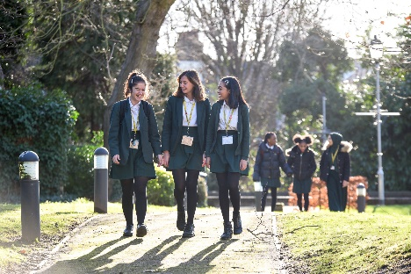

**WALTHAMSTOW SCHOOL FOR GIRLS**

***“NEGLECT NOT THE GIFT THAT IS IN THEE”***

Job Description

**The specific responsibilities will be defined following the successful appointment.**

**Job title:** **Deputy** **Headteacher (KS4)**

**Reporting to**: Headteacher

**Responsible for:** Allocated Head of Faculties (HOF) and other named members of staff

**Line management of:** HOFsother named members of the Faculty.

**Liaising with:** LT, other HOFs, Student Progress Leader (SPL), Student Support Services, relevant staff with cross-school responsibilities, relevant teaching and support staff, LEA personnel, governors, parents/carers and external agencies.

**Working time:** 195 days per year – full time. Attendance at identified calendared events during the school year

**Salary / TLR Allowance:** L25-L29

**Disclosure:** Enhanced

|  |  |
| --- | --- |
| **Key Responsibilities** | The key responsibilities for this post will be:   * To be responsible for KS4, pastoral and academic * To be responsible for the curriculum and its development * To have leadership responsibility for the development and direction of the North East London Teaching School Hub, working collaboratively with school leaders and creating a centre of excellence for teacher development across the region |
| **Core Purpose** | The Deputy Headteacher will lead by example and provide inspiration and motivation for the school community by:   * Proactively supporting and embedding the school ethos and associated policies * Sharing responsibility for the development of whole school improvement initiatives and strategically planning for both the short and long term to sustain the momentum of an initiative * Working in partnership with staff and governors to create a sense of shared ownership and to ensure that school improvement strategies are monitored and evaluated rigorously * Developing appropriate evidence informed strategies for improvement as part of well-targeted plans which are realistic, timely, appropriately sequenced and suited to the school’s context * Ensuring strategic planning takes account of the vision, values and aspirations of the school community, as well as our commitment to equalities   The Deputy Headteacher will lead by example and provide inspiration and motivation for the Hub by:   * Developing and communicating a clear vision for the Teaching School Hub * Implementing monitoring and reporting on the strategic development plan for the Hub and its KPIs * Working with strategic partners to develop further professional development opportunities to improve the quality of teaching and leadership across the Hub * Maintaining a robust Quality Assurance framework to ensure the quality of all Teaching School Hub provision * Working with the Assistant Director and Project Managers to develop and deliver the Early Career Framework, NPQs, ITT and CPD |
| **Leadership** | The Deputy Headteacher will work with the Headteacher to:   * Provide effective professional challenge and support to senior and other colleagues * Provide information and advice to colleagues and the governing body and support robust accountability processes throughout the school * Ensure that highly effective learning and teaching is at the heart of the school and share responsibility for raising the quality of learning and teaching * Promote a culture of ownership through rigorous self- evaluation |
| **Leading and Developing Others** | The Deputy Headteacher will lead, motivate, support, challenge and develop staff in specified teams and departments to ensure the best outcomes for the school through:   * Being a role model for others, demonstrating a high standard of leadership * Recognising, developing and maximising the potential of others * Challenging ineffective practice and providing support through strategies for improvement * Building a collaborative culture which positively embraces change and progress through staff empowerment and teamwork * Treating people fairly, equitably, with dignity and respect to create and maintain a positive school culture and to allow an appropriate work-life balance * Creating a climate which enables staff to develop and maintain a passion for their subjects and confidence in their roles * Making sure that learning and teaching across the school ensures the highest standards in every student’s learning and the best possible academic outcomes * Supporting the development of positive working relationships with and between all staff * Leading and coaching groups of staff in appropriate professional learning activities, delegating appropriately and evaluating outcomes * Developing the role of subject leaders so that there is a measurable impact on student learning * Developing the role of pastoral leaders so that the monitoring and improvement of students’ attendance, behaviour and home learning is systematic and highly effective |
| **Curriculum Development and Assessment** | The Deputy Headteacher will contribute to curriculum development and assessment by:   * Ensuring that curriculum development is a dynamic and creative process, resulting in a provision that is both inclusive and academically challenging, meeting the changing needs of students and changing national requirements * Knowing how to analyse and evaluate whole school data in order to monitor and measure the impact of school developments * Knowing how to utilise other sources of evidence to inform action and sustain good progress * Ensuring assessment is appropriate to the curriculum and meets the needs of students and parents |
| **Effective deployment of staff and resources** | The Deputy Headteacher will utilise staff resources effectively by:   * Supporting the appointment, deployment and development of staff to make the most effective use of their skills, expertise and experience and to ensure that all staff have a clear understanding of their roles and responsibilities * Managing the school effectively in the absence of the Headteacher * Working with the School Business Manager and faculty leaders to identify priorities for expenditure and secure best value for money   The Deputy Headteacher will work with the Headteacher and School Business Manager by:   * Developing the budget for the Hub and ensuring financial sustainability * By providing up to date information, data and financial progress for the Hub |
| **Quality Assurance** | The Deputy Headteacher will work to create a highly effective educational experience for all students by:   * Ensuring the whole school evaluation and monitoring procedures are rigorously applied and that they make substantial contribution to improving student and teacher performance * Leading self-evaluation of curriculum areas and making recommendations for improvement based upon process outcomes |
| **Governance, accountability and working in partnership** | Under the direction of the Headteacher, the Deputy Headteacher will:   * Understand and contribute to the role of effective governance * Ensure that staff understand their professional responsibilities and are held to account * Ensure the school effectively and efficiently operates within the required regulatory frameworks and meets all statutory duties * Work successfully with other schools and organisations, including through the Hub * Maintain excellent relationships with fellow professionals and colleagues to improve educational outcomes for all students |
| **Whole School Contribution** | * To play a full part in the life of the school community, to support its distinctive aims and ethos and to encourage staff and students to follow this example * To undertake continuous professional development * To comply with the school’s Health and Safety policy * To undertake any other duty as specified by STPCD not mentioned above |

These are the main areas of responsibility, but all job descriptions may be reviewed according to the needs of the school.

This job description is carried out in accordance with provisions of the School Teachers’ Pay and Conditions document and within the range of teachers’ duties set out in that document.

The school will endeavour to make any necessary reasonable adjustments to the job and the working environment to enable access to employment opportunity for disabled job applicants or continued employment for any employee who develops a disabling condition.

This job description is current at the date shown but, in consultation with you, may be changed by the Headteacher to reflect or anticipate changes in the job commensurate with the grade and job title.

September 2021

*This school is committed to safeguarding and promoting the welfare of children and young people and expects all staff and volunteers to share this commitment.*

Person Specification

|  |  |  |  |  |  |  |
| --- | --- | --- | --- | --- | --- | --- |
|  | **Criteria** | Essential | Desirable |  | Assessed by application | Assessed by selection process |
|  | **Qualifications** | | | | | |
| 1 | A good honours degree or equivalent | / |  |  | / |  |
| 2 | Qualified Teacher Status (QTS) | / |  |  | / |  |
| 3 | Registered with GTC | / |  |  | / |  |
| 4 | Further relevant post graduate study or NPQH |  | / |  | / |  |
|  | **Experience** | | | | | |
| 5 | At least 3 years of senior leadership experience in a secondary school | / |  |  | / |  |
| 6 | Outstanding classroom practitioner with a strong track record of results | / |  |  | / | / |
| 7 | Successful recent strategic impact as an AHT or DHT in a comprehensive school setting | / |  |  | / | / |
| 8 | Successful experience in leading across several schools, for example through an instrumental role in a Teaching School, MAT, local authority or similar context |  | / |  | / | / |
| 9 | Successful experience of raising standards for all, with measurable outcomes, as a result of own contribution in own school or across other schools | / |  |  | / | / |
|  | **Qualities, skills and Knowledge** | | | | | |
| 10 | A vision for education that is closely aligned with the ethos and ambition of the school | / |  |  | / | / |
| 11 | Good knowledge and understanding of the wider educational agenda including current national policies and educational issues, particularly in the four areas of development for the Hub: CPD, ITT, Early Career Framework and NPQs | / |  |  | / | / |
| 12 | An understanding of effective project management, including strategic planning, the ability to identify and manage potential risks, marketing and sound financial management |  | / |  | / |  |
| 13 | Be able to analyse data meaningfully and act effectively on the outcomes | / |  |  | / | / |
| 14 | Possess excellent verbal and written communication skills, with the ability to present effectively to a range of audiences | / |  |  | / | / |
| 15 | Be a visible and high-profile leader who models excellence and can support and challenge others | / |  |  | / | / |
| 16 | Be ambitious for all our students, demonstrating a commitment to and evidence of promoting inclusion, diversity and equal opportunities | / |  |  | / | / |
| 17 | Have a thorough understanding of the key features of effective learning, teaching and assessment and the ability to embed such practice across the school | / |  |  | / | / |
| 18 | Evidence of substantial and successful line-management experience which has developed the skills and competency of post-holders | / |  |  | / | / |
| 19 | Be able to create an environment in which colleagues are keen to develop their own skills and knowledge and to collaborate in their support of one another | / |  |  | / | / |
| 20 | Appreciate and promote the safety and wellbeing of all students and staff | / |  |  | / | / |
|  | **Systems and Processes** | | | | | |
| 21 | Be able to maintain and further develop a safe, calm, and ordered environment for students and staff that is rooted in the effective safeguarding of students and the promotion of exemplary behaviour | / |  |  | / | / |
| 22 | Have experience of effectively managing the performance of staff and addressing underperformance | / |  |  | / | / |
| 23 | Have experience of developing systems to identify and share effective practice | / |  |  | / | / |
| 24 | Have experience of successful contribution to whole school self-evaluation, including successfully leading and sustaining change | / |  |  | / | / |
| 25 | Have experience of successfully working with Governors in pursuit of whole school strategic objectives |  | / |  | / | / |
| 26 | Have experience of effectively monitoring the distribution of resources to meet strategic objectives |  | / |  | / |  |
| 27 | Understand how to distribute leadership across teams in a way that encourages responsibility and accountability | / |  |  | / | / |
|  | **Personal Attributes** | | | | | |
| 28 | Reflective, self-motivated and driven to achieve the best for all students | / |  |  | / | / |
| 29 | Excellent team building and coaching skills | / |  |  | / | / |
| 30 | Approachable, reliable and has presence | / |  |  |  | / |
| 31 | Thinks creatively, solves problems and has an eye for detail | / |  |  | / | / |
| 32 | Demonstrates high levels of professionalism, loyalty and integrity | / |  |  | / | / |
| 33 | Models and exemplifies the school’s values | / |  |  | / | / |
| 34 | Optimism and the desire to find positive solutions to problems, often in pressurised and challenging circumstances. | / |  |  | / | / |

September 2021

*This school is committed to safeguarding and promoting the welfare of children and young people and expects all staff and volunteers to share this commitment.*

SIP 2021-2024 Introduction (Draft)

Our vision: Where are we heading and what are we trying to achieve?

Our vision for WSFG is...

• A school where we value great learning and great teaching because we know that this is the key to unlock our students’ potential and inspire them on a journey of lifelong learning

• A school where all staff understand their role as agents of social change so that we focus on improving the life chances of all students, particularly the most vulnerable and disadvantaged

• A school where all of our girls feel safe and nurtured because of our robust support and safeguarding systems, where students understand how to improve their wellbeing, and where there is a culture of empathy and kindness

• A school where every student feels known, valued and listened to; students are empowered to become decision makers and have the confidence to undertake any role or profession, regardless of gender, sexual-orientation, race or ethnicity, knowing that in doing so, they are making the world a better and more equal place

• A school where there is distributed leadership; systems ensure that staff feel listened to and valued and effective communication enhances staff wellbeing

• A school which produces great leaders, both in its students and staff, and where there is a culture of female leaders being ‘10% braver’

• A school where students have broad horizons: physically, intellectually, culturally and emotionally

• An outstanding school where its evidence-based practice is shared, both nationally and internationally

• A school where the curriculum is broad and balanced, is used as a tool to develop critical thinking, where leaders understand its impact and where students feel the curriculum is both relevant and meets their needs

• A school which is enhanced by its leadership of the Teaching School Hub, seeing it as a mechanism for sharing and learning from the best teacher training and development practice in North East London and across the country.

**What is the purpose of the SIP?**

• The SIP acts as an ambitious medium and long-term plan for the school

• It creates an accurate baseline from which we can plan so that we have a clear idea of ‘where we are’ as a school, in terms of our priorities

• We need to ensure that we have a clear evidence base for any actions we take and our SIP actively encourages this process

• The ‘impact’ section allows us to see the journey we need to make, with clearly-defined, measurable outcomes

• The ‘actions’ should be what enables us to make that journey and should be carefully reviewed in order to ensure that they will have the desired impact, rather than actions for their own sake

• Since it is impact-driven, the SIP allows us to plan backwards and understand the actions we need to take from our current position.

**Who is it for?**

• The SIP has been created by a range of stakeholders: staff, governors and senior leaders. In June and July, students and parents will be consulted on these priorities and plans.

• The SIP is for the whole school community but will be used by governors to hold the school to account

**How will it be used?**

• This is an ‘organic’ document which will be constantly updated and reviewed by leaders and governors

• In the Autumn term, additional information for the baseline will necessitate changes in actions and intended outcomes

• The SLT will review the SIP actions and measure their impact against the intended outcomes at least every half-term

• Middle leaders will create their own faculty versions of the SIP so that their actions reflect those of the whole school and, in turn, feed into the process, forming part of the cycle of evaluation and review

**What are our priorities and why?**

• Our SIP priorities were proposed by a working group of middle leaders, led by the Headteacher, in February and March 2021. SLT at the SLT conference interrogated quantitative and qualitative information to ensure that these were the right priorities for the school. Staff and governors at our SIP day in April then explored the priorities further through a more detailed planning exercise and made decisions about which should be our most important priorities.

• There are four priorities so that we can focus on fewer priorities and more impact. These are our key priorities, which are all of equal importance: student wellbeing; staff wellbeing; pedagogy for achievement and progress; leadership and coaching development.

https://educationendowmentfoundation.org.uk/public/files/Publications/Implementation/EEF-Implementation-Recommendations-Poster.pdf

**The Three Year Plan**

Year 1 (2021 – 22):

Preparation

1. Knowing our school: What data do we need? What don’t we need? What do we currently collect? What systems do we need to adapt or create? How effective are our data tracking systems? What training do we need? Start to plan for changes. - DSH/ ALL

Student Wellbeing

2. Student wellbeing: safety and mental health - reviewing and mapping results of S11 audit; training; review student voice systems for wellbeing - KPR

3. Gather evidence (internal and external) and map provision for extra-curricular activities to impact on student wellbeing; plan training - AAHT3

4. Re-establish and review BfL systems, including initial changes since Easter: reinforcing routines and expectations/ using SIMs for rewards and sanctions/ implementing a consistent reporting system; review with staff and student voice; plan and implement training - JSN / DHT2

Staff Wellbeing

5. Work on one theme from staff survey with staff wellbeing group; establish a clear area of focus; plan and research; establish training needs - HMA / AAHT1

Develop Leadership and Coaching to Empower students and staff

6. Implement coaching training programme for staff as part of CPD programme; review and evaluate effectiveness of coaching training, programme and implementation; begin to scope what effective coaching looks like for students - MPH

7. What does it mean to be an effective leader? Explore and gather evidence through ML, SLT and governor meetings and conference. What training is needed for teaching and non-teaching leaders? Explore leadership behaviours and competencies with SLT MLs and governors. - HMA

Developing pedagogy for achievement and progress

8. Develop consistency in approaches and pedagogy between subjects: review data; review key aspects of curriculum; plan and consult for implementation, working with MLs; review curriculum for progress, coverage, equality and diversity. DSH / AAHT2

9. What do we know about teaching and learning from our lesson observations? What are the areas we need to work on? What training do we need? What does it tell us about the curriculum? What have we learned from coaching trios? Planning based on outcomes. Strengthen pedagogy by establishing a coaching culture; establish a T/L team; training for T/L team. - JSN

10. How effective is our assessment system? What do parents and students need to know? What do our staff tell us? Planning. Development groups. Training. - DSH

*Review all of the evidence to establish: What is our culture like? What are our beliefs as a school? Is there a key area of focus we need to address?- HMA / ALL

Year 2: (2022-23)

1. Implement changes to data and information systems

2. Implement first set of changes from S11 audit; implement changes to student voice systems

3. Implement first set of changes to extra-curricular activities to impact on student wellbeing

4. Measure impact of initial changes to BfL systems; developing a ‘kinder culture’ around GREEN values; revisit GREEN with parents, staff and students; develop GREEN ‘passport’; implement first set of changes about ‘kinder culture’

5. Review work on first staff survey theme and make adjustments; work on second theme from staff survey

6. Changes to CPD, based on review and evaluation of coaching for pedagogy; increase in staff led CPD; set up coaching for students; refine PM processes.

7. Implement leadership behaviours and competencies, including through PM; work on leadership with governors

8. Develop teaching and learning: review of achievement across subjects and lesson information; review of key aspects of curriculum to ensure progress; plan accordingly; establish the teaching and learning team; establish and review effectiveness of the new CPD model

9. Implement changes to current assessment, recording and reporting policy and practice; work with stakeholders to develop and review

Year 3: (2023-24)

• Implementation of changes, based on evaluation and review from year 2

• Sustain impactful improvements

By the start of year 3, we would expect to see:

• Better use of systems for collecting data and information, including assessment, reporting and recording

• Students reporting improvements in support for safety, mental health and wellbeing, as a result of actions resulting from S11 and other surveys; consistency across year groups

• Focused planning, evaluation and review of extra-curricular activities for disadvantaged students

• Students and staff feeling that learning is supported by changes to BfL systems, including rewards and sanctions; consistent systems contribute towards the creation of a ‘kinder’ culture across all year groups; fewer exclusions and behaviour incidents

• Staff wellbeing group being able to measure improvements in terms of the first two themes in the survey and being able to review its impact

• Coaching practice for staff being embedded through CPD; CPD expanding in its scope and ambition so that CPD has greater breadth, a sharper focus on meeting individual needs and robust quality assurance mechanisms; Performance Development (Management/ Appraisal) will be adapted to ensure that there is triangulation between PD, CPD and the SIP so that we create a self-improving system.

• All leaders at all levels have a shared understanding of what great leadership looks like, codified in Leadership Competencies and applied through Performance Development

• There is greater consistency of practice and outcomes between subjects because of enhanced opportunities for training and development, systematic sharing of best practice at middle leader level and through the work of the Teaching and Learning team; improved outcomes at GCSE in both progress and attainment

• As a result of a robust, evidence-based review of our assessment policy and practice, we will start to see the impact in terms of student progress and self-reporting, staff workload and parent satisfaction





**Vision**

**Our ambition is to ensure that every child has a great teacher who unlocks their potential and inspires them on a journey of lifelong learning.**

**Core Aims**

* To act as agents of social change, improving the life chances of all young people, especially the most disadvantaged
* To provide exemplary training and development, for leaders and practitioners, which meets the needs of all schools in our area, so that every child has access to the highest quality education and develops a desire for lifelong learning
* To strengthen the local training and development offer by drawing on existing knowledge and expertise, connecting schools and facilitating networks across our three boroughs
* To create a powerful community of leaders and practitioners which has a demonstrable impact on the lives of all young people across Haringey, Redbridge and Waltham Forest, especially the most disadvantaged.

**Core Values**

* We uphold the seven Nolan principles of public service: selflessness, integrity, objectivity, accountability, openness, honesty and leadership.
* Leaders model the Ethical Leadership Framework principles of trust, wisdom, kindness, justice, service, courage and optimism.
* We are collaborative, collegiate and mutually supportive.  By developing strong partnerships, we can learn from and challenge each other.
* We are relentless in pursuit of the highest quality in all we do, insisting on evidence-informed practice and robust evaluation.
* Everything we do supports teachers, leaders and school staff to effect social change by improving the educational and social outcomes for all children and young people, especially the most disadvantaged.

**Overarching Strategic Objectives**

1. Articulate a compelling vision, mission and strategic goals which express the hub’s role in acting as an agent of social change by improving outcomes for all children, especially the most disadvantaged
2. Strengthen recruitment into the teaching profession by increasing the number and quality of trainee teachers (ITT)
3. Improve retention of Early Career Teachers by ensuring they have access to and receive high quality training and support
4. Enable teachers and school staff to improve continuously throughout their career through research, training, coaching and support
5. Support the development of outstanding leaders through networks, training and coaching
6. Work as a truly inclusive organisation, systematically sharing and celebrating best practice in our local area
7. Putting in place systems and structures through which we challenge ourselves consistently to be better.

North East London Teaching School Hub

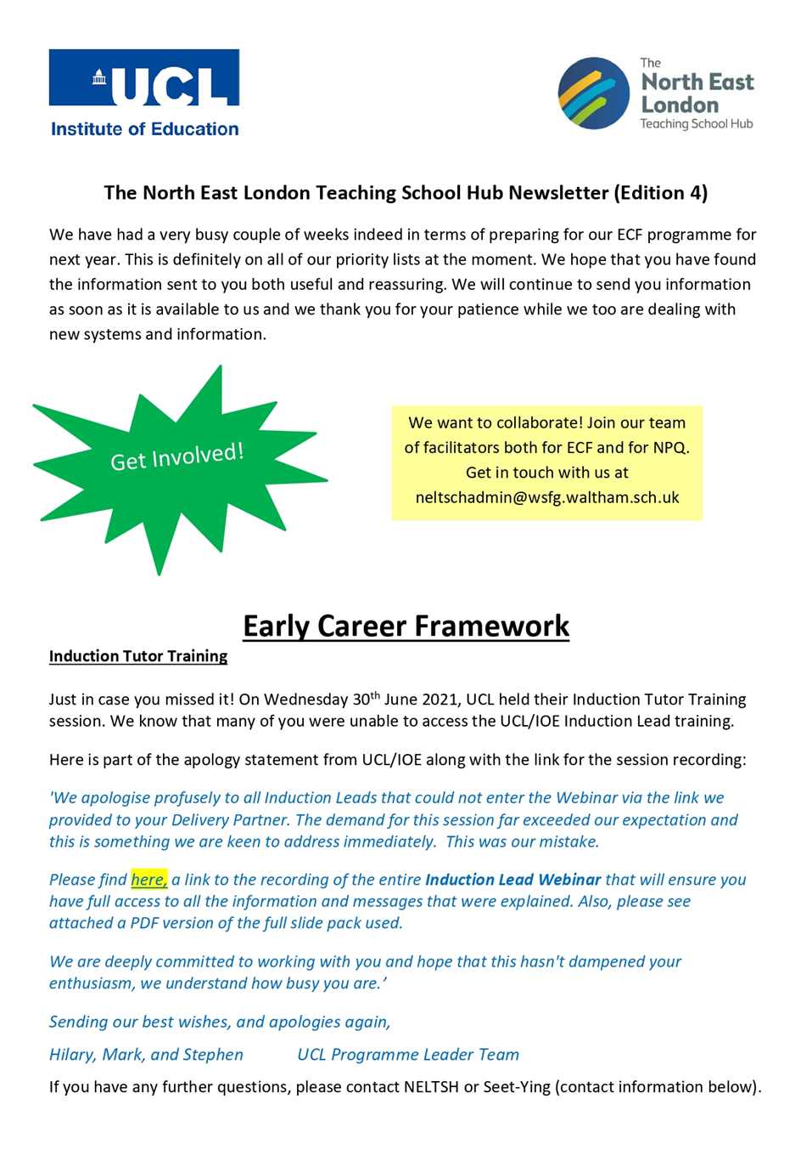

For further information regarding the NELTSH please follow the link below:

<https://www.wsfg.waltham.sch.uk/neltsh>

Staff Benefits

Outlined below are some of the additional benefits available to staff working at Walthamstow School for Girls.

Cycle 2 work scheme

This benefit offers staff the opportunity to make tax and national insurance savings whilst keeping fit at the same time.

Commitment to CPD

The best CPD has a measurable impact on the progress of students. For this reason, we believe in giving our staff dedicated training time, delivered during twilights. We are developing a comprehensive CPD programme, where all staff follow long-term courses, beginning with training as coaches by John Kane, an external provider. Staff then work in triads to coach each other, developing their practice through bespoke feedback training.



**Eye Tests**

All staff using computer equipment should have eye and eyesight checks at regular intervals. Eyesight testing should also happen where staff experience visual difficulties, which may reasonably be considered to be caused by computer work. Staff working within schools in the London Borough of

Waltham Forest may be entitled to reimbursement of some costs associated with vision testing and the frames and lenses needed to enable them to work safely on display screen equipment.

**Staff Wellbeing**

Staff Wellbeing is one of our school SIP priorities. There is a staff wellbeing development group which examines both strategic and operational approaches to improving the wellbeing of all groups of staff in our school.

At Walthamstow School for Girls we also offer a staff running club, Badminton club, Boxfit exercise sessions, yoga and the London Club (historical walks around London).

**Workplace Options - Employee Assistance Provider**

A confidential counselling, help and information service is provided for all those employed by Waltham Forest and is available free of charge 24 hours a day, every day of the year. This service can help with a range of problems from practical everyday matters to sensitive and emotional issues. For further information please call 0800 328 1437 or contact: [**www**.**employeeassistance.org.uk**](http://www.employeeassistance.org.uk)





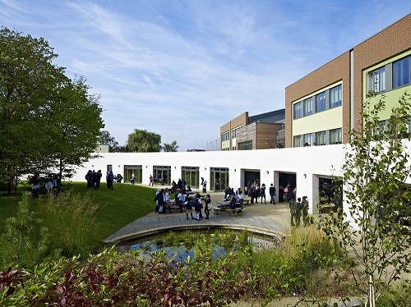

For further information about our school please visit our website: [**www.wsfg.waltham.sch.uk**](http://www.wsfg.waltham.sch.uk)