The Holy Family
Catholic School
a voluntary academy

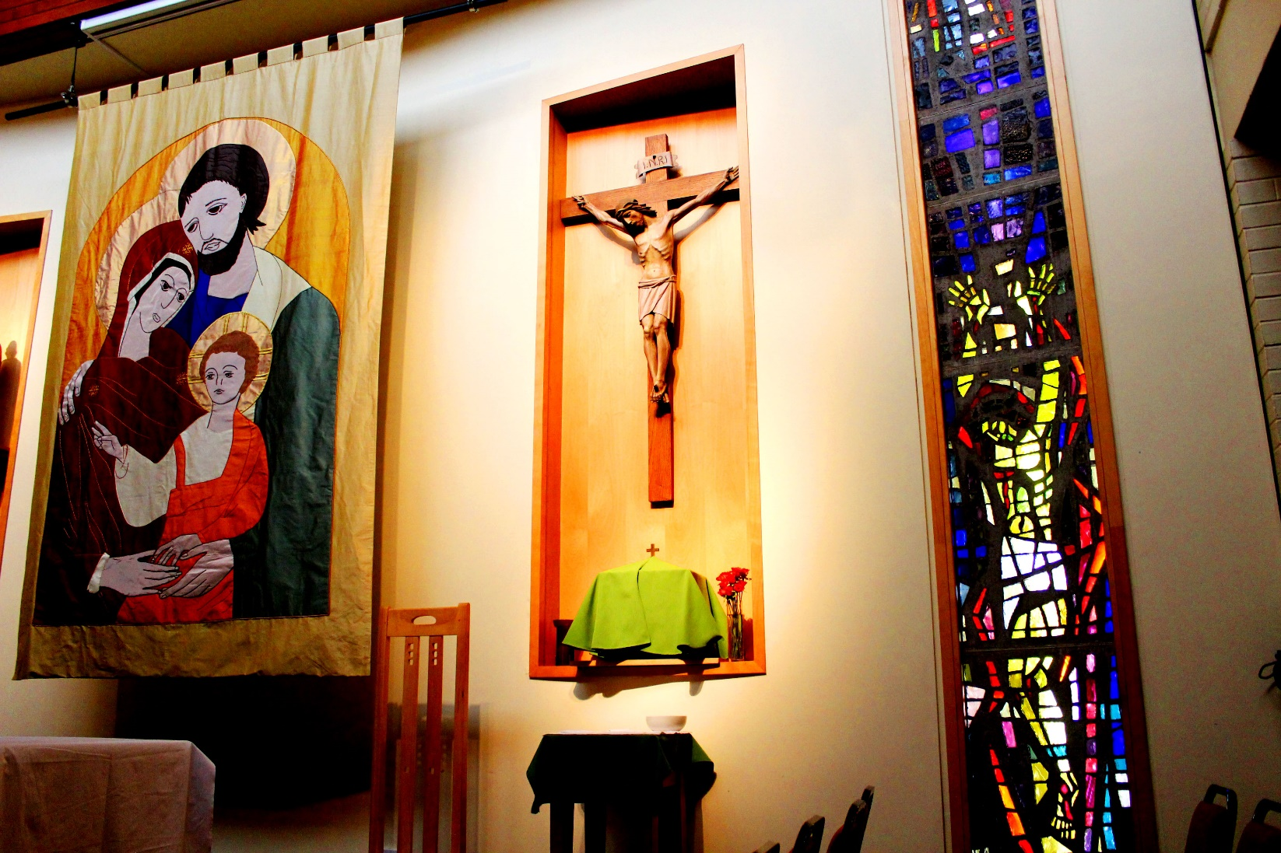

Deputy Headteacher
Recruitment Pack
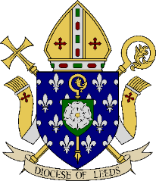

The Holy Family
Catholic School
a voluntary academy

Our Ref: SMA/MC

April 2024

Dear Applicant

Deputy Headteacher

Thank you for your interest in the position of Deputy Headteacher at The Holy Family Catholic School. We hope you find the information will be useful to you.

The school belongs to the Blessed Christopher Wharton Catholic Trust. We are an 11 – 18 mixed, school serving the Catholic community of Keighley (Diocese of Leeds). We have an excellent reputation locally and nationally for the quality of our ethos, teaching and learning, and sustained improvement over time.

We hope you find the information in this pack useful and please do look at the school’s website https://www.holyfamilyschool.uk for further information. We encourage visits to the school and you are welcome to contact Mrs Clare regarding any further information or queries you may have.

Applications should be sent to Mrs M Clare at school or via email mclare@holyfamilyschool.uk.

We look forward to receiving completed application from you by Friday, 19 April 2024 at 9.00 am

Yours sincerely

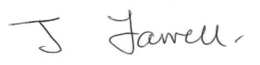

J Farrell S Mather
Chair of Governors Headteacher

The Holy Family Catholic School belongs to
Blessed
Christopher Wharton
CATHOLIC ACADEMY TRUST
Headteacher: Ms S Mather
The Holy Family Catholic School, Spring Gardens Lane, Keighley, BD20 6LH
Tel: 01535 210212
Email: office@holyfamilyschool.uk Web: www.holyfamilyschool.uk

Our Ethos
The Holy Family Catholic School exists to provide a contemporary education rooted in traditional gospel values where we believe that Christ is at the heart of all our endeavours inspiring us to excellence, where justice, compassion, a commitment to service and moral responsibility pervade everything that we do. We aim to awaken students to the largeness of the world around them, give them a dream of human achievement and an active concern for the human predicament here and now and in doing so reveal the truth about God, Christ and Spirit.

Awakening Minds
Our faith, the teachings of Christ, is at our heart. We devote ourselves fully to our spiritual growth, striving for excellence in all that we do each day. 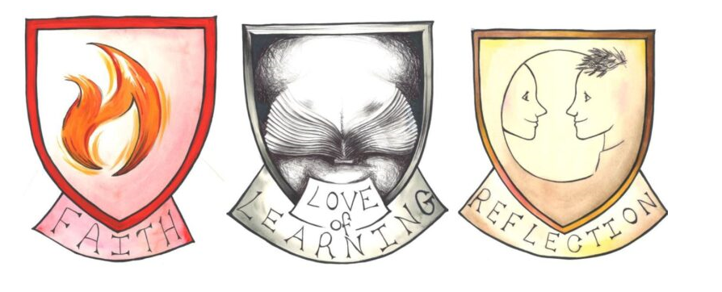

Achieving Dreams
Our work blends inspirational teaching and confident study in a stimulating environment. We learn wholeheartedly, turning our ambitions into reality with every opportunity.
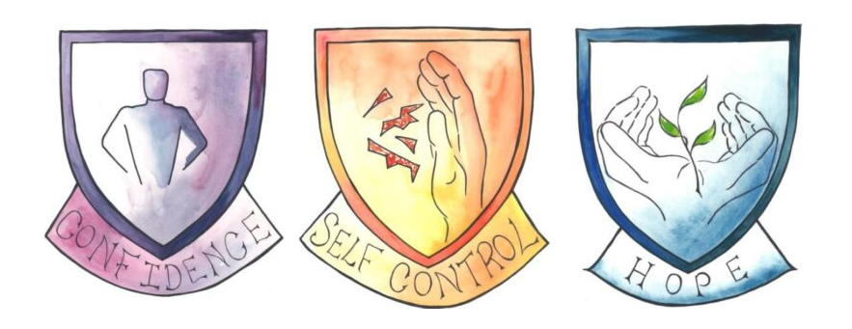
Serving Others
Our spirit leads us to take a positive role in our community. We show love, care and respect for one another and for everyone in our world today. 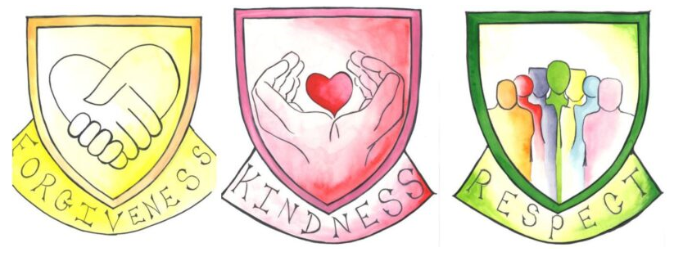

The Holy Family Catholic School is a voluntary academy, where the Governors are the employers, under the trusteeship of the Diocese of Leeds. There is a six-form entry in each year group with approximately 779 students on roll, including approximately 70 in Years 12 and 13.

The Holy Family Catholic School belongs to the Blessed Christopher Wharton Catholic Academy Trust which comprises all the Catholic Primary and Secondary schools in Bradford and Keighley and as such is one of the largest education providers in the area. We have strong associations with the three Catholic Primary schools in Keighley who are led by one executive Headteacher and look forward to enhancing students’ transition to our school by further growing our relationship with the primary pupils and their families.

We are a school on a rapid improvement journey. Welcome change is taking place within the school, about which we are all very excited. The school’s Senior Leadership Team are working rapidly and effectively with the wider staff team to move the school to a ‘Good’ Ofsted judgement and beyond.

Holy Family is a very inclusive, multicultural school. Our catchment is also characterised by significant economic, social and cultural disadvantage. Our Catholicity is instrumental in our response to this. Inspired by the example of Jesus, we work hard to improve the life of every student who studies with us, regardless of their background. We have a strong focus on our relationship with the local community, from meeting regularly with the local MP and councillors, to running a food and clothing bank.

The teachings of Jesus are at the heart of our school community. The Sacraments, the Word of God, our behaviour towards each other, our care and friendship are all central to daily life in school. Students and staff have opportunities to continue their individual faith journey through prayer and liturgy. We pray together each day; and the significant events in the Church year are all celebrated. Our Christian faith is seen in action through the wide variety of events, groups and charitable activities with which our students can get involved, including pilgrimages to Lourdes and nationally.

The school was built in the 1960s but has benefitted from further development and refurbishment. Well equipped, the campus is a large site with open grounds around it. The school is situated in a pleasant location on the outskirts of Keighley with stunning views across the Aire Valley. It is on the edge of the Bronte countryside and close to Skipton, the gateway to the Dales. It has a prominent and well-established place in the local Catholic and wider community. There are particularly strong links with the local parishes and the feeder schools in Keighley. Keighley has good bus and rail links and, as well as its close proximity to beautiful countryside, it is within travelling distance of several cultural, social and commercial centres such as Leeds, Harrogate and Manchester. There are many attractive places to live within a short distance of the school.

For further information, please look at our website: https://www.holyfamilyschool.uk

WORKING IN THE DIOCESE OF LEEDS

Thank you for taking the time to find out more about the position of Deputy Headteacher at The Holy Family Catholic School in the Diocese of Leeds.
The Diocese of Leeds covers a wide geographic area encompassing eight local authorities mainly in West and North Yorkshire well served by a network of rail and motorway links. We have 80 primary schools, 13 high schools, a sixth form college in Leeds and a residential non-maintained school for the deaf. Our smallest school is 20 pupils whilst the largest is 2,300 pupils serving both rural and urban areas. There are good partnerships between schools across the Diocese as well as within local deaneries and further networks with local authority schools. Also within the Diocesan educational provision is our Catholic university of Leeds Trinity. The secondary headteachers meet regularly as part of the Communion of Leeds Diocesan Secondaries (COLDS) which also provides a strong network for subject leaders and management staff as well as organising retreats both local and to Rome.

The Diocese offers a comprehensive programme of continuing professional development every academic year which is available on the website and open free of charge to all schools giving to the Diocesan school contribution scheme. In future years it is hoped that the teaching schools in the Diocese will also take a role in delivering the programme.

It is an exciting time to join a Diocesan school as we have Bishop Marcus who brings a wealth of experience in education. I hope that you will take this opportunity to apply to be the Deputy Headteacher at The Holy Family Catholic School.
Further information about the Diocese can be found on our website - https://www.dioceseofleeds.org.uk/education/
The Holy Family
Catholic School
a voluntary academy

Deputy Headteacher (Behaviour and Attitudes, Personal Development and Catholic Life)
Salary: L20 – L24 (£75,331 - £83,081)
Contract: Permanent
Start: September 2024

We are seeking to appoint a forward thinking and inspirational colleague to join our Senior Leadership Team from September 2024. The Deputy Headteacher will be instrumental in the strategic leadership of our school, helping us to develop towards providing excellence in Catholic secondary education in Keighley and ensuring the best possible outcomes for all of our young people.

The Holy Family Catholic School belongs to the Blessed Christopher Wharton Catholic Trust. It is an essential requirement for this position that you are a practising Catholic, someone who will act as role model and who will maintain the mission and values which underpin all that we do in our school community.

This is a key leadership post within the school supporting the Headteacher to create a common vision of excellence, helping to make The Holy Family Catholic School a truly exceptional place in which to learn and work. The successful candidate will have overall leadership responsibility for Behaviour and Attitudes, Personal Development and Catholic Life in the school

We have a strong pastoral team in the school comprising of 1 Assistant Headteacher, 3 Year Directors, 5 Year Managers and 1 Mental Health Champion. The successful candidate will lead this team, as well as overseeing and developing the support processes we have in place relating to the pastoral life of the school. The successful candidate will work closely with our Chaplain, and Faculty Leader for Religious Education to ensure the school meets the requirements expected under the Catholic Inspection Framework. They will also act as the school’s Designated Safeguarding Lead.

The successful candidate will bring professionalism and academic credibility, balanced with warmth and sensitivity. Applicants must be able to demonstrate a deep understanding of the challenges and opportunities of school leadership, with the skill to lead by example and inspire others to awaken their minds, achieve their dreams and serve others.

The Holy Family Catholic School is committed to safeguarding and promoting the welfare of children and young people. We expect all staff and volunteers to share this commitment. The successful candidate will be subject to an enhanced DBS check and only applications submitted on the CES application form will be considered.

For further information and an application pack please contact Michelle Clare, PA to the Headteacher by e-mail at mclare@holyfamilyschool.uk. If you would like an open conversation about this role, or to arrange a visit to the school prior to submitting your application, please contact Michelle Clare as above to arrange a suitable time.

Closing Date for applications: Friday, 19 April 2024 at 9.00 am
Short Listing: Monday, 22 April 2024
Interviews: Thursday, 2 May 2024 and Friday 3 May 2024

The Holy Family
Catholic School
a voluntary academy

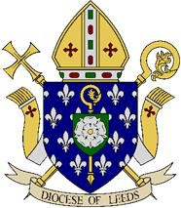

DEPUTY HEADTEACHER
JOB DESCRIPTION

JOB DESCRIPTION

POST TITLE: Deputy Headteacher
Salary: L20 – L24 (£75,331 - £83,081)
Responsible to: Headteacher

Introduction
The school has been designated by the Secretary of State as a school with a religious character. Its instrument of government states that it is part of the Catholic Church and is to be conducted as a Catholic school in accordance with canon law, the teachings of the Roman Catholic Church and the Leeds trust deed. At all times the school is to serve as a witness to the Catholic Faith in Our Lord Jesus Christ. The role of Deputy Headteacher therefore requires a practising Catholic who can show by example and from experience that he or she will work with the Headteacher to ensure that the school is distinctively Catholic in all its aspects.

This appointment is with the Governing Body of the school under the terms of the Catholic Education Service contract signed with the Governing Body as employers. It is subject to the current conditions of service for Deputy Headteachers contained in the School Teachers’ Pay and Conditions document and other current education and employment legislation. In carrying out his/her duties the Deputy Headteacher shall consult with the Headteacher and, when appropriate, with the Governing Body, the Diocese, the local authority, the staff of the school, the parents of its students, the parish(es) served by the school and other local Catholic schools, particularly where collaboration or federation is being developed.

This job description is based on the key areas identified in the National Standards of Excellence for Headteachers published by the Department for Education (2020). It recognises the role of the Deputy Headteacher in sharing responsibility for the leadership of the school.

The Governing Body and the Diocese acknowledge the importance of the role of the Catholic Deputy Headteacher and will actively offer long term support, encouragement, affirmation and realistic challenge to the successful candidate. The Governing Body and the Diocese are committed to safeguarding and promoting the welfare of children and young people and vulnerable adults and the Headteacher must ensure that the highest priority is given to following the guidance and regulations to safeguard them. The successful candidate will be required to undergo an Enhanced check for Regulated Activity from the Disclosure and Barring Service.

The core purpose of the Deputy Headteacher is to assist the Headteacher to set and implement the strategic direction of the school and to provide professional leadership and management to drive achievement of high standards in all areas of the school’s work, particularly in ensuring the provision of sustainable outstanding education through the preservation and development of its Catholic character.

The school’s objectives relate to the provision of Catholic education and the school is part of the Catholic Church and, as such, is to be conducted as a Catholic school in accordance with canon law, the teachings of the Catholic Church and the Leeds Diocese trust deed. Therefore, the post of Deputy Headteacher must be filled by a practising Catholic who can show, by example and from experience, that he or she will ensure that the school is distinctively Catholic in all aspects.

NATIONAL STANDARDS OF EXCELLENCE FOR LEADERS

The National Standards of Excellence for Headteachers (2014) define high standards which are applicable to all Headteacher roles within a self-improving school system. These standards are designed to inspire public confidence in head teachers, raise aspirations, secure high academic standards in the nation’s schools, and empower the teaching profession. Headteachers occupy an influential position in society and shape the teaching profession. They are lead professionals and significant role models within the communities they serve. The values and ambitions of head teachers determine the achievements of schools. They are accountable for the education of current and future generations of children. Their leadership has a decisive impact on the quality of teaching and pupils’ achievements in the nation’s classrooms. Headteachers lead by example the professional conduct and practice of teachers in a way that minimises unnecessary teacher workload and leaves room for high quality continuous professional development for staff. They secure a climate for the exemplary behaviour of pupils. They set standards and expectations for high academic standards within and beyond their own schools, recognising differences and respecting cultural diversity within contemporary Britain. Headteachers, together with those responsible for governance, are guardians of the nation’s schools.

National Standards of Excellence for Headteachers,
DfE Jan 2015

JOB DESCRIPTION

Excellent Deputy Headteachers: qualities and knowledge

Deputy Headteachers:

- Work within the school and with the parish to hold and articulate clear values and moral purpose, which takes account of the school’s Catholic mission focused on providing a world-class education for the pupils they serve.

- Demonstrate optimistic personal behaviour which stems from Christ’s vision for humanity. Promotes positive relationships and attitudes towards their pupils, staff, parents, governors and members of the local community recognising their individual worth as made in the image and likeness of God.

- Inspired by Christ, lead by example - with integrity, creativity, resilience, and clarity - drawing on their own scholarship, expertise and skills, and that of those around them.

- Sustain wide, current knowledge and understanding of education and school systems locally, nationally and globally, and pursue continuous professional development.
- Work with political and financial astuteness, within a clear set of principles influenced by the Gospel message and Church teaching, centred on the school’s vision, ably translating local and national policy into the school’s context.
- Communicate compellingly the school’s vision and drive the strategic leadership, empowering all pupils and staff to excel.

Excellent Deputy Headteachers: pupils and staff

Deputy Headteachers:

- Demand ambitious standards for all pupils, overcoming disadvantage and advancing equality, instilling a strong sense of accountability in staff for the impact of their work on pupils’ outcomes that reflect the distinctive characteristics of Catholic education.

- Secure excellent teaching through an analytical understanding of how pupils learn and of the core features of successful classroom practice and curriculum design, leading to rich curriculum opportunities and pupils’ well-being. Ensure high quality provision for the academic, spiritual, moral, social, emotional and cultural well-being of all pupils and families.

- Establish an educational culture of ‘open classrooms’ as a basis for sharing best practice within and between schools, drawing on and conducting relevant research and robust data analysis.

JOB DESCRIPTION

- Create an ethos within which all staff are required to treat all people fairly, equitably, and with dignity and respect. Inspire, encourage and support staff to develop their own skills and subject knowledge, and to support each other.
- Identify emerging talents, coaching current and aspiring leaders in a climate where excellence is the standard, leading to clear succession planning.

- Hold all staff to account for their professional conduct and practice, emphasising the distinctive nature of Catholic Education.

Excellent Deputy Headteachers: systems and process

Leaders:

- Ensure that the school’s systems, organisation and processes are well considered, efficient and fit for purpose, upholding the principles of transparency, integrity and probity reflecting the school’s Gospel values.
- Provide a safe, calm and well-ordered environment for all pupils and staff, focused on safeguarding pupils and developing their exemplary behaviour in school and in the wider community to promote Gospel values which unite society in a commitment to social justice and the common good.
- Establish rigorous, fair and transparent systems and measures for managing the performance of all staff, addressing any under-performance, supporting staff to improve and valuing excellent practice.

- Welcome strong governance, rooted in faithful stewardship of Gospel values, actively supporting the governing board to understand its role and deliver its functions effectively – in particular its functions to set school strategy and hold the headteacher to account for pupil, staff and financial performance.

- Exercise strategic, curriculum-led financial planning to ensure the equitable deployment of budgets and resources, in the best interests of pupils’ achievements and the school’s sustainability.
- Distribute leadership throughout the organisation, forging teams of colleagues who have distinct roles and responsibilities

JOB DESCRIPTION
Excellent deputy headteachers: the self-improving school system

Leaders:
- Lead outward-facing schools which work with other schools and organisations - in a climate of mutual challenge – where each pupil is championed to ensure they secure their unique potential and achieve excellence

- Develop effective relationships with fellow professionals and colleagues in other public services to improve academic, spiritual, moral, social, emotional and cultural outcomes for all pupils.
- Challenge educational orthodoxies in the best interests of achieving excellence, harnessing the findings of well evidenced research to frame self-regulating and self- improving schools.

- Shape the current and future quality of the teaching profession through high quality training and sustained professional development for all staff.

- Model entrepreneurial and innovative approaches to school improvement, leadership and governance, confident of the vital contribution of internal and external accountability.

- Inspire and influence others - within and beyond schools - to believe in the
fundamental importance of Catholic education in young people’s lives and to promote the value of education.
Child Protection Leaders:
- Ensure that the child protection policies and procedures adopted by the Governing Body are fully implemented and followed by all staff
- Ensure that sufficient resources and time are allocated to enable staff to discharge their child protection related responsibilities effectively

Specific Responsibilities

The specific responsibilities of the Deputy Headteacher at The Holy Family Catholic School are:

- To undertake activities as prescribed by the Headteacher
- To deputise for and act as the Headteacher in their absence.
- To undertake the role of Designated Safeguarding Lead at the school.

The Holy Family
Catholic School
a voluntary academy

DEPUTY HEADTEACHER PERSON SPECIFICATION

PERSON SPECIFICATION

Please note source of evidence of fulfilled criteria:
Application Form - AF Letter – L References – Ref Interview - I  QUALITIES AND KNOWLEDGE | Essential or Desirable | Evidence
Is a practising and Committed Catholic (see below) | E | AF/I/Ref
Qualified Teaching Status | E | Cert
Good Honours Degree | D | Cert
Experience as an effective leader at middle or senior leadership level in a school | E | AF/I
Experience as an effective leader at middle or senior leadership level in more than one school | D | AF/I
Leadership Qualification or the willingness to complete one (e.g. NPQSL or NPQH) | E | AF/I
Evidence of continuing professional development relating to Catholic ethos, mission and religious education e.g. CCRS (Catholic Certificate in Religious  Studies) | D | AF/Cert
Lead by example and be a positive role model with excellent communication skills | E | AF/I/Ref
Have Personal impact and presence | E | I
Participation in a Parish Community | E | I/Ref
Has an understanding of the leadership role in the spiritual development of students and staff in the  school. | E | AF/I/Ref
Understanding of current educational provision and the wider school systems | E | AF/I

 | Essential or Desirable | Evidence
PUPILS AND STAFF
Have ambitious standards and high expectations for all pupils | E | AF/I/Ref
Excellent understanding of high quality teaching and learning | E | AF/I/Ref
Promote the development of the whole child | E | AF/I/Ref
Use data analysis to effectively drive whole school improvement | E | AF/I/Ref
Encourage all staff to develop their unique potential | E | AF/I/Ref

 | Essential or Desirable | Evidence
SYSTEMS AND PROCESS
Ensure the safety of all staff and pupils at all times | E | AF/I/Ref
Promote excellent behaviour and positive attitudes to school life | E | AF/I
Systems for performance management to hold staff to account | E | AF/I
Ability to challenge under –performance | E | AF/I
Promote distributed leadership throughout the organisation | E | AF/I

PERSON SPECIFICATION

 | Essential or Desirable | Evidence
SELF IMPROVING SCHOOL
Knowledge and experience of working with other schools and organisations | E | AF/I/Ref
Effective partnerships with a range of professionals | E | AF/I
Use well evidenced research to achieve excellence | D | AF/I
Provide high quality opportunities for staff development | E | AF/I/Ref
Confident, entrepreneurial, and innovative approach to school improvement | D | AF/I
Source of inspiration and encouragement for all in the school community. | D | AF/I

 | Essential or Desirable | Evidence
CHILD PROTECTION
Ensure that the child protection policies and procedures adopted by the school are fully  implemented and followed by all staff | E | AF/I
Ensure that sufficient resources and time are allocated to enable staff to discharge their child protection related responsibilities effectively | E | AF/I
DSL Level 3 Qualification or willingness to complete | E | AF/I

 | Essential or Desirable | Evidence
SECURING ACCOUNTABILITY
Develop a Catholic school ethos | E | AF/I/Ref
Ensure individual staff accountabilities are clear, understood, agreed, reviewed and evaluated | E | AF/I
Work with the Governing Body to enable it to meet its responsibilities | E | AF/I
Develop an accurate and understandable account of the school’s performance for a range of audiences | E | AF/I
Personally contribute to school achievements taking account of feedback from others | E | AF/I

 | Essential or Desirable | Evidence
STRENGTHENING THE COMMUNITY
Build a school culture and curriculum which takes account of the richness and diversity of the community’s Catholic Christian faith | E | AF/I/Ref
Create and promote strategies for challenging racial and other prejudices | E | AF/I
Ensure learning experiences for pupils are linked into and integrated with the wider community | D | AF/I
Ensure a range of community based learning experiences | D | AF/I
Collaborate with agencies in providing for the academic,  spiritual, moral, social emotional and cultural well-being of pupils and their families | D | AF/I

PERSON SPECIFICATION

 | Essential or Desirable | Evidence
APPLICATION FORM AND LETTER
Application form to be completed in full and legible | E | AF
Supporting statement to be clear, concise and related to the specific post and appointment criteria | E | L

 | Essential or Desirable | Evidence
CONFIDENTIAL REFERENCES AND REPORTS
A positive and supportive written faith reference from a priest where the applicant regularly worships. | E | R
A positive recommendation from current employer or Headteacher | E | R
A second professional reference | E | R

PERSON SPECIFICATION

What is the objective definition of a ‘practising Catholic’ for appointments to key posts in Catholic Schools?

To objectively define what a ‘practising Catholic’ is when assessing applicants for key leadership posts within a Catholic school, it is necessary to understand that there are general obligations as well as essential components that constitute ‘practice’ of the faith in the teaching of the Catholic Church.

The Church’s general obligations for its members require that they strive to live lives of holiness by being faithful to the teaching of the Gospel, by trying to uphold the values
proclaimed in the Beatitudes, by assisting in the Church’s mission to make Christ known to all peoples, by upholding privately and publicly the Church’s moral and social teaching, by endeavouring to follow an informed conscience and by making every effort to keep
the precepts of the Church. This is the ‘practice’ of the Catholic faith in its widest and all- encompassing sense. At the heart of these general obligations though, there are essential components for “full communion” with the Catholic Church. These are sacramental initiation (Baptism, Confirmation and the Eucharist) and the bonds of profession of faith, the sacraments and ecclesiastical governance. The preservation of this full communion is not limited to purely religious activity but is to be an integral part of the whole pattern of behaviour of a member of the Church. It is what essentially constitutes being a committed and ‘practising Catholic’.

For further information including examples where there may be a reason why somebody is not in a position to take up a key responsibility in a Catholic school, please see ‘Christ at
the Centre’ by Mgr. Marcus Stock, CTS Publications ISBN 978-1-86082-843-

APPLICATION AND ASSESSMENT

Application Documents
Applicants are asked to provide a covering letter and complete the CES Leadership Application form, which can be downloaded from the school website or provided on request by emailing mclare@holyfamilyschool.uk

Applications should be returned, via email, to mclare@holyfamilyschool.uk by 9.00 am on
Friday, 19 April 2024.

Informal Discussion
Candidates are encouraged to arrange an informal discussion about the role with Sharon Mather, Headteacher. Please contact Mrs Clare via email on mclare@holyfamilyschool.uk who will arrange a mutually convenient time.

Assessment and Interview
Candidates meeting all the requirements for the post will be short-listed and details of the assessment programme will be confirmed via email.

As part of the selection process, in addition to assessing your skills and knowledge against the requirements of this role, specific questions will be asked to assess your suitability to work with children.
Under the Equality Act, we are legally required to consider making reasonable adjustments to ensure that disabled people are not disadvantaged in the recruitment and selection process. We are therefore committed to meeting, wherever possible, any needs you specify on the application form, please contact us if you need to discuss this in detail.

We will consider any reasonable adjustments under the terms of the Equality Act to enable an applicant with a disability (as defined under the act) to meet the requirements of the post.

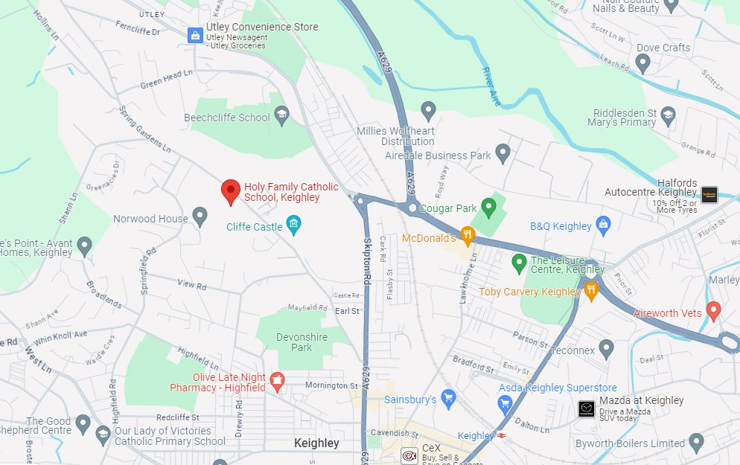

The school is situated in close proximity to motorways and major roads, as well as a number of public transport links.

The Holy Family Catholic School
Spring Gardens Lane
Keighley
BD20 6LH

