Deputy Headteacher
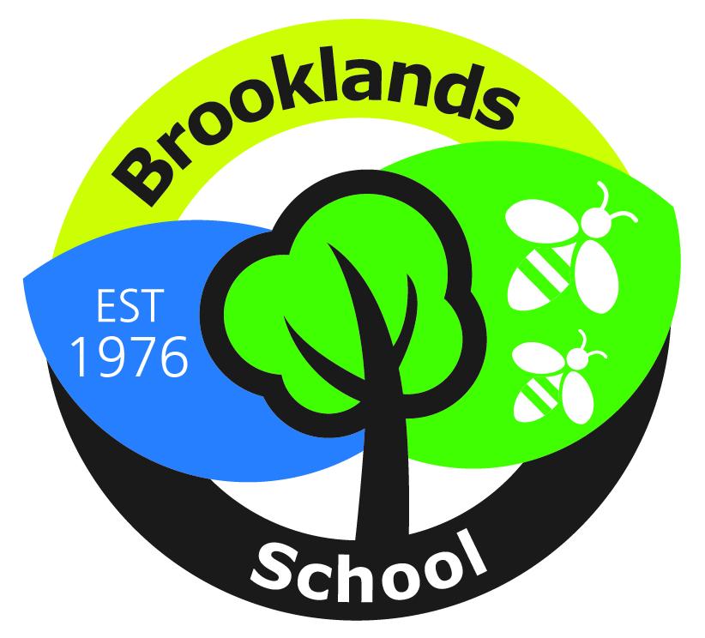
Location: Brooklands Community Special School, Burnside Avenue, Skipton,
North Yorkshire, BD23 2DB

Job Description

Job Title: Deputy Headteacher
Pay Range : Leadership Scale L12 -17
Responsible to: The Headteacher, Governing Body and LA

The appointment is subject to the current conditions of employment for Deputy Headteachers contained in the School Teachers' Pay and Conditions Document, the 1998 School Standards and Framework Act, the required standards for Qualified Teacher Status and other current legislation.

MAIN PURPOSE

LEADERSHIP AND MANAGEMENT
- Works closely with the Headteacher in developing the strategic vision of the school and ensures that the vison of the school is communicated in compelling terms to all staff and stakeholders and to involve them so that they, in turn, drive forward an ambitious and aspirational agenda which demonstrates full commitment to the continued development of Brooklands
- Formulates the school improvement plan and school self-evaluation, working with staff, parents and governors to ensure effective, sustainable school improvement and efficient management of school resources
- Holds and articulates clear values and moral purpose, focused on providing high quality education for all our children and young people at Brooklands
- Effectively supports and challenges staff whilst retaining loyalty to the Headteacher and school leadership team decision

DUTIES AND RESPONSIBILITIES

SHAPING THE FUTURE
- Ensures the vision for the school is clearly articulated, shared, understood and acted upon effectively by all
- Works with individual staff and teams to translate the school vision into agreed objectives and operational plans which will promote and sustain school improvement
- Strategic planning with the SLT, governors, staff, stakeholders
- Systematic evaluation of performance across all aspects of provision, which includes clear ‘next steps’
- Ensuring and maintaining high quality specialist provision for children and young people with complex needs;
- Working in partnership with schools, other agencies and services to improve and develop services and provision to benefit children and young people with special needs
- Contribute to a culture and ethos where high care is matched by high expectations of progress
- Assist in the effective planning and management of Brooklands’ resources
- Promote staff commitment to adopting new technologies and provide training to support staff so they are skilled in using them effectively to support quality learning
- Model exemplary team building and coaching to create a culture in which everyone achieves their potential
- Develop the effectiveness of teams and individuals to enable them to be confident leaders and managers in their own areas of responsibility

LEADING TEACHING AND LEARNING
- Inspires colleagues in a wide range of settings to ensure the highest possible quality of teaching and outcomes for pupils
- Embeds a strong culture of self and peer improvement
- Establishes robust systems for monitoring the quality of teaching, learning and assessment whilst also developing a mutually supportive ethos and culture of self evaluation
- Reviews and evaluates teaching to identify areas of best practice and areas for development in order to promote a culture of continuous improvement
- Uses data and benchmarks to monitor progress and to ensure that outcomes for pupils are sufficiently challenging to bring about outstanding achievement
- Works in partnership with key staff in the development and implementation of planned curricular initiatives, monitoring their impact on improved outcomes
- Develops a strategic approach to embedding pupil progress data in Learning Journeys (assessment for learning tool) so that it is used by all staff to accelerate achievement
- Ensures all staff develop stimulating and challenging learning environments which secure effective learning and provides high standards of achievement and behaviour increasing independence for all our students
- Coaches teachers across the school to improve their practice
- Undertakes teaching duties to cover teachers where necessary, providing a professional model, clearly demonstrating effective teaching, classroom organisation and display, and high standards of achievement
- Makes a significant contribution to formal reports e.g. Governing Body

DEVELOPING SELF AND WORKING WITH OTHERS
- Creates and develops an ethos and culture in which all staff recognise that they contribute to and are accountable for the success of the school including improving the quality of education provided and standards of achievement
- Creates a culture of aspiration through continuous development of skills so that motivation is sustained for self and other staff
- Develops and maintains constructive and positive working relationships with all staff
- Motivates and challenges all staff to maintain high expectations of behaviours
- Plays a significant role in the implementation of the school’s performance management policy, to secure school improvement and individual professional development

MANAGING THE ORGANISATION
- Contributes to the overall strategic direction and improvement of Brooklands
- Works with the Headteacher in managing strategic partnerships with other organisations
- Models exemplary attitudes to change and innovation
- Recruits, retains and deploys staff appropriately
- Promotes multi-agency working in order to impact positively on provision and outcomes
- Supports the Headteacher in implementing evidence based school development plans
- Ensures that policies and practices take account of national and local policies and initiatives
- Fulfils the statutory duties, including in relation to the curriculum, safeguarding and child protection

SECURING ACCOUNTABILITY
- Manages staff roles and ensures that responsibilities are clearly defined, understood and agreed
- Works with the Governing Body to enable them to meet their statutory responsibilities
- Present the school’s performance and other school initiatives to a range of audiences; parents, governors, school improvement officers and other external agencies.

STRENGTHENING COMMUNITY
- Creates and promote positive strategies for inclusive practice
- Works in collaboration with all partners, stakeholders, agency bodies and voluntary organisations to impact positively on provision and outcomes
- Works in partnership to build and develop a range of community based learning experiences
- Networks with other schools and providers to improve outcomes – e.g. 14-19; FE etc
- Strengthens relationships with parents / carers through open and effective communications to support improvements in pupils’ achievements and personal development

CHILD PROTECTION/PUPIL SAFEGUARDING
- Ensure that the child protection policies and procedures adopted by the governing body are fully implemented and followed by all staff
- Ensure that sufficient resources and time are allocated to enable staff to discharge their child protection related responsibilities effectively

OTHER DUTIES/RESPONSIBILITIES
- Undertakes any professional duty of the Headteacher which may be delegated
- Deputises in the absence of the Headteacher both at short notice and over a longer term, undertaking the full range of professional duties provided by the Headteacher

ENTITLEMENT
The Headteacher and governing body are fully committed to ensuring the professional effectiveness of the Deputy Headteacher in this role through:
- the provision of leadership and management time;
- support for the provision of professional development opportunities, e.g. leadership development programmes with the NCSL.

