Appointment of Deputy Headteacher

Information for Candidates

General Information
Burford School is a standalone academy renowned for its ethos, educational standards and achievements. The school offers non selective, comprehensive education for 1475 day and boarding pupils aged 11 – 18. The school is one of the few remaining state boarding schools in the country and is heavily oversubscribed for both day and boarding places. Burford is at the heart of the community in West Oxfordshire and has one of the largest catchment areas in the south of England. The school has been on its current site occupying 36 acres of rolling land at the top of Burford since 1957, but can trace its roots back to 1571. This year marks the school’s 450th Anniversary, an immensely important milestone which will be celebrated within the community and led by our new Headteacher. The Boarding House is located in the centre of Burford and forms an important part of the community.
Context
The school always encourages students to do the best they can by giving them every opportunity to succeed. We have an outstanding pastoral system which supports both students and their families. Attendance is above 95% and student attitudes and behaviour are excellent. Burford School is renowned for its extra-curricular provision, and all students are encouraged to participate in further interests. The Deputy Headteacher will be expected to participate in and oversee the extra-curricular programme.
In a time where students face increasingly more complex challenges, particularly following the pandemic, the Deputy Head requires determination, resilience and considerable experience in leading and embedding strategies that enable students to manage their wellbeing and achieve their potential.
Following significant success and expansion the school is looking to appoint a strong, organised and talented Deputy Headteacher to take us forward on the next exciting stage of our journey.
The successful candidate will be the stand-alone Deputy and carry the responsibility for the leadership and management of the school when the Headteacher is off site. They will be able to draw on knowledge and experience of successful school systems and approaches whilst also able to innovate and devise new solutions as challenges unfold and the school evolves.

Aims of the Post

To support the Headteacher and Senior Leadership Team in the overarching aim of enabling a safe, productive and innovative environment that facilitates outstanding teaching and learning.

Specific Role Responsibility

General
- To deputise for the Headteacher
- Lead by example, providing inspiration and motivation, to support and promote the School values and mission
- Undertake an appropriate programme of teaching in accordance with the duties of a standard subject teacher, as outlined in the Pay and Conditions Document
- To support the Headteacher in staff recruitment, interviewing and observing prospective staff
- To supervise, monitor and appraise allocated Heads of Departments
- Provide regular feedback for colleagues in a way which recognises good practice and supports their progress against professional and personal objectives
- To keep up to date with educational reform policy by ensuring an awareness of education initiatives and their usefulness
- To attend all staff meetings, Heads of Key Stage meetings, Senior Leadership meetings and relevant review meetings
- To attend public events and promote the school through supporting marketing and development initiatives
- To attend School evening events and Parents Evenings
- Be committed to own professional development, attending INSET, keeping abreast of the latest developments and thinking, coaching and mentoring, self-evaluation and peer review.
- Monitor the delivery of and evaluate effectiveness of provision in all areas of responsibility to inform future developments
- To have an overview of school compliance
- To have responsibility and oversight for future development of the digital strategy
- Reflect on personal contribution to school achievements and take account of feedback from others
- Collaborate with other schools and organisations in order to share expertise and bring positive benefits to own and other schools
- Provide relevant data to ensure the school’s accountability to a wide range of groups, particularly parents, carers, governors and the DfE.
- Be available to deal with whole school matters outside of school hours, and during holidays on a rota basis in the event of emergencies
- To have oversight for effective Extra-Curricular Provision

Behaviour
- To lead and maintain effective discipline systems.
- With Heads of Key Stage, make arrangements for, and sometime supervise, detentions
- To develop and lead a programme of parent talks and support as appropriate
- Communicate with parents on issues of behaviour and attendance, and initiate, attend and record meetings as required

Pastoral
- To support the work of the Assistant Headteacher: Pastoral as demanded
- To ensure that the wellbeing and safety of students are at the forefront of all decisions, policies, planning and action
- To lead and manage processes for pupil recruitment, admission and retention.
- To be the School’s Deputy Designated Safeguarding Lead
- To support safeguarding training and ensure that staff are up to date on safeguarding advice and legislation
- Monitor and update the uniform list, liaising with the supplier and responding to any parental enquiries

Operational
- Design, implement and embed strategies that ensure the school and the people and resources within it are organised, efficient and managed so that everyone can achieve their potential
- To lead and coordinate the organisation of the school, ensuring smooth day-to-day running.
- To review, amend and implement the School’s policies as appropriate
- To lead the organisation of all major school events, including awards ceremonies

Boarding Department
- To monitor and support the effective management and leadership of the Boarding Department.
- Oversight of pastoral care, welfare, discipline and admissions for the Boarding Department
- Boarding Ofsted – support with preparation and help to lead
- To be a lead professional for the Governing Body’s Boarding committee and produce and deliver the Director of Boarding report on a termly basis
- Support Head of Boarding with staffing issues
- Overview of the site at Boarding, liaising with site manager
- Oversee the educational and social development of residential students
- Plan for strategic development of Boarding Department with Headteacher and Boarding Governors
- With Director of Business and Finance, annually set Boarding budget, oversight of monthly monitoring of budget and ensure correct governance and stewardship of finance, accounts and other resources
- Maintain and uphold Boarding National Minimum Standards
- Oversee Boarding Health and Safety
- Work with the School’s Designated Safeguarding Lead to ensure the highest standards of safeguarding for our Boarding students

The postholder will be expected to carry out such other duties as reasonably requested by the Headteacher that are commensurate with its level of responsibility.

Not all of the above duties will need to be performed all of the time and will vary according to the needs of the school and Senior Leadership Team at different points. The specific focus for the DHT work programme will be negotiated and agreed at the beginning of the performance management cycle.

This job description will be reviewed at regular intervals and is subject to change as the needs of the school evolve. Any changes would be made after full consultation with the staff involved.

Person Specification

Job title: | Deputy Headteacher
Skills
Ability to work in a way that promotes the safety and wellbeing of children and young people | Essential
Outstanding interpersonal skills and emotional intelligence, with the ability to relate well to people on all levels, to encourage, motivate and confidently resolve conflicts | Essential
Excellent organisational and administrative skills, with the ability to remain calm under pressure, managing competing priorities and juggling a range of tasks and issues at the same time | Essential
Firm, compassionate and patient in dealings with students, parents and staff, and can empathise with the challenges that life presents | Essential
Strong analytical and problem solving skills with the ability to bring positive solutions, being open minded to new ideas | Essential
An outstanding communicator who is dynamic, able to articulate ideas and capture an audience | Essential
Good numeracy skills, with the ability to interpret statistical data and manage budgets | Essential
Courage and determination in the face of challenge or criticism, with the humility to accept mistakes and seek help as necessary | Essential

Qualifications and Professional Experience
Qualified to at least first degree level and have QTS | Essential
Track record of success as a middle/senior leader in secondary education | Essential
Substantial and successful experience of pastoral and safeguarding leadership and management | Essential
Experience of leading, managing and developing teams | Essential
Experience in a boarding environment | Desirable

Professional and Technical Knowledge
The ability to lead the operational control of the school on a daily basis and ensure its smooth running | Essential
Widespread knowledge of current educational issues, and a commitment to keeping up to date with changes | Essential
The ability to lead in strategic planning and school development | Essential
Excellence in the use of data to improve standards and track student progress | Essential
Knowledge of effective strategies for achieving the highest standards of student behaviour and attainment | Essential
Proficiency in self and school evaluation | Essential
A thorough understanding of ICT and its use across all aspects of the school, with a clear understanding of the potential for IT in enabling innovative and effective approaches to learning and school organisation | Essential

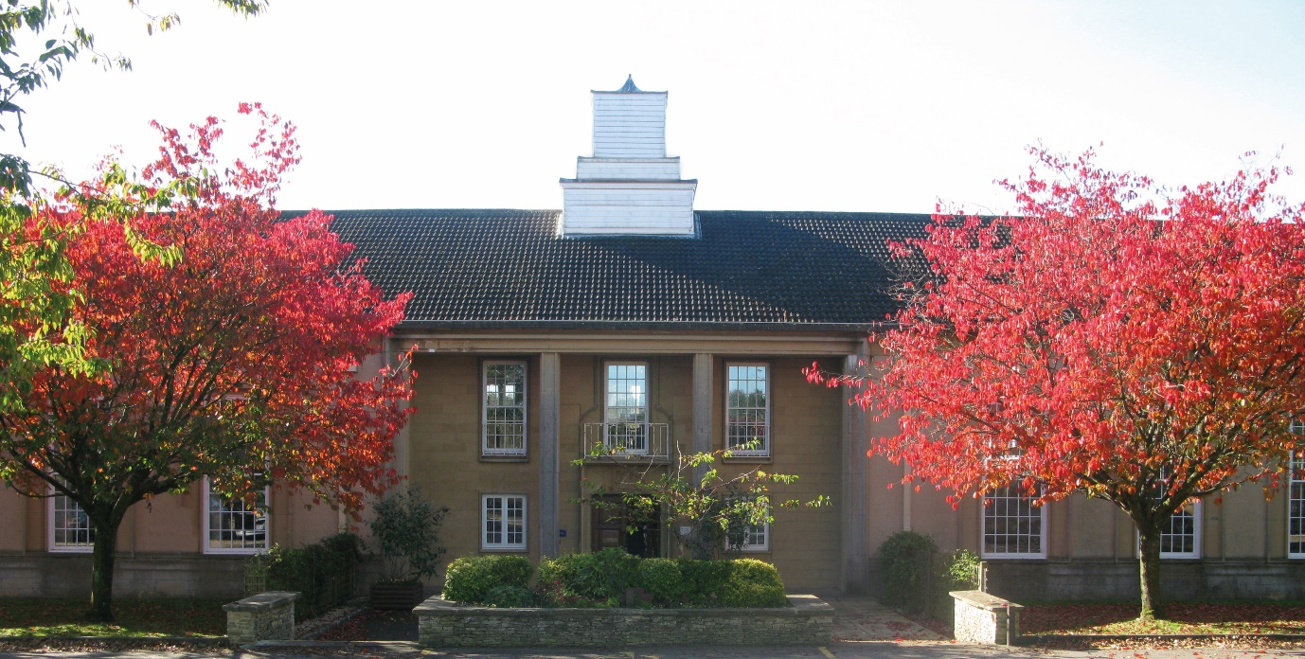

Burford School
Oxfordshire
OX18 4PL
www.burford.oxon.sch.uk

