Deputy Head Teacher
Deep Learning
Ayresome Primary School

Application pack

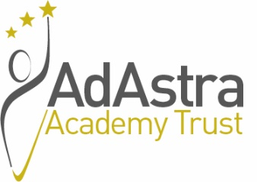

Dear Applicant,

Thank you for taking the time to look through the following information about Ayresome Primary School. We very much look forward to hearing from you as you progress your interest in the post to an application.

We believe that a visit to the school is essential and would warmly encourage you to arrange one. Please do contact me on 01642 244961 or via AYCharlotte.Haylock@ayresome.net and I will be delighted to show you around the school and answer any questions that you may have.

Kind regards,

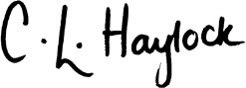
Charlotte Haylock
Executive Head Teacher
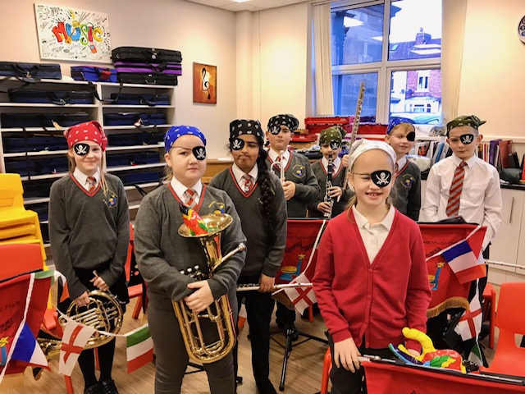

CONTENTS

- Trust Vision
- School Context
- Job Advert
- Job description
- Person specification

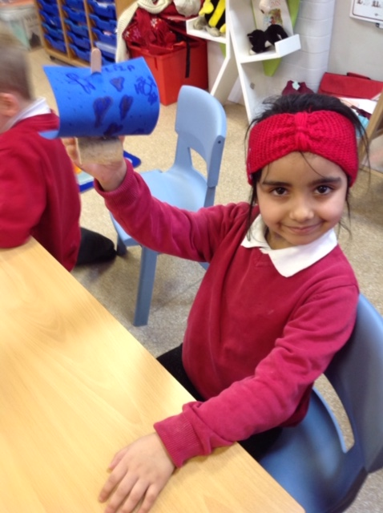

TRUST VISION
Ad Astra belives that we are unique and different – we learn as much from our family of schools as they do from the Trust.

We strongly believe as Michael Fullan said: “Isolation is the enemy of improvement”. ‘Leading in a Culture of Change’ [2007].

As a Trust we have High Social Capital based upon;
Trust
Reciprocity
Goodwill towards one another
Openness and Honesty

Our Values reverberate across the organisation;
Support
Togetherness
Achieve
Respect
Success

We think if you choose to work within Ad Astra you will find it will be the best decision you will ever make. As a Trust we strongly believe in ‘Maximising the Togetherness’. Ad Astra meaning ‘to the stars’ and our strapline; ‘Stars in the Making’ is equally resonant with employees as with our pupils, they can all be the best they want to be within Ad Astra.

I am proud to be CEO of an organisation that is currently one of the largest employers within the Tees Valley. I have been involved in education for over 43 years whilst always being employed within the Tees Valley. I want our Trust to have a positive, national profile using personal leadership experience developed in working for the DfE and as a National Leader of Education for a number of years. This is a crucial post in the development of our Trust so feel free to get in touch.

To learn more about this post and working in our trust please contact me: andy.brown@adastraacademytrust.com

We look forward to hearing from you.
Andy Brown OBE CEO Ad Astra Multi-Academy Trust
SCHOOL CONTEXT
I am obviously new to the School too: I joined the Ayresome team in January as Executive Headteacher also responsible for another large primary school in Hartlepool. I have worked within Ad Astra Trust since its formation in 2015, and have been a senior leader in education in the North East for over 15 years which included an interim headship supporting another primary school. I am really looking forward to embarking on this journey with Ayresome and I am excited to be involved in appointing the new Deputy - someone who is as passionate as me about making a difference.
Ayresome Primary School is a very large 2-11 primary school situated in the Gresham Ward of Middlesbrough and serves an area of significant social and economic deprivation. The school was formed from the amalgamation of Ayresome Infants and Ayresome Juniors in 2002. The school has approximately 700 pupils on roll and has high mobility. The school employs a large team of around 90 dedicated and committed staff.
As a school, Ayresome Primary school is on an exciting journey with developments to ensure that the school makes rapid progress in moving from a school which requires improvement, to a good school, thus ensuring that all children achieve the very best that they can. This role presents a great opportunity to become an integral part of a team who have the drive and ambition to work alongside experienced colleagues to establish excellent standards in teaching and learning through teaching an ambitious curriculum, thus resulting in higher levels of achievement for all.
There are a number of different languages spoken by pupils with a significant number of children new to England and of Eastern European Roma origin. This different cultural mix within school adds to the vibrancy and family ethos to ensure that everyone within the community is celebrated.
The school promotes six key values of respect, trust, tolerance, ambition, determination and excellence.
The school has recently undergone a substantial refurbishment programme, to ensure that the well maintained building continues to provide a welcoming learning space for the local community.
The surrounding area is mostly terraced housing but a large park also borders the school. The school is blessed with two playgrounds, a purpose build MUGA with 4G surface and a developed garden area with a green space for all aspects of outdoor learning. The outside areas for the Early Years are established and continually being updated.

JOB SUMMARY
AYRESOME PRIMARY SCHOOL, Worcester Street, Middlesbrough, TS1 4NT

Deputy Headteacher – DEEP Learning (Non class-based)
Salary range: L14-18, £58,135 - £64,143, permanent post, to commence 1st January 2022 (or earlier if possible)
Ayresome Primary School is seeking to appoint an excellent Deputy Headteacher who can demonstrate outstanding practice and an ability to harness the skills and enthusiasm of all staff and pupils, through being a role model for teaching and learning. The successful candidate will work in partnership with the Executive Headteacher and the Trust to lead the school on an exciting journey to ensure the school makes rapid progress in moving to a “good” school and providing an inspirational education for all, helping every child to achieve the very best that they can.
This post is non class-based although a key part of the role is developing teaching and learning.
The successful candidate will be someone who is already a senior leader and shows a commitment to and enthusiasm for enhancing their own knowledge and skills in all aspects of school leadership, able to play a pivotal role in shaping the future of our school. This role presents a great opportunity to become an integral part of a team who have the drive and ambition to work alongside experienced colleagues to establish excellent standards in teaching and learning through teaching an ambitious curriculum, thus resulting in higher levels of achievement for all. Ayresome Primary School is also committed to continued professional development for all staff within an inclusive and supportive environment and would support the successful candidate on NPQH if requested.
Visits to School are warmly encouraged and candidates are welcome to visit us at a time of their convenience. Please contact Charlotte Haylock, Executive Headteacher on 01642 244961 or via AYCharlotte.Haylock@ayresome.net to book an appointment.
The closing date for applications: 9am, Friday 25th June 2021
The selection process will be held on both Friday 2nd July and Tuesday 6th July.
Ayresome Primary School is committed to safeguarding and promoting the welfare of children and young people and expects all staff and volunteers to share this commitment. As such the successful candidate will be required to undertake an enhanced Disclosure & Barring check.
Application forms and further details are available via the Ad Astra website site:
http://www.adastraacademytrust.com/careers/

Candidates must only apply using the application form provided; CV’s will not be accepted. Please upload your completed application form via the link on Ad Astra’s Website: http://www.adastraacademytrust.com/careers/
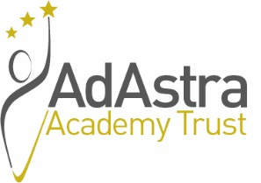

Ayresome Primary School
Deputy Head Teacher DEEP Learning - Teaching and Learning
Job Description

Overall Purpose
To meet the requirements of:
- A teacher as set out in the School Teachers Pay and Conditions Document.
- The Professional Standards for Teachers.

Deputy Head Teachers play a critical role in the life of the School and the wider Academy Trust via:
- Sharing in the leadership and management of the school.
- Supporting the Executive Headteacher in meeting the aims of the school.
- Being a role model for teaching and learning.
- Making a distinctive contribution to the raising of pupil standards.
- Contributing effectively to the work of the wider school team.
- Taking advantage of CPD opportunities and using the outcomes effectively to improve pupils’ learning.
- Ensuring the continuation of the high standards of safeguarding and promotion of the welfare of children.
- Line managing employees.

The key responsibility areas for this post are:
- Pedagogy, effective teaching & learning strategies
- Coaching and mentoring
- Curriculum.
- School improvement.
- School self-review.
- Monitoring cycles.
- Assessment.
- Enriched and Extended curriculum offer.
- Effective curriculum design for EAL pupils
- Pupil progress

Responsible to:
Executive Head Teacher
Main Duties and Responsibilities:
Leading Teaching and Learning Duties and Responsibilities
- Lead learning within the school team by supporting the development and implementation of teaching styles and strategies and to provide programmes and activities which match learner aspirations and potential in order that at all children enjoy and achieve.
- Ensuring that standards in the school reflect national aspirations and that challenging targets are met.
- Lead, develop and enhance the teaching practice of others through monitoring, evaluation and promoting improvement strategies to secure effective teaching and learning for learners.
- Lead learning across the school by implementing assessment strategies, data analysis, and appropriate intervention strategies to ensure that identified standards of learner achievement are met.
- Challenge and support each colleague’s pupil progress to ensure pupil progress is being maximised most effectively.
- Facilitate an ethos within the school and the wider trust which encourages staff to work together, share knowledge and understanding, celebrate achievements and accept responsibility for outcomes.
- To have a clear vision and purpose for the raising standards of attainment.
- To develop subject knowledge and expertise keeping up to date with national developments, teaching practice and methodology to support staff and pupils in achieving high standards in the primary national strategy.
- To support colleagues in ensuring effective curriculum coverage, continuity, progression and challenge through the application of extensive knowledge and well-informed understanding of assessment requirements and arrangements for the subject/curriculum area.
- To monitor and evaluate subject delivery through lesson observations, work scrutiny, planning audits, resource audits and data analysis and produce reports and development plans.
- To arrange for the purchase of appropriate resources to enable colleagues to teach the subject effectively within the constraints imposed by the subject budget allocation.
- To ensure resources are well organised, well maintained and accessible to colleagues.
- To offer guidance and support to staff in developing the subject and to the leadership team in leading, managing and developing the subject/area.
- To direct the Teaching of EAL across the school and ensure effective Curriculum design for EAL pupils.
- To manage EAL across the school
- To work alongside the Trust, external agencies and cluster schools to enhance and further develop practice.
- To report and present impact of school improvement to the Trust and Local Academy Council.

Teaching and Learning Duties and Responsibilities
- To plan and deliver engaging and motivating lessons and an appropriate, broad, balanced, relevant, differentiated and challenging curriculum to all pupils appropriate to their needs.
- Designing and refining approaches to teaching that are effective and consistently well matched to learning objectives, integrating recent developments, including those relating to pedagogy.
- To assess, record and report on all aspects of pupils’ progress and development.
- Contribute to raising standards of pupil attainment.
- To provide or contribute to oral and written assessments relating to individual pupils or groups of pupils, internally, with parents and outside agencies.
- To ensure high standards of behaviour so effective learning can take place, and good relationships can be formed within the school community.
- To contribute to whole school planning activities.
- To give advice on the development and well-being of children.
- Applying teaching skills which lead to learners achieving well relative to their prior attainment, making progress as good as, or better than, similar learners nationally.
- To play a full part in the life of the school community and support its ethos, values and aims.
- To contribute significantly to implementing workplace policies and practice and promoting collective responsibility for their implementation.
- To have high expectations and lead by example.
- To contribute to the evaluation and monitoring of the school curriculum and to assist in the process of development and change to ensure the continuing relevance of policies and procedures to the needs of the pupils.
- To work as a member of a team, promote collaboration and to contribute positively to effective working relations within the school.
- To have, and share with colleagues, extensive knowledge and understanding of how to use and adapt a range of teaching, learning and behaviour management strategies, including how to personalise the learning experience to provide opportunities for all learners to achieve their potential.
- To comply with the schools Health and Safety policy and undertake risk assessments as appropriate.
- To engage actively in Performance Management and Professional Development to ensure professional skills are developed and kept up to date.
- To contribute to the professional development of colleagues through coaching and mentoring, demonstrating effective practice, and providing advice and feedback.
- To share and support the school’s responsibility to provide and monitor opportunities for academic and personal growth.

The work of schools changes and develops continuously which in turn requires staff to adapt and adjust. The duties and responsibilities above should not therefore be regarded as immutable but may change in line with national prescription on teachers’ terms and conditions of employment and/or any relevant school improvement priorities set from time to time. Any major changes will involve discussion and consultation with you.

Whilst the main duties and responsibilities of the post are set out above, each individual task to be undertaken has not been identified. Teachers will be expected to comply with any reasonable request from their line manager to undertake work related to teaching and learning that is not specified within this job description and which is commensurate with the level of the post.

June 2021

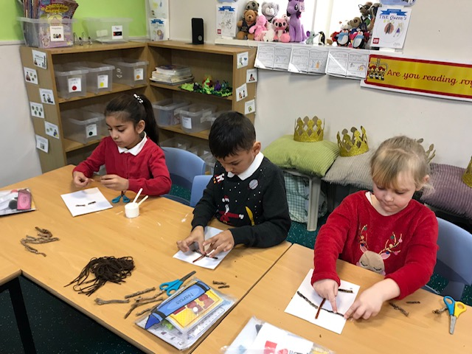

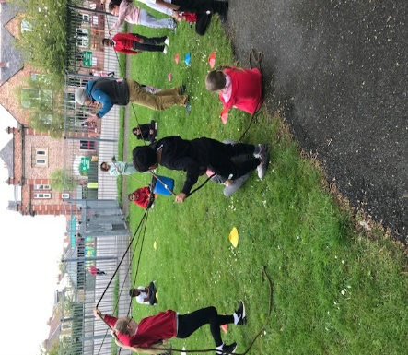

This post has been designed around the work of David Hargreaves and Deep Leadership- A new shape for schooling. You may find this helpful-Reference: http://complexneeds.org.uk/modules/Module-3.2-Engaging-in-learning---key-approaches/D/downloads/m10p020d/a_new_shape_for_schooling_1.pdf

Ayresome Primary School

Deputy Headteacher DEEP Learning – Person Specification
Requirements | Essential Criteria | Desirable Criteria
Educational qualifications and training | - Qualified teacher status – degree or equivalent (application)  - Evidence of continued and relevant professional development (application) | - Higher degree/diploma (application)  - NPQH or further professional development (application)
Skills, abilities, knowledge and competencies | - Senior position or significant leadership and management responsibility in a school (application, references, interview)  - Proven ability to lead and manage staff and to develop high performing teams (application, references, interview)  - Ability to work in partnership with the Executive Headteacher and Local Governance (application, references, interview)  - Experience of leading on aspects of successful school improvement identified through the school’s self evaluation process (application, references, interview)  - Successful teaching experience across the primary age range. Judged to be an outstanding teacher (application, references, interview)  - Ability to plan strategically (application, interview) | - Experience of meeting the needs of children of varying abilities (application, interview)  - Experience of leading a core subject in a primary school (application, interview)  - Experience of teaching in more than 1 setting (application, interview)
Professional knowledge, understanding and experience | - Ability to analyse, interpret and act upon relevant school improvement information and data (application, interview)  - Knowledge and experience of school improvement strategies and an ability to support the Executive Headteacher in managing and enhancing the performance of all staff (application, references, interview)  - Experience of providing professional direction to the work of others through coaching, mentoring and performance management/appraisal (application, interview)  - Demonstrable experience of monitoring, evaluating and improving the quality of teaching and learning (application, references, interview)  - Substantial knowledge of the National Curriculum, current curriculum developments and a detailed understanding of the principles of good curriculum provision. (application, references, interview)  - Experience of leading curriculum developments and continued professional development. (application, references, interview)  - Detailed understanding of safeguarding and raising attainment and achievement (application, interview) | - Experience of managing an aspect of the delegated budget and the principles of best value (application, interview)
Personal qualities | - High expectations of children’s achievements and behaviour (application, interview)  - Ability to empathise with children across the primary age range and to be firm, fair and consistent (application, interview)  - Excellent interpersonal skills and the ability to motivate and inspire others (interview)  - Ability to sustain effective relationships with the school community (application, interview)  - Ability to be reflective and self critical (interview)
Professional philosophy and commitment | - Clear and articulate vision for the development of primary education (application, interview)  - Commitment to promoting equal opportunities and meeting the educational, social and emotional needs of all children (application, interview)  - Commitment to high standards and continuous improvement (application, interview)
Additional | - Enhanced DBS clearance

