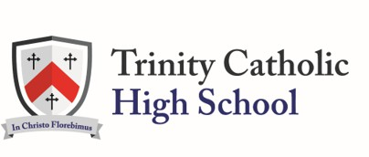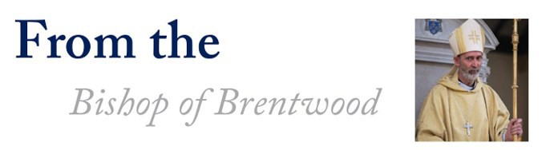

Over the years, Catholic schools have made a significant contribution not just to the life of the Catholic Church, but also to the life of the nation as a whole. Catholic schools are places of great ethnic richness, they are characterised by tolerance, respect, a genuine spirit of enquiry and the search for truth. The education and formation that takes place in our Catholic schools is part of our contribution to the Common Good of society as a whole. Perhaps for these reasons and for the way children are cared for and valued, so many parents choose to send their children to a Catholic school.

Education is one of the most powerful weapons in combating poverty and in helping children to reach their full potential as human beings. So Catholic education is part of the Church’s effort to realise Christ’s desire for us all that we might “have life, and have it to the full.” (John 10:9) This is achieved not just in the teaching of RE, but by a whole system of gospel-based values encompassing the way everyone relates to each other in all that we do and in extracurricular ac- tivities, in other words by the whole Catholic ethos of the school. Here we find a genuine means of exposing young people to the Gospel of Jesus Christ, and of helping them to respond to Christ’s invitation to “follow me”.

I am particularly grateful for those who participate in Catholic education and who craft this great treasure. Parents who choose a Catholic school and often go the extra mile to contribute to its life and help in practical ways with the running of a school. Over the years our forefathers fought hard to establish and maintain Catholic Education in these lands. Now it is our turn to work together to ensure that Catholic Education is maintained, supported and enabled to grow and develop for the future generations of children across the Diocese of Brentwood.

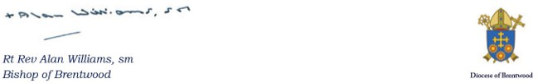



# School Vision and Values

*Compassion – Vocation – Wisdom*

1. At Trinity we believe that, through the Eucharist, our Vocation is to love God, be compassionate

to our neighbour and grow in wisdom, this is the path of excellence.

1. At Trinity we believe that religion lies as the heart of every individual’s vocation. We must be compassionate and wise to all. We must value other people’s religious beliefs and their practice of them.
2. At Trinity we believe that our vocation is to serve. According to Christ, those who follow this vocation should be accorded a special dignity and respect. We must have the wisdom to realise that all who serve the students act as their parents, their mothers and their fathers.
3. At Trinity we believe that our vocation is to build and develop a community which is compas- sionate and dedicated to the pursuit of excellence in all aspects.
4. At Trinity we believe that the fabric of the school and all its resources are for our enjoyment.

We must take great care of these.

1. At Trinity we believe that our vocation is to become more compassionate and deepen our wis- dom. In doing so, we can better serve others, both in our own communities and those communi- ties attached to it, be it our neighbourhood, our country or those communities in the world which require our compassion.
2. At Trinity we believe that our vocation must always protect and show great compassion to those weaker than us, this is the wisdom of God made flesh in Jesus Christ.
3. At Trinity we believe we are here to make our parents and families proud.
4. At Trinity we believe that what we do, what we achieve is important in this life and in the life to

come where compassion, vocation and wisdom reach their fulfilment.

1. Our Vision is summed up in this Acclamation.

*“May the Father of our Lord Jesus Christ Enlighten the eyes of our mind,*

*So that we can clearly see What hope God holds for us.*

*Alleluia.”*

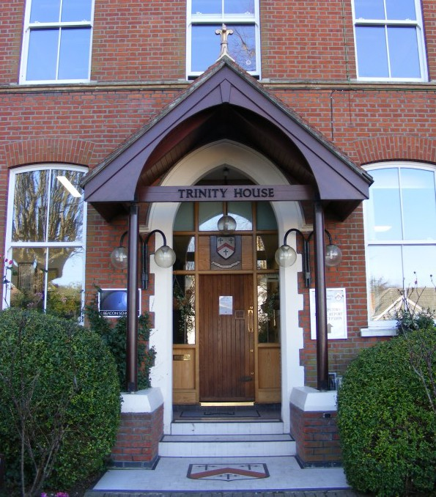

## The Founding of Trinity: 1944 – 1981

One of the greatest successes of the parish, which fitted closely into the

ideals of the founding Dowager Duchess, was the expansion of Catholic education in the Woodford area. Butler’s Education Act of 1944 completely reorganised state education and soon made its im- pact felt on St. Anthony’s School. From its formation until 1946, St. Anthony’s had been an all age elementary school but, from September of that year, all senior children of both sexes who had not qualified by means of examination at age 11 for admission to selective schools, were automatically transferred to St. George’s Secondary School at Walthamstow. The effect on Catholic education in the area was parlous and led, in 1950, to the formation of one of the most powerful pressure groups ever instituted in the parish, the C.P.E.A., the Catholic Parents and Electors Association. They im- mediately adopted a high profile, not only on general educational issues, but in an attempt to ration- alise and develop Catholic education in the area. The C.P.E.A. received tremendous help from the Franciscan community: extra land was given by the Fathers to St. Anthony’s School for its enlarge- ment and, in September 1958, the friars considered the selling of the Montclair site for the new sec- ondary modern school of St. Paul’s. In 1962 Monclair was eventually sold and, in September 1964, the new secondary modern school opened its doors.

The C.P.E.A. were also instrumental in the development of the convent school in Mornington Road. In 1945 this had been placed on the list of schools recognised by the Ministry of Education and be- came known as St. Mary’s Grammar School. Due to the efforts of the C.P.E.A., the new Grammar School obtained aided status. The need, however, to establish a long term solution to Catholic edu- cation 11 – 18 continued and reached its climax in September 1976 when St. Mary’s Grammar School (Mornington Road) and St. Paul’s Secondary Modern School (Sydney Road) were merged into the new Comprehensive Trinity Catholic High School. The Franciscan and Parish community was generous in their support of the C.P.E.A. and the Diocese of Brentwood, not only in a pecuniary fashion, but being involved on the Governing Boards and in the busy pastoral work of these merging schools.

1976 saw Prime Minister James Callaghan’s initiative implemented, the creation of comprehensive schools on a national level. The amalgamation of St. Paul’s and St. Mary’s Grammar schools were part of this. Sister Mary-Joachim eventually retired as Headteacher of St. Mary’s Grammar School and Mr Joseph Green became overall Head of both sites, now reconstituted as Trinity Catholic High School. In 1981, Mr Joseph Green retired after long years of faithful service and Dr P.C. Doherty OBE was appointed as his successor with Michael Wilshaw as his First Deputy (Sir Michael Wil- shaw later became Her Majesty’s Chief Inspector of Schools, after his outstanding service both at Trinity and St. Bonaventure’s Newham).

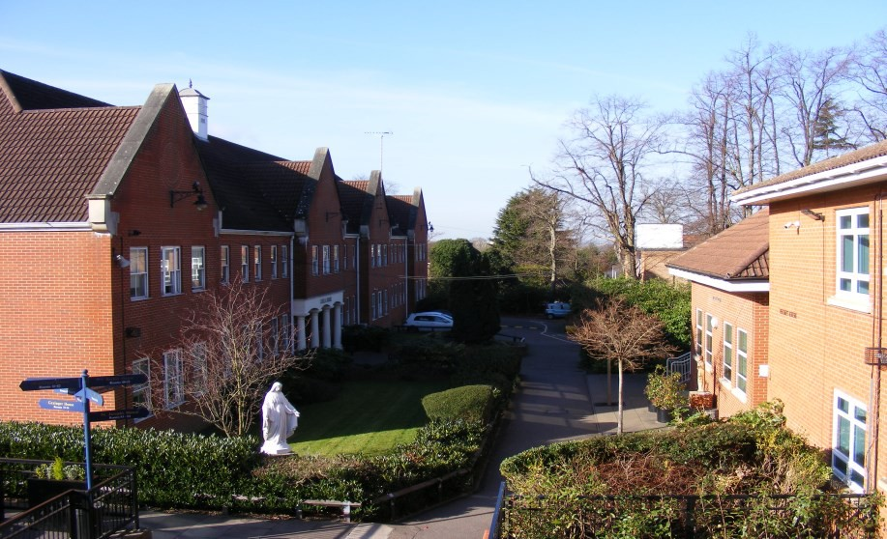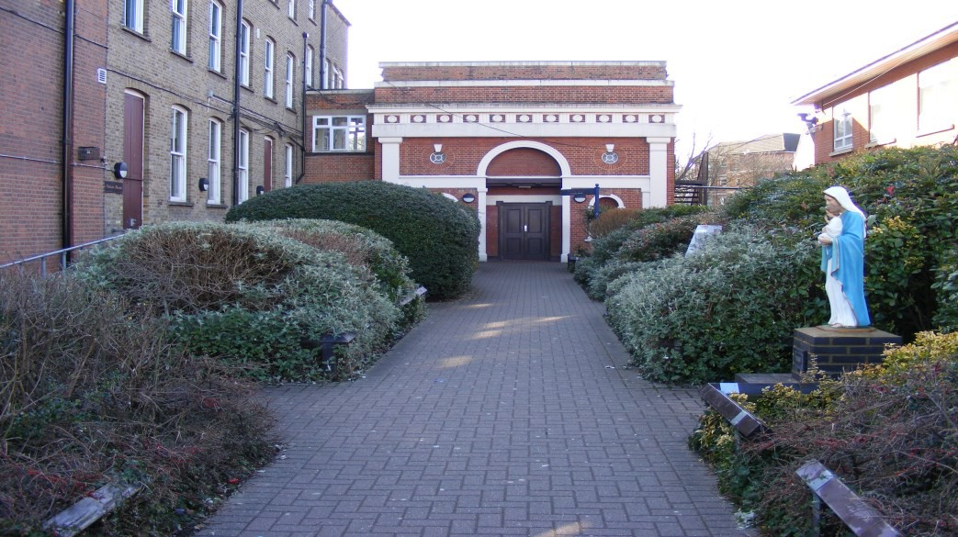

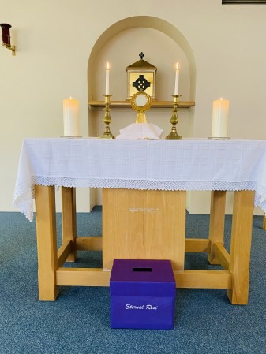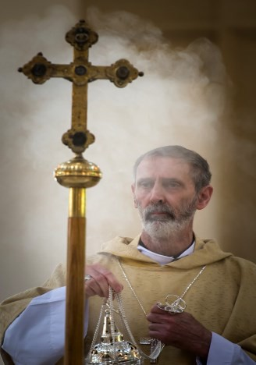Founded in 1976, Trinity Catholic High School is one of the most distinguished Catholic schools in the country.

In partnership with parents, Trinity aims through a Christ-centred curriculum, to develop young men and women of faith, good character, strong intellect and generous spirit, able to move confidently into the world and to use their talents and gifts to lead and serve others.

The School is part of the Catholic Church, and, as such, is conducted in full accordance with the Canon Law and the teachings of the Church. Religious Education, in particular, is in accordance with the rites, practices, discipline and liturgical norms of the Catholic Church, and at all times the School serves as a witness to the Catholic faith.

Jesus Christ is “the way, the truth and the life”. Those who profess this faith believe that in Christ the truth about Almighty God and the truth about the human person is revealed.

The unfolding of this truth constitutes the Church’s teaching. The acceptance of this truth brings true freedom and the fullness of life. Proclaiming this truth, this Gospel (Good News), by making Christ known to all peoples, constitutes the mission of the Church.

The first key reason why Catholic schools are established, then, is to be part of the Church’s mission in education, to place Christ and the teaching of the Catholic Church at the centre of people’s lives. “Education is integral to the mission of the Church to proclaim the Good News. First and foremost every Catholic educational institution is a place to encounter the living God who in Jesus Christ re- veals his transforming love and truth.”

This evangelising mission is exercised through the diverse interaction of Catholic schools with their local parishes, families, societies and cultures they serve.

To put Christ and the teachings of the Catholic Church at the centre of the educational enterprise is the key purpose of Catholic schools. In a Catholic school, the Church seeks to build the foundation of our spiritual development, our learning and teaching, the formation of culture and our society in Christ. The fullness of life is to be found when Christ is at the centre of our lives. The Church has therefore “…in a special way the duty and the right of educating, for it has a divine mission of help- ing all to arrive at the fullness of Christian life”.

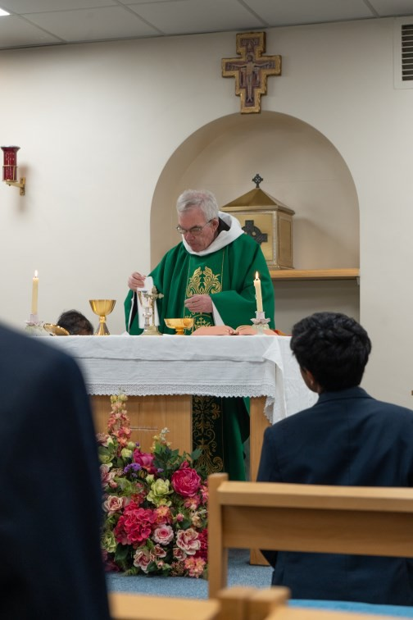By placing Christ at the centre of all that they are and all that they do, Cath- olic schools have the potential to promote the “fullness of Christian life” through an “…educational philosophy in which faith, culture and life are brought into harmony.”

This means that the Church provides Catholic schools to be more than just places where pupils are equipped with learning and skills for the workplace and responsible citizenship. Rather, they are to be the communities where the spiritual, cultural and personal worlds within which we live are harmo- nised to form the roots from which grow our values, motivation, aspirations and the moral imperatives that inform our choices and actions as persons.

It is with good reason therefore that Pope Benedict XVI described Catholic schools as “an essential resource for the new evangelization”.