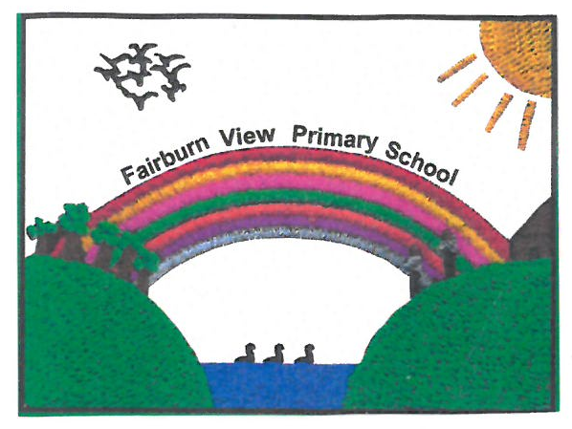 | Fairburn View Primary School  STANSFIELD DRIVE, AIREDALE, CASTLEFORD, WF10 3DB  Telephone: 01977 558 350  Head teacher: Alex Webb BA(Hons) PGCE (SEND) NPQH  admin@fairburnview.co.uk  www.fairburnview.co.uk
Thank you for your interest in the role of Deputy Headteacher at Fairburn View Primary School.

The school and Governing Body are delighted to introduce our school, and outline the exciting opportunities this role presents. Fairburn View is a warm, inclusive and ambitious primary school where children are at the heart of everything we do. We pride ourselves on creating a nurturing environment in which every pupil is supported to achieve their full potential - academically, socially and emotionally.

We are seeking to appoint an experienced, committed and skilled leader to join the Senior Leadership team at our school. The Deputy Headteacher will play a central role in strengthening the leadership, supporting staff development, and securing consistent high quality teaching and learning across the school. They will build strong links within the community, and work in partnership with pupils, families and the wider community to ensure that every child thrives, and has access to the education that they deserve.

At Fairburn View, we value collaboration, professional trust and continuous professional development. You will be joining a dedicated and supportive team who work closely together to drive school improvement, uphold high expectations, and ensure the wellbeing of both pupils and staff. We are committed to investing in leadership development and providing opportunities for you to grow within your role.

We encourage you to visit the school to experience our ethos first-hand and meet our pupils and staff.
If you share our commitment to excellence, inclusion and safeguarding, we would be delighted to receive your application.

We look forward to welcoming you to Fairburn View Primary School.

Yours sincerely,

Alex Webb Jonathon Foster
Headteacher Chair of Governors

School Context

Age Range | 2-11
Number on roll | 485
IDACI Score | 0.64 (112th out of 113 primary schools in Wakefield)
Pupil Premium | 46.3%
SEN Register (EHCPs) | 15.2% (3.9%)

2025 School Results

 |  | EYFS GLD |  | Phonics (Y1) |  | Phonics re-check (Y2) |  | MTC Average Score (Y4) |  | MTC Full Marks
School |  | 47% |  | 53% |  | 35% |  | 19.3 |  | 21%
National |  | 68% |  | 80% |  | 0% |  | 21.1 |  | -
KS2 |  |  | Achieved the Expected Standard |  |  | Achieved the Higher Standard |  |  | Average Scaled Score
KS2 |  |  | School |  | National | School | National |  | School |  | National
KS2 | Reading |  | 60% |  | 75% | 13% | 33% |  | 102 |  | 106
KS2 | Writing |  | 47% |  | 72% | 0% | 13%
KS2 | Maths |  | 55% |  | 74% | 8% | 26% |  | 100 |  | 105
KS2 | GPS |  | 47% |  | 73% | 5% | 30% |  | 100 |  | 105
KS2 | RWM Combined |  | 30% |  | 62% | 0% | 8%
Visits to school

We would welcome the opportunity to show you around our school, and meet our staff and pupils. Group visits have been arranged for the 20th May at 2pm, and the 2nd June at 9am. Please contact Alex Webb (Headteacher) by email (awebb@fairburnview.co.uk) to book a place on a visit, or to arrange a visit outside of these times if needed.

How To Apply

Please use the standard application form (CVs are not accepted), and complete the form fully, making full reference to the job description and person specification. Please ensure that you include all relevant training and qualifications that will support your application. If you require any further information about the school or role to support your application, please do not hesitate to get in touch.

Application Closing Date: Friday 5th June 2026
Shortlisting Date: Monday 8th June 2026

Interviews will consist of a lesson observation within your own school, followed by an invite to a formal interview at our school.

Observations: 10th June – 18th June 2026
Interviews: Friday 19th June 2026

Starting Date: January 2027

