Dear Applicant,

If you are reading this letter you will already know that St Bartholomew’s is looking for a new Deputy head teacher. On behalf of the Headteacher, Governing Body, children and families of the school, I would like to express our delight on your interest in this position.

If you were to join us, you would find a close-knit school with excellent children and dedicated staff, a supportive governing body and an active PTFA.

The school is conveniently situated in Great Harwood and is no more than 5 miles from the M65 providing excellent accessibility.

So, what can we offer you at St Bartholomew’s, apart from one of the longer website addresses? With strong links to the Parish Church and enthusiastic teaching and support staff you would be coming to join a leadership team and school passionate about education and learning. The governing body will work closely with you to ensure that we are delivering the best standard of education possible.

Our children are friendly, eager to learn and always represent/reflect the school in the best possible way.

For more information on the school including links to our inspection reports, policies and school life you can visit our website (but you knew that already).

Thank you again for your interest in our school, we look forward to receiving your application.

Yours sincerely

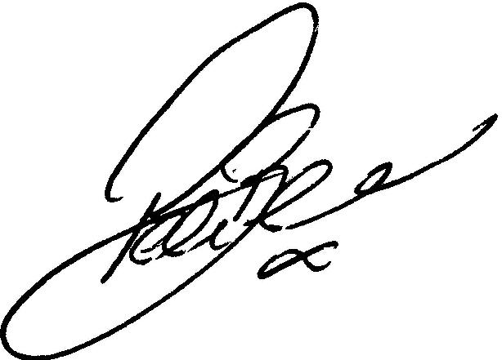

Peter Bell
Chair of Governors
