GEORGE MITCHELL SCHOOL

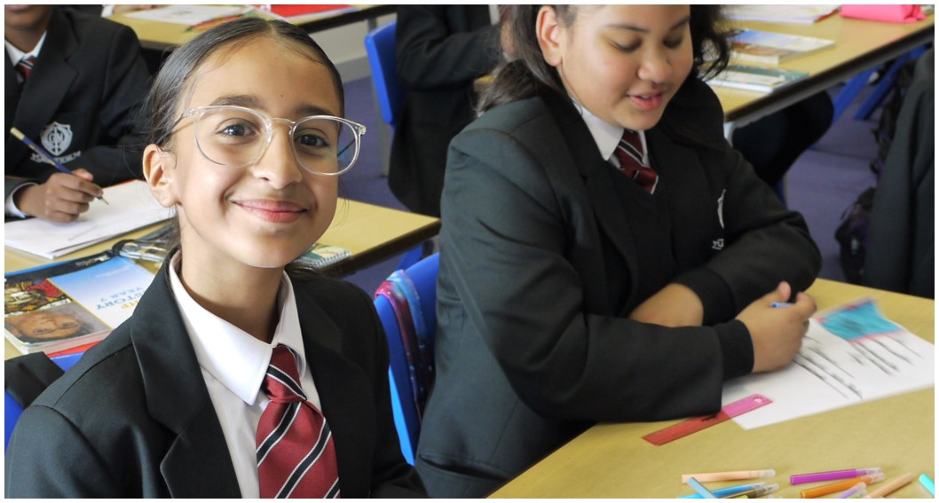

Deputy Headteacher
(Head of Primary Phase)
APPLICANT RECRUITMENT PACK
George Mitchell School
Farmer Road, Leyton, E10 5DN
www.georgemitchellschool.com

Dear Applicant,
I am delighted you have taken the time to look at the Deputy Head teacher (Head of Primary Phase) opportunity we have available, and are considering joining George Mitchell School. We are looking to appoint an outstanding leader who will join the Senior Leadership Team as Deputy Head teacher to lead the Primary phase of our all through school.
Whilst this post is a senior leadership position in the Primary phase, should you be successful in your application, you will be joining an all-through senior team with plenty of exciting opportunities for cross phase work. All senior leaders at George Mitchell School hold one or more responsibilities that are whole school.
This is an exciting opportunity to make a significant difference to the life chances of our students. George Mitchell School is a wonderful place to work. Our students are ambitious and hard-working, they embrace our high aspirations and the range of opportunities offered to them both during and beyond the school day. This is highlighted not only by our strong examination results but also by the maturity of the students, their sense of responsibility, community and fun. They are a delight to work with.

George Mitchell School is in an exciting period of development as we look to challenge ourselves to excel in all areas of the curriculum and provision. We are making every effort to become a beckon school not just by building on our own best practice but also by looking outward for innovation and advancement. We aspire to provide the very best educational opportunities and outcomes for all our students. We encourage our staff to develop their skills and proficiencies and have in place a strong professional development programme.

We offer an inclusive curriculum that caters for a comprehensive range of students in both phases. We are proud of the fact that our curriculum is both carefully tailored to the needs of our students, and also highly academic. We seek to nurture our children’s talents and abilities, and to help our young people become confident, mature and responsible members of society who are able to fulfil their ambitions.

Having joined the school, myself as Headteacher in September 22, the advertisement for this post comes at an exciting time for George Mitchell School. The successful candidates will build on the huge improvements that have already taken place.

Please explore our website or come and visit to find out more about our students, our team and the school. The job description and person specification give you an indication of the scale and ambition we have for this post. If you have the passion, commitment and resilience to make a significant difference in this role I would be delighted to receive your application.

We welcome visitors to the school. Please contact us if you would like to arrange a visit. Please complete our application form (found on our website) and write an accompanying letter that outlines your experience and achievements that equip you for this role and how you will make an impact in our school. Your letter must be no longer than two sides of A4 with a minimum font size of 11. Successful candidates will be notified of interview arrangements in due course.
I thank you for taking an interest in this position and I hope that having read more about the school you will decide to apply for the post. I look forward to receiving your application.

Kind regards,

Benita Simmons
Our Vision
“More is in Me”
George Mitchell School’s Mission Statement
Our motto ‘More is in Me’ applies to everyone in our school community. We expect and encourage students, staff and families to push beyond themselves to improve their skills so that our students are given the best learning opportunities in school and at home.
At George Mitchell School education is about:
- Providing children with meaningful qualifications and opportunities which enable them to be successful and achieve within school, in their lives and in their work after leaving us.
- Helping each child become a successful learner who is confident, happy and fulfilled. With a set of positive traits (PRIDE) which guides their conduct and supports them to become responsible citizens who can make a positive contribution to society.

We expect our students to develop:
- A thirst for learning and a desire to achieve their best at all times
- Respect for themselves and others
- The ability to make safe and informed choices about what they do
We aim to provide an aspirational and excellent academic environment that supports students to make sustained progress from Nursery to Year 11. In our school, learning comes first.
How is this achieved?
Our teaching is innovative and challenging. Students achieve most when they enjoy their learning so we encourage active participation in the classroom. Through high standards of teaching, thorough preparation and extracurricular revision, our dedicated staff help students to achieve their best in examinations.
George Mitchell School has a progressive and inclusive curriculum. In the Early Years, we focus on providing children with the best possible start to the beginning of their learning journey by engaging and deepening their understanding of the world around them. We aim to develop a love of reading and learning from an early age based on books, stories and quality texts and provide contextual learning and enrichment opportunities through external visitors and visits.

At Key Stage 1 and 2, our primary intention is to promote curiosity and a love of learning through enhancing our pupils’ strengths and exposing pupils to new experiences that give them new depths of knowledge. Pupils develop skills in Reading, Writing and Mathematics across all curriculum areas, supported by school trips that engage and underpin the learning done in classrooms.
The school is committed to maintaining a safe and positive environment that is conducive to learning. We foster an ethos that values perseverance, respect, independence, diversity and excellence – a robust system of rewards and sanctions supports this, and relationships between staff and students are excellent.
Exceptional pastoral care supports our students’ personal development, builds their self-esteem and underpins their progress. Where possible, Learning Leaders and Tutors remain with students throughout their school career, getting to know them really well and provide a clear point of contact for parents.

More about George Mitchell School
George Mitchell School is committed to providing an outstanding, all round education for every child.

The school has three phases; reception/early years, primary and secondary. We have just under 1100 pupils, of which 100 are in the EYFS, 400 are in primary and 600 are in secondary. We were oversubscribed in the secondary phase. Combined we have 62 teaching staff and 32 support staff.

George Mitchell School serves an ethnically diverse community and the majority of students are from minority ethnic backgrounds. The proportion of students who speak English as an additional language (EAL) is above average national and this is representative of the demographics of Waltham Forest.

The school is also committed to safeguarding and promoting the welfare of our children. We are also committed to Safer Recruitment practices and procedures. Shortlisted applicants will be questioned about their commitment to the safeguarding of young people and the successful candidate will be subject to an enhanced DBS clearance.

George Mitchell School is part of the Partnership Learning Multi-Academy Trust.

Ofsted
Ofsted praised the good leadership, teaching and the rapid improvements seen and we have set our sights on becoming an Outstanding school in the future. Our Ofsted report can be found at https://files.api.beta.ofsted.gov.uk/v1/file/2542288
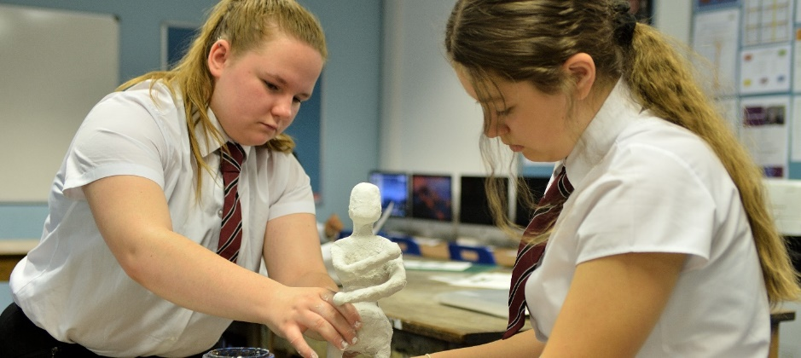

Wellbeing, Amenities and Facilities
Impact Fridays
The primary and secondary have recently introduced ‘Impact Fridays’ with a pacier day and an earlier finish for students, allowing everyone a pleasant start to the weekend. On Fridays, the school day finishes at 1.15pm in the primary and 1.30pm in the secondary.
Staff activities
There are a number of enjoyable activities that take place after school for those staff who wish to get involved – these include yoga, badminton and other sporting activities.
There are also a number of staff social events.
Free access to our employee support helpline
All staff and their families have access to our Employee Assistance Programme, which can offer confidential support on a range of issues including legal, financial, medical, consumer and counselling.
Travel and Transport
Local transport links are good through tube and bus networks. Leyton Midland Road Overground station is a 5 minute walk away. There is parking on both sites.
IT Support and Working Environment
IT support for staff is good. There is good provision and access to computers in school for staff to use. Staff can also access documents and drives with remote access facilities.
All curriculum areas have an office and storage space. Staff are mostly sited in curriculum or year specific classrooms.

How to Apply

Please read this application pack carefully. Below, you will find the person specification, which lists the key competencies that we are looking for. Please make sure that all sections of the application form are completed. Any applications received that are incomplete may not be accepted. Additional sheets may be used if there is insufficient space.

Personal Details

Make sure that your name, address and telephone numbers and email are legible.

Present and Past Employment

Starting with the most recent, list all the employers you have worked for and provide details of the job title and the period you worked for them. This information may be used to assess whether you meet the experience requirements for the post. Please list any break in employment, giving reasons.

References

You must give your present or most recent employer as one of your referees.

Education, Qualifications and Training

Starting with the most recent, in each section please list qualifications and training. You may continue on a separate sheet if necessary. This information may help assess whether you have a relevant qualification or meet some other requirement.

Supporting Statement

Please make sure you address the criteria outlined in the job description and the person specification when writing your personal supporting statement. We highly recommend that you visit our school before applying for the position. To arrange a visit, please contact the school office on 0208 539 6198.

Your completed application form is the only basis for considering your initial suitability for the post. No assumptions will be made about your experience or skills.

Disclosure of Criminal Record
George Mitchell School operates a strict pre-employment vetting process, which includes a Disclosures and Barring Service (DBS) check. Successful applicants seeking to work with children and/or young people are required to undergo an Enhanced DBS (Children and Adults) this will include a check against the barred list.

We look forward to receiving your application.

DEPUTY HEADTEACHER
JOB DESCRIPTION

Reporting to: Head teacher (All Through)
Line management of: Assistant Head teachers and other named members of staff
Contracted working time: 195 days per year – full time. Attendance at identified calendared events in school year
Salary/Grade: L20 – L24
Disclosure Level: Enhanced

Job Purpose:
The Deputy Head teacher is expected to deputise for and support the Head teacher with regard to internal organisation and management of the school, take a leading role in the coordination of the whole school and uphold, through personal example, the philosophy on which the school’s life is based ‘More is in me’ and its values.

The Deputy Head teacher will provide professional leadership for the school in the area determined in accordance with their experience and skillset agreed with the Head teacher, which secures success and continuous improvement in teaching and learning, ensures a high-quality education and school
experience for all learners. Staff are the major resource upon which the school’s continued success will be determined. The Deputy Headteacher will take a major role in supporting and developing all staff.

The Deputy Head teacher will take a leading role in achieving the school aims:
- Providing children with meaningful qualifications and opportunities which enable them to be successful and achieve within school, in their lives and in their work after leaving us.
- Helping each child become a successful learner who is confident, happy and fulfilled. With a set of positive traits (PRIDE) which guides their conduct and supports them to become responsible citizens who can make a positive contribution to society.

Main areas of responsibility:
- Deputising for the Head teacher
- Working with Assistant Head teachers to raise achievement across the whole school
- Providing clear strategic direction to further improve the quality of education at the school.
- Oversee assessment and report data
- Oversee the design of the curriculum, in light of current and proposed changes
The Deputy Head teacher will support the Head teacher:
- In continuing the development of the school’s vision
- In promoting the aims of the school through the implementation of the policies of the Directors and Governing Body.
- In developing an environment in which staff and pupils are able to achieve their full potential.
- In developing and implementing the School Development Plan & strategic targets; continually monitoring, reviewing and updating the plan/targets.
- In enabling staff to carry out their delegated roles and responsibilities.
- In leading on areas as agreed with the Head teacher, and highlighted in the SLT line management structure.
Leading and Managing:
The Deputy Head teacher will support the Head teacher:
- In taking an active role in the recruitment and selection of teaching and support staff.
- In encouraging and motivating all staff to contribute to improvements to the quality of education provided and the standards achieved.
- In taking an active role in the deployment and performance management of staff, encouraging initiative and teamwork and ensuring that they receive appropriate professional development.
- In creating and maintaining good working relationships with all members of the school community.
- In promoting the school’s ethos, through personal example, ensuring the highest standards are expected from all members of the school community.
- In ensuring that professional duties are fulfilled as specified in the School Teachers’ Pay and Conditions Document.
- In maintaining a duty of care regarding pupil, staff and visitors’ health, safety and welfare.
- In keeping abreast of new initiatives
Accountability:
The Deputy Head teacher will:
- Work closely with the Head teacher and Governing Body and Link Governors as appropriate.
- Undertake a teaching commitment, including cover if necessary.
- Develop and secure a positive working relationship with all stakeholders.
- Take an active role in the development and organisation of the whole school performance management process, monitoring staff to meet local and national requirements and support continual professional development for all staff.
- Be responsible for the areas agreed with the Head teacher, as outlined in the SLT line management structure.
It is recognised that a long and inclusive list can never of itself sum up the key role of the Deputy Head teacher. The Deputy Head teacher is a senior professional within the school. Their work and professionalism should provide leadership to other staff and sound guidance to all pupils. It must be recognised that there will be tasks which the Deputy Head teacher will be expected to undertake as part of the role of a senior manager. These may change in their content and complexity as the school develops in the future.
Teaching:
- To undertake an appropriate programme of teaching in accordance with the duties of a standard scale teacher.
Other Specific Duties:
- Be accountable to the Headteacher for all delegated pastoral and management tasks.
- Employees of the Trust must uphold Safeguarding Policies and Procedures
- To play a full part in the life of the school community, to support its distinctive ethos and policies and to encourage and ensure staff and pupils to follow this example.
- To continue personal professional development as agreed.
- To engage actively in the performance review process.
- To comply with the school’s Health and Safety policy and undertake risk assessments as appropriate.
- To work collaboratively with colleagues within the Trust schools to promote further school improvement.
- To undertake any other duty as specified by STPCD not mentioned in the above.
Whilst every effort has been made to explain the main duties and responsibilities of the post, each individual task undertaken may not be identified.
Employees will be expected to comply with any reasonable request from a manager to undertake work of a similar level that is not specified in this job description.
Employees are expected to be courteous to colleagues and provide a welcoming environment to visitors and telephone callers.
The school will endeavour to make any necessary reasonable adjustments to the job and the working environment to enable access to employment opportunities for disabled job applicants or continued employment for any employee who develops a disabling condition.
This job description is current at the date shown, but, in consultation with you, may be changed by the CEO/Headteacher/Governing Body to reflect or anticipate changes in the job commensurate with the grade and job title.
Whilst every effort has been made to explain the main duties and responsibilities of the post, each individual task undertaken may not be identified.
This job description is current at the date shown, but, in consultation with you, may be changed by the CEO/Headteacher/Governing Body to reflect or anticipate changes in the job commensurate with the grade and job title.
Our values:
The post holder will be expected to operate in line with our values which are:

Perseverance – Enjoy the Challenge
Respect – Be Kind, Be Safe
Independence – Think for Yourself
Diversity – Include Everybody
Excellence – Go above and Beyond

Safeguarding
We are committed to safeguarding and protecting the welfare of children and expect all staff and volunteers to share this commitment. A Disclosure and Barring Service Certificate will be required for all posts. This post will be subject to enhanced checks as part of our Prevent Duty.

Person Specification for Deputy Headteacher
A = application R = reference I = interview process
CRITERIA | ESSENTIAL | DESIRABLE | TESTED BY
Qualifications
Good honours degree |  |  | A
Qualified teacher status |  |  | A
Evidence of relevant continuing professional development eg. NPQH, Teacher leaders etc |  |  | A
Knowledge and Skills
At least 3 years’ experience at Senior Leadership Level in Primary Education |  |  | A, R
A clear working knowledge of how to lead curriculum development and manage innovation and change |  |  | A, R, I
A Secure understanding of whole school data and management systems to include SIMS and 4matrix |  |  | A, R, I
Experience in the use of data, tracking and target setting to raise attainment at individual student and cohort level and identify performance. |  |  | A, R, I
A track record in raising whole school academic standards across Key Stages |  |  | A, R, I
The ability to manage change effectively |  |  | A, R, I
Successful experience of coaching or mentoring trainees/NQTs |  |  | I
An effective communicator at all levels |  |  | A, I
A strategic thinker |  |  | R, I
The ability to generate a vision and influence others |  |  | R, I
A clear working knowledge and understanding of the current OFSTED framework |  |  | A, R, I
Teaching & Learning
The ability to devise and implement strategies for raising achievement and for intervention strategies |  |  | A, R
A clear understanding of different models of teaching and learning |  |  | A, R, I
An outstanding and effective classroom practitioner |  |  | A, R, I
Knowledge of how children learn, develop and progress through the stages |  |  | R, I
A clear understanding of assessment procedures |  |  | A, R
An ability to recognise and encourage outstanding practice |  |  | A, I
Developing self and working with others
Experience of delivering INSET |  |  | A, R
The ability to develop, empower and sustain teams and individuals |  |  | R, I
The ability to give and receive effective feedback and act to improve personal performance |  |  | R, I
Experience of making effective use of school to school support |  |  | A
Ability to motivate staff, students, parents, governors and other stakeholders |  |  | A
Managing the Organisation
An understanding of the principals of effective management, delegation and organisation |  |  | A, R, I
Experience of performance management |  |  | A, R
The ability to prioritise and manage time effectively |  |  | R, I
The ability to make decisions and act upon them |  |  | R, I
The ability to analyse data, develop strategic plans, set targets and monitor and evaluate progress |  |  | A
Experience of whole school budgets and financial management |  |  | A, I
Securing Accountability
The ability to use a range of data to support, monitor and improve aspects of school life |  |  | R, I
Experience of effective school evaluation |  |  | A, R
The ability to acknowledge excellence and challenge performance that is not yet good |  |  | R, I
Strengthening the Community
Experience of successful collaborative working with other organisations and agencies |  |  | A, R, I
The ability to work effectively with parents and carers to support their children’s learning |  |  | A, R, I
The ability to listen to, reflect and act on community feedback |  |  | A, R
Personal Qualities
Is fair compassionate and has a strong sense of social justice |  |  | R, I
Has a belief in the potential of all students |  |  | R, I
Stamina |  |  | R
Excellent interpersonal skills |  |  | R, I
High expectations and aspirations |  |  | R, I
Level headedness |  |  | R, I
A sense of humour |  |  | R, I
Motivation and drive |  |  | R, I

