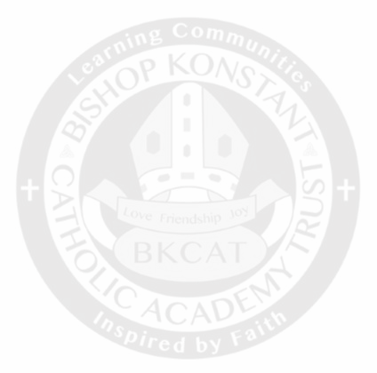
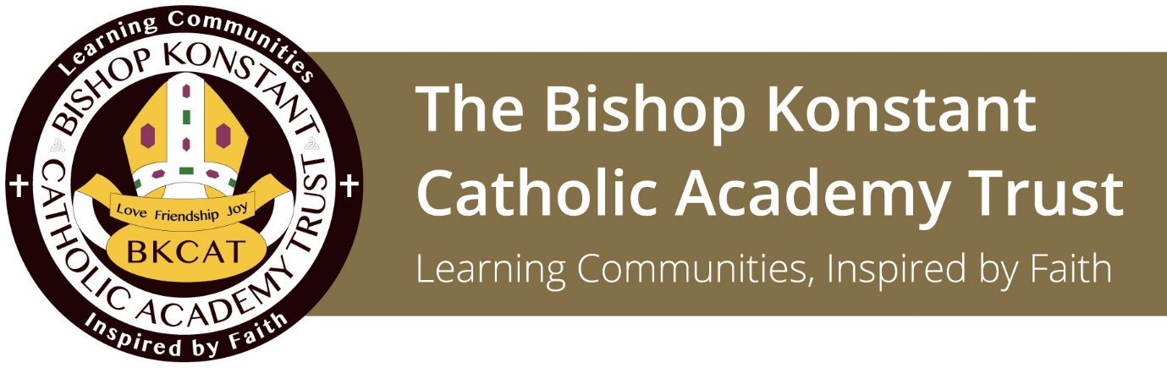

Deputy Headteacher
Holy Family St Michael Catholic Primary School
Recruitment Pack

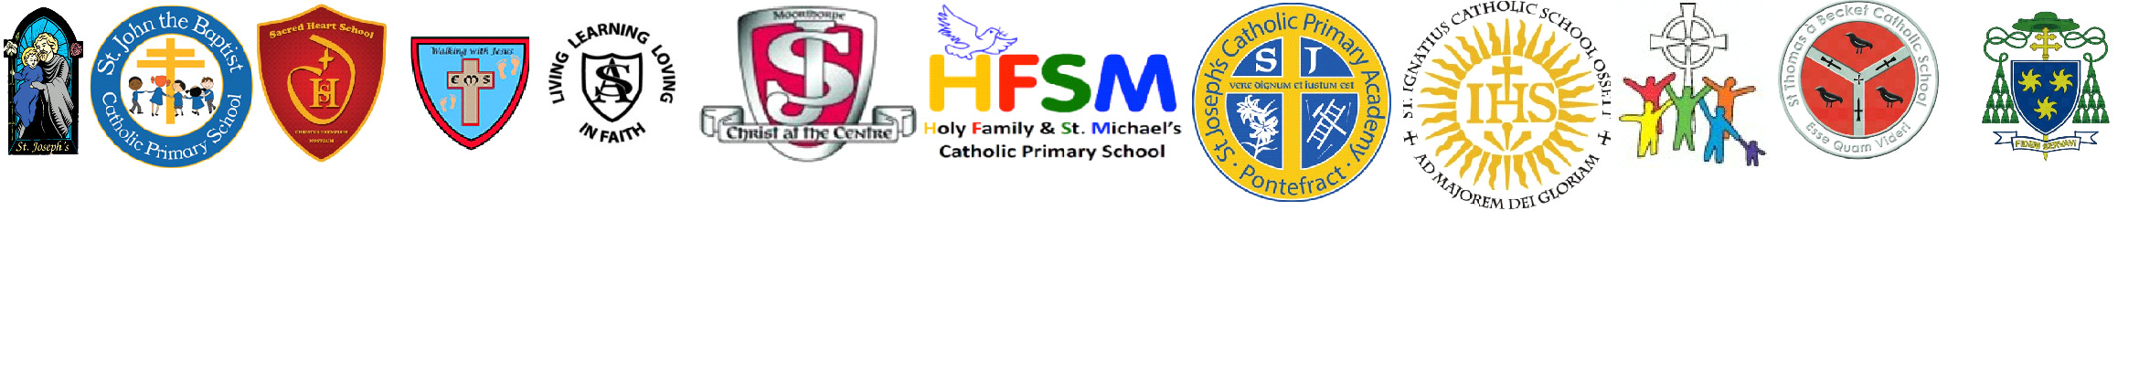
Cor ad Cor Loquitur: Heart Speaks unto Heart

‘I understood that the Church had a Heart and that this Heart was burning with Love. I understood that Love contains all vocations, that Love is everything, that it embraces all times, all places; in a word that Love is eternal.’ – St Therese of Lisieux

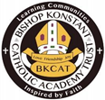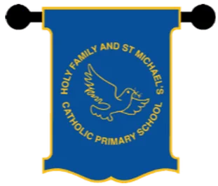

Candidate Recruitment Pack

Deputy Headteacher, Holy Family St Michael Catholic Primary School

Contents

- Welcome from the CEO

- Welcome from the Headteacher

- Mission and Principles of the BKCAT

- Advert

- Job Description

- Person Specification

- Definition of a Practising Catholic

Closing Date: Friday 25th April 2025 at 9am
Interview and Selection: W/C 5th May 2025
Start Date: September 2025

Dear Applicant,
We are delighted that you are interested in the position of Deputy Headteacher at Holy Family St Michael Catholic Primary School within the Bishop Konstant Catholic Academy Trust (BKCAT). The Trust is proud to bear the name of David Konstant, a former Bishop of Leeds who was a teacher before his priestly ordination and remained involved in education throughout his life as a priest and later as Bishop of this diocese.
The Bishop Konstant Catholic Academy Trust, part of the Diocese of Leeds, was formed in 2012. We are a Catholic multi-academy Trust comprising twelve primaries and three secondaries, in four local authorities (West Yorkshire, Leeds, North Yorkshire and the East Riding of Yorkshire).
The Bishop Konstant Catholic Academy Trust was formed to preserve, maintain, and develop Catholic education in the areas served by our schools. As a Trust we are committed to providing the highest quality of education for every child and young person we serve and want to ensure that every child and young person benefits from the Trust.
We have a vision for our Trust that goes beyond our individual schools and that changes our perception from my school to our family of schools. Working collaboratively, each school benefits from others’ strengths and expertise within the Trust and practically from the services provided and procured centrally. The Bishop Konstant Catholic Academy Trust is a dynamic entity, which responds to the needs of each of our parish communities, whilst upholding Catholic principles. As a Catholic multi-academy Trust, we have a wonderful opportunity to shape the future of Catholic education and have a positive impact on the lives of around 5000 children who attend our schools.
Our schools are supported by a Trust Central Team which operates under the leadership of the CEO. The team provides core business functions to ensure that the Trust complies with its statutory responsibilities and supports the operations and educational performance of our schools. The team works with staff and Governors in schools to ensure that the required outcomes and priorities of the Trust are achieved in accordance with the Trust’s Mission and Strategic Plan as agreed by the Trust Board.
If successful, you will find a Trust with a strong sense of solidarity and collaboration among our school leaders and communities.
We look forward to receiving your application.
Yours sincerely,
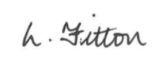

Lesley Fitton
CEO

A welcome from the Headteacher
Thank you for your interest in the role of Deputy Headteacher at Holy Family and St Michael’s Catholic Primary School. I am delighted that you are considering joining our school community.

As a Catholic school, we seek to live out the values of Jesus Christ, we promote these values by our words and deeds and recognising that every child is unique and is created in the image and likeness of God. Through our Mission statement, ‘We are building Confidence, Compassion & Courage through the teachings of Jesus Christ’ we are dedicated to ensuing that as a school community we uphold these values every day. Our school is supported by the parish of St Joseph’s, which includes the church of St Joseph’s Pontefract and the church of St Michael’s, Knottingley. Our parish priest is Canon Tim Wiley.

Holy Family and St Michael’s is a one form entry primary school. There is a dedicated team of experienced staff and together our aim is for each child to thrive within our catholic school community and to fulfil their potential in every way possible. We believe that every child can succeed.
As part of a highly collaborative and supportive Trust, we benefit from strong partnerships that enrich our provision and professional development opportunities. Our next Deputy Headteacher will play a pivotal role in shaping the future of our school, leading with vision, integrity and a deep commitment to our Catholic ethos.

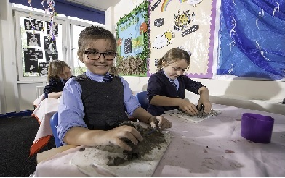

This role presents a fantastic opportunity for an ambitious and passionate leader who is eager to support me, as Executive Headteacher, and to make a lasting impact on the lives of our children and the community we serve.

If you believe you have the skills, experience, and values to contribute and further enhance our provision, we would love to hear from you.
I encourage you to visit us to experience first-hand the warmth of our school community and learn more about the role. To arrange a visit and tour of the school, please contact our Senior Administrator, Mrs Kerry Murphy on 01977 798303 or kmurphy@hfsm.bkcat.uk

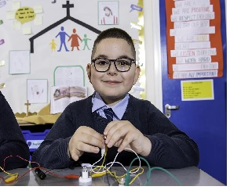

I look forward to welcoming you to our school.
Claire Cade
Executive Headteacher

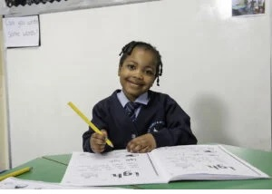


Mission and Principles

Cor ad Cor Loquitur: Heart Speaks unto Heart
‘I understood that the Church had a Heart and that this Heart was burning with Love. I understood that Love contains all vocations, that Love is everything, that it embraces all times, all places; in a word that Love is eternal.’ – St Therese of Lisieux

With Jesus Christ at the centre of the life of the Trust, we seek to provide learning communities offering the highest possible standards of education. We are committed to working in partnership and trust for the common good. We strive to encourage and empower children and young people to recognise and realise their God-given potential and to discern their vocation in life. As learning communities inspired by faith, we celebrate achievement, offering each other challenge and support, as together we follow Christ in self-giving love and service.

We have a vision for Catholic education that goes beyond individual schools and changes our perception from ‘my’ school, to ‘our’ schools. The challenge for us all is: how can we share our gifts and talents to ensure the education for all of our children is outstanding.

As a Trust Board we aim to provide challenge and support to the Headteachers of our Academies within the constantly shifting demands of educational theory and practice. We aim to share resources and skills for the benefit of all our Academies as each Academy continues on its journey to provide outstanding Catholic education for all its pupils.

THE SIX PRINCIPLES ON WHICH THE BISHOP KONSTANT CATHOLIC TRUST IS FOUNDED:

1. JESUS CHRIST AT THE CENTRE
2. THE DIGNITY OF EACH HUMAN MADE IN THE IMAGE OF GOD
3. EDUCATION AND VOCATION
4. SOLIDARITY & LIFE TOGETHER WITH CHRIST
5. SERVICE & SUMMONS TO LOVE
6. SUBSIDIARITY & THE LITTLE WAY

Education is not and must never be considered as purely utilitarian. It is about forming the human person, equipping him or her to live life to the full – in short it is about imparting wisdom. And true wisdom is inseparable from knowledge of the Creator.’
(Pope Benedict XVI, address to teachers and religious, Twickenham, 2010)

Post title | Deputy Headteacher
Location | Holy Family St Michael Catholic Primary School, Cobblers Lane, Pontefract, WF8 2HN
Salary & Grade | Leadership 5 - 9  (£54,939 - £60,664)
Hours | Full Time  Permanent

The Academy Council at Holy Family St Michael Catholic Primary School are excited to appoint a dedicated and visionary Deputy Headteacher to our thriving Catholic community and play a pivotal role in shaping the future of our school.

Collaborating closely with the Executive Headteacher and the wider staff team to provide exceptional education, you will motivate both staff and children, advocating for excellence, fostering improvement, cultivating a supportive atmosphere, and upholding our Catholic values. As an experienced Catholic leader with a strong background of effective senior leadership, it is essential you have experience in successfully leading teaching and learning within a primary school, along with the ability to encourage spiritual and emotional development.
This pivotal role encompasses responsibility as the RE curriculum lead alongside dedicated management time, enabling the successful candidate to focus on significant leadership duties while sustaining a weekly teaching commitment.

Our Catholic education and values are integral to every facet of school life and the curriculum. In our nurturing family environment, children thrive academically, spiritually, and socially. At Holy Family and St Michael’s, we are committed to creating a safe space that fosters the spiritual, emotional, and academic development of our students, empowering them to become joyful, productive, and successful members of society. The gospel values of love, respect, honesty, justice, forgiveness, and community are at the heart of our school’s mission and inform all our actions. Our school is a vibrant place where children demonstrate positive behaviour, and staff receive the necessary support to excel.

The Bishop Konstant Catholic Academy Trust comprises of three Secondary Schools and twelve Primary Schools. We have a vision for our Trust that goes beyond our individual academies and that changes our perception from my academy to our academy. Working collaboratively, each academy benefits from others’ strengths and expertise within the Trust, and practically from the services provided and procured centrally.

Our Deputy Headteacher will:
- Be a practising Catholic with a strong faith commitment and clear vision for Catholic education
- Have the ability to lead, motivate and inspire our children on their faith journey
- Have successful proven experience as a Senior Leader
- Be an outstanding classroom practitioner and have a clear commitment to raising standards through leadership and support for other staff
- Work in close partnership with the Executive Head Teacher to further the shared vision of the school
- Have a passion to ensure that every child succeeds and is treated as an individual
- Take a lead on developing the quality of education in school by supporting all staff to deliver a progressive and cohesive knowledge rich curriculum that is ambitious for all our children

In return, we can offer:
- An excellent pension scheme
- A health and wellbeing package
- A warm and caring environment which is inspired by our strong Catholic ethos with close links to our local parish
- A supportive and forward thinking staff team and Academy Council
- A commitment to your induction, professional development and opportunities to work with other colleagues across the BKCAT
- Opportunities to meet regularly with other leaders across the Diocese of Leeds including attending retreats
- Access to colleagues in the central team for professional support and advice
Candidates are most welcome and encouraged to arrange a visit to the school by appointment. Please contact Kerry Murphy, Senior Administrator for further information and to arrange a visit by emailing kmurphy@hfsm.bkcat.uk or call 01977 798 303.
We will look forward to receiving your application. Please feel free to visit the Holy Family St Michael website and the Trust website listed below for any further reading about our school/Trust.
Holy Family St Michael website- BKCAT - Holy Family And St Michael's Catholic Primary School
The BKCAT website- https://www.bkcat.co.uk/vacancies/

Closing Date: Friday 25th April 2025 at 9am
Interview and Selection: W/C 5th May 2025
Start Date: September 2025
To apply for this position, please download and complete the application form attached to this advert and return by the closing date above to hradvice@bkcat.uk

The Bishop Konstant Catholic Academy Trust is wholly committed to ensuring children and young people are fully supported and safe. We are dedicated to the safeguarding of all children and young people whilst promoting their welfare and expect all staff and volunteers to share this responsibility. The post is subject to an enhanced DBS with barred list check and other appropriate checks including references. In line with Keeping Children Safe in Education Guidance (2024), online searches will be carried out on shortlisted candidates. This post is covered by the Rehabilitation of Offenders Act 1974 (Exceptions) Order 1975. Prior to interview, all shortlisted candidates will be required to complete a form for self-disclosure of their unprotected criminal record or information that would make them unsuitable to work with children.

Job Description – Deputy Headteacher
Holy Family St Michael Catholic Primary School

Section 1: Ethics and professional conduct

Catholic Deputy Headteachers are expected to demonstrate consistently high standards of principled and professional conduct inspired by Christ and His beatitudes and exemplified by the self-cultivation of virtues, those qualities of character fundamental to the Catholic tradition: faith, hope, love, justice, solidarity, temperance, fortitude and practical wisdom. Catholic Deputy Headteachers are expected to meet the teachers’ standards and be responsible for providing the conditions in which teachers can fulfil them.
In addition, Catholic Deputy Headteachers uphold and demonstrate the Seven Principles of Public Life at all times. Known as the Nolan principles, these form the basis of the ethical standards expected of public office holders:
- selflessness
- integrity
- objectivity
- accountability
- openness
- honesty
- leadership

Catholic Deputy Headteachers are custodians of diocesan schools and as such embody the abundant hope the Church has placed in education. Catholic Deputy Headteachers are entrusted with the task of human formation in conformity with Christ and Church teaching, and so uphold ecclesial and public trust in school leadership and maintain high standards of ethics and behaviour. Both within and outside school, Catholic Deputy Headteachers:
- build relationships of mutual respect rooted in the belief that all are made in the image and likeness of God and at all times observe proper boundaries appropriate to their professional position
- show tolerance of and respect for the rights of others, recognising differences and respecting cultural diversity within contemporary Britain enabling each person to play their full part in building and sustaining the Common Good.
- uphold fundamental British values, including democracy, the rule of law, individual liberty and mutual respect, and tolerance of those with different faiths and beliefs understanding that such values are rooted in the Catholic understanding of dialogue and the Church’s Social Teaching.
- ensure that personal beliefs are not expressed in ways which exploit their position, pupils’ vulnerability or might lead pupils to break the law, but are always orientated to the service of others in light of the Gospel.
As leaders within a Catholic school community and profession, Deputy Headteachers:
- serve in the best interests of the school’s pupils
- conduct themselves in a manner compatible with their influential position in church and society by behaving ethically, fulfilling their professional responsibilities and modelling the virtues of a good citizen of the Kingdom of God.
- uphold their obligation to give account and accept responsibility
- know, understand, and act within the statutory frameworks which set out their professional duties and responsibilities
- take responsibility for their own continued professional development, engaging critically with educational research to further the Church’s mission in education
- make a positive contribution to the wider education system within and without the Catholic sector
Section 2: Deputy Headteachers’ standards
1. School culture
Deputy Headteachers assist in:
- establishing and sustaining a Christ centred vision embodied in the school’s Catholic mission, ethos and strategic direction in partnership with the parish and Trust, those responsible for governance and through consultation with the school community and diocese
- creating a Christ inspired culture where pupils experience a positive and enriching school life enabling them to flourish
- upholding ambitious educational standards which reflect the distinctive characteristics of Catholic education and which prepare pupils from all backgrounds for their next phase of education and life
- promoting positive and respectful relationships across the school community and a safe, orderly and inclusive environment which recognises an individual’s dignity as made in the image and likeness of God
- ensuring a culture of high staff professionalism rooted in mutual respect, subsidiarity and the pursuit of excellence

2. Teaching
Deputy Headteachers assist in:
- establishing and sustaining high-quality, expert teaching across all subjects and phases, built on an evidence-informed understanding of effective teaching and how pupils learn
- ensuring teaching is underpinned by high levels of subject expertise and approaches which respect the distinct nature of subject disciplines or specialist domains, and demonstrate how each discipline and domain contributes to the Christian vision of human flourishing to live life to the full.
- ensuring effective use is made of formative assessment

3. Curriculum and assessment
Deputy Headteachers assist in:

- ensuring a broad, structured and coherent curriculum entitlement rooted in the distinctive characteristics of Catholic education which sets out the knowledge, skills, values and virtues that will be taught
- establishing effective curricular leadership, developing subject leaders with high levels of relevant expertise with access to professional and diocesan networks and communities
- ensuring that all pupils are taught to read through the provision of evidence-informed approaches to reading, particularly the use of systematic synthetic phonics in schools that teach early reading
- ensuring valid, reliable and proportionate approaches are used when assessing pupils’ knowledge and understanding of the curriculum

4. Behaviour
Deputy Headteachers assist in:
- establishing and sustaining high expectations of behaviour for all pupils, rooted in love, justice and reconciliation and built upon relationships, rules and routines, which are understood clearly by all staff and pupils
- ensuring high standards of pupil behaviour through the promotion of the virtues and courteous conduct in accordance with the school’s behaviour policy
- implementing consistent, fair and respectful approaches to managing behaviour
- ensuring that adults within the school lead by example and model and teach the virtues characteristic of a good citizen

5. Additional and special educational needs and disabilities
Deputy Headteachers assist in:
- ensuring the school holds ambitious expectations for all pupils with additional and special educational needs and disabilities in light of the principles of Catholic Social teaching
- establishing and sustaining ethos, culture and practices rooted in the distinctive characteristics of Catholic education that enable pupils to access the curriculum and learn effectively
- ensuring the school works effectively in partnership with parents, carers, parish and professionals, to identify the additional needs and special educational needs and disabilities of pupils, providing support and adaptation where appropriate
- ensuring the school fulfils its statutory duties with regard to the SEND code of practice

6. Professional development
Deputy Headteachers assist in:
- ensuring staff have access to high-quality, sustained professional development opportunities in all key and distinctive aspects, aligned to balance the priorities of whole-school improvement, team and individual needs
- prioritising the professional development of staff, ensuring effective planning, delivery and evaluation which is consistent with the approaches laid out in the standard for teachers’ professional development
- ensuring that professional development opportunities draw on expert provision from beyond the school, as well as within it, including diocesan and nationally recognised career and professional frameworks and programmes to build capacity and support succession planning

7. Organisational management
Deputy Headteachers assist in:
- ensuring the protection and safety of pupils and staff through effective approaches to safeguarding, as part of the duty of care
- prioritising and allocating financial resources appropriately, ensuring efficiency, effectiveness and probity in the use of public funds reflecting the school’s Catholic mission
- ensuring staff are deployed and managed well with due attention paid to workload
- establishing and overseeing systems, processes and policies that enable the school to operate effectively and efficiently and that are rooted in a clear understanding of the Church’s mission in education
- ensuring rigorous approaches to identifying, managing and mitigating risk

8. Continuous school improvement
Deputy Headteachers assist in:
- making use of effective and proportional processes of evaluation to identify and analyse complex or persistent problems and barriers which limit school effectiveness, and identify priority areas for improvement
- developing appropriate evidence-informed strategies for improvement as part of well-targeted plans which are realistic, timely, appropriately sequenced and suited to the school’s Catholic context
- ensuring careful and effective implementation of improvement strategies, which lead to sustained school improvement over time

9. Working in partnership
Deputy Headteachers assist in:
- forging constructive relationships beyond the school, working in partnership with parents, carers, the Parish, Trust, diocese and the local community
- committing their school to work successfully with other Catholic schools and other schools and organisations in a climate of mutual challenge and support
- establishing and maintaining working relationships with fellow professionals and colleagues across other public services to improve educational outcomes for all pupils

10. Governance and accountability
Deputy Headteachers assist in:
- understanding and welcoming the role of effective governance, rooted in strategic stewardship of the Catholic mission in education, upholding their obligation to give account and accept responsibility
- establishing and sustaining a professional working relationship with those responsible for governance which is inspired by a Christ centred vision of human formation
- ensuring that staff know and understand their professional responsibilities and are held to account
- ensuring the school effectively and efficiently operates within the required regulatory frameworks and meets all statutory duties

Based on the 2020 DfE Headteachers’ Standards published to articulate the additional responsibilities of headship in addition to the requirements of the teachers’ standards but reflecting the ethos of the Catholic school and the vocational role of a Catholic headteacher in upholding the mission of the Church.

JOB SPECIFICATION – DEPUTY HEADTEACHER
Please note source of evidence of fulfilled criteria:

Application Form - A | References – R
Supporting Statement – S | Interview - I

- QUALITIES AND KNOWLEDGE | Essential or  Desirable | Evidence
Practicing Catholic* | E | A, S, R
Qualified Teaching Status | E | A
Degree (or equivalent) | E | A
NPQH or similar | D | A
CCRS (Catholic Certificate in Religious Studies) | D | A
Recent Senior Leadership experience in a Catholic primary school | D | S, I
Lead by example and be a positive role model with excellent communication skills | E | S, I
Ability to articulate a clear vision and purpose within the mission of a Catholic school | E | S, I
Personal impact and presence | E | S, I
Participation in a Parish Community | D | S, I, R
Ability to lead the spiritual development of staff and pupils | E | S, I
Understanding of current educational provision and the wider school systems | E | S, I
Political and financial awareness | D | S, I
- PUPILS AND STAFF | Essential or  Desirable | Evidence
Have ambitious standards and high expectations for all pupil’s | E | S, I
Excellent understanding of high quality teaching and learning | E | S, I
Promote the development of the whole child | E | S, I
Use data analysis to effectively drive whole school improvement | E | S, I
Encourage all staff to develop their unique potential | E | S, I
- SYSTEMS AND PROCESS | Essential or  Desirable | Evidence
Efficient strategic leadership and prudent financial planning | D | S, I
Ensure the safety of all staff and pupils at all times | E | S, I
Promote excellent behaviour and positive attitudes to school life including attendance | E | S, I
Systems for performance management to hold staff to account | E | S, I
Ability to challenge under –performance | E | S, I
Understanding of strong governance to hold the school to account | E | S, I
Ensure budgets and resources are deployed in the best interests of pupils | D | S, I
Promote distributed leadership throughout the organisation | D | S, I
- SELF IMPROVING SCHOOL | Essential or  Desirable | Evidence
Knowledge and experience of working with other schools and organisations | D | S, I
Effective partnerships with a range of professionals | D | S, I
Use well evidenced research to achieve excellence | D | S, I
Provide high quality opportunities for staff development | D | S, I
Confident, entrepreneurial, and innovative approach to school improvement | D | S, I
Source of inspiration and encouragement for all in the school community. | E | S, I
Collaborate and communicate with a wide range of audiences including parents, pupils, colleagues, governors, Diocese, Local Authority and other schools, academies and colleges | E | S, I
5. APPLICATION FORM AND LETTER | Essential or Desirable | Evidence
Application form to be completed in full and legible | E | A
Supporting statement to be clear, concise and related to the specific post and appointment criteria | E | S
6. CONFIDENTIAL REFERENCES AND REPORTS | Essential or Desirable | Evidence
A positive and supportive written faith reference from a priest where the applicant regularly worships. | E | R
A positive recommendation from current employer or Headteacher | E | R
A second professional reference | E | R

PLEASE NOTE:
What is the objective definition of a ‘practising Catholic’ for appointments to key posts in Catholic Schools?

To objectively define what a ‘practising Catholic’ is when assessing applicants for membership of the governing authority of a Catholic school or to key posts within the school, it is necessary to understand that there are general obligations as well as essential components that constitute ‘practice’ of the faith in the teaching of the Catholic Church.

The Church’s general obligations for its members require that they strive to live lives of holiness proclaimed in by being faithful to the teaching of the Gospel, by trying to uphold the values the Beatitudes, by assisting in the Church’s mission to make Christ known to all peoples, by upholding privately and publicly the Church’s moral and social teaching, by endeavouring to follow an informed conscience and by making every effort to keep the precepts of the Church. This is the ‘practice’ of the Catholic faith in its widest and all-encompassing sense. At the heart of these general obligations though, there are essential components for “full communion” with the Catholic Church. These are sacramental initiation (Baptism,Confirmation and the Eucharist) and the bonds of profession of faith, the sacraments and ecclesiastical governance. The preservation of this full communion is not limited to purely religious activity but is to be an integral part of the whole pattern of behaviour of a member of the Church. It is what essentially constitutes being a committed and ‘practising Catholic’.

Therefore, for appointment as a member of the governing authority of a Catholic school or to key posts within the school, a ‘practising Catholic’ is to be defined as someone who has been sacramentally initiated into the Catholic Church and who adheres to those substantive life choices which do not impair them from receiving the sacraments of the Church and which will not be in any way detrimental or prejudicial to the religious ethos and character of the school. Inspired by the Gospel and sustained by God’s grace, a ‘practising Catholic’ will give sincere external expression to their interior faith through specific religious, moral and ethical behaviour which is in accordance with the teaching of Christ and the Catholic Church

For further information including examples of where there may be a reason why somebody is not in a position to take up a key responsibility in a Catholic school, please see ‘Christ at the Centre’ by Mgr Marcus Stock, CTS Publications ISBN 978-1-86082-843-0.

The Gospel of Matthew 5:3-12
The Book of Genesis 1:26-27
Dialogue and Proclamation, (1991) Pontifical Council for Inter-Religious Dialogue, Vatican.
Compendium of the Social Doctrine of the Church, 2004, Vatican.
The distinctive characteristics of Catholic education are 1. The search for excellence, 2. The uniqueness of the individual, 3. The education of the whole person, 4. The education of all and 5. Moral principles
The Gospel of John 10:10
The relevant principles being: the Dignity of the Human Person, the Call to Community and Participation, Rights and Responsibilities, the Preferential Option for the Poor and Solidarity.
Code of Canon Law, Can.210.
Code of Canon Law, Can.217.
Christ at the Centre, Section A5, Diocesan Schools Commission, Archdiocese of Birmingham, 2005, p. 8.
Catechism of the Catholic Church, n.1725-1729.
Catechism of the Catholic Church, n.871-873; Code of Canon Law, Can.211.
Code of Canon Law, Can.225 §2 and Can.227.
Code of Canon Law, Can.222 §2.
Catechism of the Catholic Church, n.1783-1785.
These are: attendance at Mass on Sundays and Holy Days of Obligation; reception of the Sacrament of Reconciliation at least once a year; reception of Holy Communion at least once a year during the Easter season; observing faithfully the prescribed days of fasting and abstinence; providing for the material needs of the Church, each according to their ability. Cf. Catechism of the Catholic Church, n.2041-2043.
Code of Canon Law, Can.205.
For someone validly baptised in a non-Catholic Church or ecclesial communion, this would require their subsequent Canonical Reception into the Catholic Church. Baptism, Confirmation and Canonical Reception can all be objectively verified through the production of a relevant certificate issued by the ecclesiastical authority where the sacraments or reception were conferred. Although, there is no canonical requirement for a register of First Holy Communion to be produced, parish priests can usually provide a reference of regular attendance at Mass for someone claiming to be a practising Catholic.
Code of Canon Law, Can.209 §1.

