Hope School, 251 Hartsbourne Avenue, Liverpool, L25 2RY

Telephone: 0151 363 3130 – Email: ao@hope-school.co.uk www.hopeschool-liverpool.co.uk

DEPUTY HEADTEACHER Pay range: L8 – L15

Hope School are looking to recruit a new Deputy Headteacher following the successful promotion of the previous post holder. This is a tremendous opportunity for either an existing Deputy Headteacher or a highly experienced senior leader with a proven record in school improvement and strong leadership skills, to JOIN this ‘outstanding’ school.

Hope is a modern purpose-built school with excellent facilities and has a committed staff team of 30. It is a friendly, warm, and welcoming school and is a Local Authority maintained special school for 68 children aged 5 to 11 years who have an Educational Health Care Plan due to their Social, Emotional, and Mental Health needs.
Crucially the school has adopted attachment and trauma-informed practices (ATP) as the basis for working with its pupils. Furthermore, the school operates a non-exclusion policy and since the school opened in 2002, no child has been excluded from the school. The school has built a formidable reputation and is recognised as being a Centre of Excellence both locally and nationally winning multiple awards for the work it does.

This is an exciting opportunity for a passionate and resilient leader, enthused to work collaboratively with the Board of Governors and has good strategic and management skills. It is also essential candidates have an awareness and support the use of ATP and have the ability to further build and develop the school's strong foundations and reputation for educational and psychological innovation.

We would welcome applications from proven leaders, who have a is commit to learn and use ATP, who will be able to demonstrate excellent leadership, management and communication skills.

For more information about Hope School and to look at our strategic overview and supporting information, please visit our website at: www.hopeschool-liverpool.co.uk

Welcome from our Headteacher

I am delighted to welcome you to Hope School, a place where every child is valued and supported for in their learning journey.

At Hope School, we specialise in working with children with Social, Emotional, and Mental Health (SEMH) needs. Our dedicated staff are trained to provide a safe and nurturing environment for all students, helping them to thrive academically and emotionally. We understand the unique challenges faced by children with SEMH needs and are committed to providing tailored support to meet their individual needs.

Our approach at Hope School is rooted in building positive relationships with our students and families and fostering a sense of community within the school. We believe that by creating strong connections with each child, we can create a supportive and empowering environment for their growth and development.

Additionally, we are proud to incorporate trauma-informed practices into our work at Hope School. We recognise the impact of trauma on children's lives and aim to create a school environment that is sensitive to their experiences. By promoting healing and resilience, we help our students to overcome challenges and reach their full potential.

We are an outward looking school and work across the authority with the HEARTs program, supporting schools and enhanced provision and providing outreach. We are also the first ARC learning hub.

As the Headteacher I welcome colleagues who are solution focused, positive and think creatively. I work collaboratively and want staff to be the best version of themselves.

Warm regards,
Mrs Maxine O’Neill

Welcome from our Chair of Governors
Dear Prospective Candidate,
On behalf of the Board of Governors, it is my pleasure to extend a warm welcome to you as you consider joining Hope School, a specialist provision dedicated to serving pupils with Social, Emotional, and Mental Health (SEMH) needs. As the Chair of Governors, I am honoured to introduce you to our vibrant and compassionate school community.
At Hope School, we are committed to providing exceptional education and support to our students, ensuring they have every opportunity to thrive and succeed despite the challenges they may face. As such, we are dedicated to recruiting individuals with the right skills, expertise, and most importantly, the passion and dedication to make a meaningful difference in the lives of our students.
As you explore this job application pack, I encourage you to reflect on how your skills and experiences align with our mission and values. We are seeking candidates who possess not only the necessary qualifications and expertise but also a genuine empathy and understanding of the unique needs of our students.
Hope School is more than just a place of learning; it is a community where every member is valued, supported, and empowered to reach their full potential. We believe in fostering a culture of collaboration, innovation, and continuous improvement, and we are excited about the opportunity to welcome new members to our team who share in this vision.
Thank you for considering joining the Hope School family. I look forward to the possibility of working together to make a positive impact on the lives of our students and the broader community.
Warm regards,
David Blythe

Hope School, 251 Hartsbourne Avenue, Liverpool, L25 2RY
Telephone: 0151 363 3130 – Email: ao@hope-school.co.uk www.hopeschool-liverpool.co.uk

STRATEGIC OVERVIEW OF HOPE SCHOOL

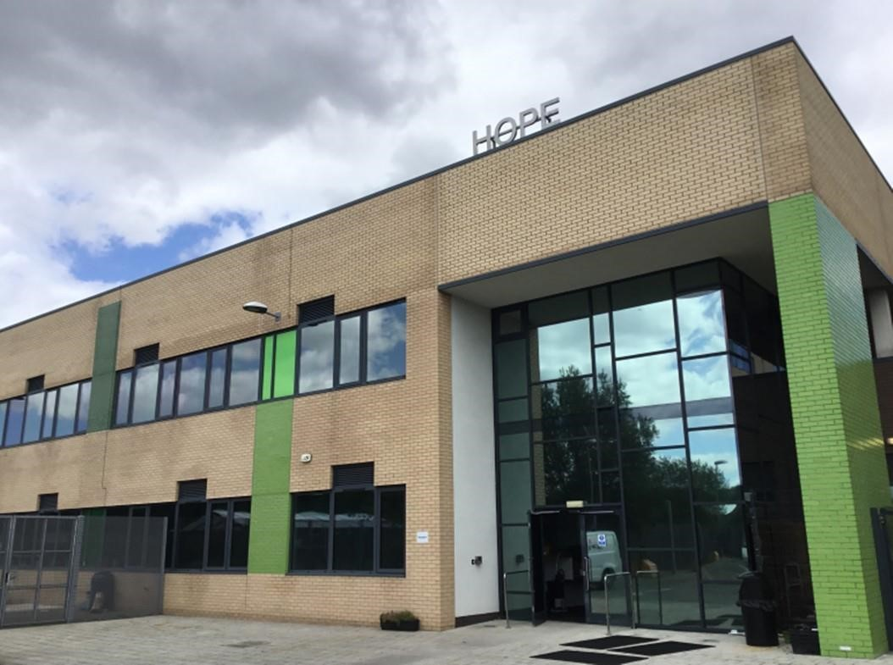
(The main entrance to Hope School)

STRATEGIC OVERVIEW OF HOPE SCHOOL

CONTENTS

- Purpose
- Introduction
- School Curriculum
- Outdoor Learning
- Performing Arts
- Therapies
- Benchmarking/External Standards
- Family Support Programme
- Pupil Voice
- Management & Staff Team
- Governance
- Summary

1.0 PURPOSE:

The key aim of this document is to provide a succinct strategic overview of Hope School, including a general understanding of the school curriculum, coupled with the support mechanisms in place that aid its pupils’ learning and development as an attachment and trauma informed therapeutic learning community.

The overarching strategic drivers are the school’s mission statement, vision, motto and core values. These are as follows:

SCHOOL VISION
Resilient, Independent Life-long Learners.

MISSION STATEMENT
At Hope School, we provide an attachment-friendly community that fosters warmth with high boundaries so that all can achieve their full potential.

SCHOOL MOTTO
If I try I can

CORE VALUES

- Gratitude – Is created by respecting all, being thankful, and helping others. We are charitable to all, locally, nationally and globally
- Resilience – Is created by trying new things and persevering when we find it difficult. We support each other in finding solutions
- Optimism – Is created by embracing change in a positive way. We encourage each other to approach everyday challenges in an enthusiastic and confident way
- Wisdom – Is created by demonstrating knowledge, understanding and reflection. We share our experiences and insight with each other
- Teamwork – Is created by respecting and working together to learn and achieve. We strive to be positive role models for each other
- Harmony – Is created by resolving any differences in a respectful, restorative way. We respect and celebrate diversity.

2.0 INTRODUCTION:

Hope is an Ofsted outstanding educational provision for children with social, emotional and mental health needs. Our commitment is to provide exceptional quality education, alongside compassionate and holistic care. At its heart, Hope is a safe, caring, and enriching environment for the 68 children attending the school, and has built a formidable reputation, recognised as being a Centre of Excellence both locally and nationally.
As a specialist provision, we support children who can present with a complex range of needs which may include: Developmental Difficulties, Neurodiversity (including ASD, ADHD) Learning Difficulties, Sensory Processing Difficulties, Speech and Language difficulties, and Communication difficulties. We have a constantly high rate of pupils entitled to Pupil Premium (59%) and high proportion of ‘Looked after children’ 18%). Many of our children (and families) have experienced adversity and trauma in their lives, and may carry with them difficult experiences of relationships (both within and outside of school) prior to arriving with us. Consequently, we believe it is essential that we can address both the developmental and relational needs of all our children. We prioritise the quality of relationships for our children and families in all we do (particularly strengthening feelings of safety and trust) and work hard to ensure that relationships across the school community are supported and nurtured.
Hope has a team of 30 highly dedicated, motivated and specialist staff. As a staff team, we understand that our children feel safer, more secure, and ready to learn when their needs are well understood and addressed by the system of adults around them. Therefore we have committed to strengthening psychologically-responsive care at whole school level (with a focus on attachment and trauma informed practice), ensuring that we provide continuing professional development and supervision for our staff to enable them to address the needs of our children, and crucially to support their families too.
Pupils can join the school at different times throughout the year and at different stages of their education (between year 1 and year 6). Our pupils are predominantly from Liverpool Local Authority, although a small number attend from outside the area. Hope school also provides assessment places for pupils who are in the process of receiving an EHCP but at risk of permanent exclusion. A place at Hope school may be offered on a short-term basis for key stage one pupils.

As a school we also strive to be fully inclusive school and ensure that all our children are treated fairly and equally. We work in partnership with parents, carers and specialist partners to ensure our pupils receive the appropriate support they need to access all aspects of school life and to enjoy their time with us. The school operates a non-exclusion policy and we are exceptionally proud that since we opened in 2002, no child has been excluded from the school.
Several years ago, after extensive research and a comprehensive strategic review, we undertook a major change by removing our rewards and sanctions policy and embarked on a journey of implementing and developing attachment and trauma-informed practices. This is not to be mistaken for a lack of rules and boundaries. We have clear systems of ensuring high standards and reinforcing positive behaviours which, we believe, creates the sense of security and safety that our children need to learn and develop relationships with staff and each other. We believe that children need both clear boundaries and an adult that can keep open and connected to them when they need more time or support to reach our expectations and live by the school rules.
Our whole school Attachment and Trauma Response care Framework is now well established in the school and underpins all the work we undertake with our pupils, their families (parent/carers) and our wider school community. We strongly believe this approach is transforming the lives of our pupils to have the skills and resilience to become lifelong learners.
Quote from a parent of a pupil recently leaving Hope School:
“At the tender age of 12 my son has learnt who he is. He knows how to handle his emotions, he knows how to regulate himself and he also knows what situations to avoid. He knows his limits, his triggers and he understands himself”.
We are now recognised at both a city wide and national level for our Attachment and Trauma Responsive approach. Hope School is a strategic partner with Liverpool Virtual School, working in collaboration with Clinical Psychologists and other specialist partners to deliver a pioneering city wide programme for schools across Liverpool aimed at strengthening Attachment and Trauma-responsive Care within Education. Known as the HEARTS programme, it was named the 2023 gold award winner at the National Pearson Awards under the category for Impact Through Partnership. Our involvement as a partner in such a prestigious and innovative project has undoubtedly been an honour for Hope School and reflects the reputation and respect the school is held by the wider education community.
Hope is a modern purpose-built school and is co-located with Gateacre Community Comprehensive School. Although it is totally independent it does have shared grounds and utilities. It was built under the Liverpool City Council’s BSF (Building Schools for the Future) programme in 2011. It has excellent internal and external facilities, a good size playing field together with a comprehensive range of quality outdoor learning equipment, a full-size indoor climbing wall, and two interactive sensory rooms.
At its last two Ofsted inspections (November, 2014 and April, 2019), the school was graded as being ‘outstanding’.
The school is governed effectively and is proud it has consistently over the years kept within its operating parameters to ensure it remains in good order with a healthy long-term budget.
3.0 SCHOOL CURRICULUM:

The curriculum was recently reviewed and developed by taking a more holistic and specific view of the needs of our children and in particular their SEMH special needs. The school's core values are also embedded across the curriculum.

As mentioned above, the key aim is that pupils leave Hope School with the knowledge, skills, and resilience to be lifelong learners.
For core subjects, academic attainment is captured through age-related expectations. One-page profiles are also used to fill gaps in attainment, additional needs, or other supportive developments which may be required.

Preparation for adulthood or independence is a key element in the curriculum and we make use of the curriculum programs which are designed to motivate and enhance learners' confidence, self-esteem, and resilience coupled with developing core skills in teamwork and communications.

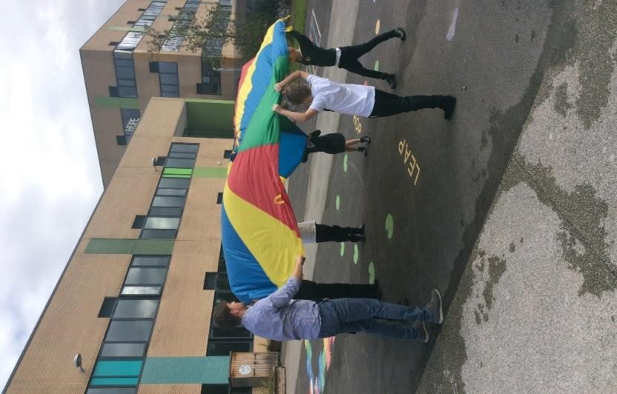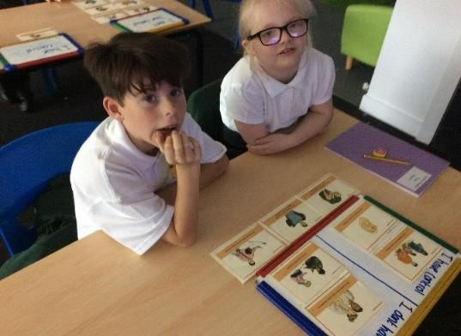

4.0 OUTDOOR LEARNING:

For many years the school has accessed for its pupils the local outdoor facilities, which has helped our children to develop many skills that are hard to teach in the classroom. It primarily encourages children to be active with the key aim of developing confidence and self-esteem through hands-on learning in a woodland environment.

Hope School has developed its own broader outdoor learning facilities and curriculum with the advantage of being on our school site.

We know our children thrive on this learning approach, and importantly we can ensure the activities are curriculum-led and focused to ensure we fully meet government requirements. Importantly, having the facilities on our school site is most beneficial as it saves valuable traveling time and enables staff to maximise on lesson time for the benefit of the children.

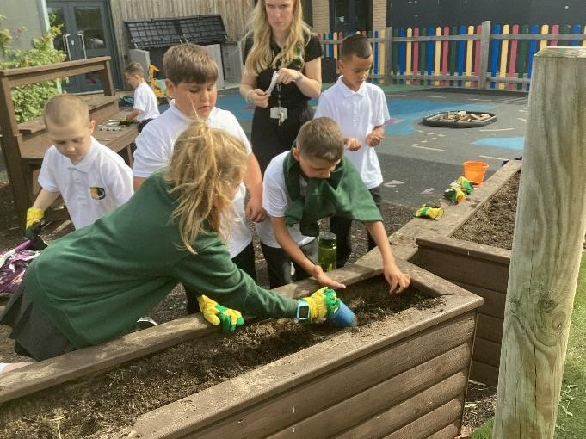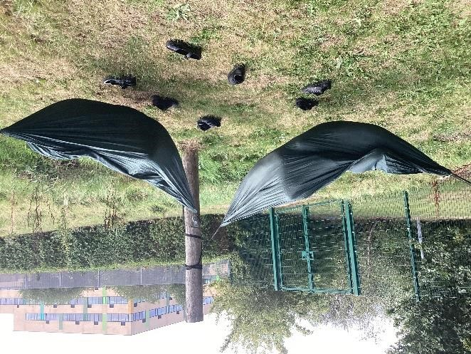

5.0 PERFORMING ARTS:

Performing arts play an important part in the pupil's school life with our most impressive feature being aerial hoops and silks. These activities do help to build confidence in children as well as having a positive effect on their physical, mental, social, and emotional development.

The celebration of these activities usually cumulates in an annual Arts week when parents and carers are invited to several events to see the children sing and perform in their various activities.

6.0 THERAPIES & SUPPORT:

Children attending the school have complex needs and we offer support through a range of support therapies as appropriate to meet the individual child’s needs. They include the following:

- Occupational Therapy, Speech & Language Therapy, Cognitive Behaviour Therapy, Educational Psychology, play therapy, theraplay and Clinical Psychology
- Mindfulness, Zones of Regulations and Thrive.

This support enhances the bespoke curriculum we offer to our children. This proactive approach contributes to helping to reduce barriers and allows children to self-regulate emotions effectively. In addition, Aerial Ninjas supports children’s bodies to be ready for sitting and writing when required and generally contributes to building up their confidence.

7.0 BENCHMARKING /EXTERNAL STANDARDS:

Hope School has developed a culture of continuous improvement and measures the impact and effectiveness of strategies, policies, and procedures the school has implemented by benchmarking against local and national standards. The independent feedback from these assessments provides opportunities to make further improvements. Examples of current re-accreditations achieved include:

- Gold Standard; Attachment & trauma sensitive schools award (ATSSA);
- An Attachment Research Community (ARC) Hub school;
- Silver Standard, Investor in People (IiP);
- Best Practice with Teaching Assistants Award (BPTAA);
- Leading Parent Partnership Award (LPPA);
- Best Practice Teaching Assistant Award (BPTAA) and
- SEND Inclusion Award (SENDIA);
- Plus various other standards

8.0 FAMILY SUPPORT PROGRAMME:

A key element to our success has been the engagement and working in partnership with parents and carers. We have a dedicated specialist Family Support Worker who can provide advice and guidance.

We also offer a range of Family Support Programmes. For example, understanding attachment and trauma practices, building on their strengths to overcome concerns, difficulties, etc., and how they can support their children at home to self-regulate and show a range of emotions appropriately.

9.0 PUPIL VOICE:

The opinions and ideas of our pupils are important to us at Hope School. We hold regular pupil voice meetings to give our children the opportunity to voice their concerns and to pass on ideas.

10.0 MANAGEMENT & STAFF:

We have a committed and dedicated management, staff teaching, and support team of 30 who strive to ensure our pupils achieve and enjoy life in school.

The well-being of staff has been pivotal in our attachment journey and the introduction of regular confidential supervision has had a profound and positive impact on the welfare of our staff and helped to identify and address issues promptly. Furthermore, all staff undertake regular training to support their professional development. For the academic year 23/24 all staff have had the option to attend psychotherapy sessions on a weekly basis for the year.

11.0 GOVERNANCE:

Strong and effective governance is critical to ensuring the success of any school and this has been provided by a challenging and supportive Board of Governors at Hope who have three termly meetings throughout the year to receive performance updates.

The governors also have individual designated lead responsibilities Safeguarding, Attachment & Trauma, Finance, Leadership & Management and Curriculum. The Head and Chair also hold regular one-to-one meetings.

The school being relatively small, governors are generally highly visible which allows them to talk regularly to pupils and staff through classroom observations, learning walks, and attending lunch breaks to obtain meaningful feedback. The governors also attend open days which are specifically for parents and carers and again this allows them the opportunity to engage with them.

An informative Termly Governors Newsletter, is sent out to parents and carers and staff to provide them with updates and how the school is progressing.

The governors have an annual review exercise to evaluate their own effectiveness and carry out some forward planning.

12.0 SUMMARY:

The foregoing overview has endeavoured to provide some understanding of Hope School’s aims, ethos, culture, and importantly how the carefully designed curriculum is delivered and supported. The report has purposely been strategically focused and not from an operational viewpoint. However, more comprehensive details and information on Hope School can be obtained on the school's website: www.hopeschool-liverpool.co.uk

It will be appreciated that safeguarding and the welfare of our pupils are given the highest priority. Whilst our curriculum fully reflects the importance of literacy and numeracy, overall it has been adapted to meet the specific SEMH needs of our pupils. Furthermore, Hope regularly develops ways to support our pupils to discover a real passion for learning.

Adopting attachment and trauma-informed friendly practices have undoubtedly been highly successful in helping drive up educational standards, and the personal development of our pupils. It is most important the school’s development approach continues and is fully supported by Hope’s future strategic partners.

It’s important to mention that there is an excellent working relationship between the governors, the Head, and his senior leadership team. The governors firmly believe the school is led by a highly committed and inspirational leadership team with the pupil's best interest at the heart of its decision-making.

Hope School, 251 Hartsbourne Avenue, Liverpool, L25 2RY
Telephone: 0151 363 3130 – Email: ao@hope-school.co.uk
www.hopeschool-liverpool.co.uk

Deputy Headteacher Job Description

Position: | Deputy Headteacher
Pay Range: | L8 – L15
Responsible to: | The School’s Board of Governors

This is a leadership post on the school senior leadership team. The leader will be expected to have teaching commitments as well as meet the requirements of leadership.

The post holder will be expected to support and endorse a safe environment for all pupils whilst also following trauma informed practises. This senior position will hold both operational and strategic responsibilities for Hope School.
In addition to carrying out the duties of this post in line with the remit outlined in the current School Teachers’ Pay and Conditions Document including the conditions of employment for Head teachers and the school’s own policies and procedures.

The Board of Governors is committed to safeguarding and promoting the welfare of children and young people. The Headteacher must ensure that the highest priority is given to following the guidance and regulations relating to safeguarding and child protection. Appointment is conditional upon receipt of satisfactory Disclosure and Barring Service (DBS) checks in relation to criminal and child protection matters.

A. The Core Purpose of the Deputy Headteacher:
The core purpose of the Deputy Headteacher is to provide professional leadership and management for the school. This will promote a secure foundation from which to achieve high standards in all areas of the school’s work. This senior position should host a person who is a role model of our core values and someone who can build relationships with staff, stakeholders, colleagues, children and families.
The Deputy Headteacher, will establish policy and ensure all policies and procedures are followed through monitoring and assessment cycles. One primary purpose is the deployment and activities of staff ensuring we get the best out of the colleagues working directly with the children.
Drawing on a wealth of knowledge to monitor progress towards the schools aims and targets.

B. Standards
- School Culture
  - Sustain the school’s ethos and strategic direction in partnership with the headteacher and those responsible for governance and through consultation with the school community
  - create a culture where pupils experience a positive and enriching school life
  - uphold ambitious educational standards which prepare pupils from all backgrounds for their next phase of education and life
  - promote positive and respectful relationships across the school community and a safe, orderly and inclusive environment
  - ensure a culture of high staff professionalism

- Teaching
  - establish and sustain high-quality, expert teaching across all subjects and phases, built on an evidence informed understanding of effective teaching and how pupils with SEND learn
  - ensure teaching is underpinned by high levels of subject expertise and approaches which respect the distinct nature of subject disciplines or specialist domains
  - ensure effective use is made of formative assessment

- Curriculum and Assessment
  - ensure a broad, structured and coherent and therapeutic curriculum entitlement which sets out the knowledge, skills and values that will be taught
  - establish effective curricular leadership, developing subject leaders with high levels of relevant expertise with access to professional networks and communities
  - ensure that all pupils are taught to read through the provision of evidence-informed approaches to reading, particularly the use of systematic synthetic phonics in schools that teach early reading
  - ensure valid, reliable and proportionate approaches are used when assessing pupils’ knowledge and understanding of the curriculum

- Behaviour
  - establish and sustain high expectations of behaviour for all pupils, built upon relationships, rules and routines, which are understood clearly by all staff and pupils
  - ensure high standards of pupil behaviour and courteous conduct in accordance with the school’s policy
  - implement consistent, fair and respectful approaches to managing behaviour
  - ensure that adults within the school model and teach the behaviour of a good citizen

- Additional and Special Educational Needs and Disabilities
  - ensure the school holds ambitious expectations for all pupils with additional and special educational needs and disabilities
  - establish and sustain culture and practices that enable pupils to access the curriculum and learn effectively
  - ensure the school works effectively in partnership with parents, carers and professionals, to identify the additional needs and special educational needs and disabilities of pupils, providing support and adaptation where appropriate ensure the school fulfils its statutory duties with regard to the SEND code of practice
- Professional development
  - ensure staff have access to high-quality, sustained professional development opportunities, aligned to balance the priorities of whole-school improvement, team and individual needs
  - prioritise the professional development of staff, ensuring effective planning, delivery and evaluation which is consistent with the approaches laid out in the standard for teachers’ professional development
  - ensure that professional development opportunities draw on expert provision from beyond the school, as well as within it, including nationally recognised career and professional frameworks and programmes to build capacity and support succession planning

- Organisational management
  - ensure the protection and safety of pupils and staff through effective approaches to safeguarding, as part of the duty of care
  - prioritise and allocate financial resources appropriately, ensuring efficiency, effectiveness and probity in the use of public funds
  - ensure staff are deployed and managed well with due attention paid to workload
  - establish and oversee systems, processes and policies that enable the school to operate effectively and efficiently
  - ensure rigorous approaches to identifying, managing and mitigating risk

- Continuous school improvement
  - make use of effective and proportional processes of evaluation to identify and analyse complex or persistent problems and barriers which limit school effectiveness, and identify priority areas for improvement
  - develop appropriate evidence-informed strategies for improvement as part of well-targeted plans which are realistic, timely, appropriately sequenced and suited to the school’s context
  - ensure careful and effective implementation of improvement strategies, which lead to sustained school improvement over time

- Working in partnership
  - forge constructive relationships beyond the school, working in partnership with parents, carers and the local community
  - commit their school to work successfully with other schools and organisations in a climate of mutual challenge and support
  - establish and maintain working relationships with fellow professionals and colleagues across other public services to improve educational outcomes for all pupils

- Governance and accountability
  - understand and welcome the role of effective governance, upholding their obligation to give account and accept responsibility
  - establish and sustain professional working relationship with those responsible for governance
  - ensure that staff know and understand their professional responsibilities and are held to account
  - ensure the school effectively and efficiently operates within the required regulatory frameworks and meets all statutory duties

This job description forms part of the contract of employment of the person appointed to the post. It reflects the position at the present time only and may be reviewed in negotiation with the employee in the future. The appointment is subject to the current conditions of employment in the School Teachers’ Pay and Conditions Document

Hope School, 251 Hartsbourne Avenue, Liverpool, L25 2RY
Telephone: 0151 363 3130 – Email: ao@hope-school.co.uk
www.hopeschool-liverpool.co.uk

Deputy Headteacher Person Specification/Selection Criteria

Position: | Deputy Headteacher
Pay Range: | L8 – L15
Responsible to: | Headteacher

Listed below are the personal attributes required to fulfil the duties listed in the Job Description

Key: A – Application Form I – Interview C – Certificates/Qualification Evidence

Note: Candidates failing to meet any of the essential criteria will not be shortlisted for the next stage of the recruitment process

- Qualifications
Criteria | Essential | Desirable | Evidence
Qualified teacher status | E |  | A, C
Degree or equivalent qualification | E |  | A, C

- Professional Development
Criteria | Essential | Desirable | Evidence
Evidence of appropriate professional development for the role | E |  | A, I
Has successfully undertaken child protection training | E |  | A
Has successfully undertaken appropriate training for the role of Designated Safeguarding Lead or has a commitment to do so | E |  | A, I
Has successfully undertaken the Secretary of State’s Safer Recruitment Training or has a commitment to do so before taking up post or within twelve months of taking up post | E |  | A, I, C
Has successfully undertaken attachment and trauma informed training and/or has an excellent understanding of ATP |  | D | A, I

- School leadership and management experience

Criteria | Essential | Desirable | Evidence
Recent and successful leadership as a Deputy Headteacher, Head of School or Assistant Headteacher. | E |  | A, I
Ability to articulate a clear vision for the school and its future development | E |  | A, I
Aptitude to think strategically and plan for educational improvement | E |  | A, I
Involvement in school self-evaluation and development planning | E |  | A, I
Experience of curriculum leadership and development |  | D | A, I
Proven experience of reviewing, evaluating and leading improvements in teaching and learning to raise standards which have positively impacted on outcomes for all children including those with SEND |  | D | A, I
Have an awareness of the financial management of a school |  | D | A, I
Have an awareness of the need for accountability and of the systems which support it | E
Knowledge and understanding of strategic financial planning and budgetary management in relation to their contribution to school improvement and pupil achievement |  | D | A, I
Had responsibility for policy development and implementation | E |  | A, I
Have an up to date knowledge and understanding of key legislation particularly in relation to working with and protection of children | E |  | A, I
Demonstrate a good awareness of current national and local educational policy and strategy | E |  | A, I
Experience of and ability to contribute to staff development across the primary range (e.g. coaching, mentoring, INSET for staff) | E |  | A, I
Understand how to work effectively with a Governing Body |  | D | A, I
The ability to provide advice and support to the Governing Board to enable it to meet its responsibilities |  | D | A, I
Demonstrate a clear understanding and rational for behaviour management and a proven track record of the effective implementation of a range of behaviour management strategies | E |  | A, I
Knowledge and understanding of the restorative justice approach and attachment and trauma in formed practice |  | D | A,I
Experience of working with and engaging positively with parents to promote the caring family/community culture and ethos of the school | E |  | A, I

- Experience and knowledge of teaching

Criteria | Essential | Desirable | Evidence
Successful experience of teaching in a Primary school | E |  | A, I
Attachment and Trauma Informed practice experience |  | D | A, I
Significant teaching experience within the relevant in the Primary phases | E |  | A, I
A current knowledge and understanding of all key stages represented in the school. | E |  | A, I
Experience of providing professional challenge and support to others through the Performance Management Process |  | D | A, I
Experienced in the effective use of assessment information to improve pupil learning and competence in tracking progress and attainment within accountability systems to monitor and raise standards |  | D | A, I
Exemplify how the needs of all pupils, including vulnerable groups, have been met through high quality teaching | E |  | A, I
Experience of contributing to the development and implementation of statutory policies and procedures | E |  | A, I,

- Professional attributes

Criteria | Essential | Desirable | Evidence
Excellent written and oral communication skills (which will be assessed at all stages of the process) | E |  | A, I
Ability to develop effective relationships with staff | E |  | A, I
A working knowledge of a variety of digital platforms and systems for both management and communication |  | D | A, I
Be a leader of learning, demonstrating, promoting and encouraging outstanding classroom practice | E |  | A, I
A willingness to engage with all stakeholders | E |  | A, I
Show a good commitment to sustained attendance at work | E |  | Reference

Ethics and Professional Conduct

All the following are essential for the post and will be assessed throughout the process.

Senior leaders are expected to demonstrate consistently high standards of principled and professional conduct. They are expected to meet the teachers’ standards and be responsible for providing the conditions in which teachers can fulfil them.

Teachers uphold and demonstrate the Seven Principles of Public Life at all times. Known as the Nolan principles, these form the basis of the ethical standards expected of public office holders:

Selflessness, integrity, objectivity, accountability, openness, honesty and leadership.

- Confidential references and reports

Positive and supportive references are required from:

- The applicant’s present school or current employer;
- Another professional. Where the applicant is not currently employed working with children, this must be the most recent school or college employer. Local agreements may prescribe that the second professional reference is provided by a SIP or local authority adviser whenever possible.

The Headteacher reserve the right in exceptional cases to seek additional references from other former employers where this seems appropriate.

Final confirmation of the appointment is subject to satisfactory reports on health and attendance which will be requested only after the offer of appointment has been made.

- Application form and supporting statement

The most up to date application form provided by the school and must be fully completed and legible. The supporting statement should be no more than 2 A4 pages (font size 11 minimum) and should be clear, concise and related to the post and setting applied for, paying attention to Section F and G above.

Hope School follows safe recruitment practices to protect children. The aim of these practices is to ensure, as far as is possible, that anyone, paid or voluntary, who seeks to work in this school is safe to do so.

Hope School, 251 Hartsbourne Avenue, Liverpool, L25 2RY

Telephone: 0151 363 3130 – Email: ao@hope-school.co.uk
www.hopeschool-liverpool.co.uk

Application Dates
- Recruitment Time Line – Key Dates
Closing Date for Applications | 16th April 2024
Shortlisting | 19th April 2024
Interviews | 24th & 25th April 2024
Start Date | 1st September 2024
All applications will be acknowledged
References will be sought for shortlisted candidates prior to the interview date
The successful candidate will be required to complete an enhanced DBS and Barred List check

- Arranging a school visit
Visits to the school are encouraged and welcomed.
Please contact the school office on 0151 363 3130 and ask for Helen Stewart to arrange a visit appointment.

Visits are welcomed on:
Friday 1st March AM
Wednesday 6th March AM
Monday 11th March AM
Tuesday 19th March AM
If you cannot make any of these times we will do our best to accommodate your needs.

- Safer Recruitment in Education
Hope school is committed to safeguarding and promoting the welfare of children and young people. Our school has an equal opportunities policy. For selection and recruitment in accordance with its safeguarding policy, the successful candidate will be required to have an enhanced DBS check along with a check against the DBS children's barred list. All posts are subject to statutory pre-employment checks and satisfactory references.

This post is exempt from the provisions of the Rehabilitation of Offenders Act 1974 (as amended in 2013 & 2020) and shortlisted candidates will be required to disclose any relevant criminal history prior to interview. Please see the document “Guidance for Completing an Application Form” for further information.

d. Submitting an application

The following application documents are downloadable from the advert page on the School Improvement Liverpool website and school website: Job description / Person Specification / Application form / Equal Opportunities Monitoring Form / Application overview / Guidance for completing an application. Also for your information the school`s Child Protection Policy and the staff Code of Conduct.

Applications are by the Liverpool Local Authority Standardised Application form and will be managed electronically. Applicants should not submit CVs in lieu of the application form as these will not be considered.

The application form must be fully completed and legible and must be accompanied by the Equal Opportunities Monitoring form – both downloadable as above. The supporting statement should be no more than 2 A4 pages (font size 11 minimum) and should be clear, concise and related to the post and setting applied for, paying attention to the Person Specification.

Completed application forms and monitoring forms should be emailed to Helen Stewart, School Business Manager, by 12.00 midnight on Tuesday 16th April.

h.stewart@hope-school.co.uk

Please “Subject” your email DHT Application and confirm your full name, address and preferred email address for contact.

e. A problem or question?

Maxine O’Neill Headteacher and Helen Stewart, School Business Manager are on hand to support and can be contacted on the above email address.

