

**Kelsall Primary and Nursery School**

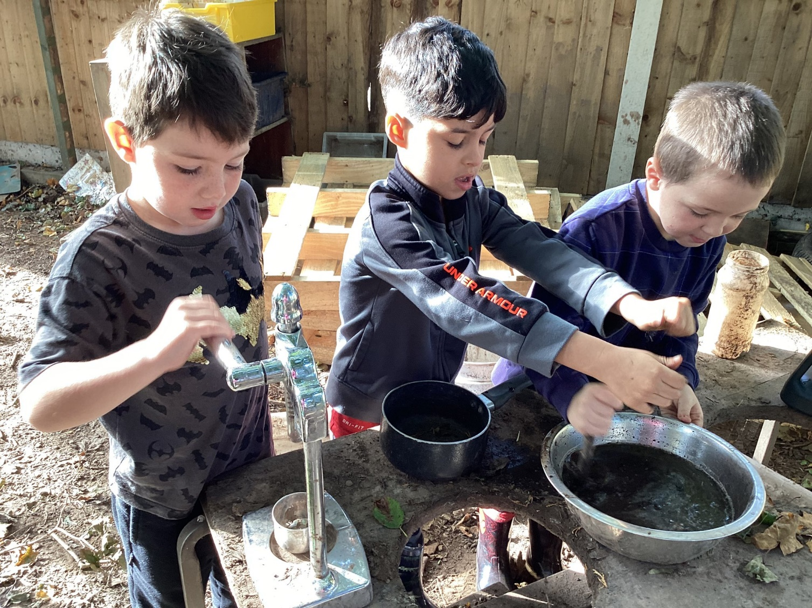

**Deputy Headteacher**

Recruitment Pack

May 2024



A Warm Welcome

### We are delighted to extend a warm welcome from Kelsall Primary and Nursery School. Thank you for your interest in

### joining our vibrant educational community.

### Kelsall Primary School and Nursery is ‘daring and different’ and a beacon of creativity and innovation among Cheshire

### schools. With an innovating and challenging curriculum and nurturing environment, we are dedicated to fostering

### ‘a love of learning’ and guiding children to become ethical people with a motivating desire to develop as a learner;

### finding out more about the complex world they live in and the contribution they can make to a better future.

### Our dedicated team of teachers and support staff exemplify our core values and offer unwavering care and support

### to each and every child. We embrace crew culture and believe that this encourages a true sense of belonging for

### all children in our learning community and promotes an academic mindset by holding each other to account for our

### learning. Crew is enacted all day, every day and by everyone.

### We take pride in the strong partnerships we have forged with parents and extended families within our community, knowing that collaboration is key to unlocking the potential of every child.

### We are excited about the prospect of welcoming a leader who is passionate about making a difference in the lives of

### our pupils and the community. Your leadership will be instrumental in maintaining strong standards of education, whilst

### aligning with the overarching goals of Cheshire Academies Trust. Thank you for considering this opportunity.

### We look forward to embarking on this exciting journey with you.

### Warmest regards,

 

### C:\Users\head\AppData\Local\Microsoft\Windows\INetCache\Content.

### Sarah White Steve Ellis

### Headteacher CEO

**Deputy Headteacher Vacancy at Kelsall Primary and Nursery School**

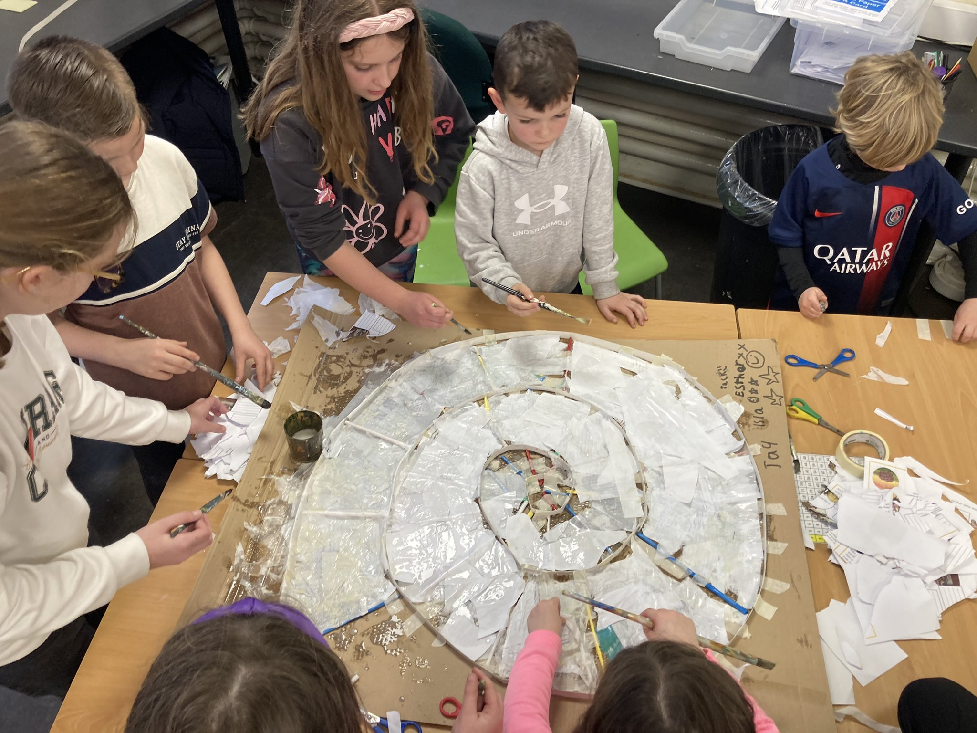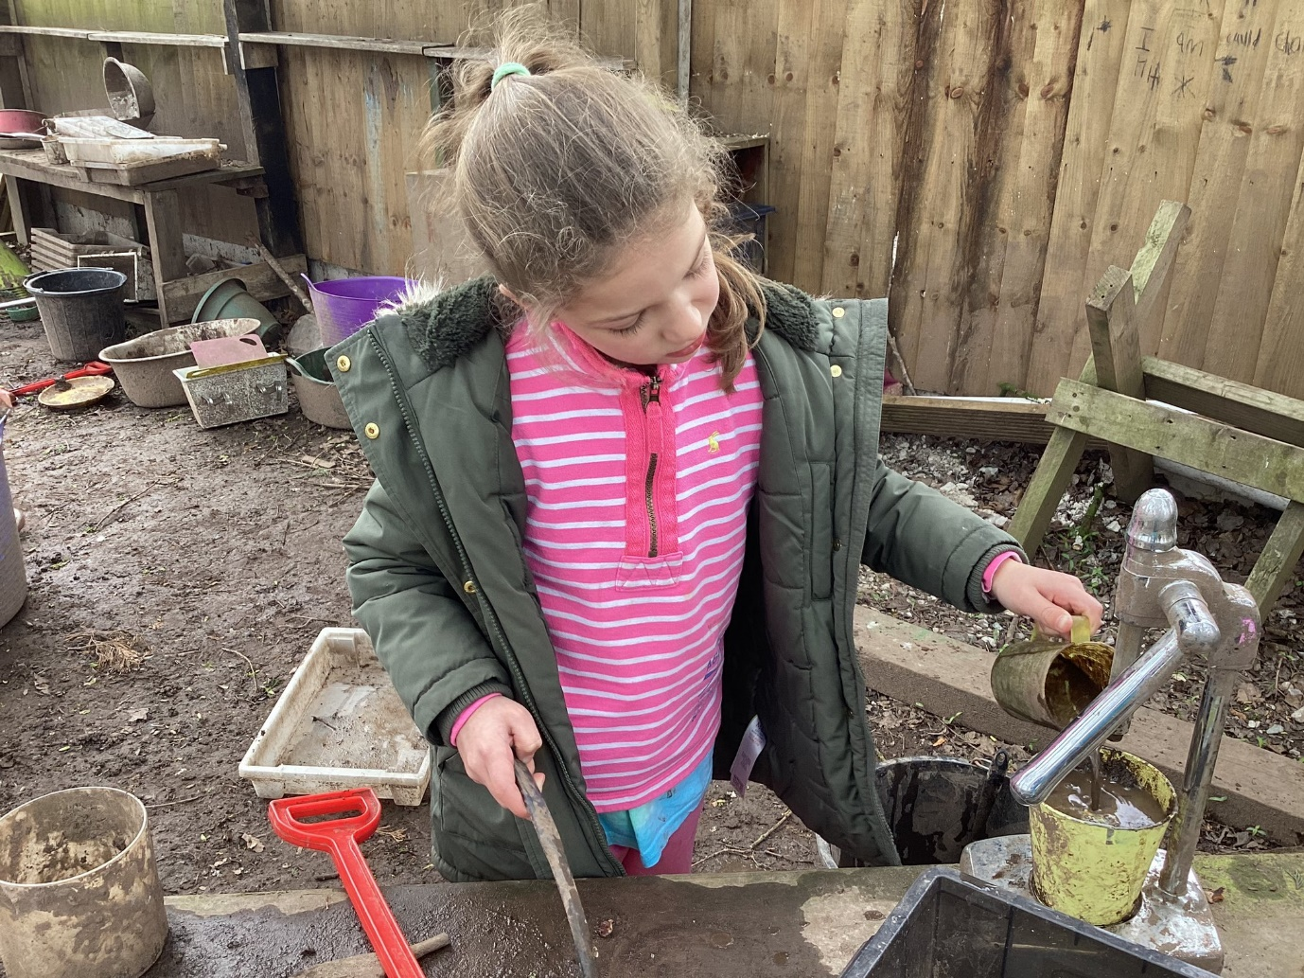

We are delighted to announce an exciting opportunity for an inspirational Deputy Headteacher to join our team at Kelsall Primary and Nursery School from September 2024. We are a vibrant and welcoming one-form entry school, dedicated to providing an enriching educational experience for children aged 2 – 11.

The Headteacher, in collaboration with the Trust and Local Governing Board, is actively seeking a committed, enthusiastic, and innovative Deputy Headteacher to join our wonderful school. We are in pursuit of a strategic leader, adept at nurturing a culture of collaboration, innovation, and excellence within our school community who can lead the SEND provision across the school. The ideal candidate will possess the vision and drive to build upon our existing positive ethos, leveraging our strengths to support our future development priorities. If you are a dedicated educator with a passion for developing a love of learning, we invite you to apply and become an integral part of our dedicated and friendly team at Kelsall.

**Key Responsibilities:**

* **Strategic Leadership**: Support the development and implementation of innovative educational strategies and SEND provision that align with the school’s vision and the broader objectives of Cheshire Academies Trust.
* **Academic Excellence**: Uphold and enhance the academic standards at Kelsall Primary and Nursery School, ensuring that all pupils achieve their fullest potential.
* **Wider School Outcomes**: Foster a holistic and creative approach to education that encapsulates not only academic success but also the personal, social, and emotional development of our pupils.
* **Culture and Values**: Embody and promote the school's ethos and crew culture- a commitment to deliver an exceptional education that fosters a love of learning throughout the whole curriculum. Working together to make a difference.
* **Innovative Learning Approaches**: Employ creative and innovative approaches to learning and teaching, encouraging staff and students to explore new ideas and methodologies.

**The Ideal Candidate Will Possess:**

* A proven track record of effective leadership within an educational setting.
* A robust understanding and experience of raising educational standards and school improvement.
* The ability to engage, inspire, and motivate pupils, staff, and the wider school community.
* A commitment to inclusive education and the ability to foster a supportive, empowering environment for all through crew culture.
* Strong communication and interpersonal skills, with the capacity to build and maintain positive relationships with pupils, staff, parents, and the wider community.
* A creative and innovative mindset, with the ability to implement forward-thinking educational practices.

**We Offer:**

* The opportunity to help lead a vibrant, high-achieving school
* A supportive, committed school community
* A happy, well-managed school with a strong team ethos of crew
* Wonderful pupils that demonstrate outstanding levels of academic progress
* A culture that values and nurtures leadership and professional growth within Cheshire Academies Trust’s ambitious senior leadership team
* Annual salary progression within a national pay scale (performance-related)
* Membership of the Teacher Pension Scheme
* An annual flu vaccination
* Access to our ‘green schemes’ including cycle to work, electric cars and white goods

**Application Process:** Interested candidates are invited to submit an application and a covering letter, outlining your suitability for the role and how you would contribute to the vision and values of Kelsall Primary and Nursery School. Details of the application process and deadlines can be found on the Kelsall Primary and Nursery School website.

**Kelsall Primary and Nursery School is committed to safeguarding and promoting the welfare of children and young people and expects all staff and volunteers to share this commitment. Appointments will be subject to an enhanced DBS check and satisfactory references.**

For more information and to apply, please visit our website or contact the Headteacher, Sarah White, [head@kelsall.cheshire.sch.uk](mailto:kpshead@cheshireacademiestrust.co.uk)

**Person Specification**

|  |  |
| --- | --- |
| **Educational Qualifications and Training:** | |
| *Essential* | * Qualified Teacher Status * Degree or equivalent |
| *Desirable* | * Evidence of further study * NPQH |
| **Experience:** | |
| *Essential* | * Varied experience and understanding of teaching and learning across the primary age range * Previous recent experience in a senior leadership role in a primary school * Successful experience of leading and managing whole school developments, raising standards of attainment and achievement across the school * Experience of data analysis and target setting * Responsibility for developing, monitoring and evaluating an aspect of school provision * Experience of leading and managing people * Experience of contributing to self-evaluation and school improvement * Experience of leading training and other staff development activities, including performance management |
| *Desirable* | * Experience of teaching in more than one key stage * Experience of leading SEND across a school * Experience of coaching and mentoring * Experience of working with governors, parents and the wider community |
| **Knowledge and Understanding:** | |
| *Essential* | * Knowledge of the curriculum expectations for EYFS, Key Stage 1 and 2 * In-depth knowledge of curriculum development and effective pedagogy * Sound understanding of assessment, recording and reporting systems and procedures * Understanding of strategies for school improvement * Knowledge of how effective use of performance development, data and target setting can raise standards * Up-to-date knowledge and understanding of current educational issues |
| *Desirable* | * Evidence of highly effective teaching in more than one year group * Experience of leading a core subject/school development priority * Knowledge of relevant tracking systems to analyse school development priorities |
| **Skills:** | |
| *Essential* | * Ability to positively influence others and demonstrate a collaborative and inclusive way of working * Value others and promote a positive staff morale * Ability to motivate, lead and manage people to work both individually and in teams * Ability to implement change and plan strategically * Outstanding communication skills, with a range of audiences both orally and in writing * Understanding, analysis and interpretation of school performance data * Ability to prioritise, work under pressure and meet deadlines * Effective problem solving skills * Effective administrative and organisational skills |
| **Personal Attributes:** | |
| *Essential* | * Value all children and committed to the development of the whole child * Relate well to pupils, staff and parents and care about their individual needs * Able to adapt to changing circumstances and new ideas in a positive and creative manner * Ability to deal with sensitive issues in a professional and confidential manner * Has high standards of self and others * Good judgement * Energy and enthusiasm * Integrity and loyalty to the school team and local community * A good sense of humour * A commitment to safeguarding and promoting the welfare of children |



## Post:

Deputy Headteacher

## Salary:

L3 – L7

## Location:

Kelsall Primary and Nursery School

## Reports to:

Headteacher

.



Job Description for

**DEPUTY HEADTEACHER**

Kelsall Primary and Nursery School

**Purpose of Job**: To play a significant leadership role, under the direction of the Headteacher, in formulating the aims and objectives of the school, establishing the policies through which they shall be achieved, managing staff and resources to achieve the aims and objectives of the school and monitor progress towards their achievement and leading the SEND provision across the school.

**Key Responsibilities**

**1. Core Purpose and Accountability**

1.1. To play a significant role under the direction of the Headteacher in formulating the aims and objectives of the school, establishing the policies through which they shall be achieved, managing staff and resources to achieve the aims and objectives of the school and monitor progress towards their achievement.

1.2. Undertake the professional duties of the Deputy Headteacher reasonably delegated to you by the Headteacher

1.3. Undertake the professional duties of the Headteacher, in the event of her absence from the school.

1.4. In partnership with the Headteacher and the Senior Leadership Team, provide professional leadership and management of teaching and learning throughout the school

1.5. To provide professional leadership and management of school development priorities

1.6. To lead the strategic direction and operation of the SEND provision across the school

**2. General**

2.1. To facilitate and encourage learning which enables students to achieve high standards, to share and support the corporate responsibility for the well-being, education and discipline of all children

2.2. To uphold the school’s ethos and aims which underpin good practice and the raising of standards whilst promoting core values.

2.3. Work as part of the Kelsall team to develop areas of provision that impact positively on teaching and learning across the school

2.4. Take an active role in the school self-evaluation process and setting strategic development priorities (SQM)

2.5. Actively undertake professional development through keeping abreast of the latest developments and thinking, coaching and mentoring, self-evaluation and peer review

**3. Performance Management**

3.1. To undertake annual Performance Management, setting and agreeing targets linked to school development priorities with the Headteacher and Local Governing Body

**4. Key Areas**

**4.1. Impact on educational progress:**

Strategic direction/Shaping the future

1. Support the Headteacher with ensuring the vision for the school is clearly articulated, shared, understood and acted upon effectively by all.
2. Demonstrate the vision and values of the school in everyday work and practice by motivating and working with others to create a shared culture and positive climate
3. Assist the Headteacher in the on-going and annual review of standards of leadership, teaching and learning and across all areas of school provision to complete the school’s strategic quality management document (SQM)
4. Create specific and measurable subject development plans which contribute positively to the achievement of the School Development Plan and which actively involves all staff in its design and execution
5. Develop and implement policies and practices for the subject/area(s) which reflects the school’s commitment to high achievement and is consistent with national and local strategies and policies
6. Promote high expectations for attainment and support the target setting process
7. Establish short, medium and long term plans for the development and resourcing for the specific areas of responsibility
8. Monitor the progress made in achieving subject/area plans and targets, and evaluate the effect on teaching and learning
9. Work with outside agencies and stakeholders to inform future action

**4.2. Leading Learning and Teaching, developing and enhancing the teaching practice of others:**

a. Work with the Headteacher to raise the quality of teaching and learning and pupil’s achievement, setting high expectations and monitoring and evaluating effectiveness of learning outcomes

b. Provide regular feedback for colleagues in a way which recognises good practice and supports their progress against professional and performance management objectives resulting in a tangible impact on students learning

c. Develop whole staff, phase teams and individuals to enhance performance

d. Undertake coaching/mentoring to support staff towards outstanding outcomes and achieving their academic best

e. Plan, organise and deliver staff meetings, where necessary bringing in outside speakers

f. Keep abreast of the latest developments in the area and disseminate effectively to other members of staff

g. Plan, delegate and evaluate work carried out by team(s) and individuals

h. Create, maintain and enhance effective relationships with all stakeholders

i. Support the recruitment and selection process of teaching and support staff

**4.3. Securing Accountability:**

a. Work with the Headteacher to ensure the school’s accountability to a wide range of groups, particularly parents, carers, local governors, the trust and the DfE; ensuring that pupils enjoy and benefit from a high quality education, for promoting collective responsibility within the whole school community

b. Develop a school ethos and vision which enables everyone to work collaboratively, share knowledge and understanding, celebrate success and accept responsibility for outcomes

c. Work with the local governing body (providing information, objective advice and support) to enable it to meet its responsibilities

d. Develop and present a coherent, understandable and accurate account of the school’s performance to a range of audiences including the trust, local governing body, parents and carers

e. Reflect on personal contribution to school achievements and take account of feedback from others

f. Agree, monitor and evaluate pupil progress information to make a measurable contribution to whole school targets

g. Engage all staff in the creation, consistent implementation and improvement in schemes of work and curriculum plans which encapsulates key school learning strategies

h. Provide guidance on a choice of teaching and learning methods/strategies as well as coaching and mentoring others where appropriate

i. Evaluate the quality of teaching and standards of achievement, setting targets for improvement

**4.4. Resource Management:**

a. Work with the Headteacher to provide effective organisation and management of the school and seek ways to improve organisational structures and functions based on rigorous self-evaluation

b. Work with the Headteacher to ensure the school and the people and resources within it are organised and managed to provide an efficient, effective and safe learning environment

c. Alongside the Headteacher, oversee and evaluate the subject/area budget allocation to ensure the

budget is spent in line with subject/area SDP priorities and best value principles

d. Work with staff to secure and allocate resources that support effective learning and teaching within the subject area(s)

**4.5. Developing Self and Working with Others**

a. Work with the Headteacher to build a professional learning community which enables others to achieve

b. Support staff, within your team and within the whole school, in achieving high standards through effective continuing professional development

c. Be committed to your own professional development

d. Implement successful performance management processes with an allocated team of staff

e. Treat people fairly, equitably and with dignity and respect to create and maintain a positive school culture

f. Develop and maintain a culture of high expectations for self and others

g. Regularly review own practice, set personal targets and take responsibility for own professional development

**4.6. Strengthening Community**

a. Work with the Headteacher to engage with the internal and external school community to secure equity and entitlement

b. Collaborate with other schools in the trust and organisations outside of the trust in order to share expertise and bring positive benefits to their own and other schools

c. Work with the Headteacher to work collaboratively at both strategic and operational levels with parents and carers and across multiple agencies for the well-being of all children

Not all of the above duties will need to be performed all of the time and will vary according to the needs of the school at different points. The specific focus for the Deputy Head’s work programme will be negotiated and agreed at the beginning of the performance management cycle.

EQUAL OPPORTUNITIES

The post holder will be expected to carry out all duties in the context of and in compliance with the School’s Equal Opportunities Policies

This job description will be reviewed at regular intervals and is subject to change as the needs of the school evolve.

*Candidates will be expected to outline their suitability for the role, aligned to both the job description and person specification via their letter of application. The interview process will be designed to offer candidates further opportunities to share and expand on their skills and experience. Shortlisted candidates will be required to provide evidence of their qualifications at interview and any offer of employment will be on receipt of acceptable references. The school may choose to make social media checks on shortlisted candidates, in line with Keeping Children Safe in Education 2023 (KCSiE 23) guidance.*

How to apply

If you believe you are the ideal candidate for our Deputy Headteacher position and would like more information or to have an informal discussion, please contact the Headteacher, Sarah White by email. [head@kelsall.cheshire.sch.uk](mailto:head@kelsall.cheshire.sch.uk)

We encourage all interested candidates to visit our school to gain a deeper understanding of the role. To arrange a visit, please contact the school at 01829 752811 or contact the school business manager by email. [businessmanager@kelsall.cheshire.sch.uk](mailto:businessmanager@kelsall.cheshire.sch.uk)

To apply, kindly complete the application form and submit it alongside a letter of application (not exceeding two A4 pages) that highlights your skills, qualifications, and experience relevant to the job description and person specification. Please send these documents to Mrs. Amanda Crowder, School Business Manager, at [businessmanager@kelsall.cheshire.sch.uk](mailto:businessmanager@kelsall.cheshire.sch.uk). Please note that we do not accept CVs and applications that include a CV will not be considered.

Kelsall Primary and Nursery School is fully committed to safeguarding and promoting the welfare of children and young people. We expect all staff, volunteers, and third parties to share this commitment. The recruitment process will involve safer recruitment practices, pre-employment background checks, and is subject to the receipt of satisfactory references prior to interview. Shortlisted candidates must provide proof of qualifications at the interview. An enhanced DBS check is also required and will be conducted before final confirmation of appointment.

We welcome applications from all suitably qualified candidates. Please be advised that we are unable to provide feedback on the shortlisting process. If you do not hear from us by 21st May, please consider your application unsuccessful on this occasion.

**Visits to the school can be booked on an individual basis.**

**Closing Date: Monday 20th May, 9am**

**Shortlisting: Monday 20th May**

**Interviews: Thursday 23rd May**

*We reserve the right to close advertisements early. Advertisements will therefore close at 9am either on the advertised closing date, or the day the decision has been taken to close the advertisement early.*