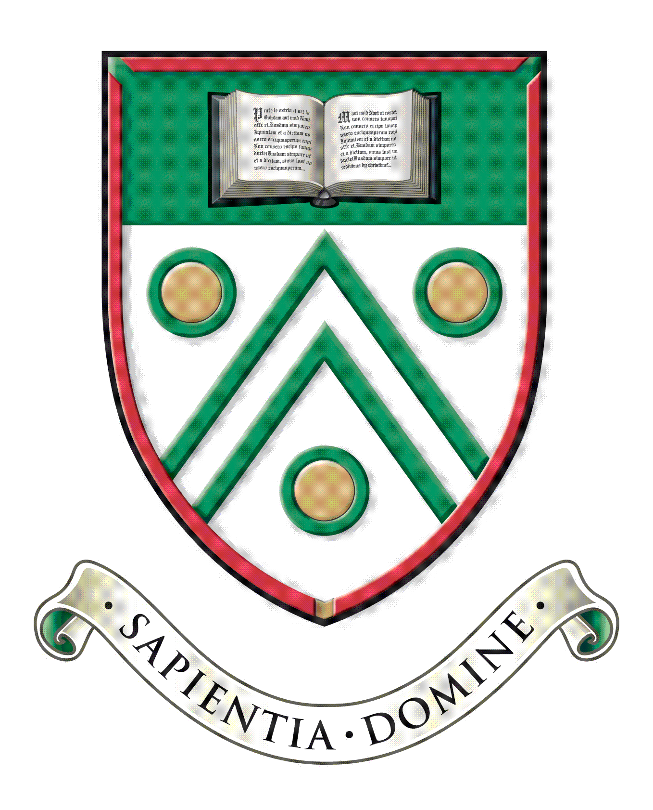

Langley Grammar School

Reddington Drive

Langley, Berkshire. SL3 7QS

Tel: 01753 598300

e-mail: school@lgs.slough.sch.uk

web: www.lgs.slough.sch.uk

Headteacher: Mr J Constable

**Deputy Headteacher**

**Main scale (London Fringe) L20-24 (currently £80,857 to £89,033)**

***Full-time, permanent role***

***Required for January 2025***

Our current headteacher is leaving the school at the end of this term and one of our two deputy headteachers has been promoted to the role from January 2025. We are therefore seeking an enthusiastic and committed leader to join our team with the experience, skills, and initiative to help us develop our highly successful school still further.

*Are you someone who*:

* can motivate staff and inspire students to build on their current achievements?
* will continue to raise standards of attainment and students’ personal development?
* has excellent interpersonal skills and a commitment to collaborative working?
* has the drive and energy to implement our strategic vision?
* is innovative and able to effectively deliver change?

*We can offer you*:

* a welcoming, caring, and stimulating environment with excellent teaching facilities;
* students who strive to maximise their achievement and are fully supported by parents who work with us in partnership;
* high-quality staff fully committed to supporting student's academic and personal development;
* a range of wider benefits and excellent opportunities for your professional development;

The Candidate information pack and application form are available on the school website at [www.lgs.slough.sch.uk](http://www.lgs.slough.sch.uk/).

*We are committed to safeguarding and promoting the welfare of children and expect all staff to share this commitment. Applicants must be willing to undergo child protection screening appropriate to the post, including online checks, checks with past employers, and the* *Disclosure and Barring Service.*

Preliminary school visits are welcomed. Applications should be returned by midday on **Thursday 26th September** to Mrs. De Cheyne, Head’s PA at [vacancies@lgs.slough.sch.uk](mailto:vacancies@lgs.slough.sch.uk).

*Interviews are scheduled for the* ***7th and 9th October 2024.***