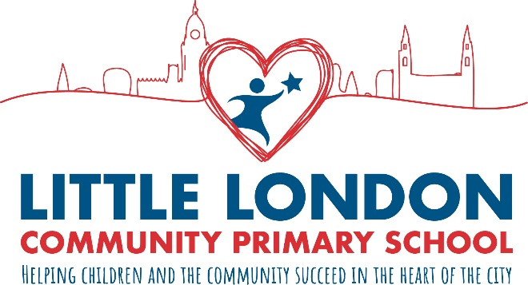
Little London Community Primary School
Meanwood Road
Leeds
LS7 1SR
Telephone: 0113 244 2457
E-mail: office@littlelondonprimary.co.uk
Headteacher: Mrs Fran Bowman

Role: Deputy Headteacher
From: 1st September 2023
Contract Type: Permanent
Salary: L12-17 (£58,105-£65,699)
Working Pattern: Full Time

Here at Little London Primary School a superb opportunity has arisen to become our new Deputy Headteacher. Our current Deputy Headteacher is retiring and I am looking for a brilliant, caring and dedicated person to work with me to lead Little London Community Primary.

Little London is on a very positive journey of improvement, you can be part of this journey, shaping the future and making a huge difference very quickly to the children, staff and community we serve. You will work with me to bring the potential of the school to the forefront and make it a beacon of community and educational excellence.

If you would love to work in a diverse, vibrant and dynamic school, are excited by the prospect of leading Little London in the next phase of its journey and working with a fantastic, forward thinking, positive staff team then please consider applying. Visits to the school are encouraged.

Please see the Headteacher Message included in the recruitment pack for more information about this role.
If you require further information about the role, or would like to arrange a visit then please contact Lisa Parchment at our school on 0113 244 2457.
To apply for this job, please download and complete the application form attached. A CV is not required. Application forms should be returned to the school either by email to office@littlelondonprimary.co.uk or by post to the school.
We are committed to safeguarding and promoting the welfare of children and young people and expect all staff and volunteers to share this commitment. All staff are subject to an enhanced DBS check. A conviction may not exclude candidates from appointment but will be considered as part of the recruitment process.

Deadline for applications: Wednesday 1st February 9am

Shortlisting: Wednesday 1st February

Interviews: Tuesday 7th and Wednesday 8th February

