**Archbishop Tenison’s**

**Church of England High School**

**Selborne Road, Croydon, CR0 5JQ**

***Tel: 020 8688 40*14** [www.archten.croydon.sch.uk](http://www.archten.croydon.sch.uk)

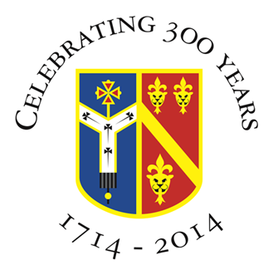

**DEPUTY HEADTEACHER – POLICY AND PRACTICE**

**Location:  Croydon, Surrey Required For: 1st January 2024 (preferably)**

**Contract: Permanent Salary: L19-L23 (£72,542 - £79,635)**

This post is vital for the care and oversight of pupils. It starts with the transition from primary school and goes up to GCSE and beyond. The successful candidate will set high standards in pastoral leadership and practices. You will have a deep understanding of how we can work better as a staff team to create a stronger educational culture. You will enjoy working with parents, Governors and others for young people to thrive personally, academically and socially here.

We are a cohesive Christian learning community with a strong curriculum vision, looking now for a new colleague to take this on further.

Since September 2021, in a successful new Senior Leadership Team, the person in this role has played a critical part in the school’s move out of the pandemic; the increase in pupil numbers to 150 in Years 7, 8 and now 9; and the formation of new team of Senior Pastoral Leaders.

We are looking for you to:

* have a strong Christian understanding of the purpose and calling of a Church school and equip us better to achieve *academic excellence for each person as part of a Christian community*.
* work closely with the Headteacher on our strategic development as the only Church of England secondary school and Sixth Form in Croydon
* be a person of integrity, with a depth of experience and understanding, and able contribute to a strong Senior Leadership Team and very committed staff team
* be an outstanding classroom teacher and school leader to work with aspirational pupils and give academic leadership to both school and Sixth Form
* have ambition, imagination and Christian hope; faithfulness, courage and patience; develop professionally and personally in a secure, but lively atmosphere

**We are an 11-18 Church of England mixed comprehensive  
with a strong, vibrant, academic Sixth Form - 757 pupils (6th Form:111)**

**Closing date: 5pm, Thursday 5th October 2023**

**Full details on this role and to apply online please visit** [**www.archten.croydon.sch.uk**](http://www.archten.croydon.sch.uk)

VISITS RECOMMENDED - contact Joan Andrew, Headteacher's PA

*Archbishop Tenison's is an equal opportunities employer and committed to*

*safeguarding and promoting the welfare of children.  Enhanced DBS check required. Social media profiles of shortlisted candidates will also be checked.*

**Interviews: Tuesday 17th and Wednesday 18th October 2023**