DEPUTY HEADTEACHER APPLICATION PACK

Recruiting for September 2021
Closing date: 3rd May 2021

Dear Applicant,

Thank you for looking at our advertisement for the position of Deputy Headteacher at The Viridis Federation of Orchard, Southwold & Hoxton Garden Primary Schools. I hope that you will find this pack helpful. If you would like to learn more about our schools partnership, I would be delighted to answer any questions that you may have and arrange a visit so you can see what we do for yourself. My contact details are in this pack.

Our schools are based in Hackney, East London with convenient transport links to wider London. We have been in partnership since January 2012 and are a hard federation with a joint Governing Body. We have a joint pupil roll of over 1350 pupils and all three schools are graded ’good’ or ’outstanding’ by Ofsted.

Our pupils achieve well above national averages despite all three schools being in areas of challenge. We have a very skilled team of highly committed and professional teachers and leaders who work incredibly hard. However, there is always much to do. We look to create exciting and innovative opportunities for children to be successful and enjoy learning and also look to share ideas of best practice with other schools. We have very high standards for what can be achieved with the benefits of a shared expertise and support.

We are seeking a new Deputy Headteacher to build capacity and offer new expertise to our senior leadership team. First and foremost we are looking for someone who is confident, knowledgeable and who has the passion, energy and skill to make a difference. This post will be based on one school site with responsibility for teaching, learning, standards, assessment and inclusion in either the Lower School (EYFS and KS1) or Upper School (KS2).

There are many opportunities to work with staff across the partnership. We take our role in raising the aspirations of our children and meeting the ambitions of our staff very seriously and can offer coaching, mentoring and support to ensure your success.

If you are hardworking and looking to take the next step to further develop your leadership potential then we would very much look forward to hearing from you.

Kind regards, Rachel Davie (Executive Headteacher)

Orchard, Southwold and Hoxton Garden have been working in a very successful partnership for over 5 years. We have a joint Governing Body and strong links to our Local Authority, Hackney Education. Each school has its own leadership team who work together with the common aim of giving children the very best. We have very high standards for what can be achieved with the benefits of a shared expertise. Although many of our pupils come from disadvantaged backgrounds or speaking a language other than English, we do not use this as an excuse for under achievement and have the same ambition for all pupils regardless of circumstances. Disadvantaged pupils at our school achieve significantly better than those nationally because of this belief, ambition and hard work.

We are looking to appoint a skilled individual who wants to make a difference to the life opportunities of our children and families and who is able to effectively support our inclusion team.

In particular we are looking for someone who:

- Has previous experience of working in a primary school
- Has high expectations of what can be achieved
- Is passionate about how children learn best and never gives up on them
- Is flexible with a good sense of humour and an understanding of the ‘bigger picture’
- Hard working, creative and has a good sense of fun
- Tough enough to cope with the daily challenges that working in fast paced inner city schools can bring
- Is an excellent communicator who is able to earn the trust and respect of others
- Is able to work to their own initiative as well as part of a team
- Puts children and their right to an excellent education first
- Has experience of planning provision for vulnerable children and hard to reach families

We can offer you:

- A genuine opportunity to make a difference
- Opportunities to work across partner school sites
- High quality support and CPD to ensure that you are successful
- An exciting, well organised and vibrant environment in which to work.
- A fantastic community of parents and children who deserve the best
- A supportive and highly experienced leadership team

If you would like to learn more about us and what we do there is more information on our school websites including an outline of our curriculum and our aims in more detail. We would also be delighted to give you a tour and answer any questions that you may have and this can be arranged by calling Beverley Shore (School Manager) on 0208 985 7785. Alternatively email us at: recruitment@vs.hackney.sch.uk.

Yours sincerely, Rachel Davie (Executive Headteacher)

Contents
Welcome Letter
Why work with us?
Who are we looking for?
How to apply
Job Description
Personal Specification

Why work with us?

- A genuine opportunity to lead and make a difference.
- High quality CPD and support from our experienced leadership team including coaching and mentoring to make sure that you are successful.
- An exciting, well organised and vibrant environment in which to work.
- Happy schools with a fantastic community of parents and children who deserve the best.
- Opportunities to work with our partner schools and partner Deputy Headteachers.
Who are we looking for?

- Is a confident and inspiring teacher with high expectations of what can be achieved.
- Understands how children learn best and never gives up on them.
- Is flexible with a good sense of humour and an understanding of the bigger picture.
- Can effectively coach, mentor and work alongside others.
- Understands the communities that we serve and is tough enough to cope with the challenges that a fast paced inner city school can bring.
- Is a thinker and innovator who can take risks to make a project their own.
- Is a strong communicator, able to work in a dynamic team

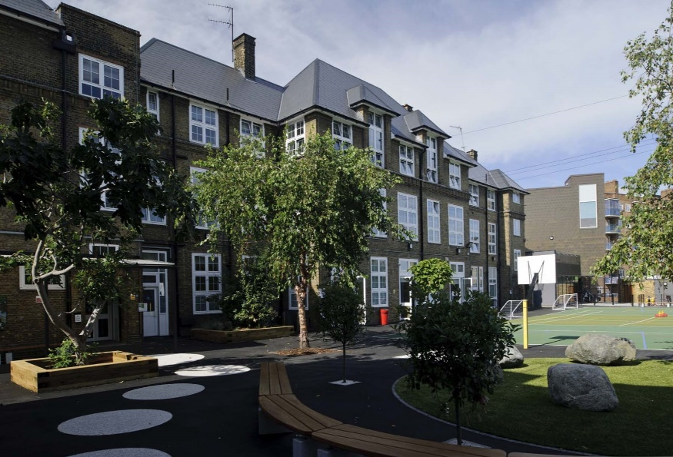
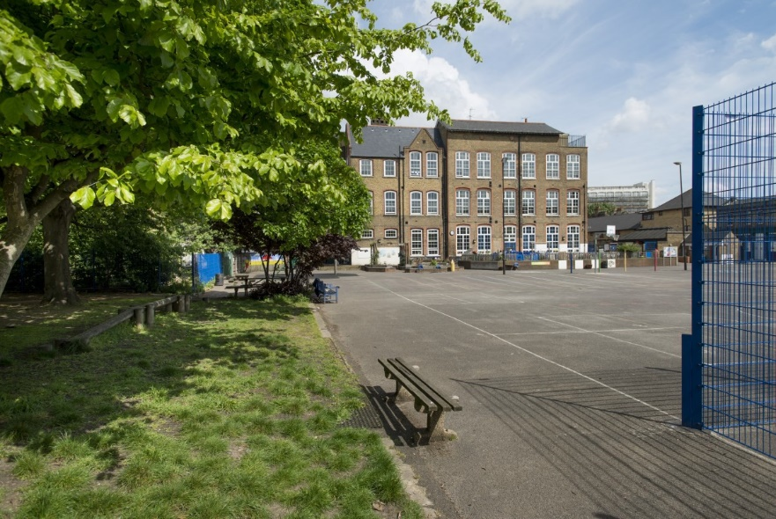
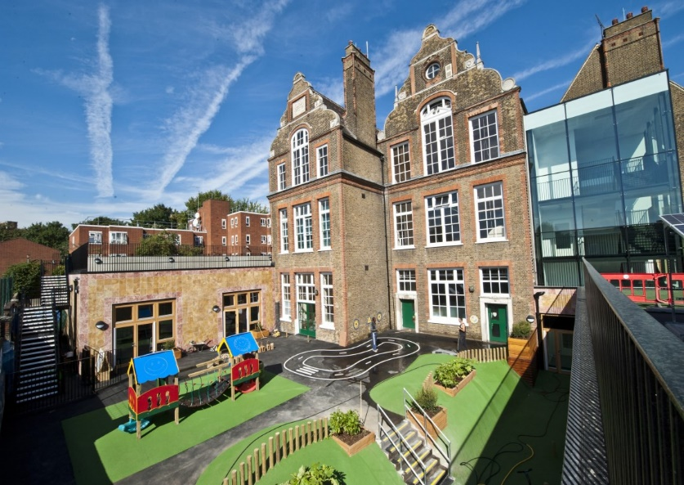

HOW TO APPLY
- Read the job description and person specification carefully.
- Complete the application form either electronically or print it off and hand write it.
- Ensure your supporting statement relates to the competencies outlined in the person specification.
- Email your competed application to Ms Beverley Shore at
recruitment@vs.hackney.sch.uk

or send by post:

Recruitment
c/o Southwold Primary School Detmold Road
London E5 9NL

Our schools are committed to safeguarding and promoting the welfare of children and young people and expects all staff and volunteers to share this commitment. Successful candidates will be required to complete an enhanced DBS disclosure.

We welcome applications from all sections of the community, regardless of gender, race, religion, disability, sexual orientation or age.

Should you like to arrange to visit our schools please contact Ms Beverley Shore on: 0208 806 5201 or email: recruitment@vs.hackney.sch.uk

We look forward to receiving your application!

Closing date: 3rd May 2021

Deputy Headteacher
JOB DESCRIPTION
Grade: Salary L10 – L14 (£60,701 – £66,114)

JOB PURPOSE
All members of the school’s Senior Leadership Team are expected to:

- Demonstrate leadership by example.
- Set high standards, acting as role models for colleagues.
- Show a commitment to enabling all pupils to maximise their achievements.
- Contribute to the provision of a safe, secure learning environment.
- Support the Federation endeavours to meet the needs of the communities we serve.
- Lead and manage staff in a way that promotes their skills, confidence and expertise.
- Participate in the school’s performance management process.

The Deputy Headteacher will also be expected to:

- Have responsibility, in conjunction with the senior team, for the development of planning, coverage and delivery of the National Curriculum and teaching and learning policies.
- Support the Headteacher in the school self-review procedures, including the strategic use of analysis of performance data, and the formulation of the School Development Plan.
- Implement and maintain the discipline of the school.
- Carry out Performance Management of designated staff.
- Deputise for the Headteacher and undertake other reasonable duties at the request of the Headteacher.

PERSONAL STANDARDS

- To ensure that the school’s customer care standards are met and adhered to.
- At all times to carry out the responsibilities of the post with due regard to the school’s position and stated ambition.

THE LEADERSHIP ASPECT OF THE ROLE WILL INCLUDE

- Having secure knowledge and understanding of the National Curriculum, the SEN Code of Practice and Ofsted evaluation criteria.
- Coaching, mentoring and developing teaching teams with impact to ensure quality first teaching for pupils.
- Being the leading professional in the classroom, modelling excellent practice, high standards of professional conduct and supporting the professional development of others through leading training.
- The ability to work effectively as a member of a team and effectively line manage own team.
- Responsibility for monitoring and reporting to parents on the progress of pupils.
- Liaising with relevant staff and organisations to ensure high standards of work and behaviour are maintained.
- Consistent practise of excellent interpersonal skills and the use of excellent organisational skills and ability to liaise with colleagues accordingly.
- Managing the internal running of the school through drawing up such timetables and rotas as are required and
leading assemblies.
- Knowledge of local and national developments relating to education and the ability to disseminate information
as appropriate.
- Confidence in, and the ability to interpret, data analysis to drive pupils’ improvement.
- Accurate record keeping in accordance with the school’s policies.
- Effective management of outside agencies and ensuring up to date safeguarding training.
- Take the role of a designated safeguarding lead in line with school policies and current Government guidelines.

PERSONAL RESPONSIBILITIES

- To carry out the duties and responsibilities of the post, in accordance with the school’s Health and Safety Policy and relevant Health and Safety Guidance and Legislation.
- To promote the safeguarding of children.
- To use information technology systems as required to carry out the duties of the post in the most efficient and effective manner.
- To undertake training and professional development as appropriate.
- To undertake other duties appropriate to the post that may reasonably be required from time to time.

You must demonstrate on your application form that you meet the following essential criteria:

QUALIFICATIONS

- Qualified Teacher Status, and evident of appropriate subsequent in-service training and professional development.

EXPERIENCE

- Evidence of ability to work successfully as a leader and manager in a school at a senior level and of leading a major area of curriculum with impact.
- Substantial classroom experience preferably across more than one phase in at least one multicultural, inner-city school.

PERSONAL QUALITIES

- Proven ability to solve problems, be solution focussed and strategically plan for improvement.
- Commitment and willingness to meet the needs of the ethos and flexible working arrangements of a diverse inner-city school.
- Evidence of the personal and intellectual qualities required to set an example to others and to lead a team.
- Respect for the views of parents, carers and children, and a commitment to the involvement of these groups in the learning process.
- Ability to communicate orally and in writing effectively with colleagues, governors outside agencies and parents/carers.
- A highly motivated energetic and enthusiastic leader, who is approachable and promotes positive relationships.
- Can cope with the pressures of a demanding leadership position.

TEACHING AND LEARNING

- Proven experience of consistently high standards of own primary classroom practice.
- Evidence of a good understanding of a range of teaching styles and approaches appropriate for inclusive education.
- Evidence of proven impact in raising standards within a school through the effective development of teaching and learning, ensuring that the needs of individual /groups of pupils are met.

KNOWLEDGE, SKILLS AND ABILITY

- Evidence of a commitment to excellence and the maximising of academic and personal achievement for all pupils.
- Evident of use of assessment strategies, including assessment of learning and the use of tracking of attainment and of analysis of data.
- Evidence of the ability to maintain effective classroom discipline in a positive context and to promote well-ordered and self-disciplined behaviour throughout the school.
- Evidence of the skills and abilities required to develop and support teachers in their classroom practice, including the effective maintenance of record.
- To be able to interpret, data analysis to drive pupils’ improvement.
- To be able to line manage staff effectively.
- To keep accurate records in accordance with the school’s policies.
- Good knowledge of ICT for teaching and administrative purposes.

EQUAL OPPORTUNITIES

- Demonstrate a clear understanding of and a commitment to equal opportunities and give evidence of effective implementation.
- Ability to form and maintain appropriate relationships and personal boundaries with children and young people.

