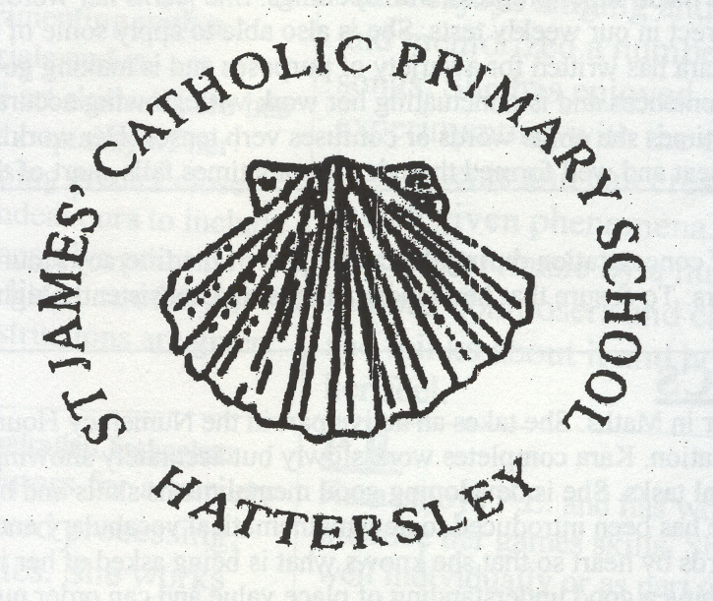
MRS. J. WALKER CHERITON CLOSE
HEADTEACHER HATTERSLEY
HYDE
TEL: 0161 368 3455 CHESHIRE
FAX: 0161 368 3177 SK14 3DQ
admin@st-james-hyde.tameside.sch.uk

Dear Candidate

On behalf of the governors of St James’ Catholic Primary School, I would like to thank you for expressing an interest in the recently advertised post of Deputy Headteacher of our school. This position has arisen due to the retirement of our current headteacher, Mrs Jackie Walker and the Promotion of our current Deputy Head Teacher, Mr Mark Woolley successfully securing the Head Teacher role.

St James’ is a very friendly and much loved Catholic Primary School serving the parish of St James the Great, Hattersley and neighbouring areas. It is a popular primary school in which the Catholic ethos is at the centre of all relationships both within and beyond the school and the community it serves. We are rightly proud of our school and the way it has gone from strength to strength over the years. This is reflected in the comments from our parents and all visitors to the school and the high regard it is held in by Diocese of Shrewsbury and our local education authority of Tameside MBC.

The governors are keen to build on the school’s successes and to continue its faithful commitment supporting the faith community here in Hattersley. This faith commitment is at the heart of all we do and underpins the relationships at all levels. It also underpins our continuous drive to raise standards through the school and ensuring that we continue to see this reflected in the physical environment for our pupils. Our mission statement ‘Together we are learning to follow Jesus’ truly reflects our school community.

Visits to the school are encouraged. Please contact Mrs Walker and her office staff to facilitate a mutually convenient time.

Yours sincerely,

Kevin Toms
Chair of Governors

