Diocese of Arundel and Brighton
ST JOHN THE BAPTIST CATHOLIC PRIMARY SCHOOL

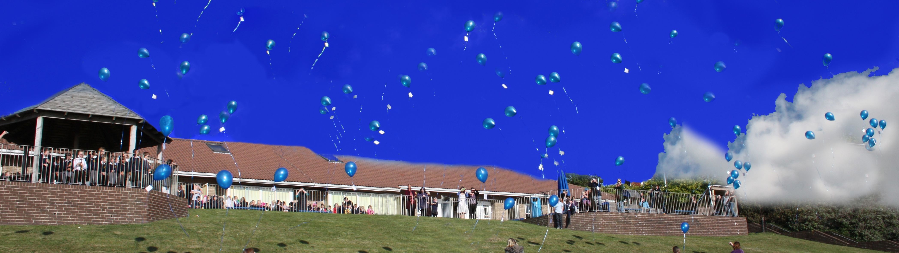
Whitehawk Hill Road ~ Brighton BN2 0AH
01273 607 924

DEPUTY HEADTEACHER

Required for September 2021
Salary Range: L4 –L8
PAN: 210 Age Range: 4-11

The Governors of this welcoming and popular Catholic school wish to appoint an excellent practitioner for the post of Deputy Headteacher from September 2021. The successful candidate will be a practising Catholic, fully committed to developing and enriching the ethos of our school. They will have a lead role in the development of the curriculum including Religious Education.

We are looking for someone special who:
- Is an excellent classroom teacher, able to inspire and motivate children to achieve their personal best and become lifelong learners.
- Is highly motivated with proven leadership skills and experience of successfully leading aspects of whole school improvement.
- Is a team player, committed to working in partnership with governors, colleagues, parents and parish.
- Has initiative, drive, integrity, a sense of humour and enjoys a challenge!
We can offer you:
- Happy, enthusiastic, well-behaved children who are full of great ideas.
- A friendly and supportive school team – staff, parents and governors.
- A lovely school, with beautiful sea views to brighten each day!
If you have a desire to challenge yourself and those around you, to extend your professional skills, knowledge and understanding and to take a lead role in the next phase of growing our school culture, then we are very much looking forward to hearing from you.
Visits to the school are warmly welcome; we have a strict Covid 19 Health & Safety plan in place. Please contact Mrs Joanne Levy, School Business Manager on 01273 607924 or by email: Joannelevy@stjohn.brighton-hove.sch.uk to arrange a visit and to request an application pack.
St John the Baptist Catholic Primary School is committed to safeguarding and promoting the welfare of children and young people and expects all staff and volunteers to share this commitment. Appointments will be subject to an enhanced DBS check.

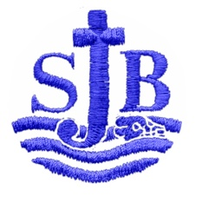
Closing Date: Monday 17th May 2021 at 12pm
Interviews: Week commencing 24th May 2021

