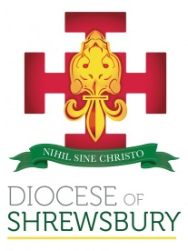
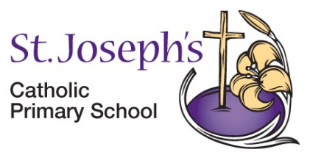
St. Joseph’s Catholic Primary School
Winsford, Cheshire. CW7 2JS

Deputy Headteacher
Required for September 2026
ISR Group 3, L6 – L13 NOR: 315 plus 20 FTE Nursery
The Governors are seeking to appoint a highly motivated and inspirational Deputy Headteacher who can support the Headteacher in leading the school to the next stage of its exciting journey.

We are seeking a Deputy Headteacher who:
- is a practising Catholic, committed to the ethos and vision of Catholic education and can nurture faith and spirituality
- is an outstanding class teacher, passionate in developing high standards and striving for excellence
- has excellent communication and interpersonal skills
- has the ability to lead, motivate and inspire staff and children to achieve the highest standards
- has experience of strategic planning and leadership

St. Joseph's is a thriving Catholic Community. We have:
- happy and well-motivated children who enjoy learning
- a dedicated, friendly and supportive staff team who have high expectations of themselves and each other
- the support of parents within a thriving parish community
- governors who have the best interests of the children at heart and effectively support and challenge our school.

The school is committed to safeguarding and promoting the welfare and safety of children. The successful candidate will be required to complete an enhanced DBS disclosure and will follow a stringent vetting and induction process. Prospective candidates are warmly welcome to visit the school. Please contact the school to make an appointment.
Closing Date: Friday 13th February 2026 at 4pm
Observations: Thursday 26th February and Friday 27th February
Interviews: Monday 2nd March 2026
Further details and CES application forms are available from www.stjosephs.cheshire.sch.uk and returnable to the Chair of Governors via the school:
Mr T Montgomery, St. Joseph’s Catholic Primary School, Woodford Lane, Winsford, Cheshire CW7 2JS
or via e-mail: admin@stjosephs.cheshire.sch.uk

Telephone: 01606 668790

