
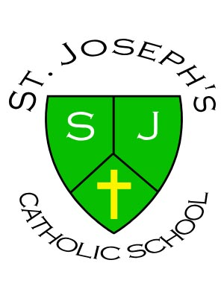St. Joseph's Catholic Primary School
West Close Road
Barnoldswick
Lancashire
BB18 5EN

Headteacher:
Mrs N Wood
Email: head@st-josephs-barlick.lancs.sch.uk
Tel: 01282 813045
Fax: 01282 854846

Friday 23rd April 2021

Dear Applicant,
The Staff, Governors, parents and, most importantly, the children of St. Joseph’s School welcome your interest in the role of Deputy Headteacher. St. Joseph’s is a small school with five mixed aged classes. At present there are 128 pupils on roll.

The governors wish to appoint a candidate who is passionate and knowledgeable about the pursuit of teaching and learning and has a love of working with children. We are looking for someone who can support the headteacher with strong leadership and is able to build on the school’s current strengths and ensure we continue to improve by embracing the opportunities which are offered in a leading Catholic primary school. The person specification provides a more comprehensive list of the qualities we are looking for.
The school is an integral part of the parish and the successful candidate will receive a warm welcome from the parish family.
A wealth of information can be found on the school website including our prospectus, latest newsletter and twitter account @StJosBarlick, the last Ofsted report (May 2017) and our Section 48 report (November 2018), when we were awarded ‘Good’.

I hope you will find the information useful and interesting.

You are very welcome to contact us if you would like further information or visit the school (following Covid regulations) where you will have the opportunity to experience at first hand the warmth and passion for learning displayed by all our pupils and staff. Please contact Mrs. Marie Beech, School Bursar, on 01282 813045 to arrange a visit.
Thank you for your interest in this post.
I look forward to hearing from you and receiving your application.
Yours faithfully,
A Wood & N Wood
A Wood (Chair of Governors), N Wood (Headteacher)

‘With Jesus at the centre of all we do and say’
