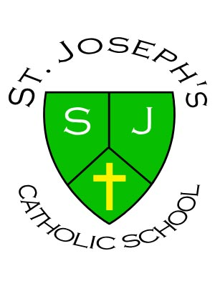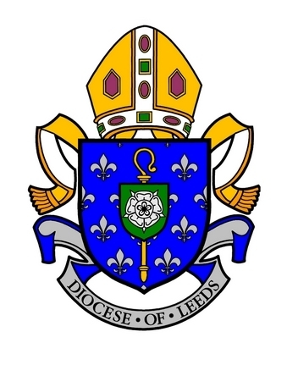
ST. JOSEPH’S CATHOLIC PRIMARY SCHOOL
West Close Road, Barnoldswick, Lancashire, BB18 5EN
Telephone: 01282 813045 Fax: 01282 854846
www.st-josephs-barlick.lancs.sch.uk

“With Jesus at the centre of all we do and say”

DEPUTY HEADTEACHER
Salary: 3-8. NOR: 128
Required 1st September 2021

An exciting opportunity has arisen at our school which was rated as good by Ofsted in 2017 and in our Section 48 inspection of November 2018. Governors are seeking to appoint a strong, highly motivated and inspirational Deputy Headteacher who is a practising and committed Catholic, to join our dedicated and caring school team. In partnership with the Headteacher you will work effectively and pro-actively with the children, parents, governing body, staff, the church and the local community.

St. Joseph’s is a small mixed aged Catholic Primary School, located in Barnoldswick in Lancashire and close to North Yorkshire. It is a successful school, committed to raising standards of achievement. We have wonderful children, supportive parents, dedicated staff and governors.

We are looking for a leader who:-

- As a practising Catholic will lead by example to continue to promote and develop the strong Catholic ethos of our school
- Is an excellent classroom practitioner who leads by example and who motivates, inspires and challenges staff and children to reach their true potential
- Understands how pupils learn and helps them make excellent progress
- Will support the Headteacher with strong leadership
- Is able to share the vision of the Headteacher, Governors and Staff for an outstanding future

We offer the successful candidate:

- A happy and caring school with a strong Catholic ethos
- A caring and supportive staff team, who are committed to ensuring every child reaches their true potential
- Continuous development opportunities to support your ambitions for future leadership progression
- Delightful children who are enthusiastic, well behaved and enjoy learning
- A family atmosphere, working closely with our supportive families and the Church community

The successful candidate could start higher up on the pay range depending upon expertise and experience.

Visits to the school are warmly welcomed by arrangement. Covid restrictions will be in place. Please contact the School Office to make an appointment Tel: 01282 813045

- Closing date: Noon on Friday 14th May 2021
- Shortlisting: Monday 17th May
- Interviews: Friday 28th May 2021
- Starting Date: 1st September 2021
Applications must be made using the CES Application Form only.
Application forms can be downloaded online or can be requested from: recruitment@btlancashire.co.uk
Applications are encouraged to be returned electronically to: recruitment@btlancashire.co.uk
St. Joseph’s is committed to safeguarding and promoting the welfare of children and expects all staff to share this commitment. The posts are subject to an enhanced disclosure application to the Disclosure & Barring Service (DBS).

