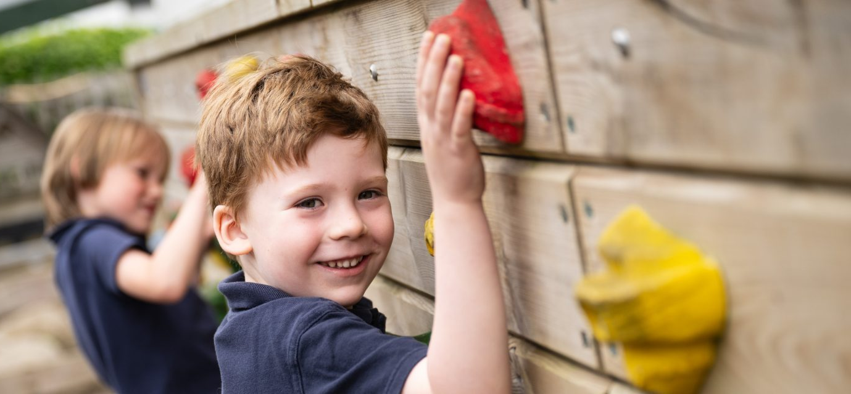
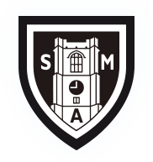
St Michael’s C of E Voluntary Aided Primary School
Aldbourne, Wiltshire, SN8 2BP

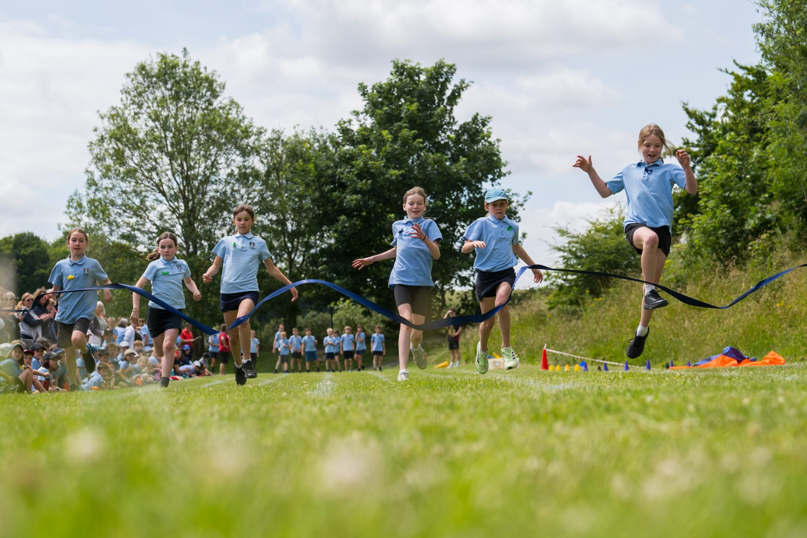
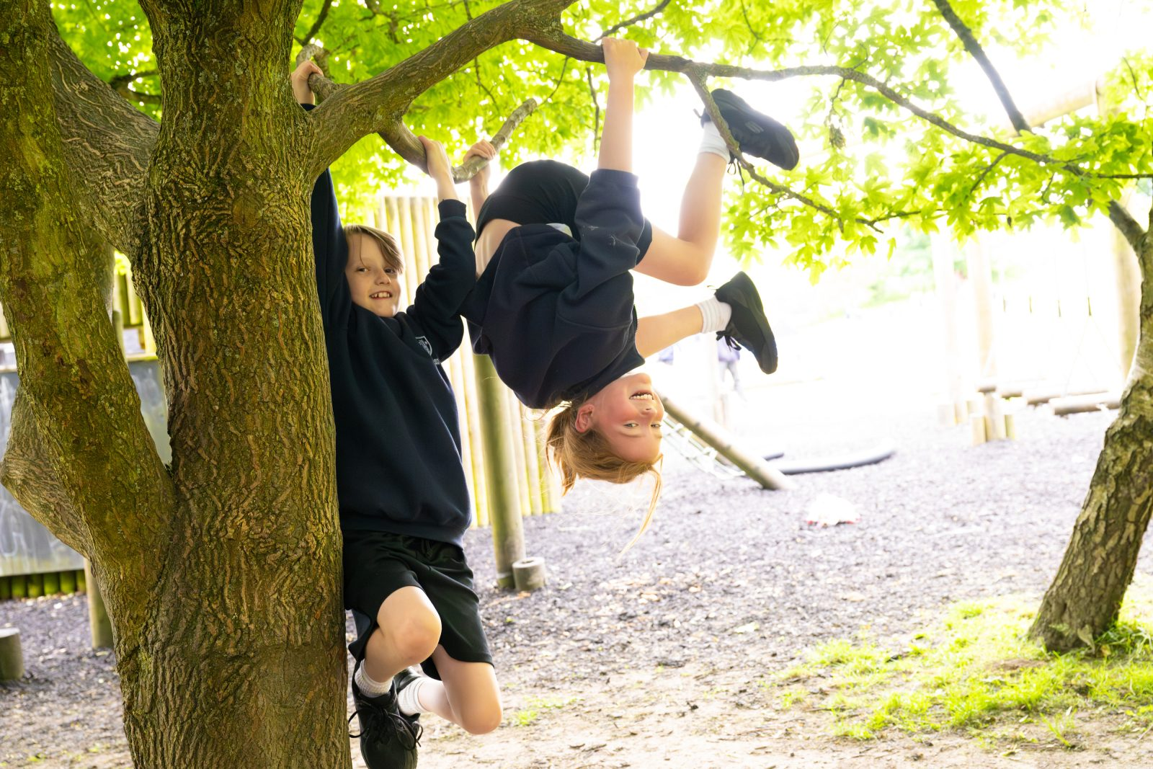
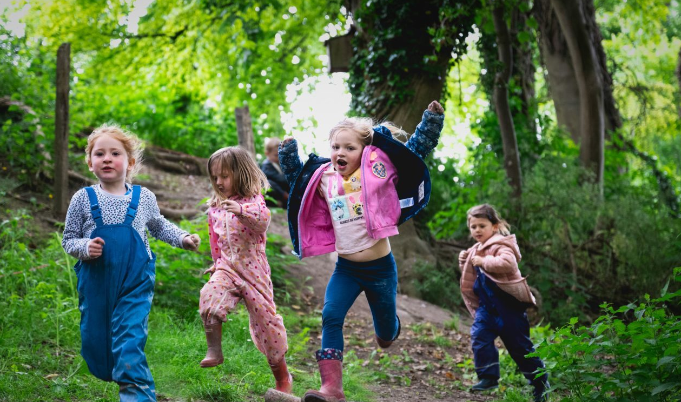
Deputy Headteacher Recruitment Information Pack

Febuary 2026

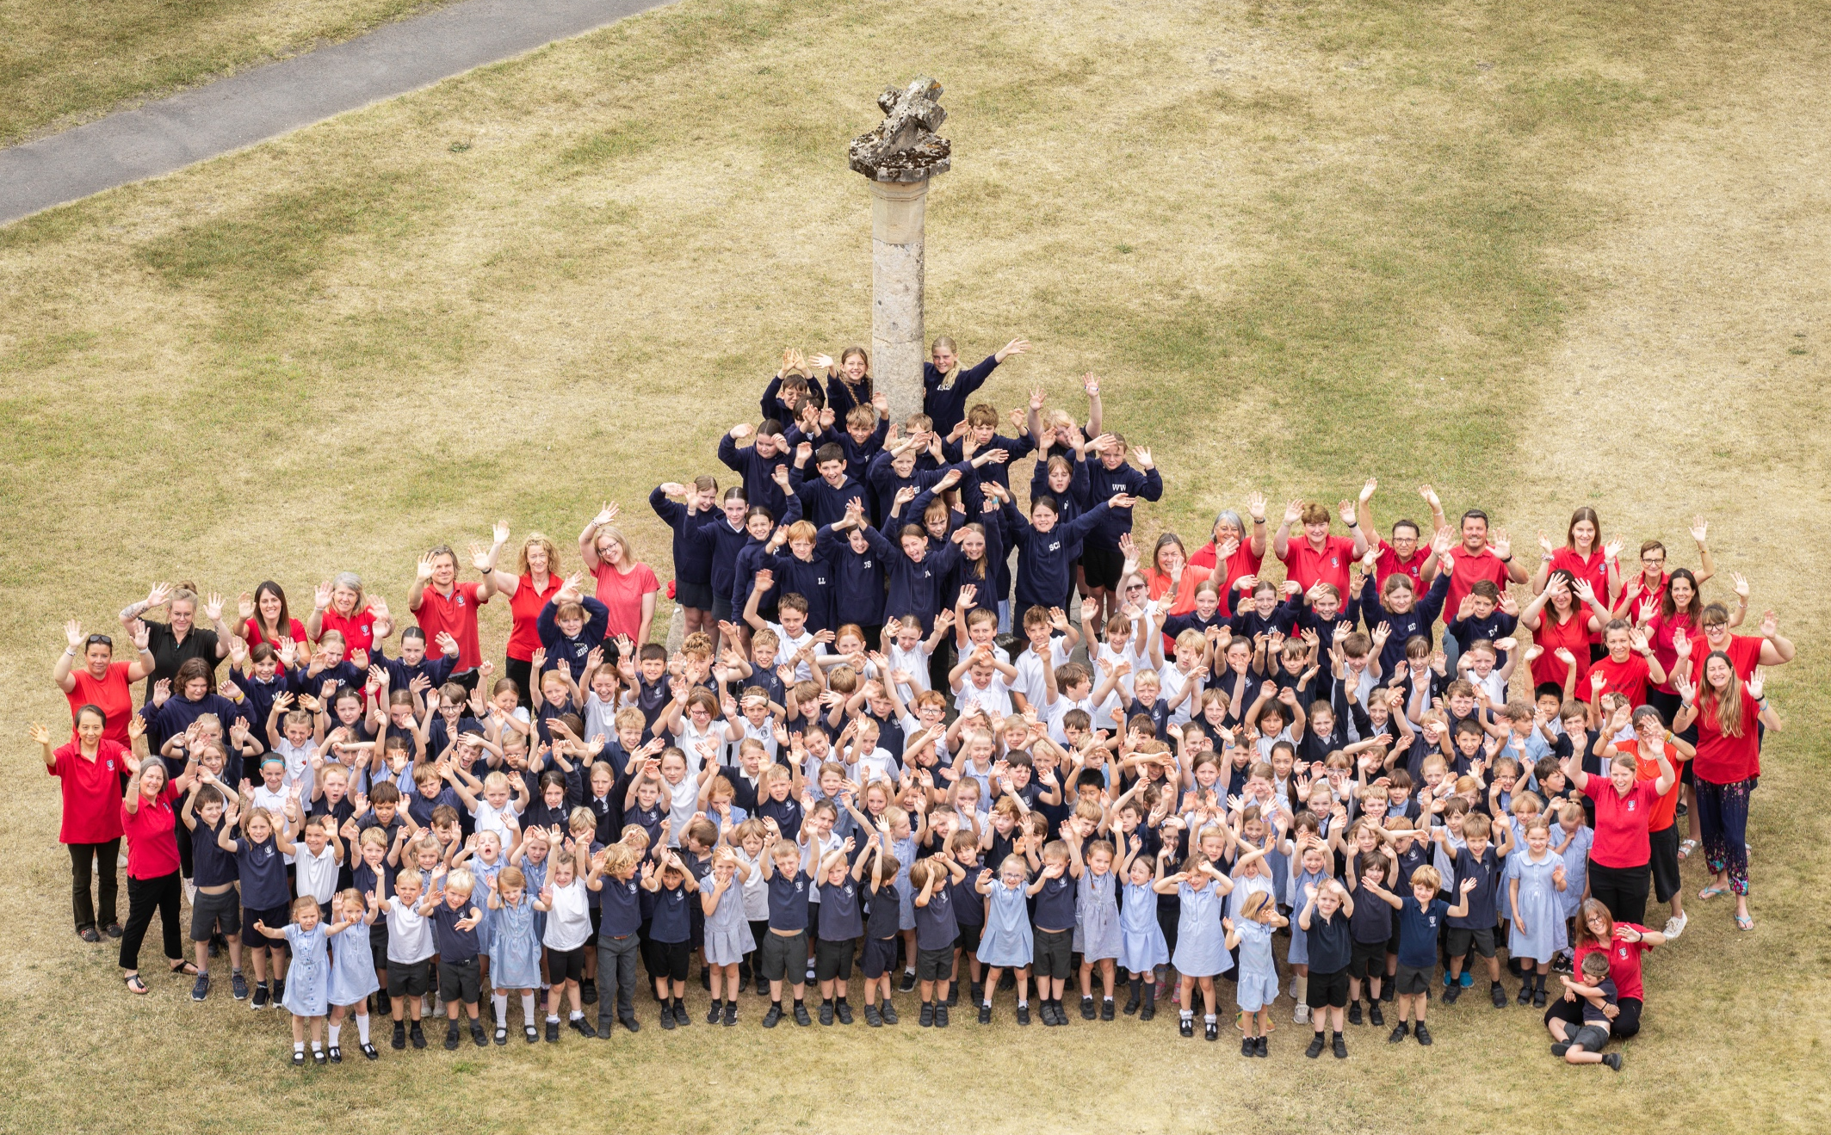
A Welcome from the Headteacher
Dear Candidate,
Thank you for your interest in this post. It is a great privilege to introduce this opportunity to join St Michael’s as Deputy Headteacher at such an exciting and significant moment in the life of our school.
Having been part of the leadership team at St Michael’s for many years, and recently appointed as Headteacher, I feel incredibly proud of the journey the school has been on and hugely excited about the next chapter ahead. St Michael’s is a deeply special community, rooted in strong relationships, shared values and a commitment to nurturing “a lifetime love for learning.”
As Headteacher, my vision is to build thoughtfully on the strong foundations already in place — continuing to develop a school where children feel known, safe and inspired, and where staff feel empowered to grow, reflect and innovate together. This vision shapes the way we nurture children who achieve exceptionally well, are spiritually aware, compassionate and respectful of the world around them.
St Michael’s combines rigorous, evidence-informed teaching with creative and innovative approaches that enrich the curriculum and broaden children’s experiences. From continuous provision and early learning, to Forest School, OPAL play and the arts, we believe that curiosity and engagement create the conditions for deep, sustained learning.
One of our greatest strengths is our staff team — passionate, reflective professionals who care deeply about children and about each other. Coaching plays a central role in our professional culture, supporting reflective dialogue, professional growth and a shared responsibility for continual improvement.
Central to our leadership approach is collaboration. Trust, open professional dialogue and a shared sense of purpose underpin the way we work together as a team and ensure that both adults and pupils can thrive. I am seeking a Deputy Headteacher who shares this belief in relational leadership and who is committed to supporting high-quality teaching through research-informed practice, a reflective professional culture and a deep understanding of inclusive education. The successful candidate will balance strategic thinking with warmth and integrity — someone who values collaboration, champions staff development and is passionate about ensuring that every child is supported to succeed.
St Michael’s sits at the heart of the vibrant village of Aldbourne, a close-knit community with a rich cultural life and a strong sense of identity. The school and church are central to village life, and our families take great pride in being part of the school’s story.
We warmly encourage you to visit us, meet our pupils and staff, and experience for yourself the spirit and values of St Michael’s. Visits are welcomed between 24th February and 12th March 2026, and can be arranged by contacting Louise Jamieson, School Bursar, at admin@stmichaelsaldbourne.co.uk.
If you wish to apply, please email admin@stmichaelsaldbourne.co.uk for an application pack by noon on Thursday 12th March 2026. Please note that we are unable to accept CVs.
I very much look forward to welcoming candidates who are excited by this opportunity and who share our commitment to creating a happy, inclusive and inspiring environment for all.

With best wishes,

Ben Everitt
Headteacher (from Term 5)

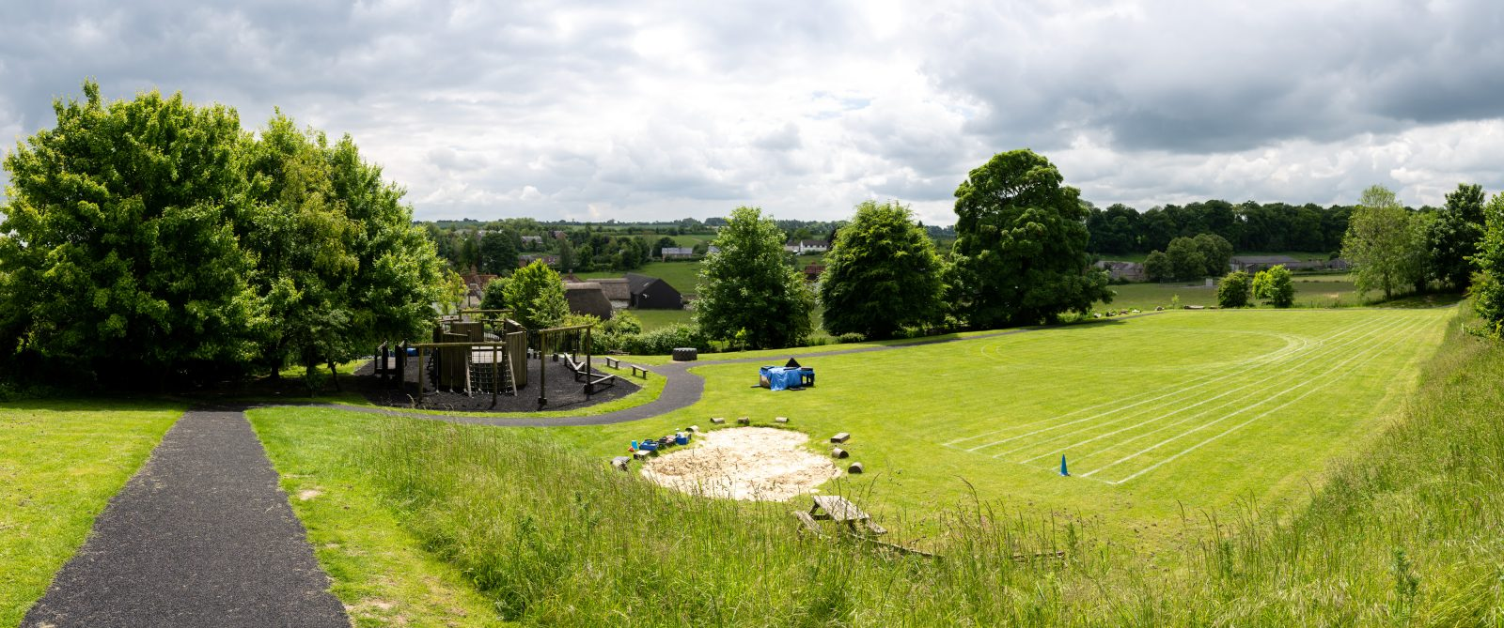
Voices from our school community
What do parents and carers say about St Michael’s?
from 2023 Ofsted Parent View (135 Responses)
- 98% of parents feel their child is safe at St Michael’s.
99%
of parents agree or strongly agree that their child is happy at St Michael’s.
- 93% of parents agree the school makes sure pupils are well behaved.
- 95% of parents say their child does well at St Michael’s.
- 94% of parents feel the school has high expectations for their child.
- 94% of parents agree there is a good range of subjects available.
- 92% of parents say their child can take part in clubs and activities.
- 89% of parents feel the school supports their child’s wider personal development.
- 94% of parents would recommend the school to another parent.

Students feel St Michael’s is special because…
“
”
“
”
“
”
“
There is not bullying
Continuous provision goes on until end of year 2
We can play with all
the OPAL stuff
Everyone cares about each other
We are respectful and are lucky to have amazing teachers
“
“
Learning is made fun
”
”
”

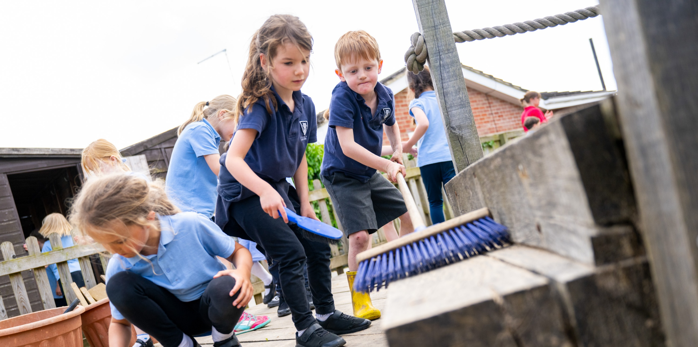
St Michael’s at a glance

Age Range: | 4-11 Years
Location: | Aldbourne, Wiltshire
Type of School: | CofE, Voluntary Aided School
Organisation: | Headteacher
Current Staff Numbers:  Current Teaching Staff: | 40 in total  10 Teachers (Full and Part Time)
Non-Teaching Staff: | 1 Headteacher  18 Teaching Assistants (Regular and Casual)  13 After-school (Regular and Casual)  5 Support Staff
Number of children on roll (and max): | 194 (210)
Average Class Size | 27.7 children
Classes: | 7 (one per year group)
24/25 Attendance: | 95.9%
Children claiming free school meals: | 12.4%
Children with SEN: | 12.4%
Children with English as an additional language: | 8.3%
Children in receipt of Pupil Premium: | 19%
Ofsted Rating (July 2016)  Note: In window for full inspection | Outstanding  https://reports.ofsted.gov.uk/provider/21/126392
24/25 EYFS – Good Level of Development: | 79% (69% national average)
24/25 Key Stage 2 RWM: | 84% (80% national average)
 | 91% (75% national average)
 | 88% (72% national average)
St Michael’s C of E VA School, Aldbourne
Job Description and Person Specification for the Role of Deputy Headteacher

Salary: L3 – L7
Starting Date: Term 6 2026 or September 2026

St Michael’s is an Ofsted Outstanding school (2016) at the heart of Aldbourne village, Wiltshire. Rooted in Christian values of Honesty, Respect, and Love, we are a joyful, research-led community of 194 pupils where curiosity is celebrated, individuality is nurtured, and children develop a lifelong love for learning. Following the promotion of our current Deputy Head to Headteacher we are looking to appoint a Deputy Headteacher who is passionate about learning.

We are looking for a Deputy Headteacher who:
- Is an inspiring classroom teacher, able to lead by example
- Can work in partnership with the Headteacher in ensuring the continual improvement of the school
- Is able to demonstrate good communication and interpersonal skills and has the ability to lead, motivate, develop and support staff

Job Description

Leadership and Management
- Support the Headteacher in the overall leadership of the school and ensure continuity of policy, organisation and strategic direction (the job will include some dedicated leadership release time).
- Work with the Headteacher and governors to identify priorities for school improvement and lead strategies to raise standards.
- Encourage a positive, collaborative team culture across teaching and support staff.
- Organise TA staff duties, timetables and deployment, as well as organising appropriate cover.
- Undertake the full professional duties of the Headteacher in their absence.
- Take part in professional development and contribute to the training of staff.
- Act as a subject leader, promoting high standards in the allocated curriculum area.

Curriculum, Teaching and Assessment
- Assist with the leadership and oversight of the whole-school curriculum, ensuring it is broad, balanced and meets statutory requirements.
- Support monitoring of teaching and learning across the school, offering coaching and feedback where needed.
- Contribute to assessment procedures, including moderation, record-keeping and the analysis of school data.
- Teach full-time (other than agreed leadership release) in an assigned class, planning and delivering high-quality learning that supports the progress and development of all pupils.
- Contribute to the display and presentation of pupils’ work around the school.
- Maintain accurate records of attainment, progress and pastoral information.

Pupil Welfare, Behaviour and Safeguarding
- Help maintain high standards of behaviour, discipline and pupil welfare throughout the school.
- Promote positive attitudes towards adults, peers, learning and the school environment.
- Uphold effective safeguarding practices and promote the health and safety of all.
- Provide pastoral support and liaise with parents and external agencies when needed.
- Understand the importance of inclusion in the classroom and wider school environment.

Faith, Ethos and Community
- Support and promote the Christian life and ethos of the Voluntary Aided school.
- Lead whole-school and class assemblies and support pupils’ spiritual development.
- Maintain links with pre-school settings, secondary schools and the wider community, supporting transition and enrichment opportunities.
- Support school and community events wherever possible.

Duties will be kept under review and may be amended as necessary in consultation with the Headteacher to meet the evolving needs of the school.

Person Specification

 | Essential | Desirable
Qualifications | - Qualified Teacher Status  - Evidence of commitment to own professional development | - Interest in future NPQH  - Leadership qualification
Experience | - Excellent classroom practitioner  - Relevant teaching experience gained through teaching the primary age range  - Experience of completing leadership projects, preferably related to a core subject leading to whole school improvement  - Experience of monitoring teaching and learning, including analysis of assessment data  - Ability to support colleagues in areas of teaching and learning  - Good understanding and use of assessment, including target setting and tracking  - Strong knowledge of effective SEND practice. | - Teaching in more than one Key Stage.  - Experience at leading performance management  - Using coaching for school improvement  - Experience/knowledge of Teaching Walkthrus.  - Experience and knowledge of the pedagogy around play-based learning in EYFS & KS1
Leadership and management | - Senior leadership and management experiences  - A good understanding of whole school issues  - Ability to set high and clear expectations, to hold others, including Teaching Assistants, accountable for performance and the contributions they make to the school community  - Experience of having led whole school initiatives  - Good communication skills with a wide range of stakeholders  - Knowledge and understanding of current educational initiatives  - Ability to take the leadership when appropriate  - Working knowledge of effective safeguarding practice. | - Experience of mentoring and leading performance management  - Experience of whole school self-review and evaluation  - Uses evidence based research to guide leadership, teaching and learning.  - Level 3 Advanced DSL
Personal Qualities | - Committed to working as a member of a team  - Have high expectations of children’s attainment, behaviour and attitude  - Support and value the Christian ethos of the school  - Good planning and organisational skills  - Excellent communication skills  - Ability to enthuse and lead a team with sensitivity and energy | - A practicing member of a mainstream Christian church  - Experience of leading Christian collective worship  - Knowlegde of Diocese evaluation/inspection

Selection Process

We warmly encourage prospective candidates to visit St Michael’s in March 2026 to experience our ethos and community first-hand. Visits will provide an opportunity to meet pupils and staff and to see our distinctive approaches in action. To arrange a visit, please contact Louise Jamieson, School Bursar, via email at admin@stmichaelsaldbourne.co.uk.

How to Apply
- Please email admin@stmichaelsaldbourne.co.uk for an application pack.
- Please complete the application form in full and return, unfortunately CVs cannot be accepted.
- The closing date for applications is noon Thursday 12th March 2026.

Shortlisting
- Candidates will be assessed against the criteria set out in the Person Specification.
- All applicants will be notified of the outcome of shortlisting.

Interviews
Interviews will take place on Thursday 19th March 2026.

Safeguarding and Safer Recruitment
St Michael’s is committed to safeguarding and promoting the welfare of children and young people. We expect all staff and volunteers to share this commitment. All applicants will be subject to an enhanced Disclosure and Barring Service (DBS) check. References will be taken up prior to interview.
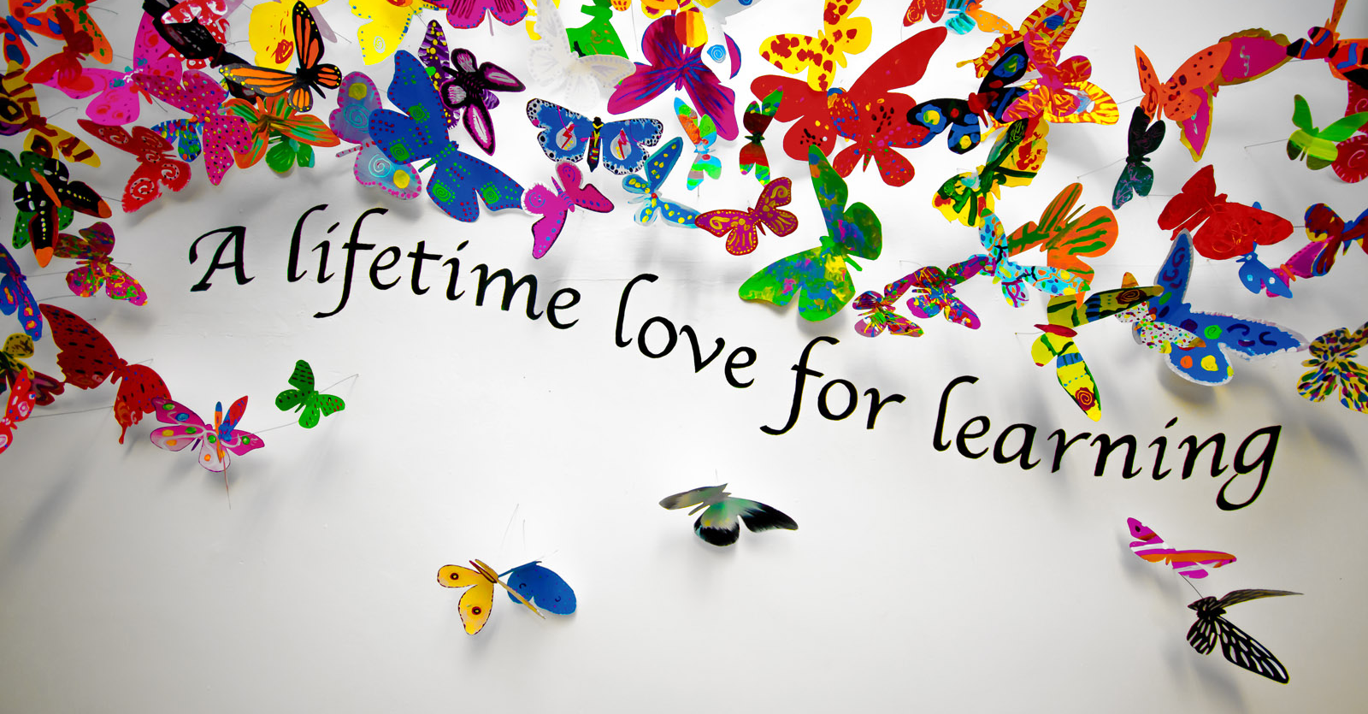
The appointment will be subject to all relevant safer recruitment checks in line with Keeping Children Safe in Education.

