

**WALTHAMSTOW SCHOOL FOR GIRLS**

***“NEGLECT NOT THE GIFT THAT IS IN THEE”***

Candidate Information Pack

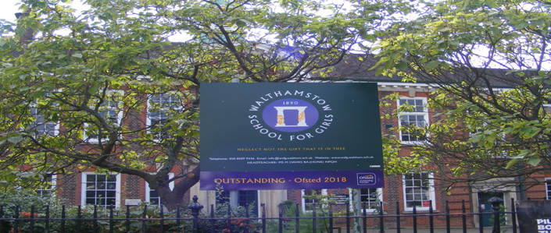

**Information for applicants for the post of**

**Deputy Headteacher: Teaching and Learning**

**Required for September 2023**

Contents of Applicant Pack

* Welcome letter from Helen Marriott – Headteacher
* School Prospectus Link
* School Improvement Plan Link
* What staff value about our school
* Pre-employment checks
* Faculty Information (where applicable)
* Additional Information and Key Policies
* Staff Benefits

**Visits to the school are positively encouraged, with an opportunity to meet with Helen Marriott. Please email Mandy Madhani, Human Resources Manager,** [**m.madhani@wsfg.waltham.sch.uk**](mailto:m.madhani@wsfg.waltham.sch.uk)

**School Prospectus 2022**

[2022 prospectus v2 25-9-22 ver 4(1) - Copy law 2.pdf](https://wsfg-my.sharepoint.com/:b:/g/personal/mmadhani_320_wsfg_waltham_sch_uk/EU-OW05LQ9xIjpv4v4DvvG8Bb-B_sew_NN8wJwAvtNkDbA?e=YDtvUq)

**School Improvement Plan 2021=2024 – introduction**

<https://sway.office.com/8kD9HWBkxtkwJZUC?ref=Link>



Welcome letter from Helen Marriott, Headteacher

March 2023

Dear Applicant

I am delighted that you are considering applying for the role of Deputy Headteacher : Teaching and Learning at Walthamstow School for Girls. I consider it a privilege to lead staff and students in this exceptional school where we are passionate about education being a vehicle for promoting equality for all and where our mission is to empower young women to become leaders of the future. We are a truly comprehensive school, proud of our diversity and committed to social justice. Although we are an Outstanding School (Ofsted, 2018), achieve exceptional outcomes and have consistently been in the top 20% of schools nationally for progress, our focus is on developing exceptional young women, not just on academic achievement. Our designation as a Teaching School Hub has given us the opportunity to work collaboratively with leaders and practitioners throughout Haringey, Redbridge and Waltham Forest to improve the life chances of young people in 239 schools across our area. There could not be a more exciting time to join the students and staff at WSfG!

We actively value staff and students: we are committed to their development and the contribution they make to shaping the future direction of the school. Our school SIP, created initially with middle leaders and then with a wider range of stakeholders, demonstrates our commitment to staff and student wellbeing, distributed leadership and creating robust systems, founded on evidence-informed practice. I have included a summary in this pack so that you have a ‘flavour’ of how our key priorities will be developed over the next few years.

We are committed to Safer Recruitment practices and procedures and shortlisted applicants will be questioned about their commitment to the safeguarding of young people. The successful candidate will be subject to an enhanced DBS clearance.

Having read the candidate information, I hope that you feel excited by both the role itself and the chance to be part of WSfG at a pivotal moment in its development. We welcome visits from prospective candidates and would be proud to show you round our wonderful school.

I look forward to hearing from you.

Helen Marriott

Headteacher MA NPQH



Additional Information and Key Policies

Please follow the links provided below:

Safeguarding:

[SAFEGUARDING POLICY 2022-2023.pdf](https://wsfg-my.sharepoint.com/:b:/r/personal/mmadhani_320_wsfg_waltham_sch_uk/Documents/Human%20Resources/Key%20Policies/SAFEGUARDING%20POLICY%202022-2023.pdf?csf=1&web=1&e=oEEQR2)

Keeping Children Safe in Education:

[KCSIE_2022_Part_One.pdf](https://wsfg-my.sharepoint.com/:b:/r/personal/mmadhani_320_wsfg_waltham_sch_uk/Documents/Human%20Resources/Key%20Policies/KCSIE_2022_Part_One.pdf?csf=1&web=1&e=Omqzja)

Guideline for employing people with criminal records

[LBWF-CRB-Guidance-for-applicants-community-schools.pdf](https://wsfg-my.sharepoint.com/:b:/r/personal/mmadhani_320_wsfg_waltham_sch_uk/Documents/Recruitment/Applicant%20packs/Applicant%20Info%20Packs%202023/WF%20ATTACHMENTS/LBWF-CRB-Guidance-for-applicants-community-schools.pdf?csf=1&web=1&e=rXStFv)

Applicants Guide to Prevention of Illegal Working:

[APPENDIX_17_Applicant_guide_to_illegal_working.pdf](https://wsfg-my.sharepoint.com/:b:/r/personal/mmadhani_320_wsfg_waltham_sch_uk/Documents/Recruitment/Applicant%20packs/Applicant%20Info%20Packs%202023/WF%20ATTACHMENTS/APPENDIX_17_Applicant_guide_to_illegal_working.pdf?csf=1&web=1&e=v3gvcd)

LBWF Safer Recruitment Guidance

[WF Safer Recruitment Guidance notes (advertising).doc](https://wsfg-my.sharepoint.com/:w:/r/personal/mmadhani_320_wsfg_waltham_sch_uk/Documents/Recruitment/Applicant%20packs/Applicant%20Info%20Packs%202023/WF%20ATTACHMENTS/WF%20Safer%20Recruitment%20Guidance%20notes%20(advertising).doc?d=w1fd69569c1e14d33ab54098e38f541cb&csf=1&web=1&e=Hob786)

LBWF Equalities Policy Statement and Equality Act 2010 guidance

[WF Equal_Opportunities_Policy_Statement_(advertising).doc](https://wsfg-my.sharepoint.com/:w:/r/personal/mmadhani_320_wsfg_waltham_sch_uk/Documents/Recruitment/Applicant%20packs/Applicant%20Info%20Packs%202023/WF%20ATTACHMENTS/WF%20Equal_Opportunities_Policy_Statement_(advertising).doc?d=w57bdfc130c92443c858dbca07d57ee40&csf=1&web=1&e=FeyQ4C)

LBWF Equal Opportunities Policy Statement

[APPENDIX_21_Equal_Opportunity_Statement v2.pdf](https://wsfg-my.sharepoint.com/:b:/r/personal/mmadhani_320_wsfg_waltham_sch_uk/Documents/Recruitment/Applicant%20packs/Applicant%20Info%20Packs%202023/WF%20ATTACHMENTS/APPENDIX_21_Equal_Opportunity_Statement%20v2.pdf?csf=1&web=1&e=uJNIuH)

**Candidates are encouraged to visit the school website for additional information:**

[**https://www.wsfg.waltham.sch.uk/**](https://www.wsfg.waltham.sch.uk/)

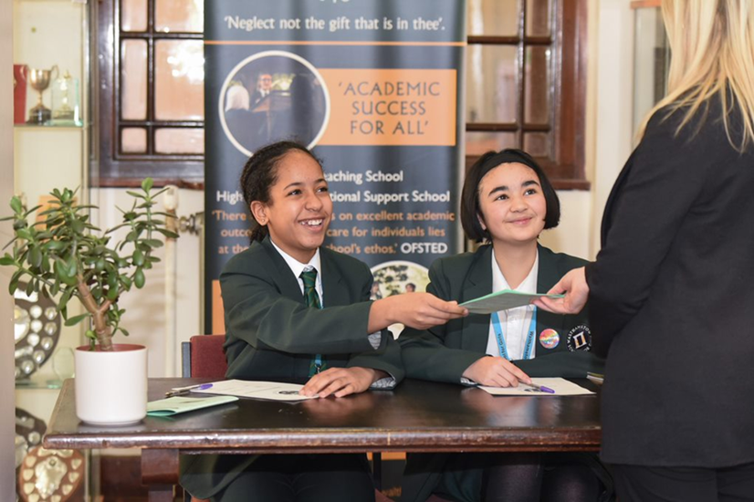

What staff value about the school

* This school feels safe, kind and caring. We are not driven by results – we seem to be driven to produce fabulous young women
* Ethos of the school, supportive colleagues and strong management with compassion

*“There are very strong working relationships between staff and pupils based on mutual trust and respect.” Ofsted 2018*

* I value the ethos of hard work in the students and how the school promotes kindness, tolerance and maturity amongst the students
* Atmosphere of diversity, respect and inclusion
* Freedom to teach in a range of styles





If you are successful at interview and are offered a post at Walthamstow School for Girls we will be required to carry out a number of pre-employment checks. All offers of employment are conditional on these checks being satisfactorily completed.

The checks completed are:

**Identification documents**

All staff are required to provide proof of their identity and that they have the right to work in the UK.

**Online / Social Media Checks**

As recommended in Keeping Children Safe in Education 2022, online searches are carried out on all shortlisted candidates at Walthamstow School for Girls. The searches are carried out to identify any issues or incidents that have happened, and are publicly available online, which the school might want to explore with the candidate at interview. If you are shortlisted you will be asked to complete a form to provide details of your social media platforms and the handles you use on each site.

**Criminal Record Checks (DBS)**

All offers of employment are subject to a satisfactory Enhanced Disclosure from the Disclosure and Barring Service DBS (formerly the Criminal Records Bureau CRB). Full information relating to this check and the Rehabilitation of Offenders Act 1974 is included in our New Starter Information Pack, issued with offer letters. Before completing the online DBS application you are advised to read the guidance information received with the email link.

Please note any information provided on your application form in the Disclosure and Criminal Background section will only be viewed by those who need to see it as part of the recruitment process. Any information disclosed will be treated in strictest confidence.

**Employment history and references**

On your application form it is important that you provide your full employment history including information regarding any gaps in your employment. References will be requested, prior to interview, from the information provided on your application form. We reserve the right to seek further references deemed appropriate and all references are verified on receipt.

We may ask you to help us to chase your referees to make sure that we receive your references as quickly as possible.

If you are currently employed in a school we will request a reference from your current Headteacher.

**Qualifications**

If your role requires you to hold a professional qualification you will be asked to provide evidence in the form of original certificates. Copies of these will be held on your Personnel file.

**NCTL Checks (Teaching staff only)**

All teachers are checked against the NCTL central register, this includes a Prohibition check.

**Pre-Employment Health Check**

All staff will be asked to complete a pre-employment health questionnaire. Any information that is disclosed as part of the health check will only be shared with relevant key members of staff and will be treated in the strictest of confidence.

Staff Benefits

Outlined below are some of the additional benefits available to staff working at Walthamstow School.

**Commitment to CPD**

**Excellent staff development is at the heart of our practice at Walthamstow School for Girls, enhanced by our leadership of the North East London Teaching School Hub.** We know that, quite simply, we must prioritise continuous professional development if we are going to nurture our staff and enable them to develop the skills and knowledge to maximise their impact on student learning and progress. The best CPD has a measurable impact on the progress of students.

For more information about our CPD offer, including our brochure, please see our website: <https://www.wsfg.waltham.sch.uk/page/?title=Staff+Development&pid=56>



**Cycle 2 work scheme**

This benefit offers staff the opportunity to purchase a bike (from a range of providers) making a tax saving, whilst keeping fit at the same time.

**Eye Tests**

All staff using computer equipment should have eye and eyesight checks at regular intervals. Eyesight testing should also happen where staff experience visual difficulties, which may reasonably be considered to be caused by computer work. Staff working within schools in the London Borough of

Waltham Forest may be entitled to reimbursement of some costs associated with vision testing and the frames and lenses needed to enable them to work safely on display screen equipment.

**Staff Wellbeing**

Staff Wellbeing is one of our school SIP priorities. There is a staff wellbeing development group which examines both strategic and operational approaches to improving the wellbeing of all groups of staff in our school.

At Walthamstow School for Girls there are also a number of staff organised activities including a running club, yoga and Boxfit exercise sessions.

**Workplace Options - Employee Assistance Provider**A confidential counselling, help and information service is provided for all those employed by Waltham Forest and is available free of charge 24 hours a day, every day of the year. This service can help with a range of problems from practical everyday matters to sensitive and emotional issues. For further information please call 0800 328 1437 or contact: [**www**.**employeeassistance.org.uk**](http://www.employeeassistance.org.uk)

**Non-meeting weeks**

There are designated Home and Family non-meeting weeks throughout the year to support with reduced workload and staff wellbeing.

**Staff Car Park**

There is parking available on site for all staff.

