Two Rivers High School
Torc campus, silverlink road, glascote heath
tamworth, staffordshire, b77 2hj
01827 426124

Deputy Headteacher

Dear Applicant

Thank you for your interest in the post of Deputy Headteacher at Two Rivers High School in Tamworth, Staffordshire.

Our special school is unique and our dedicated team work diligently, striving relentlessly to raise standards and attainment for our pupils. The school supports mainstream high schools in Tamworth.

Each child is an individual with different needs and we aim to provide a personal approach to each child’s learning. This is achieved by employing highly trained teachers and support staff who are committed to giving every child the extra support they need. We have created a positive, happy and safe learning environment where everyone is valued equally.

This role is challenging and you will be responsible for the well-being of our student population delivered in a safe, secure and supportive environment.

The successful candidate will be part of our experienced and dedicated Leadership Team reporting directly to the Head, Miss Gail Brindley.

Two Rivers is an outstanding school and we are looking for applicants that stand out from the crowd. You will bring sound knowledge and proven experience in special educational needs, together with strong management skills and the ability to be flexible and caring and enjoy being part of our team.

If you recognise the impact that quality educational provision and teamwork can have on enhancing the ability and achievements of every pupil, then we encourage you to apply.

Good luck!

Gail Brindley
Headteacher

BACKGROUND INFORMATION
Two Rivers High School was formed in September 2005, when the two special schools in Tamworth federated to create two age-phased generic schools. The Federation was split on two sites, one for primary aged pupils and the other for secondary aged pupils. Since this time we have become a member of Endeavour MAT.

Two Rivers High School has received the Quality Inclusion Mark, Gold Arts Mark, Dyslexia Friendly Status, Healthy Eating School, CPD Mark and PE Active Mark. The High School has achieved Dyslexia Friendly Status at Level 1 and currently working towards recognition at Level 2. These are tremendous awards that reflect the excellent quality of education that we strive to offer our pupils.

The school is an integral part of the local community in Tamworth and the wider area; our pupils take part in a wide variety of projects including supporting Residential Homes, Tamworth Community Garden and the local allotments. Links with Staffordshire Partnership and local businesses offer opportunities for work related learning. Our sixth form benefits from many vocational subjects such as Engineering, Hair and Beauty and Retail.

HIGH SCHOOL SITE
The High School is on a campus shared with South Staffordshire College, Torc Campus, Tamworth and Tamworth Nursery.

Our facilities equal any High School including a Sports Hall, ICT Suite, Music Room, Performing Arts Room plus a Theatre, Science Lab, Therapy Rooms etc. Indoor courtyards provide a relaxing ambiance to the school.

Outside the school there are tennis courts, football pitches as well as seated areas. The playing fields lead to Tamworth Athletics Stadium.

TEACHING AND LEARNING
The High School is a large provision with 190+ pupils on roll. We provide an enhanced staff pupil ratio with pupils with the most complex needs being taught in smaller class groups. All classrooms have computers, iPads and interactive white boards to enhance pupils learning. There is sensory provision for those pupils not able to access the National Curriculum.

The High School delivers the curriculum through a secondary model. Much of what is delivered beyond the core subjects resembles the best practice found in alternative provision utilising a range of accredited courses.

Over the years the school has been involved in local and national competitions and has regularly out performed mainstream schools.

At Key Stage 4 & 5 pupils are entered for a wide range of external accreditation. This includes Unit Awards; Entry Level Certificates; Level 1 Certificates (GCSE); Duke of Edinburgh Award and Vocational Awards.

Pupils can transfer at YR11/12/13 or 14 to a college or wider community environment and are supported in that transition.

SAFEGUARDING
The health and welfare of all our pupils is paramount and taken very seriously. The school has rigorous safeguarding procedures and a nurse is based on the site part-time. A range of alternative therapies and counselling are also available to support pupils’ emotional needs.

SCHOOL AIMS
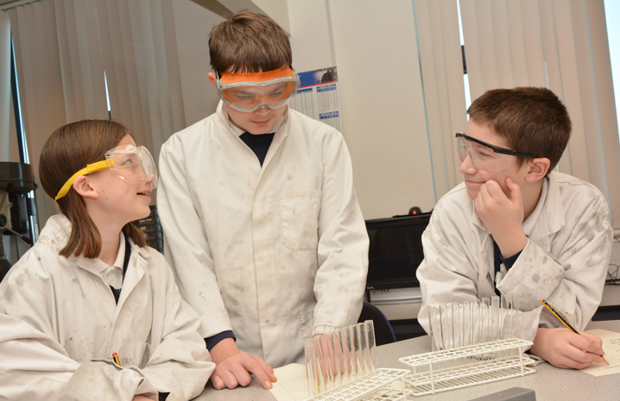
The school strives relentlessly to raise aspirations and attainment by providing high quality teaching and learning in a safe and secure environment in which the pupils’ welfare is paramount and where everyone is valued equally. The school promotes, encourages, supports and celebrates learning by ensuring:

- Excellent relationships between pupils, staff, parents and carers.
- High expectations for learners.
- Challenging, creative and age appropriate curriculum, relevant to the needs of the pupils.
- Positive, happy and motivating learning environment and culture.
- Holistic approach to the pupils learning, health and welfare is achieved.
- Strong links with the community.

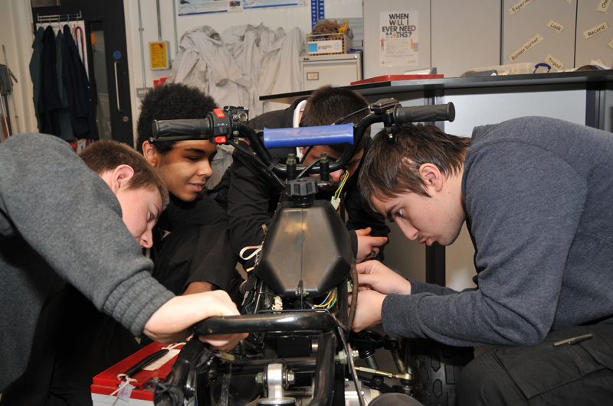
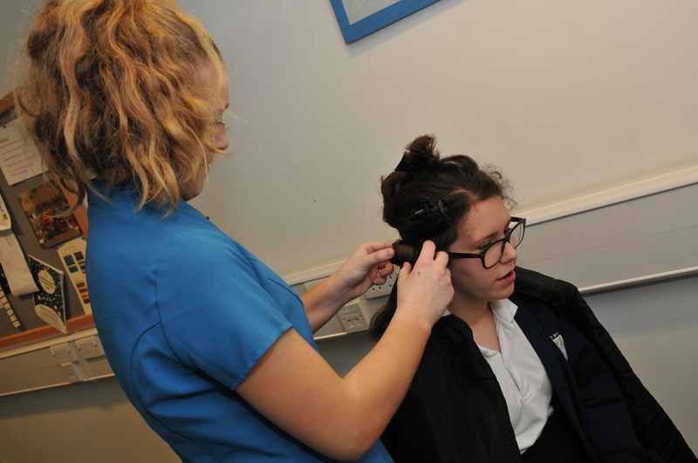
- Confidence and self-esteem of all pupils is nurtured and combined with respect for others and understanding of responsibilities, self-discipline and high standards of behaviour.

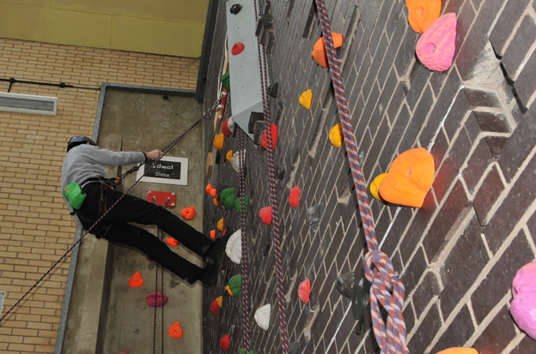

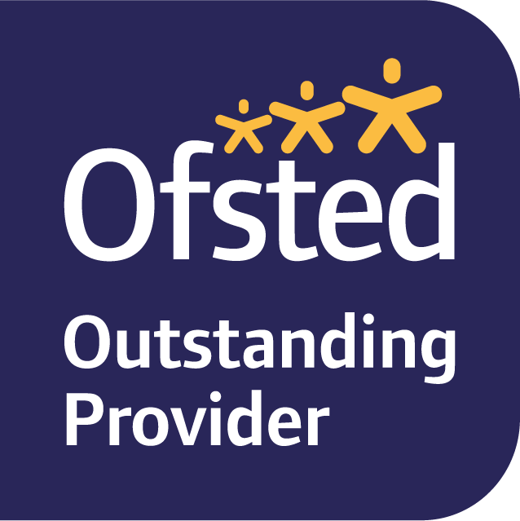
OFSTED
Our last Ofsted Inspection was in January 2019 and our school was assessed as outstanding on every level. Here are some of the key findings from the inspection report which can be reviewed in full on our website:

- “Pupils are taught well, and they have positive attitudes to learning.”

- “Pupils in every year group make strong progress and move on to appropriate destinations when they leave the school.”

- “Staff help to prepare pupils for life in modern Britain by developing pupils’ social skills and encouraging them to become as independent as possible.”

- “Staff plan activities thoughtfully and have high expectations of all pupils”.

- “The leadership team has maintained the outstanding quality of education in the school since the previous inspection. Leaders have built on the strengths identified in the previous inspection report and have taken effective action to make further improvements.”

- Staff work well with parents and outside agencies to help to protect pupils, and pupils are taught to keep themselves safe in a range of situations.”

LOCATION
Two Rivers High School is located in Tamworth in South Staffordshire in the heart of the West Midlands. It is a large market town located only 14 miles from northeast Birmingham and bordering Warwickshire. The choice of housing location and leisure facilities is vast for any applicant needing to relocate to the area.

With a population of just over 76,000 on the last census, Tamworth is one of the largest towns in Staffordshire. With a great medieval history and once the Capital of the Ancient Kingdom of Mercia, a Norman castle still stands on a probable site of a Saxon fort and is an important tourist attraction.

Tamworth is easily accessible via the A5 and M42 and a local train station. Its location in Staffordshire makes it a workplace option for any applicant living within the County or in Birmingham, Stratford Upon Avon or Warwick.

This thriving and busy town offers a combination of historical attractions reflecting its rich past and a vibrant choice of modern attractions. As well as the castle, Norman Motte and Assembly Rooms, the National Memorial Arboretum, Twycross Zoo, Drayton Manor Theme Park and Snow Dome are all within easy reach. Shopping in Tamworth offers independent shops in the old town and new retail parks on the outskirts of the town with many high street superstores.

Tamworth has over 20 different suburbs with an average detached house selling for just under £320,000 and a semi-detached house for £210,000, with an overall average of approximately £215,000 (Source: Rightmove).

deputy Headteacher

Salary: L16-20

Full time permanent position
Two Rivers High School is outstanding in every aspect of school life and we expect the same from our staff in pursuit of excellence in teaching and learning. We are an academy special school offering a challenging and creative curriculum to pupils with diverse abilities and needs, and are highly regarded by parents and carers and in the community.

Our new Deputy Headteacher will have the enthusiasm and commitment to maintain and raise standards, with the experience and knowledge of working with pupils with specific needs.

You will bring:
- Experience as an established classroom practitioner who aspires to join an effective management team
- Understanding and knowledge of severe learning difficulties including ASD
- An imaginative approach to learning and the initiative to develop existing community and business links
- A range of people management skills and an ability to tackle issues and be accountable and responsible for decisions
- A track record of leading in whole/departmental initiatives

Two Rivers High School can offer you:
- The opportunity to lead in an outstanding school with a number of awards recognising our achievements
- Super pupils who enjoy learning and describe their teachers as ‘the best’
- Governors and leaders who are dedicated and effective, ensuring every pupil makes strong progress and succeeds
- A first-rate site with a range of facilities to enhance the learning

We are committed to the safeguarding and welfare of all children and young people. This post is subject to an Enhanced Disclosure and Barring Service check.

For an informal discussion or to arrange a visit, please contact Gail Brindley, Headteacher on 01827 426124

Further information: www.tworiversschool.net

APPLICATION PROCESS

Deputy Headteacher

Key Dates:

Closing date: Sunday 18th April 21

Shortlisting date: Monday 19th April 21

Interviews: w/c 26th April

Start date: 1st September 2021

The school website will provide prospective candidates with further information about our school.

We do hope that you apply and if you do, you need to submit a fully completed application form and self disclosure form by the closing date as above. Please note that we do not accept CVs and no applications will be accepted after the closing date.

Shortlisting will be based on the information contained within your application form only.
If you wish to send an accompanying letter with your application, it should be no longer than one side of A4 paper.

Please email your application for the attention of Miss Gail Brindley, Headteacher to: recruitment-high@tworiversschool.net

For further enquiries, please contact the school on 01827 426 124

We look forward to receiving your application.

Deputy Headteacher

Job Description

Reporting to: Headteacher
Executive Focus: Leadership and Management
Day to day staffing
Continuing Professional Development
Operational Focus: Parental engagement
Deputise for the Head

Key Responsibilities:
- To undertake the full range of professional duties in the Head’s absence from school.
- To undertake any professional duties of the Headteacher reasonably delegated by them.
- SLT lead on the provision and delivery of holistic and multi-disciplinary support enabling all pupils to access the curriculum.
- Support the Head in ensuring that the school’s systems, organisation and processes are well considered, efficient and fit for purpose, upholding the principles of transparency, integrity and probity.
- Deputy Safeguarding Lead with responsibility for holding the DSL to account and ensuring all safeguarding systems and processes are compliant and quality assured.
- Ensure staff receive the necessary statutory and developmental training.
- Support the Assistant Head responsible for attendance of students and strategies/plans to improve attendance, including liaison with external agencies.
- Responsibility for the organisation, implementation and effectiveness of the school’s pastoral system.
- Responsible for the preparation and suggested exclusion of students, including the preparation of any permanent exclusion documents.
- Act as Health and Safety Coordinator (including Educational Visits).
- Ensure the school fulfils its statutory duties under the SEND Code of Practice
- Liaise with LA on Home/School transport.
- Engage with and lead on parental engagement and parental communication strategy which ensures good quality information provision, identification of any additional needs, nurturing of the home-school relationship for the benefit for the child and swift resolution of any concerns.
- Lead on lesson observation.
- Any other issues or responsibilities as may arise or are identified by the school or Headteacher.

Strategic Direction and Development of the School:
- To work with the Headteacher to formulate the aims and objectives of the school and translate these into implementation plans.
- Developing and leading designated developments within the School Development Plan, with a framework for monitoring and review.
- To communicate compellingly the school’s vision and drive the strategic leadership, empowering all pupils and staff to excel.
- Actively contribute to Two Rivers High School self-evaluation processes.
- Act as team leader for the teacher appraisal process.
- Challenge educational orthodoxies in the best interests of achieving excellence, harnessing the findings of well-evidenced research to frame self-regulating and self-improving schools.
- To lead on reporting to governors on school improvement.
- To ensure governors are fully informed about safeguarding issues relating to the pupils, staff and school environment.
- Overseeing the review, management and implementation of the policies relating to the above-named areas of responsibility.
- Attend all relevant meetings that relate to the job description.

Leading & Managing Staff:
- To hold and articulate clear values and moral purpose.
- Line manage the Assistant Headteachers holding them to account for performance and outcomes, providing appropriate support and guidance as and when required.
- To strategically lead Middle Leaders on all aspects of school improvement.
- Promote a culture of inclusion within the school community where all views are valued and taken in to account.
- To demonstrate optimistic personal behaviour, positive relationships and attitudes towards pupils and staff, and towards parents, governors and members of the local community.
- To lead by example - with integrity, creativity, resilience, and clarity.
- Hold all staff to account for their professional conduct and practice.
- Provide a safe, inclusive, calm and well-ordered environment for all pupils and staff.
- Organise and support the induction of staff new to the school and those being trained within the school.
- Act as an induction co-ordinator for NQTs and have responsibility for students on teaching practice and those undertaking work experience, as appropriate.

Effective Deployment of Staff:
- Participate as required in the selection and appointment of teaching and support staff, including overseeing the work of supply staff/trainees/volunteers in the school in the absence of the Head.
- Line management of supervisory assistants and management of non-teaching time (breaks and lunch breaks).
- Responsibility for timetabling and cover to ensure the smooth operation of the school at all times.

Health and Safety Issues:
- Support the member of SLT responsible for the development of Individual Behaviour Support Plans as well as risk assessment for students
- Child Protection and Safeguarding and all related matters in this respect, including the training of staff.
- Oversee accident reporting and H& S issues

Teaching and Learning:
- To be an outstanding classroom practitioner and teach timetabled lessons as directed by the Head.
- Support the building and fostering of an open and transparent teaching culture where colleagues undertake peer observation to share good practice and enhance skills.
- Have ambitious expectations of all pupils with SEN and disabilities

Person specification- deputy head – Two rivers high school

 | Essential | Desirable | Evidence
Qualifications | QTS  Degree or equivalent in a relevant subject | Post Graduate qualification in SEN.  NPQSL  Evidence of recent continuing professional development. | AF
Background and experience | Successful leadership and management experience in a school  Successful teaching experience in a High School or Special School for minimum 6 years  Experience of leading Performance Management Reviews  Be an outstanding classroom practitioner with a proven track record of improving academic outcomes for all pupils.  Experience in improvement of challenging behaviours  Ability in developing whole school initiatives  Ability to lead, inspire, motivate & manage diverse groups of people  Experience of leading teams  Experience of working closely with the wider school community, external agencies, other schools etc. | Demonstrate commitment to a school through involvement with extra - curricular activities  Experience of training & developing staff  Experience in analysis of data | AF  I  R
Knowledge and skills | Manage a classroom and have the ability to teach outstanding lessons.  Ability to plan lessons effectively for all pupils in a class, setting clear learning intentions  A commitment to the development of individualised learning programmes  Knowledge and understanding of positive behaviour strategies  Clear understanding and commitment to Safeguarding procedures  Understanding of the new OFSTED Framework regarding Teaching & Learning and Leadership and Management  Ability to analyse data and pin point key issues to inform planning and learning  High level ICT skills  Be up-to-date on current educational thinking, issues, initiatives & strategies regarding SEN | Experience of raising standards within key whole school priorities  Understanding of using data to raise standards  SCIPr trained (or similar)  Has undertaken L2 Safeguarding training  Has taken part in Multi-Agency meetings to improve outcomes for pupils/families  TEACCH  PECS  MAKATON  Behaviour management | AF  I  R
Personal qualities | Resilience to stress in busy and challenging environment  Strong interpersonal skills, with the ability to develop and maintain good relationships with all members of the school community and partners.  Works well in a team  Self-confident, decisive, can make difficult decisions and have inner strength and resilience  Enthusiastic, display drive and determination.  Creative, analytical & optimistic  Supportive of colleagues  Effective communication and interpersonal skills  Has a high degree of integrity, is honest, trustworthy and reliable  Discrete, diplomatic & tactful  Enjoys working with children | Be an innovative, creative thinker who is able to anticipate and solve problems and inspire others to do the same | I
Other | Ability to work under pressure and prioritise effectively  Commitment to maintaining confidentiality at all times  Commitment to safeguarding and equality.  Good personal, professional standard of presentation, good attendance record and has high expectations of self and others |  | I

