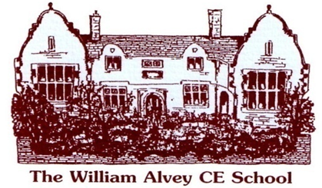
William Alvey CofE Primary School
Person Specification
Post: Deputy Headteacher
Salary: Leadership Points 12 – 16 (£65,286 - £72,162)

Essential | Desirable
Qualifications
Qualified Teacher Status | Engagement in own continuous professional development.  Evidence of additional further educational qualifications.
Experience and skills
An outstanding teacher  Knowledgeable about the Primary curriculum - including wider curriculum subjects - and understands the learning journey from EYFS to Key Stage 2.  A reflective practitioner who continues to look for ways to improve their own practice and the practice of their colleagues.  A team player with good interpersonal, and communication, skills.  The ability to motivate, lead and inspire children, staff, governors, parents and other relevant stakeholders. | Experience of teaching in more than one key stage.  Experience of a significant leadership role.  Experience of leading and managing change.  Be able to research a variety of topics and succinctly articulate their findings. This includes keeping up to date with national developments, such as Ofsted subject reviews, and reporting these back to colleagues.
Knowledge & Understanding
A practitioner with a very good knowledge and understanding of:  - - Current national education initiatives.  - - Target setting; pupil tracking; and other methods of analysing both pupil attainment and achievements.  - - The importance of measuring the impact of interventions and taking next steps to ensure progress.  - - Strategies for inclusion and development of all children.  - - A commitment to developing an enriched and diverse curriculum in school and through extra- curricular activities.  - - Child Protection and Safeguarding procedures and legislation. | - Active contribution to the whole School Development Plan.  - Monitoring and reviewing the School Development Plan.  - Working in partnership with parents and outside agencies.
Leadership Skills
The potential to be an outstanding leader with the transferable skills to coach and mentor colleagues to consistently good or better practice.  Communicate clearly and effectively with all those involved in the life of the school.  Flexible and supportive of all staff.  Dealing sensitively with people and resolving conflicts.  Think creatively and imaginatively to solve problems and identify opportunities.  Leading and managing people to work both individually and in teams; to facilitate a collaborative approach to decision making.  Work in tandem with the headteacher to ensure the school vision works in practice. | Experience of motivating and inspiring pupils, staff, parents, governors and the wider community.  Deploying staff to ensure children/ groups of children make good or better progress.  Attending governing body meetings.
Personal Attributes
- - A passion for working at the Alvey and the ability to fit in with our vision and ethos.
- - Care passionately, and work tirelessly, to ensure all children and adults reach their full potential at the Alvey.
- - Have the drive to ‘go above and beyond’ to provide a fun, meaningful and purposeful learning environment at the Alvey.
- - Be able to prioritise and manage time effectively.
- - Confident enough to express their opinion, even if it is outside the one that is collectively held. Be able to balance this confidence with the need to ‘carry people’ with them.
- - Be an excellent communicator.
- - Work under pressure and meet deadlines.
- - Be self-motivated and set personal goals.
- - Creative, positive, approachable, resilient and have a good sense of humour.
- - A sharp eye for detail.

References are essential
At least two fully supportive references, one from the current employer.

