Welcome to
Creating Tomorrow academies Trust

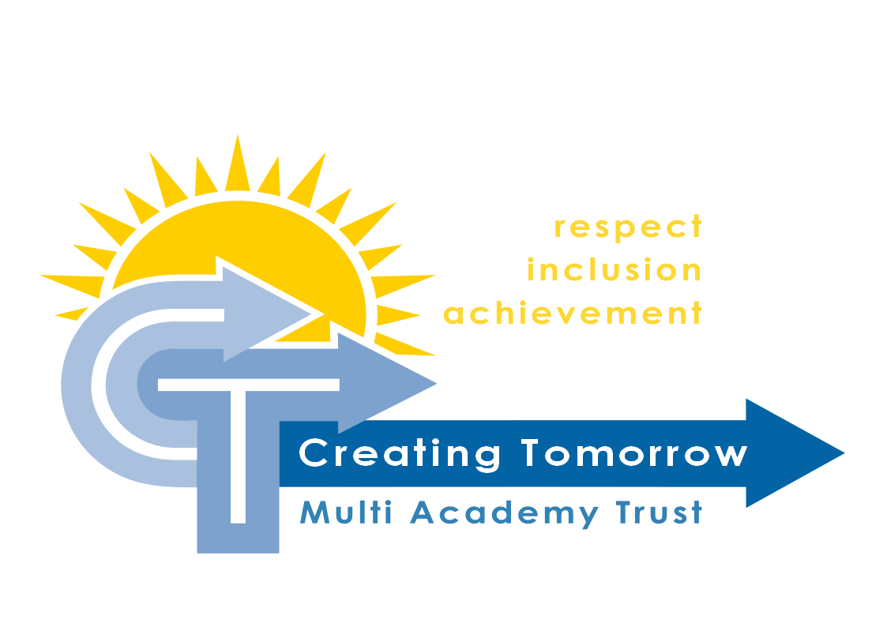

Welcome to Our Trust

Creating Tomorrow is a group of schools and a college that have come together to make sure all children have the opportunity to succeed – irrespective of their learning needs.
We place an emphasis on the individual; from the individual child through to the individual setting, to make sure that everything we do is done with a focus on supporting and maximising opportunities. We strongly feel that the expertise to do this is within each setting, they are best place to do this and so the role of the Trust is to enable.
We believe that we are better together and so collaboration is vital, developing the links and bonds that support us all to succeed.

I look forward to welcoming you personally
Kevin Latham (CEO)

Contents
Welcome from the CEO Page 2

Our Trust Page 4
Mission, Values and Vision Page 5
“We believe that …” our Trust philosophy Page 6
Leadership at Creating Tomorrow Page 11
Framework for Ethical Leadership in Schools Page 13
Governance in our Trust Page 14

Windmill Hill School
Introduction to our new school Page 15
Site Plans Page 16

Our Curriculum
Creating Tomorrow Curriculum Philosophy and model Page 18
Windmill Hill Curriculum Page 22

Support for you
Wellbeing Page 29
Continuing Professional Development Page 30

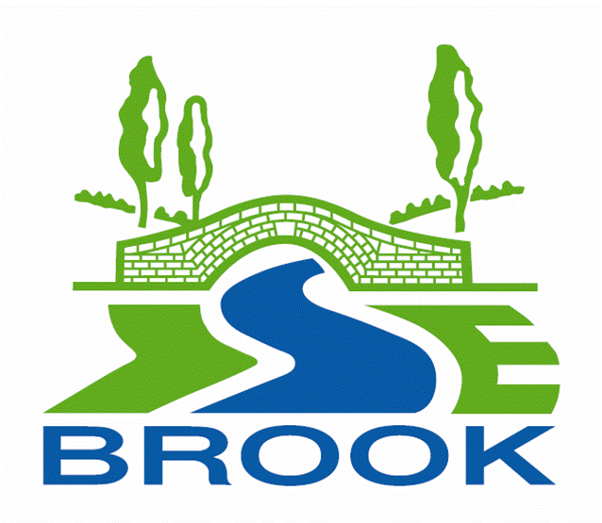
Our Trust
Windmill Hill School
Secondary SEND
www.windmillhillschool.org.uk
Isebrook School
Secondary SEND
www.isebrooksen.co.uk
Wren Spinney Special School
Secondary SEND
www.wrenspinney.co.uk
Daventry Hill School
All-age SEND
www.daventryhillschool.co.uk
Creating Tomorrow College
16-25 specialist Post-16 Institute
Website under construction

Mission:
Creating Tomorrow academies Trust is an inclusive community of learners building the skills and confidence to succeed in a changing world

Values:
- Respect
- Inclusion
- Achievement

Our Vision:
- To create a learning journey from 0 to 25, for all children and young people
- For every child to become confident, capable, resilient, aspirational members of their communities.
- All learners will be challenged to be
  - Successful Learners
  - Confident Individuals
  - Responsible Citizens
- To develop an effective learning community that provides an excellent education for our pupils through highly effective collaboration based upon mutual support and challenge, across special and mainstream schools

We believe that ….
we will have fun
we make a difference

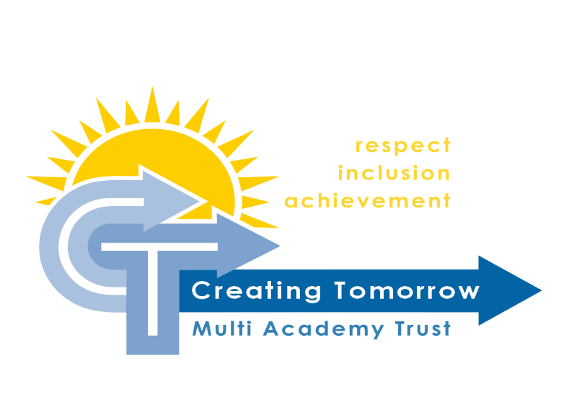

we choose
our attitude
we must be “present”

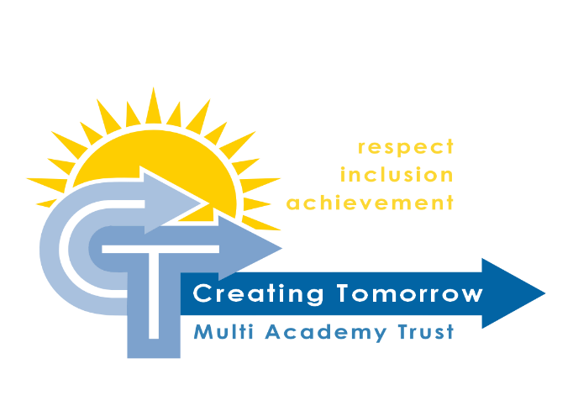
Together we will ....
Make a difference

Curriculum to develop skills for the
future
Curriculum to develop
skills for now

Communication skills and clarity
Life long
Learning for all
Safety
first

Together we will ....

Be positive: shared vision
Be considerate: shared values

Choose our attitude

Be professional: transparent and open
Be the best we can be: continuing professional development
Be an employer of choice:
Commitment to staff

Together we will ....
Be present
With our families:
Multi-disciplinary working
With each other:
Clear expectations

Care: Health and wellbeing support
Support each other: Partnerships

With our staff:
Teach / train
Coach / mentor

Together we will ....
Professional networks
Have fun
New opportunities
Supportive and relaxed

“Do with not to”

Reduce workload, make learning and teaching fun

Leadership at Creating Tomorrow

As one of the most senior most leaders in the school, the Deputy Headteacher’s role is wide and varied, however there are a number of core features that are consistent to all leadership roles across the trust.

The five core features of senior leadership at Creating Tomorrow academies trust:

Moral Purpose
  - Pupils first – a belief that all pupils can achieve and an unwavering commitment to pursue successful outcomes for all
  - Championing the vulnerable
  - Commitment to equality of opportunity

An Effective Team Player
  - Dynamic and supportive
  - Committed and passionate
  - Innovative and high performing
  - Emotionally intelligent
  - Proactive contribution

Dynamic and Creative Executive Leadership
  - Leading through others
  - Altruistic collaboration

A Significant Contributor to Strategic Thinking and Development
  - Inspire and drive
  - Oversee the development of strategy and policy
  - Lead consultation and implementation

Courageous and Committed Leadership, Effective Role Modelling
  - Observing the highest standards
  - Getting every day right

The ten personal qualities needed for leadership roles at Creating Tomorrow academies trust:
- A capacity for hard work
- Eternal optimism and resilience in the face of challenges
- The ability to inspire
- An unshakeable conviction that young people can be successful in spite of their circumstances or other external factors
- High level interpersonal skills
- Excellent time management
- The ability to remain calm under pressure or in stressful situations
- The ability to pause and reflect and think before making an important decision
- The ability to respond positively to and deliver constructive criticism
- The ability to delegate effectively

Our Leaders are expected to exhibit Nolan’s Seven Principles of Public Life and in turn exhibit the behaviours of Ethical Leadership in Education as shown on the next page:

Framework for Ethical Leadership in Education
The Ethical Framework for Educational Leadership is based upon the seven principles of public life:
Selflessness | School and college leaders should act solely in the interest of children and young people
Integrity | School and college leaders must avoid placing themselves under any obligation to people or organisations that might try inappropriately to influence them in their work. Before acting and taking decisions, they must declare and resolve openly any perceived conflict of interest and relationships
Objectivity | School and college leaders must act and take decisions impartially and fairly, using the best evidence and without discrimination or bias. Leaders should be dispassionate, exercising judgement and analysis for the good of children and young people
Accountability | School and college leaders are accountable to the public for their decisions and actions and must submit themselves to the scrutiny necessary to ensure this
Openness | School and college leaders should expect to act and take decisions in an open and transparent manner. Information should not be withheld from scrutiny unless there are clear and lawful reasons for so doing
Honesty | School and college leaders should be truthful
Leadership | School and college leaders should exhibit these principles in their own behaviour. They should actively promote and robustly support the principles, and be willing to challenge poor behaviour wherever it occurs. Leaders include both those who are paid to lead schools and colleges and those who volunteer to govern them
Schools and colleges serve children and young people and help them grow into fulfilled and valued citizens. As role models for the young, how we behave as leaders is as important as what we do. Leaders should show leadership through the following personal characteristics or virtues:
Trust | Leaders are trustworthy and reliable  We hold trust on behalf of children and should be beyond reproach. We are honest about our motivations
Wisdom | Leaders use experience, knowledge and insight  We use experience, knowledge, insight, understanding and good sense to make sound judgements. We demonstrate restraint and self-awareness, act calmly and rationally, exercise moderation and propriety as we serve our schools and colleges wisely
Kindness | Leaders demonstrate respect, generosity of spirit, understanding and good temper  We give difficult messages humanely where conflict is unavoidable
Justice | Leaders are fair and work for the good of all children  We work fairly for the good of children from all backgrounds. We seek to enable all young people to lead useful, happy and fulfilling lives
Service | Leaders are conscientious and dutiful  We demonstrate humility and self-control, supporting the structures and rules which safeguard quality. Our actions protect high-quality education
Courage | Leaders work courageously in the best interests of children and young people  We protect their safety and their right to a broad, effective and creative education. We hold one another to account courageously
Optimism | Leaders are positive and encouraging  Despite difficulties and pressures, we are developing excellent education to change the world for the better
Governance Structure
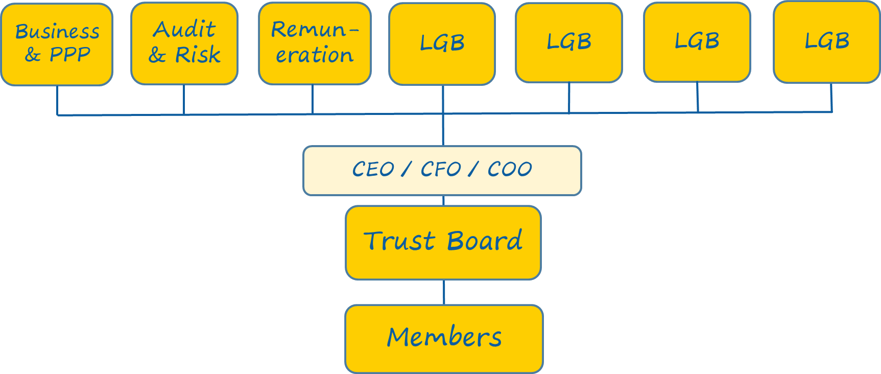

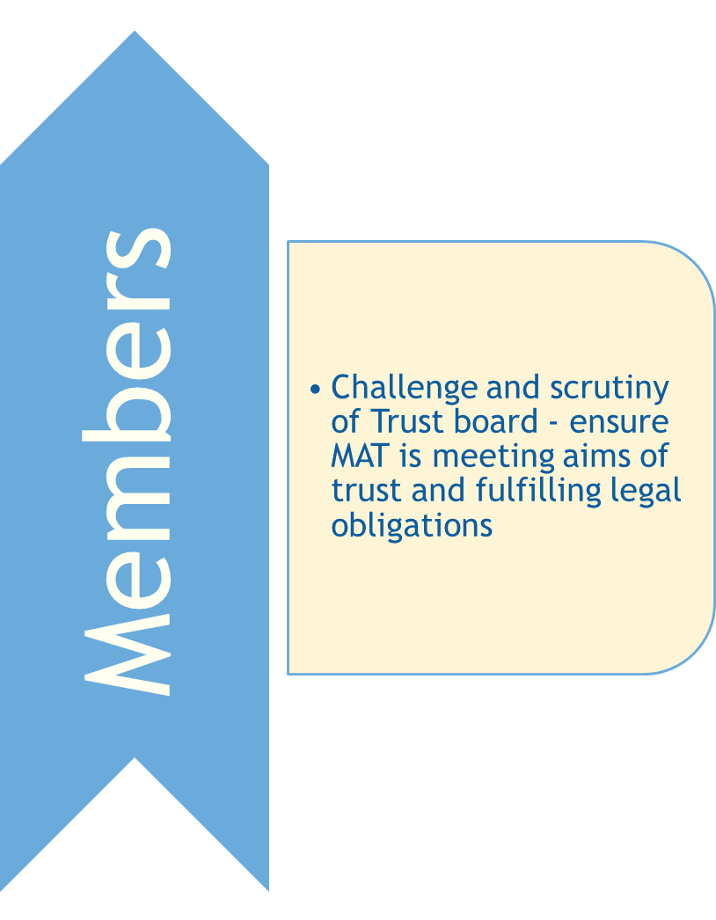
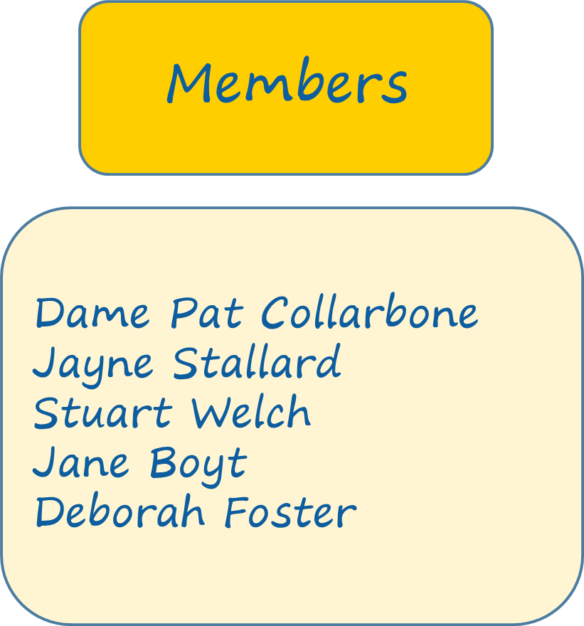

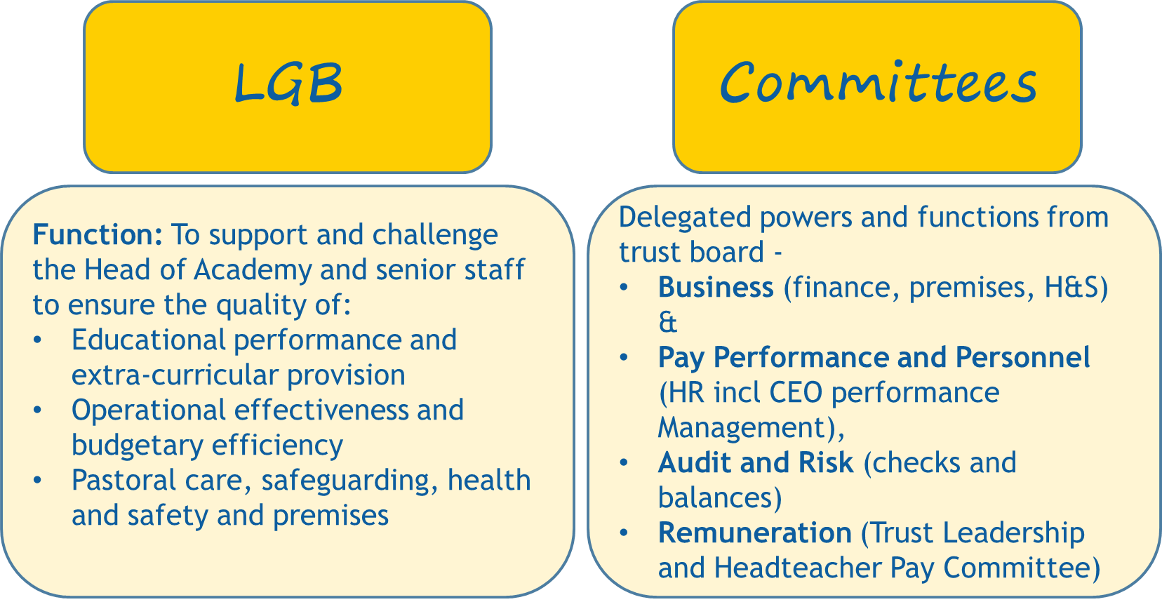

Windmill Hill School

Exciting new school to compliment the already strong special schools in Luton.
120 place special school for children and young people with a range of special education needs and disabilities (SEND) primarily difficulties with cognition and learning:
- Severe and complex learning difficulties
- Moderate learning difficulties
Learners may also have a range of other needs:
- Communication and interaction
- Sensory and physical
- Social and emotional
Working in close partnership with Woodlands Secondary Special School, Lady Zia Werner and Richmond Hill Primary Special Schools
Working towards Luton council's vision for special educational need and disabilities (SEND):
- Supporting children and young people with SEND
- Develop a range of quality local provision
- Enable children and young people to play, learn, live and work within their local communities
- Preparing children and young people, aged 0-25, for their adulthood where they can live and work in Luton as independently as possible.

Our new school – site plan

Windmill Hill is located in a mixed residential / business area, close to Luton train station and a number of green spaces

Windmill Hill is moving into an existing building that has previously been a secondary and primary school.
Extensive external works are being undertaken to provide an accessible playground and safe access onto site for transport.

Internally specialist areas are being provided for complex autism and physical difficulties, including a sensory and physio room. Completing the ground floor learning areas are a specialist food technology room, multi-use hall and a sixth form area.
On the first floor there will be additional classrooms, a music room, pastoral area and gym / dance / drama space.

How we approach the curriculum at Creating Tomorrow

Curriculum Purpose:
To provide our pupils and students with the skills to live as independently as possibly in an ever changing world, to be:
- Successful Learners
- Confident Individuals
- Responsible Citizens

Curriculum Philosophy:
The biggest indicator for a successful life is social capital – the links and support networks that an individual has around them which supports emotional health and wellbeing.
Our curriculum needs to be designed to develop these links:
- Support for the individual to develop the skills to make links (self-regulation and communication skills) – Me
- Develop positive relationships (communication skills and emotional regulation) – We
- Build personal skills that help to develop positive mutually beneficial relationships, not only at an individual level but between groups (Our) and to benefit others (Your).

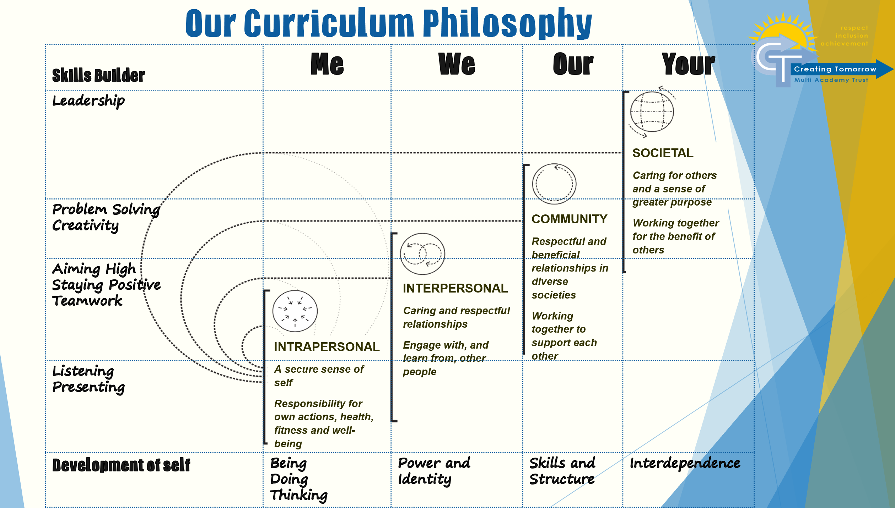

Curriculum Content:
To be successful our children need to feel safe and build trusting relationships. Only when we enable this will our children be able to engage in learning activities and develop the skills necessary.
Our curriculum is based around 3 themes of safety:
- Of self – the ability to self-regulate and manage own emotions and so engage in learning experiences
- For self – the ability to be independent and autonomous (do things not only by yourself but for yourself)
- With others – the ability to manage and develop positive relationships
These 3 themes ultimately lead to the 4 outcomes for Preparation for Adulthood:
- Employment
- Independent Living
- Friends, Relationships and Community (Community Inclusion)
- Health
Our students have faced, and do face, numerous obstacles to learning and it is our role as educators to put in place whatever strategies are necessary to remove all barriers to learning. Across our trust we will utilise all available resources to ensure our students are available to learn.
Our Approach to Personalisation:
Personalisation |  | Curriculum Planning
EHCP Outcomes / End of Key Stage Targets |  | Long Term Planning
Provision |  | Medium Term Planning /  Curriculum Targets
Annual IEP Objectives (using Skills Builder) |  | Short Term Planning

Assessment:
The purpose of assessment within our schools is to celebrate success and identify next steps for further development.
Assessment is an ongoing activity and as such should be active – Assessment for Learning and Assessment of Learning, as much as is practically possible, should occur alongside students. Students should be engaged in celebrating success and identifying their next steps for learning.
EHCP outcomes (long term objectives)) will be identified through the annual review process when reviewing the EHCP. We will use ‘PfA Outcomes across the age ranges for children and young people with SEND’.
Annual IEP objectives (yearly curriculum targets) will be identified during the annual review. We will use ‘Skills Builder SEND’ to identify steps to success to meet outcomes identified in the EHCP

Assessment of Learning will be by using MAPP and captured within Evidence for Learning, quantifying success:
INDEPENDENCE: Learners complete tasks independently
Can they do it on their own?
FLUENCY: Learners reach a level of mastery combining speed and accuracy
Are they getting better at it?
MAINTENANCE: Learners maintain competency over time through repetition. They remember after a break
Can they do it more often? Are they more reliable?
GENERALISATION: - Learners achieve mastery in different settings or contexts, with different stimuli or with different staff
Can they do it with different people or in different places?

Our curriculum at Windmill Hill

Our students’ learning will be sequential, building on prior learning however with a clear direction towards aspirational outcomes, as identified through their EHCPs.
The curriculum intent is to deliver the school’s vision and core values to meet our purpose.

Our Purpose  To deliver lifelong learning to create happy, successful, adults. |  | Our Vision  We will inspire and empower all learners to achieve.
Our Core Values
 | Respect | Compassion | Achievement | Responsibility
 | - I can take & share  - I can wait my turn  - I can use kind words and actions | - I can accept changes  - I can say sorry  - I can have time for my friends | - I can keep trying  - I can keep myself safe  - I can ask for help | - I can take turns  - I know who can help me  - I can share things I enjoy with my friends
 | - I can be kind  - I can take turns  - I can be poli  - I can listen to others  - I can look after belongings | - I can accept people’s differences  - I can show patience  - I can accept people’s opinions | - I can keep going  - I can stay on task when others are struggling  - I can give it a go  - I can say sorry | - I can enjoy time with my friends  - I can enjoy being part of a class  - I can be part of my local community  - I can celebrate with my friends
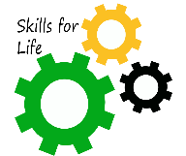  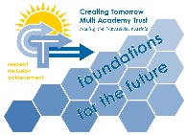 | - I can consider the feelings and wishes of others.  - I can treat people equally.  - I can listen to others.  - I can treat people as I would like to be treated.  - I can accept other people for who they are. | - I can accept that other people may have different beliefs, religions, cultures or values.  - I can listen to others opinions and beliefs, even if I don’t agree with them.  - I understand that other people may act differently towards me.  - I can show patience with others who are different.  - I can agree to disagree | - I can regulate my emotions.  - I can try new challenging things.  - I understand that when mistakes happen I can learn from them.  - I can try again if I don’t succeed at first.  - I can maintain a positive attitude. | - I can inspire others.  - I can work with people in a positive way.  - I can share successes.  - I can tell someone if I see or think something is wrong.  - I can help make a safe, secure and happy place.
Key values are important to underpin the curriculum and build a sense of community, these will be delivered through the curriculum and brought to life through delivering elements of Skills Builder on a rolling programme, introduced in assemblies and highlighted as a ‘key focus’ in medium term planning
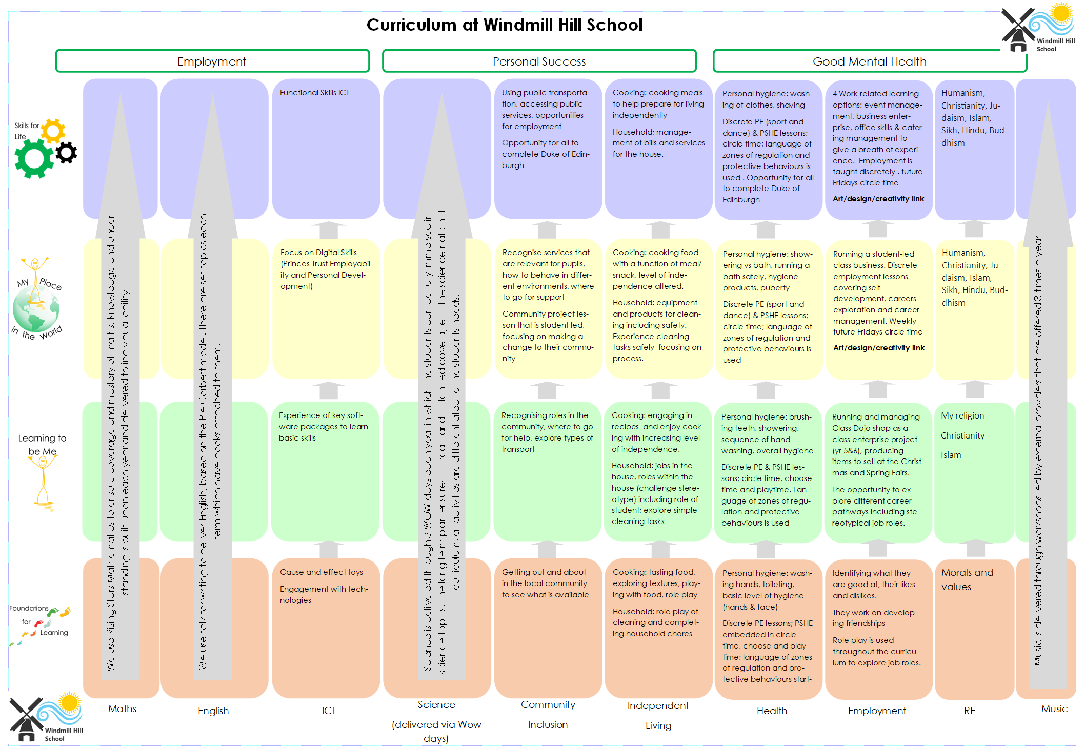

PHSE

PSHE is a core subject in special schools, and as such will be given prominence in our timetable through a focus on outcomes for adulthood (please see curriculum models above). All our schools use materials adapted from the PSHE Association to ensure that all areas, including Relationships and Sex Education are taught appropriately and coherently. We pledge to undertake a full consultation with parents in regards to the ‘sex education’ and the content delivered.

Windmill Hill School will support a diverse community, and it is vital that we are welcoming to everyone (irrespective of faith and beliefs) and therefore threaded throughout the curriculum, and in the way that we work, will be core values (please see the graphic above “How our curriculum can link to our School vision and Values”), which will be explicitly linked to our Relationship Policy (Behaviour) and expectations for how everyone is to act. Through PSHE we will explicitly teach the values (Fundamental British Values) of:
- Respect - students to develop school expectations and review the school Relationship Policy
- Tolerance - Learning from religion is an important aspect of RE and clearly teaches tolerance. Working together in groups develops understanding of each other’s strengths and weaknesses and how we can support
- Individual Liberty - developing responsibility for yourself, independence, and autonomy, develops a sense of worth and enables young people to take control of their own choices and so individual liberty

- Democracy - democracy comes from the power of a shared voice. Student voice will be vital in developing Windmill Hill School into the provision we want and so from the onset a school council will be introduced
- Rule of Law - Underpinning democracy, tolerance, liberty, and democracy is the understanding that ‘we are all in it together’. Developing an understanding that rules are important to keep everyone safe and to give everyone a voice.

Our schools are pilots for Skills Builder (SEND) (as explained previously) and the 8 areas will be developed and built upon through an agreed whole school focus and delivered through PSHE activities:
- Listening
- Presenting
- Teamwork
- Staying Positive
- Aiming High
- Creativity
- Problem Solving
- Leadership

PSHE is a key area for schools to report to trustees and there are key performance indicators specifically identified in these areas.

Enrichment and Extended Services
Our curriculum needs to be personalised to the individual’s needs, which can change throughout the year, and so needs to be flexible and responsive. It needs to be meaningful and engaging and to develop the whole child and so develop a “… quality provision that will enable children and young people to play, learn, live and work within their local communities in preparation for their adulthood where they can live and work in Luton as independently as possible”.
Our schools are expected to operate comprehensive enrichment / alternative options and the curriculum at Windmill Hill may include activities such as:
- Riding for the Disabled
- Forest Schools
- Duke of Edinburgh
- Prince’s Trust
- Sports Leadership Award
- Construction and land studies
- Mechanics
If individuals require additional support / activities, (such as equine studies) then this may be sourced using curriculum or Pupil Premium funding as appropriate.
Underpinning the curriculum will be a deep understanding of the needs of the individual and pastoral support, supporting the family through family support workers, which will enable the correct provision to be implemented.

Support for You

Wellbeing in our Trust

We are all affected by poor mental health at times during our lives and it is important the appropriate support is available in a timely manner.
Health and wellbeing is everyone’s responsibility and we encourage an open and honest culture whereby anyone can discuss any issues they may have.
The Trustees of Creating Tomorrow take the health of all employees seriously and are committed to supporting our staff. The Trustees ensure that support is available through:
- Effective line management
- Commitment to reducing workload
- Supportive and professional working environments
- Employee support programs
  - Health Assured (confidential counselling support available through employee Perkbox account).
  - The Teacher Support Line telephone number 08000 562561 or website www.teachersupport.info

Continuing Professional Development
The greatest resource we have is our staff. We aim to develop an exceptional provision for some of the most vulnerable young people in our community, and therefore we need the best staff to deliver the best curriculum.
We aim to do this through quality professional development opportunities, effective line management and supervision.
Model for Professional Support at Creating Tomorrow

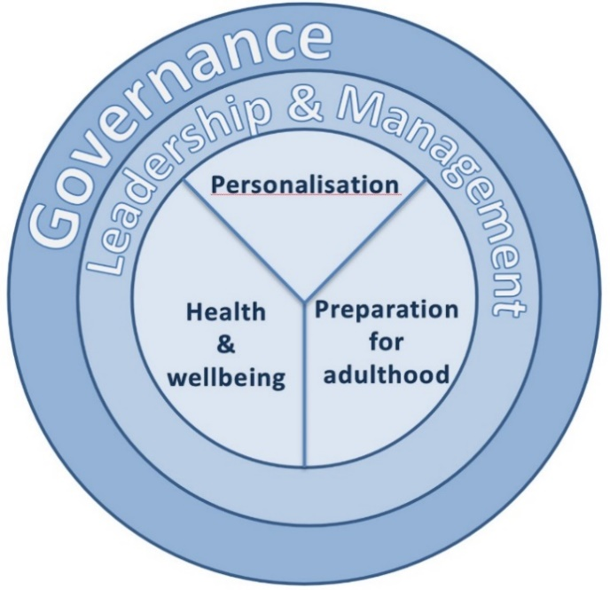
Priority Areas:

At each level, based on expectations of role and standards – if not meeting then professional development must be to support performance management
If meeting standards then professional development is to support professional development against:
- Trust priorities
- School priorities
- Career progression
- Subject / skill development in relation to organisation needs

Continuing Professional Development Model
Staff Career Development Opportunities (constantly being updated!)
Staff Role | Training Opportunities | Development Opportunities
Whole Staff Offer | Safeguarding –  - Child Protection  - Health & Safety  - Manual Handling  - Intimate Care  - Team Teach  - Medication  - First Aid  - Specific medical care needs – epilepsy awareness, diabetes support  - Health and Wellbeing – incl LGBTQ+  - E-safety  - Education Visits  - Relationships (behaviour for learning) | Supervision / support
 | MiDAS training | Coaching / mentoring
 | Food Hygiene | Buddying
 | Induction programme | Observing good practice
 | Learning and Teaching –  - Assessment  - Curriculum delivery – differentiation etc  - Speech and Language / Communication  - Relationships  - Dyslexia awareness  - Subject specific training e.g. swimming, colourful semantics  - Autism Awareness  - Attachment awareness training  - PECS | Visiting other providers
 |  | Network meetings / forum for specific roles e.g. Family support worker network, moderation group, SEN Data group, SENCo Network, DSL Group, Health Care Network Group
Office Staff | Apprenticeships
Professional Qualifications
e.g. AAT, CIPFE, DSBM
Teaching Assistants | Apprenticeships | Opportunities to lead activities / sessions
 | TA Level 2 Training | Opportunities to stand in for teacher
 | TA Level 3 Training | TA2 / TA3 / TA4 positions
 | TA Level 4 / HLTA Training | Olevi TA Development Programmes
 | Specialist TA positions (i.e. music, sport, science)
 | Foundation Degree in Teaching and Learning
 | School Direct
 | Degree conversion through assessment
Teachers | Specialist skills training, i.e. Team Teach Training, PECS | Appraisal
 | Post Graduate Qualifications | Subject Lead
 | UPS | Student mentoring
 | Building Leaders for the Future | TA Performance Management
 | National Professional Qualification for Middle Leaders | New Teacher Mentoring
 | Leadership Apprenticeships | Olevi Teaching Development Programmes
 |  | NQT Mentoring
 |  | School to School Support
 |  | KSL positions
Leadership | National Professional Qualification for Senior Leaders | Appraisal
 | National Professional Qualification for Headship | School Development Priority Lead
 | Leadership Apprenticeships | Staff training
 |  | School to School Support
 |  | ‘Acting up’ opportunities

