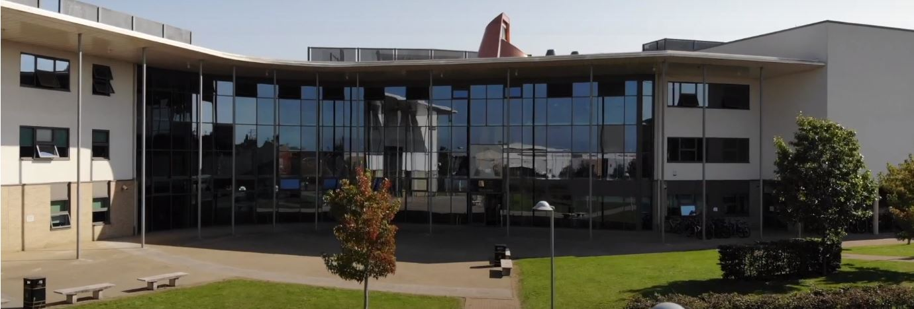
Application Pack
Deputy Leader – Life Centre
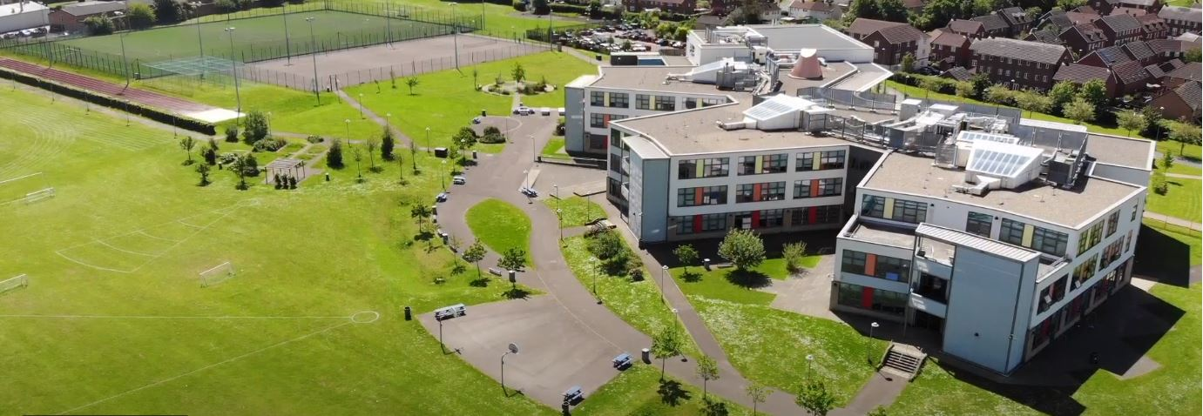
Where every member of our extended family realises their God-given potential, inspired by John 10:10. Jesus said ‘I have come so you may have life in all its fullness’.
2014 2018

www.asachelt.org

All Saints’ Academy, Cheltenham, Gloucestershire.
Principal: Mr Dermot McNiffe

Deputy Leader of The Life Centre
Start date: 1st January 2023
Salary: Teachers Main Scale Points 1-12/ Unqualified Scale Points 1-11 plus TLR 2a (£2,873 per annum)
Hours of work: Full Time
Contract: Permanent
Closing date: 9.30am Monday 12th December 2022

We are looking to appoint a confident and enthusiastic Deputy Leader of The Life Centre to support the Leader of The Life Centre.

The Life Centre is a small but important department within the Academy providing support to those students who need it, to ensure they achieve the best academic qualifications they can.

All Saints’ Academy is one of the best GCSE performing non-selective secondary schools in the Cheltenham and Tewkesbury area, and it has been for a number of years now.

Following another Good judgement, Ofsted reported:

• All Saints’ Academy is an inclusive school.
• Leaders and directors have been successful in improving pupils’ life chances by ensuring that they have achieved well in recent years.
• Staff hold fast to the school’s values and ethos, which unite them in their drive to improve standards.
• There is a clear determination to support pupils and their families to overcome barriers.
Ofsted 2018

Sponsored by the Anglican Diocese of Gloucester, we are an Academy serving at the heart of our local community. All Saints’ Academy has a Life Vision, ‘Where every member of our extended family realises their God-given potential, inspired by John 10:10. Jesus said 'I have come so you may have life in all its fullness'.

We are an inclusive Church Academy who welcomes applications from all denominations and those of none.

What we offer:
- The Academy is in an attractive new building, within easy access to Cheltenham, Tewkesbury and the M5 with onsite catering facilities
- Entry into the Teachers Pension scheme
- Free access to the onsite gym facility
- Access to our Employee Assistance Scheme
- Free onsite parking including electric charge points

The Academy is committed to safeguarding and promoting the welfare of children and young people, and expects all staff and volunteers to share this commitment. Shortlisted candidates will be subject to an online search in line with Keeping Children Safe in Education 2022 recommendations. Successful applicants will be subject to enhanced DBS clearance.

To apply for this role please send complete an online application form found on the Academy website www.asachelt.org If you have any questions regarding this role please contact Katie Jordan, HR Manager at hr@asachelt.org

All Saints’ Academy is committed to ensure that all applicants and employees are given equal opportunities and that no applicants or employees are discriminated against on the basis of gender, gender reassignment, race, disability, pregnancy or maternity, sexual orientation, marital or civil partnership status, age or religion and belief.

Job Description

Post Title: Deputy Leader of The Life Centre

Salary: All Saints Teacher Main or Unqualified scale plus TLR 2A

Core Purpose: To support the leadership of The Life Centre, an inclusive provision for students at risk of permanent exclusion or other learning needs.

Reporting To: Principal, Vice Principals, Leader of The Life Centre and SENCO.

Role Purpose | - To support the development of an alternative curriculum that is suitable to meet students’ educational needs.  - Design and implement timetables that compliment integration back into the main academy curriculum provision, further education, training or employment.  - To organise individual student curriculums following admission to The Life Centre.  - To work effectively with agencies and independent alternative providers to monitor and support students so that the curriculum offered is of good quality and meets students’ individual needs.  - To support the home/academy link with parents or carers to facilitate consistent attendance and quality of provision.
Supervisory Responsibilities | - To supervise and help organise the activities of Life Centre teaching staff and other Academy staff.
Duties and Responsibilities (Specific) | - To support the implementation of students’ timetables on referral to The Life Centre.  - To ensure students in The Life Centre receive an engaging and appropriate curriculum that meets students’ needs.  - To regularly monitor, review and evaluate the safety, well-being and education of students in The Life Centre.  - To monitor and respond to on-going assessment in order to set appropriate targets to maximise individual performance and progress.  - To support external providers in developing and implementing agreed systems of monitoring, recording and assessing progress.  - In collaboration with the Progress Team, monitor and report on attendance for students in line with the Academy’s Attendance Policy.  - To support the preparation of reports to parents, SLT, Trustees and agencies.  - To ensure all alternative providers and stakeholders rigorously and accurately adhere to the terms and conditions of their Service Level Agreement.  - To support effective links are maintained with other agencies as appropriate.  - To support the preparation, maintenance and monitoring of accurate records for the group.  - To support the collation, monitoring, evaluation and reporting of achievement data including progress towards targets (academic and social), attendance and external accreditation for students if applicable.  - To implement the Academy’s agreed policies, practices and procedures.  - To undertake the required teaching commitment as directed by the Leader of The Life Centre and Senco to ensure students have access to appropriate support packages in literacy, numeracy and behaviour and to prepare for reintegration including post-16 progression.  - To undertake relevant and appropriate CPD as identified through Performance Management  - To attend meetings relating to students when required.  - To maintain an appropriate working atmosphere through careful management of resources and establishing clear protocols.  - To undertake any other duties commensurate with the scale and function of the post that may reasonably be required.
Duties and Responsibilities (General) | - To adhere to existing working practices, methods, procedures, undertake relevant training and development activities and to respond positively to new and alternative systems.  - It will be necessary to work with information technology and associated systems in accordance with Academy policies.  - Comply with relevant health and safety legislation, policies and procedures in the performance of the duties of the post.  - To maintain confidentiality and observe data protection and associated guidelines where appropriate.
Methods of Working | - The post holder will be expected to adopt a participative and collaborative style of management encouraging team working.  - The post holder will be expected to take an active part in appraising their own work against agreed priorities and targets.
Additional Duties | - To play a full part in the life of the Academy community, to support its distinctive vision, mission and ethos to encourage and ensure staff and students follow this example.  - This job description sets out the main duties of the post 2021 – 2022. The post holder is required to undertake any other reasonable tasks at the discretion of the Principal.  - The responsibilities set out in this job description will be discussed annually as part of the annual performance management review and are subject to change in order for the Academy to develop strategically and effectively.

PERSON SPECIFICATION

Deputy Leader of the Life Centre

 | Essential | Desirable
Qualifications | - Educated to degree level  - Qualification in Education or relevant alternative | - Further professional qualifications in relevant area.  - Qualified Teaching Status
Skills | - Excellent teaching skills.  - Ability to teach at all levels.  - Ability to offer extra-curricular activities.  - Able to inspire, lead and support young people.  - Show initiative and approach challenges with a positive attitude.  - Able to use data effectively to assess prior attainment, track progress and set student targets.  - Experience of working with students with behavioural or learning needs. | - Ability to use ICT as a learning and teaching tool and a motivator.  - Knowledge of exam specifications.
General | - Flexible and enthusiastic attitude.  - Clear ability to relate to young people.  - A commitment to a positive culture of learning.  - Resilience to support and find ways to develop young people.  - Excellent communication skills.  - Experience of planning successful lessons.  - Clearly able to demonstrate the standards relevant to experience in teaching. | - Have ideas that you can turn into practice.  - Ability to self-review effectively and set appropriate targets.  - Willingness to organise and participate in school trips.  - Willingness to organise and participate in school productions and extracurricular activities.

