DEPUTY SENDCO
MPS/UPS + TLR + SEN Allowance
Required for Easter 2023

Candidate Pack

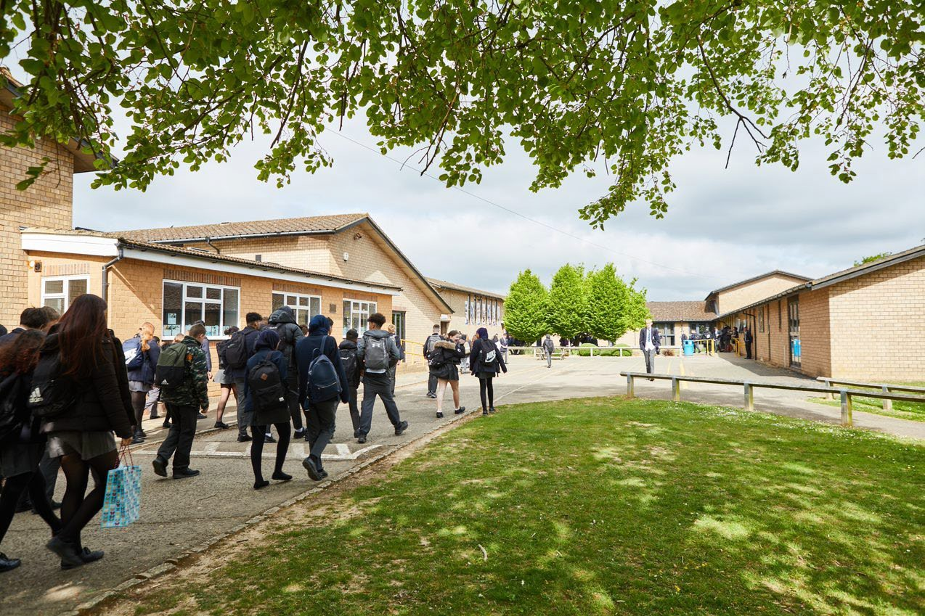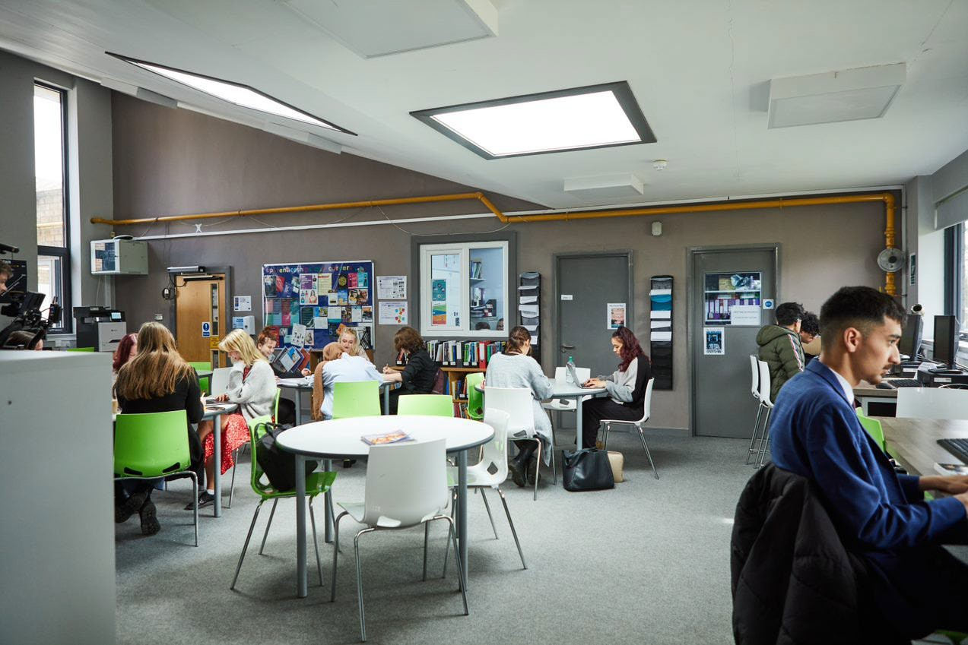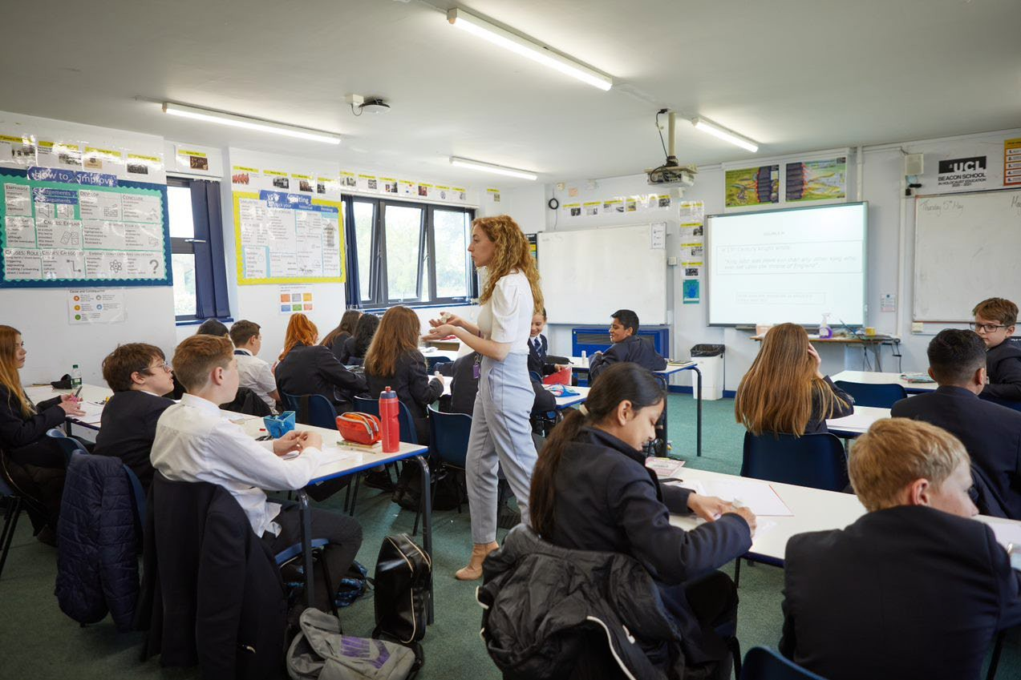
Welcome letter from the Headteacher

Dear Prospective Candidate

Thank you for your interest in the position of Deputy SENDCo at Sir William Ramsay School.

I joined Sir William Ramsay School as the new Headteacher in May and am committed to getting the school back to ‘Good’ as quickly as possible. Clarity, consistency and rigour are central to our plans to ensure that all students enjoy learning and make good progress. Our plans include significant developments in high quality teaching and learning, the introduction of ambitious targets, a focus on developing excellent teaching, meaningful homework and improvements in behaviour for learning. We are also rolling out a digital learning 'One to One Device' strategy across the school to ensure that students can receive innovative teaching and access state of the art resources at both home and school.

We are seeking to appoint an enthusiastic and highly effective Deputy SENDCO to work alongside the SENDCo to promote the progress of SEND students throughout the school, including running a Physical Disability ARP and a Hearing Impaired ARP.

The ideal candidate will have a passion for ensuring every student can access the curriculum whatever their ability or additional need. Most importantly, you should be the type of person who likes a challenge, believes in their own abilities and wants to make a difference to the lives of others.

If you would like to find out more about the role or to arrange a conversation with the SENDCo please contact TThompson@swr.school.

I will hope to meet you in the near future.

Yours faithfully

Paul Ramsey
Headteacher

Vision and Values at Sir William Ramsay School

Empowering Everyone to Achieve

Vision
A community where every voice counts, where talent and creativity are brought to life, where students grow in confidence, build resilience and are prepared for the rest of their lives.

Values
- We are respectful – we always treat people, property and the environment with kindness and consideration
- We are ambitious – we ask for help when we need it and strive to be the best we can be
- We are reliable – we do what is asked of us and deliver on our commitments
- We are resilient – we prepare for the future and adapt and grow from challenges

Mission
We aim to achieve our vision by:
- Raising students above the ordinary by developing and delivering lifelong learning which transforms lives
- Ensuring every person feels valued, safe and happy
- Enabling students to feel proud of themselves, and to take pride in the success of others
- Promoting a culture of mutual respect where everyone is treated as a valued member of the school community
- Encouraging positive communication so that words and actions are thoughtful, supportive and motivational
- Placing parents and carers at the heart of the life of the school
- Having highly dedicated and well-qualified staff who are committed to continuous professional development
- Adopting an ethos of continuous improvement within all aspects of school life

Equality
Sir William Ramsay is an inclusive and diverse community. We work to eliminate all forms of discrimination on the grounds of ethnic origin, religion, sexual orientation, gender, disability or ability.
This is achieved via the following principles:
- Ensure that students have the opportunity to reach their potential in all areas of school life
- Ensure that parents and students can make choices free from prejudice and stereotyping
- Oppose any form of racism, sexism, disability discrimination, homophobia or any other form of discrimination
- Value every student’s language and cultural background

JOB DESCRIPTION

Job Title: | Deputy Special Educational Needs and Disability Coordinator (Deputy SENDCo)
Grade: | Main or Upper Pay Range plus TLR 2b + SEN Allowance
Reports to: | SENDCo
Responsible for: | Working with the SENDCo to ensure the SEND Code of Practice is implemented in the school.  And accountable for raising standards of student attainment, achievement, behaviour and attendance through the coordination of all aspects of SEND provision.  Working with the SENDCo to effectively manage and deploy teaching/support staff, financial and physical resources within the department.  And being accountable for achieving the highest possible standards in work and conduct.

Purpose of the Job
- To implement SEND strategy across the school.
- To ensure SEND provision for individual students are stated in their EHCP is in place, monitored and effective.
- To support the SENDCo with the day-to-day management, budget and operation of the SEND Department, including effective deployment of staff and physical resources.
- To monitor progress, learning, interventions, behaviour and teaching of SEND students and use this information to improve the quality of provision.
- To deputise for the SENDCo.
- To act as a positive role model and to lead by example.
- To create and deliver engaging lessons to diverse groups of students at all levels.
- To promote and inspire enthusiasm for learning and for subjects.
- To promote high standards of student behaviour.

Main Responsibilities as a Deputy SENDCo
- To work with colleagues to implement aims, objectives and strategic plans for the department.
- To actively monitor and respond to SEND development and initiatives at a school, local and national level.
- To use the Assess Plan Do Review system, in line with the requirements of the SEND Code of Practice.
- To support the SENDCo in the leadership of the development of appropriate interventions and learning strategies in the department and across the school, monitoring their impact.
- To co-ordinate, monitor and evaluate IEPs and provision maps for SEND students.
- To be involved in Access Arrangements as directed by the SENDCo ensuring that they comply with JCQ requirements.
- To be responsible for a group of EHCP students monitoring their progress, learning, interventions, behaviour, attendance, attend PSP/PIP meetings linked to them and use this information to improve the quality of provision and student outcomes.
- To support departments and individual staff on the quality of teaching and learning that takes place the classroom.
- To deliver on whole staff, department or individual training in SEND ensuring it is relevant and timely.
- To ensure that Health and Safety policies and practices, including Risk Assessment, within the Department and out of hours provision are in line with national requirements and are updated where necessary.
- To ensure the school behaviour policy is implemented consistently in the Department so that effective learning can take place.
- To ensure the maintenance of accurate and up-to-date information in the school’s management information system.
- To ensure staff within the Department keep up to date records as required.
- To analyse and evaluate performance data provided.
- To identify and take appropriate action on issues arising from data systems and reports and to set deadlines where necessary and review progress on the action taken.
- To produce reports on examination performance, including the use of value-added data.
- To provide the Governing Body with relevant information relating to the Department performance and development.
To ensure effective communication/consultation as appropriate with the parents of students.
- To line manage the SEND Manager and Specialist LSAs and any other staff required by the school.
- To support the SENDCo with staff 6 month probation reviews as required.
- To support the SENDCo in the allocation of staff and their timetables.
- To participate in the interview process for staff posts when required and to ensure effective induction of new staff in line with school procedures.
- To manage the available resources of space, staff and equipment efficiently within the limits, guidelines and procedures laid down.
- To work with the Professional Tutor to assist/support the development of staff within initiatives such as NQT, OTT and PGCE.
- To attend where necessary at liaison events in partner schools and the effective promotion of subjects at Open Days/Evenings and other events such as Awards Evenings.

Main Responsibilities as a Classroom Teacher
- To prepare and deliver high quality, engaging and challenging lessons to a range of classes of different abilities and ages, differentiating work as required, considering prior knowledge and incorporating literacy and numeracy.
- To incorporate the strategies in place for students, for example from Student Passports, into planning so individual needs are met.
- To monitor student progress and put in place appropriate intervention strategies as required.
- To mark work, give appropriate feedback and maintain records of students’ progress and development.
- To be accountable for the students taught attainment, progress and outcomes.
- To maintain accurate and up-to-date electronic management information as required by the school such as safeguarding, progress data, test scores, student behaviours and achievements, notes of meetings with parents, interventions in place etc.
- To maintain up to date subject knowledge.
- To devise and write new curriculum materials for the team as required by the Head of Department.
- To select and use a range of different learning resources, ICT and equipment.
- To liaise with Learning Support Assistants (LSAs) or other professionals in the classroom to ensure that they know the teacher’s expectations for students they are supporting.
- To prepare students for qualifications and external examinations.
- To manage student behaviour in the classroom and on the school premises, and appropriate, consistent and effective measures in cases of misbehaviour.
- To undertake pastoral duties, such as being a Form Tutor, and supporting students on an individual basis through academic and personal difficulties.
- To communicate in a professional manner with parents/carers about their child’s progress.
- To support other colleagues.
- To promote positive self-esteem amongst students.
- To encourage positive attitudes and good behaviour amongst students.
- To develop social and emotional skills amongst students.

Other Responsibilities
- To promote the School’s vision, values and aims.
- To be aware of and comply with the codes of conduct, regulations, policies, procedures.
- To work as part of a team.
- To be generally responsible for safeguarding and promoting the welfare of students.
- To be responsible for own and team health and safety including well-being.
- To meet the Teacher Standards at a level relevant to the post-holder’s career stage.
- To actively participate in the School’s appraisal system.
- To do Continued Professional Learning as agreed with the Line Manager.

This job description is current at the date indicated below but, in consultation with the postholder, it may be changed by the Headteacher to reflect or anticipate changes in the post commensurate with the grade or job title.

PERSON SPECIFICATION – DEPUTY SENDCO

Knowledge, Skills and Experience
 | Essential | Desirable
Teaching experience [a minimum number of 2 years’ experience] | ü
Experience of working at a whole-school level |  | ü
Involvement in self-evaluation and development planning | ü
Experience of conducting training/leading INSET |  | ü
Experience of line-management responsibilities |  | ü
Sound knowledge of the SEND Code of Practice | ü
Understanding of what makes ‘quality first’ teaching, and of effective intervention strategies | ü
Ability to plan and evaluate interventions | ü
Data analysis skills, and the ability to use data to inform provision planning | ü
Effective communication and interpersonal skills | ü
Ability to build effective working relationships | ü
Ability to influence and negotiate | ü
Good record-keeping skills | ü
Qualifications
 | Essential | Desirable
Qualified teacher status or other recognised award | ü
A willingness to complete a relevant SEN Qualification | ü
Degree | ü
Personal Qualities
 | Essential | Desirable
Commitment to getting the best outcomes for pupils and promoting the ethos and values of the school | ü
Commitment to equal opportunities and securing good outcomes for pupils with SEN or a disability | ü
Ability to work under pressure and prioritise effectively | ü
Commitment to maintaining confidentiality at all times | ü
Commitment to safeguarding and equality | ü

How to Apply

Start Date: | Easter 2023
Hours: | Full-time
Salary: | MPS/UPS  TLR2b £5,191  SEN £2,384
Contract Type: | Permanent

If you wish to discover more about this exciting opportunity, need any further information or you wish to have an informal discussion, please contact James Black jblack@swr.school or the SENDCo Tracie Thompson: TThompson@swr.school

Please email your completed application form to: jointheteam@swr.school

Closing Date: 9am, Wednesday 1st February 2023
Interviews: TBC

Sir William Ramsay School is committed to safeguarding and promoting the welfare of children and young people and expects all staff and volunteers to share this commitment. We will ensure that all our recruitment and selection practices reflect this commitment.

All successful candidates will be subject to DBS checks along with other relevant pre-employment checks.

