 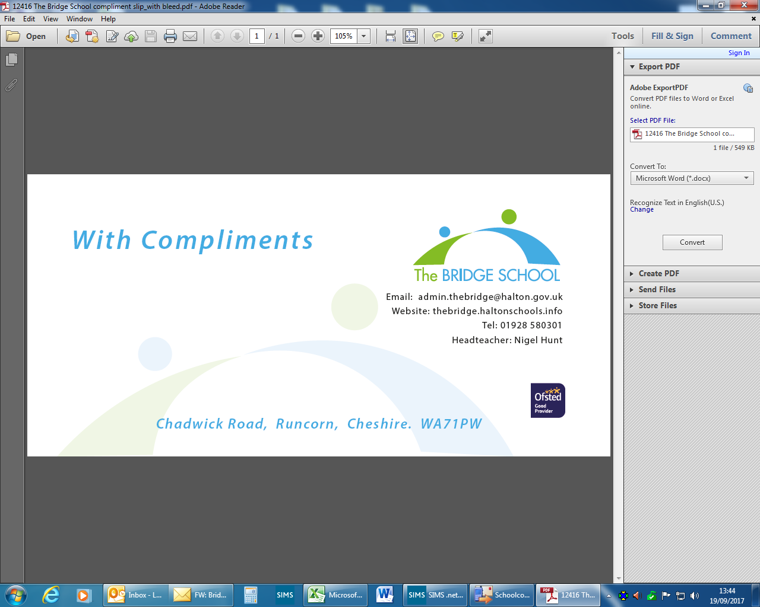

**JOB DESCRIPTION AND PERSON SPECIFICATION**

|  |  |
| --- | --- |
| Job Title: | DT Teacher (Product Design & Construction) |
| HBC Grade: | MPS/UPS + SEN 1 |
| Service: | The Bridge School |
| Division: | Children and Families |

|  |
| --- |
| **1 PURPOSE OF POST** |
| * Under the direction of the Centre Manager and Headteacher, carry out the professional duties of a school teacher as defined in ***Teachers Standards***. * Implement and deliver an appropriately broad, balanced, relevant, and adapted curriculum for students. * Facilitate and encourage a learning experience which provides students with the opportunity to fulfil their potential. |

|  |
| --- |
| **2 MAIN DUTIES AND RESPONSIBILITIES** |
| 1. To follow *Teachers Standards* as set by The Department of Education 2. Set high standards that inspire, motivate and challenge students. 3. To have secure up to date subject knowledge and related pedagogies in order to plan and teach challenging, personalised and adapted lessons that engage and motivate students. 4. Consider all individual students needs and prior attainment, and plan for them accordingly. 5. Have a broad appreciation of a range of D&T disciplines, but specifically product design, resistant materials and engineering. 6. Ensure all lessons are planned and delivered so that students can make good levels of progress. 7. Maintain accurate student records and be able to utilise a range of approaches to assessment that provide students with effective feedback and next steps for learning. 8. In line with policy, evaluate, analyse and report on student progress in relation to targets. 9. Work alongside the school leadership team to implement strategies and practice that will maintain and promote student progress both academically and personally. 10. In line with school policy, maintain and develop high standards of behaviour both in and out of the class space. 11. To have and develop a sound knowledge and understanding of a range of teaching, learning and behaviour management strategies, adapting these accordingly to the needs of the students. 12. Work with and deploy additional support staff so that they are effectively utilised to support learning. Give them clear direction and involvement in planning, delivery, and assessment. 13. Ensure the learning environment is safe and meets the required standards set by Health & Safety and supporting Risk Assessments. Ensure the environment is stimulating and welcoming, promoting effective learning conditions. 14. Take responsibility in promoting excellent student attendance and participation. 15. Ensure literacy and numeracy are actively promoted in all learning experiences, taking opportunities to plan for their integration in the D&T curriculum. 16. To be an outstanding practitioner in D&T, effectively delivering both theoretical and practical elements of learning. 17. Provide enrichment and extra-curricular opportunities for students within the D&T classes and beyond. 18. To contribute to the development of the curriculum, establishing a strong offer, linked to the wider school curriculum.   **Other Responsibilities:**   1. Be an effective team member, collaborating and sharing good practice. 2. In collaboration with the Exams Officer ensure that your subject students have access to, and entry on, appropriate accreditation opportunities. 3. To develop and implement an online/remote learning offer that reflects Teachers Standards and maximises IT software to maximise student participation. 4. Comply with all of The Bridge School policies. 5. Comply with data protection legislation and expectations of safeguarding and confidentiality. 6. Adhere to the Council’s Equal Opportunities Policy, both in delivering of services and in the treatment of clients and other employees. 7. Undertake any other duties and responsibilities as may be assigned from time to time, which are commensurate with the grade of the job. |

**The Council and its schools are committed to safeguarding and promoting the welfare of children, young people and adults and expect all staff, workers and volunteers to share its commitment.**

|  |  |  |  |  |
| --- | --- | --- | --- | --- |
|  | **Education** | **Experience** | **Knowledge** | **Skills & Abilities** |
| **ESSENTIAL** | Has Qualified Teacher Status | Experience of working with young people in an educational setting (KS3 & 4: 11 – 16 year olds) | An in-depth knowledge of all relevant legislation especially in relation to inclusive behaviour management, SEMH difficulties and schools’ duties under the Equality Act 2010. | Sensitive and effective communicator leading to effective behaviour management and positive student engagement. |
| Requirement to complete appropriate Staff Induction Programme within agreed timescale | Have worked with students with social, emotional and/or mental health difficulties. | Knowledge of the range of difficulties experienced by students with SEMH difficulties and an understanding of how these can impact on their learning and the whole school learning environment. | Ability to lead a staff team effectively to achieve positive outcomes and high levels of engagement |
| Further qualifications relating to SEND. | Evidence of high level oral and written literacy skills and numeracy. | Knowledge of the range of different approaches and strategies that might be appropriate to students with SEMH difficulties and evidence of successfully implementing them both within the classroom and in a whole school. | Ability to build and maintain effective working relationships with all young people, parents/carers and colleagues |
|  | Evidence of continuing professional development | Understanding of the principles and implementation of effective behaviour strategies to meet the needs of young people with SEMH | Ability to work effectively within a team environment, understanding roles and responsibilities |
|  | Experience of successful work within complex multi-disciplinary and multi-agency contexts | Knowledge and understanding of the factors which can influence behaviour from an individual and system perspective. | Strong interpersonal skills in order to persuade teachers and others to try new approaches and change practice |
|  | Evidence of successful classroom leadership | Demonstrable awareness of legislation relating to the SEN | Ability to advise, design and implement appropriate strategies to improve a young person’s behaviour |
|  | Experience with the process of subject led exams entry and process. | Aware of NCFE and G&G delivery for accreditation | Ability to build and maintain effective working relationships with all students and colleagues |
|  |  |  |  | Demonstrate skills in effective partnership working across organisations |
|  |  |  |  | Ability to lead a staff team effectively in order to achieve positive outcomes and levels of engagement |
| **DESIRABLE** | National Award for SEN qualification | Able to demonstrate current or previous experience of working in partnership across agencies | Understanding of principles of child development, learning styles and independent learning | Ability to adapt own approach in accordance with young person’s needs. |
| Accredited further (post graduate) learning in SEND | Experience in delivering staff training to improve delivery of vocational qualifications | Understanding of the 6 key principles of nurture and how to imbed them into learner’s curriculum. | Evidence of being an effective team member. |
| Evidence of positive ongoing CPD. | Experience of working within both a mainstream and specialist setting | Knowledge of Local Authority, Social Care and Health processes for EHC assessments. | Effective user of ICT, supporting use of data for reports. |
| Up to date Safeguard training | Experience of Line management and/or performance management. |  |  |
|  |  | Experience of Internal Verification |  |  |
| **HOW IDENTIFIED** | Production of qualifications at interview | Application / Interview / Assessment | Application /Interview / Assessment | Application / Interview /Assessment |

|  |  |
| --- | --- |
|  | **Other requirements of the post** |
| **ESSENTIAL** | Car owner with full driving license |
| Self-motivated and determined; flexible and adaptable; resilience and ownership |
| Committed to safeguarding and promoting welfare of young people |
| Able to actively support, promote and encourage The Bridge School’s ethos, culture and values |
| Willingness to participate in relevant training and development opportunities |
| **DESIREABLE** | Non QTS applicants to have experience in teaching |
| **HOW IDENTIFIED** | Interview / Assessment / Production of documentation |

Please note: Front line posts with direct customer contact should include a statement detailing the spoken English language requirements of the post.

For office use only:

|  |  |
| --- | --- |
| **Date Created:** | **25/01/24** |
| **Agreed by:** |  |

This job description is not intended to be either prescriptive or exhaustive; it is issued as a framework to outline the main areas of responsibility.