INFORMATION PACK
DESIGN AND TECHNOLOGY TECHNICIAN
Bright Futures Educational Trust
Bright Futures Educational Trust (The Trust) is a multi-academy trust set up in 2011. The Trust is made up of a richly diverse group of schools in Greater Manchester and Blackpool. We are passionate about working together within and beyond the Trust to achieve our aspirational vision: the best for everyone, the best from everyone. We are an organisation that is underpinned by values of: community, integrity and passion. In everything we do, we remember that we are accountable to the children, families and communities that we serve.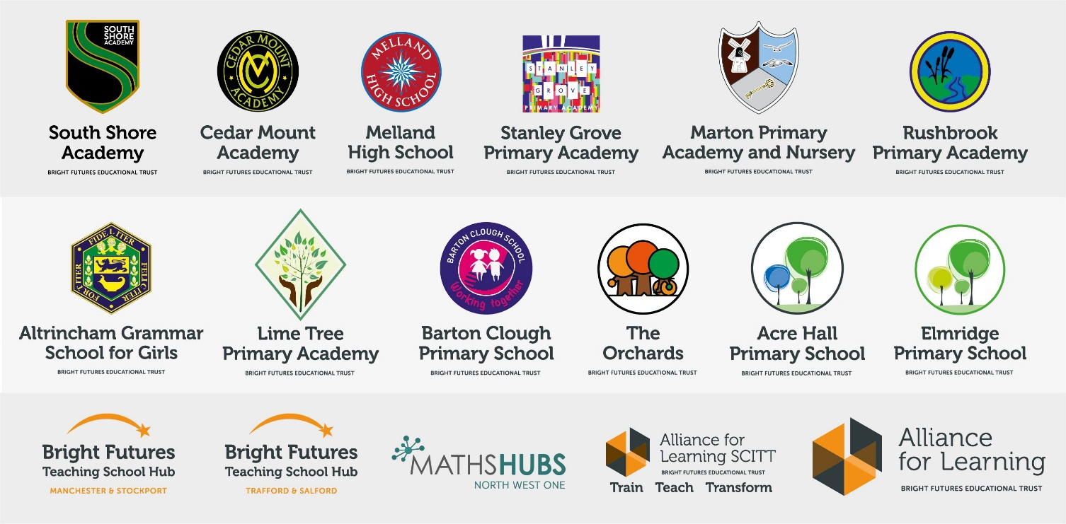
Our schools have their own identities and form one organisation and one employer, Bright Futures Educational Trust. Bright Futures’ Board of Trustees maintains strategic oversight of the Trust and delegates some of its responsibilities to the Executive Team, Principals and local governing bodies. We place a high value on integrity and probity and take seriously our accountabilities for making the best use of public money. How decisions are made is described in our delegation framework. You can find out more about the Trustees and the Executive Team on our website: http://bfet.co.uk/about-us/.

The central team, comprises the Executive Team: John Stephens, CEO; Edward Vitalis, Chief Operating Officer; Gary Handforth, Director of Education; Lisa Fathers, Director of Teaching School and Partnerships and Lynette Beckett, Director of HR & Strategy. The focus of these roles is to work with schools, providing high quality and timely guidance, leadership, challenge and support. In addition to the executive team, we have central operations for finance, HR, educational psychology and Digital Technologies. Please see our website brochure which explains our central operations: Working together for a Bright Future.
Bright Futures Development Network is another important outward facing component of our organisation. Underneath this umbrella we have 5 network hubs. ‘The Alliance for Learning’ (AFL) which provides school improvement services and CPD to over 700 schools (http://allianceforlearning.co.uk/); a North West Maths’ hub providing mathematics training and coaching to 500 schools: a SCITT (School Centered Initial Teacher Training) which is the largest in the North West. After significant national reforms to the teaching school policy, Bright Futures was designated with two new large-scale Teaching School Hubs in 2021. The areas we serve are Manchester, Stockport, Salford and Trafford.

Collaboration and strong relationships form one of the ‘commitments’ in our Strategy and all components of the Bright Futures’ family work closely together. Our Strategy was developed collaboratively and can be found on our website: Our Strategy.

Altrincham Grammar School for Girls
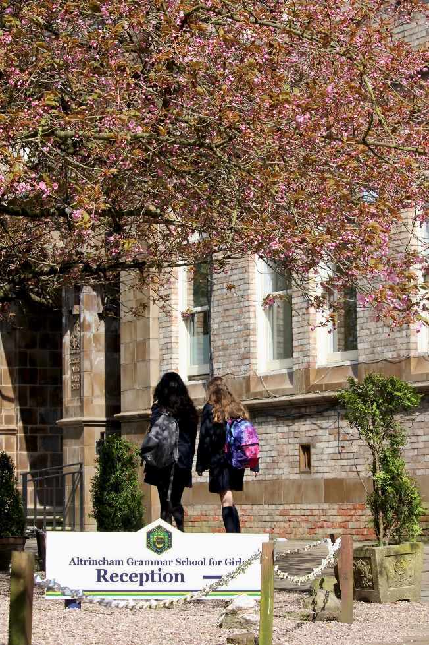
Altrincham Grammar School for Girls (AGGS) is a highly successful single sex 11 -18 academy in the South Trafford area. AGGS was in the first cohort of schools to be designated a national teaching school in 2011. AGGS is the lead school in ‘The Alliance for Learning’, which comprised schools of every type and phase, plus universities, throughout a wide geographical area. The impact of teaching school activities has been felt within the Trust and far beyond. We have a reputation for excellence regionally and nationally, of which we are very proud.

AGGS is committed to providing equal opportunity in recruitment and employment to all individuals. We will consider candidates without regard to race, ethnicity, gender, religion, sexual orientation and identity, national origin, age, military or veteran status, disability or any other legally protected status; and without discrimination based on socioeconomic, marital, parental or caregiving status, or any of the previously listed characteristics or statuses.

We value the diversity of our staff and reject any form of harassment, discrimination or victimisation. The Bright Futures Educational Trust vision is: ‘the best for everyone, the best from everyone’. To achieve this, we create and maintain a work environment and culture where people from different backgrounds, and with varying lifestyles, interests, opinions and responsibilities, treat each other with dignity and respect. It is a climate in which our staff feel safe and are inspired and motivated to be their best.

Our school is dedicated to sustaining and promoting diversity with respect to recruitment, promotion, training and general treatment during employment. We are actively seeking to extend the diversity of our staff. Furthermore, we welcome candidates who have not had previous experience of working in a grammar school.

We aim to ensure that our recruitment processes set up all candidates for success. At interview our aim is to provide a positive experience. We don’t want to catch anyone out, but rather to provide the opportunity for all candidates to be themselves and show us what they are capable of.

Why work for us?

We offer a great opportunity to join an organisation which really lives its values. Our working environment is very inclusive and whilst you can expect to be challenged in your role, you will be supported through professional learning, treated fairly and with dignity and respect. Please see the Equality, diversity and inclusion statement on our website: http://bfet.co.uk/vacancies

Terms and Conditions
Salary: NJC grade 3 (points 4-6) The pay based on the below working pattern commencing £7,851.44 rising to £8,142.87 per annum. This is based off a full-time equivalent salary of £18,933.00 rising to £19,698.00 per annum.
Working weeks: The postholder will work 38 weeks during school term time and an additional five days (pro-rata) to be agreed. A total of 39 weeks.
Hours: 17.5 hours per week over 5 days.

Holidays: You will be paid for the pro-rata equivalent of 25 days, plus 8 public holidays. This increases to 30 days plus 8 public holidays after 5 years’ service.
Pension: Local government pension scheme. Please take a look at the website: https://www.gmpf.org.uk/

Other: We offer salary sacrifice schemes for purchasing cycles and technology, through monthly interest free salary deductions.
How to Apply
We can only accept completed application forms, rather than CVs. This is because the regulatory guidelines of Keeping Children Safe in Education, require us to check various details of job applicants and an identical application format for each candidate enables us to do this.
Applications forms and criminal disclosure forms will need to be completed by 12 o’clock midday on Wednesday 22nd September 2021 using the link Design and Technology Technician application form.
The selection will take place in the week commencing 27 September 2021.

Applicants who are not contacted during this period may assume that they have not been successful but are thanked for their interest. Unfortunately, we are unable to provide feedback to unsuccessful applicants who are not called for interview.

Keeping Children Safe in Education
Bright Futures Educational Trust is committed to safeguarding and promoting the welfare of children and young people and we expect all staff and volunteers to share this commitment. This post is exempt from the Rehabilitation of Offenders Act 1974; pre-employment checks will be carried out and references will be sought for shortlisted candidates and successful candidates will be subject to an enhanced DBS check and other relevant checks with statutory bodies.
Data Privacy
You can the details of how we use the personal data that you provide us with in our Job Applicants’ privacy notice on our website: http://bfet.co.uk/wp-content/uploads/2018/07/BFET-Applicant-privacy-notice-002.pdf
JOB DESCRIPTION
DESIGN AND TECHNOLOGY TECHNICIAN

The Design and Technology Department is comprised of three teaching rooms and responsibilities will be shared between resistant materials, food and textiles. Duties in the department will include providing ancillary help and enabling the school to make the maximum use of it’s facilities. It is expected that the technician will help in the delivery of ICT as required in design and technology. The successful candidate must be prepared to train as a first-aider.

Main Responsibilities
- To provide technical support to teaching staff in the Design and Technology Department and organise duties with the best use of time and planning.
- To assist D&T staff in developing appropriate resources for teaching and learning.
- Under the direction of the subject leader, to ensure that all health & safety requirements are met.
- To assist in administrative duties in accordance with the teacher workload agreement.
- To maintain and monitor consumables and equipment in D&T and to ensure all students are able to access a wide range materials and processes.
- To carry out first line servicing of machines and equipment in D&T rooms to ensure safety and reliability. This will include cleaning, oiling, sharpening, removing dust and minor repairs.
- To prepare materials & equipment for practical lessons.
- To carry out daily visual checks of all machinery, before being used by students.
- To ensure cleanliness in the department, including maintenance of machinery and equipment in accordance with health & safety requirements.
- To carry out weekly health and safety checks on all equipment and machinery and report directly to the subject leader. To arrange for the regular safety inspections of all machinery and equipment, including the inspection of dust extraction.
- To arrange annual servicing of machinery with external contractors.
- To keep sinks and work tops clean; keep stock rooms and tool cupboards clean, tidy and in good order. To liaise with the Premises Manager/Caretaker if the standard of cleaning falls below an acceptable level.
- To become familiar with health and safety issues as they apply to D&T and assist the subject leader in the production of risk and COSSH assessments.
- To control and store safely all chemicals, flammables and specialised solutions, ensuring that current health and safety, COSHH and ESCC regulations are adhered to. To maintain all necessary safety signs adjacent to machinery.
- To maintain and monitor stock control, keep stock records, receive equipment and materials.
- To assist the subject leaders in the ordering of materials and equipment, researching and sourcing best prices.
- To purchase and transport materials and equipment from local suppliers when requested.
- To manufacture storage equipment as and when requested.
- To carry out weekly material and equipment checks across all technology rooms and maintain a record of all equipment checks.
- To assist staff in the production and updating of D&T displays within the school.
- To assist in the use of the range of CADCAM equipment, including a laser cutter and 3D printers and provide support during lesson time.
- To provide technical support to staff and students during lesson time as required.
- To advise staff on and implement practical improvements to the workshop and classrooms.
- To ensure the workshop area is kept secure, clean, tidy and free from all hazards.
- To undertake other duties as may reasonably be required by the Principal or Head of D&T.

School-wide Responsibilities
- Being aware of and acting upon relevant school policies and, in particular, those associated with child protection/safeguarding children and health and safety issues.
- Being responsible for maintaining a clean and tidy environment.
- Attending relevant meetings as required.
- Acting as a role model for the pupils in school.
- Acting as an ambassador for school and ensuring that the school’s high standards are promoted at all times.

Training and Development
As a Teaching School, we are committed to the professional development of all staff. The Design and Technology Technician will participate in the school’s appraisal arrangements.

Probationary period
Your appointment is subject to a six month probationary period. At the end of this period, provided your service has been satisfactory, your appointment will be confirmed. If your service is not satisfactory your employment may be terminated within the probationary period. The school requires six weeks’ written notice to resign from the post.

If invited for interview, candidates are requested to bring original copies of the following documents on the interview day which we need to have sight of:
- Degree Certificate (if applicable)
- QTS Certificate (if applicable)
- National Insurance Card (or letter from HMRC)
- Photo ID (passport and driving licence)
- Two other forms of identification that verify your name, address and date of birth e.g. birth certificate, marriage certificate, bank or credit card statement, utility bill.

ADDITIONAL INFORMATION

Further information about the school and the most recent OFSTED inspection are available from the school’s website.

BFET is committed to safeguarding and promoting the welfare of children and young people and expects all staff to share this commitment. Any successful applicant will be required to undertake an Enhanced Disclosure check by the Criminal Records Bureau. This post is exempt from the Rehabilitation of Offenders Act 1974.

Person Specification

 | Essential | Desirable
Relevant Experience | Previous experience in a similar role, or the ability to demonstrate skills transferable to the role. | Previous experience in a technician role.
Knowledge, skills, abilities | GCSE English and Maths up to GCSE level grade C or above.  Ability to plan, organise and prioritise work schedule.  Excellent oral and written communication skills.  Ability to work as part of a team.  Manual dexterity.  Ability to be self-motivated.  Ability to work under pressure and stay calm at all times.  Ability to preserve confidentiality.  Ability to work efficiently at speed.  Excellent IT skills.  Willingness to undertake first-aid training, ladder training, hygiene training and machinery use training. | Experience of working in a school environment.
Safeguarding | Commitment to demonstrating a responsibility for safeguarding and promoting the welfare of young people.
Personal qualities/others | Commitment to the aims and ethos of the school.  A positive approach to challenges, which seeks solutions to problems and addresses difficulties with good humour.  Flexibility and adaptability.  Willingness to work flexible hours as and when required.  Initiative and confidence when dealing with difficult situations.  Supportive nature.  Tact and discretion.  Commitment to further training and development.  Smart appearance. | .

