Wright Robinson College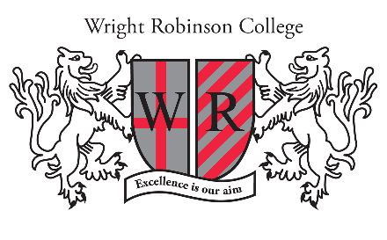
Headteacher: Martin Haworth
Design & Communications Manager

Grade: 8 - £34,728 to £38,890 (actual pro rata salary £30,503 to £34,159) Start Date: ASAP
Working Pattern: Term-time + 2 weeks

Do you aspire to be a Design & Communications Manager in an Outstanding School?

We have a new and exciting opportunity for a Design and Communications Manager to join our team. You will deliver outstanding school communications and marketing, supporting our whole school improvement and strategic plans, with responsibility for the implementation of our marketing strategy. You will contribute to our literature design, offering creative direction for our marketing material and creative delivery of high quality events. In addition, you will lead on our social media channels and assist and contribute to the maintenance, update and development of our school website.

We are looking for applicants who possess a Multi-Media, Design, Communications or Marketing qualification (preferably at degree level) or equivalent and will have experience of utilising those skills to good effect. You will have excellent ICT, oral and written communication skills, ensuring that all ‘copy’ is of the highest standard. You will be highly organised, self-motivated, flexible and conscientious in your approach to work.

Wright Robinson College is outstanding in every area of the Ofsted Inspection Framework. As an ‘Outstanding School,’ we are fully committed to continuing to further raise academic standards and attainment, across an academic curriculum.

You will be based in a friendly and supportive school with a state-of-the-art building, providing access to the latest resources to facilitate learning. As well as offering you a competitive salary, you will be provided with free access to on-site gym facilities and on-site parking. Located on the east side of Manchester, we are easily accessible through local and regional transport links.

Have you got the desire, experience and ambition to join our Team? If so, we would be delighted to hear from you. Informal enquiries can be directed to Victoria Duffy on 0161 370 5121. No agencies please.

For further information on the position, to see what our staff have to say about working for us and for details on how to apply, please follow the link below:
https://wrightrobinson.co.uk/staff-vacancies/

We are an Equal Opportunities Employer and we positively welcome applications from candidates regardless of age, disability, gender reassignment, marriage and civil partnership, pregnancy and maternity, race, religion or belief, sex and sexual orientation.
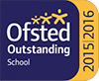
Deadline: 9am on Monday 1st November 2021

Wright Robinson College is committed to safeguarding and promoting the welfare of
children and young people and expects all staff and volunteers to share this
commitment.
All appointments are made subject to an enhanced DBS check.
www.wrightrobinson.co.uk

Tel: 0161 370 5121

Abbey Hey Lane, Manchester, M18 8RL

