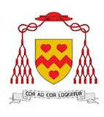 **St John Henry Newman Catholic School**

**Headteacher:** Mr John McAuley BA (Hons) MEd

**Address:** Scalegate Road, Carlisle, CA2 4NL

**Telephone:** 01228 404942 **Email:** office@newman.cumbria.sch.uk

**Website:** www.newman.cumbria.sch.uk

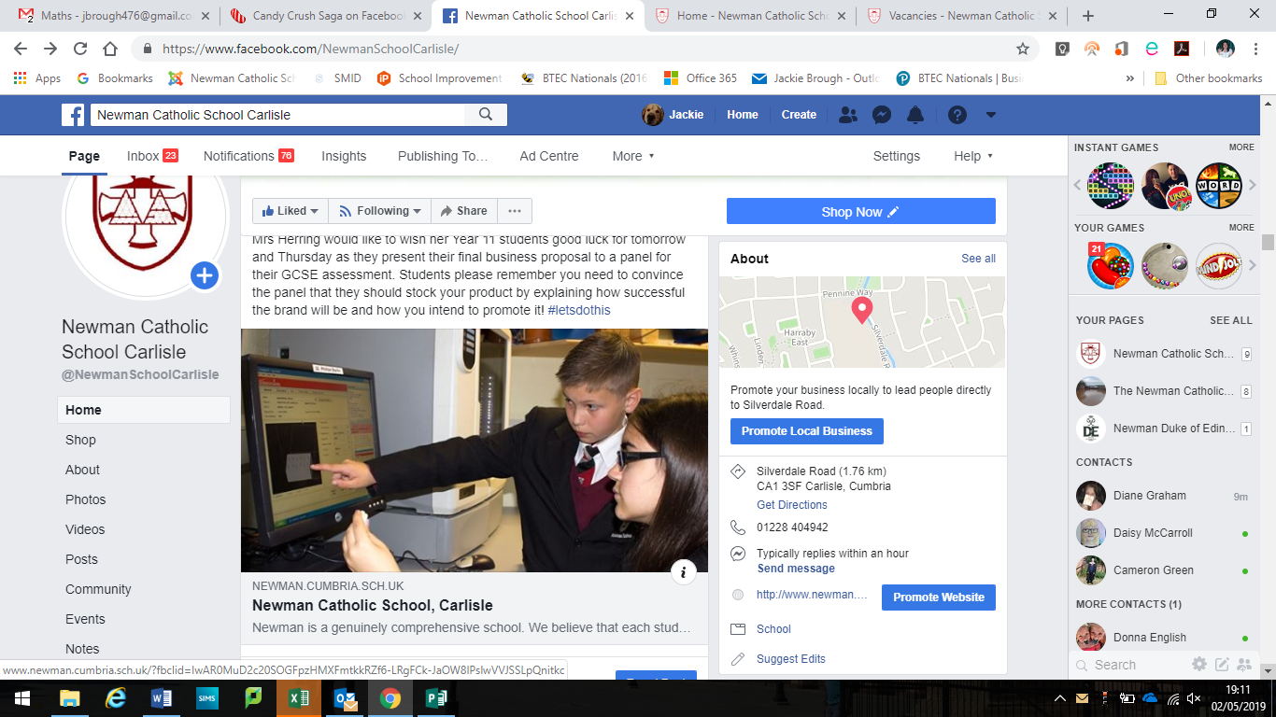

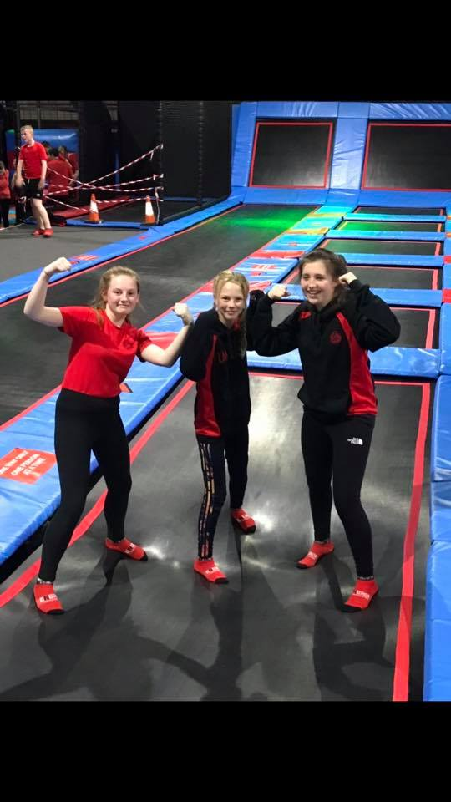





**St John Henry Newman Catholic School**

**Contents**

|  |  |
| --- | --- |
| Page 3 | Letter of welcome from the Headteacher |
| Page 4 | Our Location |
| Page 5 | New School Building |
| Page 6 | Advert |
| Page 7 - 9 | Job Description |
| Page 10 -11 | Mission Statement |

Also included with this application pack:

* Attachments - Notes to Applicant
* Application Form
* Rehabilitation of Offenders Form – issued at shortlisting stage
* Recruitment Monitoring Form
* Consent to Obtain Reference Form
* School Privacy Notice - Staff
* Code of Conduct Policy

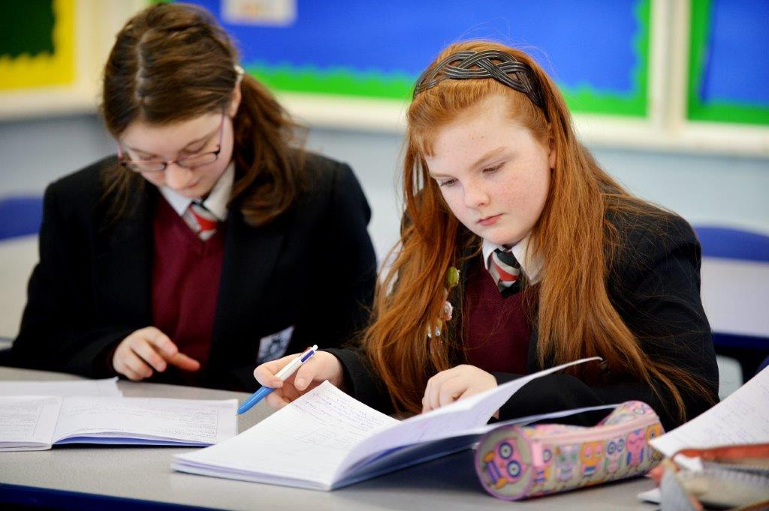

**St John Henry Newman Catholic School**

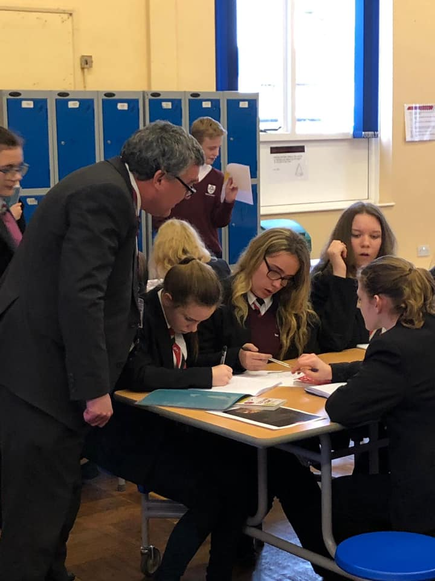Welcome to St John Henry Newman Catholic School. We are a genuinely comprehensive school and believe that our mission is to nurture each child by placing Christ and the teaching of the Catholic Church at the centre of their lives.

We integrate Gospel values and the teachings of the Catholic Church into every aspect of learning, teaching and the totality of school life.

In the words of our patron St John Henry Newman, “To live is to change and to be perfect is to have changed often”; and so we have high expectations of our pupils; we expect them to work hard, to play hard and to take a full part in the life of the school. In return, we strive to provide the best teaching and guidance in a caring and supportive environment, where pupils are challenged and give of their best.

Strong pastoral care is vital to our success and creates a happy and caring atmosphere. As a smaller school, we get to know our pupils well; their well-being is our foundation. This strong pastoral care enables us to support our pupils, not only with their academic work, but also in the varied extra-curricular activities, which are hugely important as they develop into young adults.

It is an exciting time to join Newman. Following the flooding of our site in Carlisle we have now moved to a purpose-built modern school in a developing area of Carlisle, the garden village. After a turbulent time following the flood, the school is rapidly improving and was recently commended by Ofsted for the improvements being made in the quality of teaching, the progress of pupils, and for the highly effective pastoral support. Inspectors’ findings confirmed that a journey of school improvement is underway.

We want our pupils to enjoy their education – to be happy, safe and secure and to grow in God’s love so that when they leave the school, they are equipped to change the world and make it a better place.

John McAuley

Headteacher



**St John Henry Newman Catholic School**



**Why choose this location**

St John Henry Newman Catholic School is located in Carlisle - the Border City - which is the main shopping, commercial and industrial centre in the north Cumbria. The city sits on the doorstep of both the Lake District and Hadrian’s Wall and blends 2000 years of history with a vibrant 21st century city.

The school has moved to a brand new build, located in the south of the city in a developing area known as the garden village.

The district of Carlisle, with a population of over 100,000, lies 10 miles south of the Scottish borders at the confluence of three rivers.

Originally established as a Roman settlement to serve the forts on nearby Hadrian’s Wall, it is the main commercial centre for north Cumbria. It has a long and interesting history, with Cumbria’s only cathedral and Carlisle Castle, a mediaeval fortress.

Easily accessed from the M6 motorway and A69 east-west route, Carlisle is also a major railway junction, with routes to London, Scotland, Newcastle, west Cumbria and the famous Settle-Carlisle railway.

Cumbria is a predominantly a rural county, considered one of the most beautiful regions of the UK, and includes the whole of the Lake District National Park, the Eden Valley, the North Pennines, the Furness Peninsula, and part of the Yorkshire Dales. The area has provided inspiration for generations of artists, writers and musicians. The county has some beautiful coastlines, vibrant towns and idyllic rural villages.

The quality of life is hard to beat and it is easy to see why so many people are drawn to Cumbria to live and work.

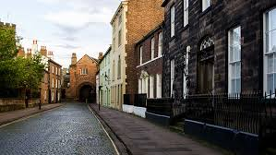

**St John Henry Newman Catholic School**

**Our New School**

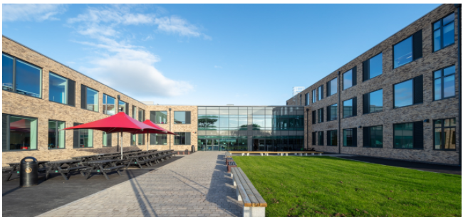

It is an exciting time for Newman, as we have moved to a new build school in the “garden village” area of Carlisle. Our school is a £15million new build in a rural location on the edge of the city. The school has been designed to provide the highest standards of education for our pupils and areas have been purpose built to allow staff to teach effectively in their subject areas.

 **St John Henry Newman Catholic School**

**Full Time Teacher of Design & Technology/Art Faculty**

**Teachers Pay Scale**

**Required September 2024**

An exciting opportunity has arisen for a creative, motivated and enthusiastic Design & Technology Teacher who will join our thriving Art, Music and Technology Faculty. The department has staff with multi skills and exact teaching content will be built around the successful candidate.

The faculty has new purpose built facilities which provide an environment in which creativity, innovation and problem solving skills can flourish.

Design and Technology and Art are taught to all pupils across our school in KS3 and we presently teach BTEC Construction, Level 1-2 Hospitality & Catering, GCSE Design & Technology as well as A' level Product Design, Food Science and Nutrition and Art.

We are interested in talking to both experienced teachers looking for a new challenge as well as newly qualified teachers at the beginning of their career.

St John Henry Newman Catholic School is committed to safeguarding and promoting the welfare of young people. This post will be subject to satisfactory DBS and health checks.

For an informal chat about the post please contact Mrs Hurst, Head of Design &Technology by email: RebekahHurst@newman.cumbria.sch.uk

For an information pack please email vacancies@newman.cumbria.sch.uk or download the forms from our website at <http://newman.cumbria.sch.uk/Vacancies/>

Your application form should be supported by a letter of no more than two pages of A4.

The closing date for applications is 12.00pm on Friday 10th May 2024

Short listed candidates will be contacted by telephone or email

 **St John Henry Newman Catholic School**

**Job Description**

Post: **Teacher**

Responsible to: **Subject leader**

Responsible for: Teaching across the age and ability range of the school as directed by the Headteacher

**Professional duties:** (These duties relate directly to the School Teachers’ Pay and Conditions Document)

**Mission Statement:**

Working with the Headteacher and Senior Leadership Team in implementing the school’s mission statement.

From time to time contributing to the review of the mission statement.

**Teaching:**

In each case having regard to the curriculum for the school, and with a view to promoting the development of the abilities and aptitudes of the pupils in the class or group assigned to her/him:

* planning and preparing courses and lessons according to the school formats;
* registering pupils in line with school protocol;
* teaching, according to their educational needs, the pupils assigned to her/him, including the setting and marking of work to be carried out by the pupil in school and elsewhere;
* monitoring, assessing, recording and reporting on the development, progress and attainment of pupils, following school procedures;

**Other activities:**

* maintaining and promoting the good name of the school
* promoting the general progress and well-being of individual pupils and of any class or group of pupils assigned to her/him;
* providing guidance and advice to pupils on educational and social matters and on their further education and future careers, including informa­tion about sources of more expert advice on specific questions; making relevant records and reports;
* making records of and reports on the educational personal and social needs of pupils using school systems and formats;
* communicating and consulting with the parents of pupils;
* communicating and co-operating with persons or bodies outside the school; and
* within the 1265 hours participating in meetings arranged for any of the purposes described above;

**Assessments and reports:**

* providing, recording and contributing to oral and written assessments reports and references relating to individual pupils and groups of pupils.

**Continuous Professional Development:**

* participating in arrangements made in accordance with regulations made for the appraisal of her/his performance and that of other teachers.

**Review, induction, further training and development:**

* reviewing from time to time her/his methods of teaching, pupil monitoring and assessment and programmes of work;
* participating in arrangements for her/his further training and professional development as a teacher including undertaking training and professional development which aim to meet needs identified in appraisal / performance management objectives or in appraisal / performance management statements;
* in the case of a teacher serving an induction period, participating in arrangements for her/his supervision, training and well-being;

**Educational methods:**

* advising and co-operating with the head teacher and other teachers on the preparation and development of courses of study, teaching materials, teaching programmes, methods of teaching and assessment and pastoral arrangements.

**Discipline, health and safety:**

* contributing to risk assessments and promoting a healthy and safe working environment
* maintaining good order and discipline among the pupils and safeguarding their health and safety both when they are authorised to be on the school premises and when they are engaged in authorised school activities elsewhere.

**Staff meetings:**

* participating in meetings at the school which relate to the curriculum for the school or the administration or organisation of the school, including pastoral and pupil progress arrangements;

**Cover**

* no teacher shall be required to provide such cover for more than 38 hours in any school year.

**Public examinations:**

* participating in arrangements for preparing pupils for public examinations, in monitoring and assessing pupils for the purposes of such examinations and recording and reporting such assessments, and participating in arrangements for pupils’ presentation for such examinations.

**Management:**

* contributing to the selection for appointment and professional development of other teachers and support staff, including the induction and assessment of new teachers and teachers serving induction periods;
* assisting the head teacher in carrying out threshold assessments of other teachers for whom he has management responsibility;
* co-ordinating or managing the work of other staff;
* taking such part as may be required of her/him in the review, development and management of activities relating to the curriculum, organisation and pastoral functions of the school;

**Administration:**

* participating in administrative and organisational tasks related to such duties as are described above, including the direction or supervision of persons providing support for the teachers in the school;
* attending assemblies, registering the attendance of pupils and supervising pupils, whether these duties are to be performed before, during or after school sessions.
* a teacher should not routinely undertake tasks of a clerical or administrative nature which do not call for the exercise of a teacher’s professional skills and judgment.

**Other duties:**

Any other duties the head may direct within the conditions of service.

**Review**

This job description will be reviewed annually or sooner if required.

J D McAuley

January 2024

 **St John Henry Newman Catholic School**

**Mission Statement**

*Our mission is to educate our pupils in the wholeness of mind, body and spirit through the teachings of Jesus Christ as proclaimed by the Catholic Church by placing Him at the centre of pupils' lives.*

*Our school commits itself to the principles of Catholic education and academic excellence, leading our pupils from shadows and images to the fullness of the Truth, as envisioned by the St John Henry Newman. The school community recognises that excellence in education can best be achieved, and future leaders nurtured, within a living tradition rooted in the Love and Truth of Christ.*

*We encourage pupils to cultivate Christian virtue and an appropriate sense of social responsibility.*

*We inspire an enthusiasm for life-long learning and are committed to success for all.*

**St John Henry Newman Catholic School**

**Governors’ Strategic Vision 2018-2023**

This text sets out our aspirations for St John Henry Newman Catholic School and provides a description of the school the governors would like to see evolve as the manifestation of their ambitions.

Each year’s School Improvement Plan will take us closer to achieving these goals and will represent the practical steps required to deliver this vision.

**We will develop a school which is characterised by:**

* Christian values, where Catholic teaching is at the centre of every aspect of school life, and kindness and compassion are qualities which are shared by the whole school community
* equal respect for all members of the school community in which diversity is welcomed and celebrated
* dedicated, highly professional and committed staff who fulfil their various roles to the highest of standards and work effectively as a team
* fostering high aspirations and determination in our pupils, and driving them to be high achievers in all aspects of their learning and development
* a safe, nurturing and inclusive outlook

**As a result of our collective efforts, we expect our pupils to be:**

* well rounded young people, independent, confident and articulate, outward facing and ready to make a positive difference in the world as responsible citizens in a tolerant and democratic society
* happy and able to fulfil all dimensions of their human potential: spiritual, academic, personal and social
* shaped by Christian values, and willing to contribute actively in their faith and secular communities, providing a positive example to others
* confident in their abilities and equipped to achieve excellence in their studies leading to success in continuing education or training and future careers
* both leaders and good team players with a strong sense of self-esteem as well as respect for others
* the best that they can be, behaving in such a way that all can be proud of them
* self-disciplined and courteous, setting an example to others

**The school will provide an environment which is:**

* an inspirational place in which to learn: spacious, light, attractive and stimulating
* suitable to meet all needs – physical, academic, personal, social and spiritual
* furnished with a distinctive and prominent working chapel open to all, at all times, with regular Masses
* supportive of learning in all domains, flexible and responsive to the changing curricular requirements of the 21st Century
* responsive to the progression routes of all pupils, including the provision of high quality post-16 programs within its own distinctive sixth form.
* an environment which brings pupils together, with communal and recreational spaces conducive to a civilised experience
* safe, secure and appropriate to the diverse needs of the pupil’s community
* well-resourced with the equipment and materials required to provide the best contemporary education possible