

**KING EDWARD VI CAMP HILL SCHOOL FOR BOYS**

**Teacher of Design & Technology**

**Full time**

**Information for Applicants**

**SUMMER 2024**

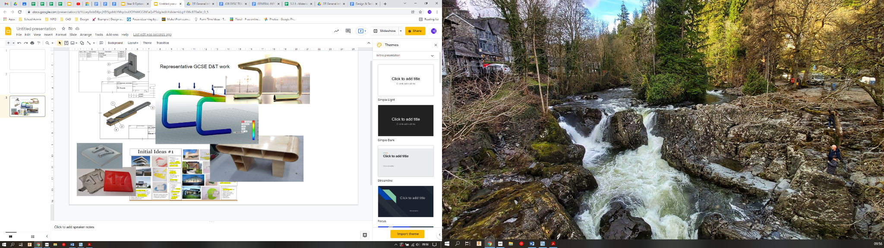**GENERAL INFORMATION ABOUT OUR SCHOOL**



King Edward VI Camp Hill School for Boys is a selective state school; it is a member of the King Edward VI Academy Trust in Birmingham, which is a group of twelve schools, six of which academically select their pupils. These schools, together with two independent schools, form the King Edward’s Foundation. The school moved from the inner city to its present location on the former Cartland Estate in 1956. Kings Heath is a pleasant suburb in South Birmingham with easy access to the M42, M40, M5 and M6 motorways, to Stratford and to the Warwickshire/Worcestershire countryside. In recent years, we have benefited from a new Sports Hall, Library, laboratories, classrooms and Sixth Form Common Room.

There are 1028 students on roll, of whom 341 are in the Sixth Form. The school admits 120 students (150 in the current Year 7, 8 & 10; likely 150 in next year’s Year 7) a year at the age of 11. Nearly all of the students stay on at the school to the age of 18 and proceed into Higher Education. Academic standards are very high – in 2023 the percentage of GCSEs passed at grades 8 and 9 was 74%. At A Level the percentage of exams passed at A*-B was 83%. 8 students won Oxbridge places this year (September 2023 entry).

The most recent OFSTED visit, in November 2023, graded the school as Outstanding in all areas.

**THE DESIGN & TECHNOLOGY DEPARTMENT**

|  |  |
| --- | --- |
| **Full Time Staff** | |
| Ian Cattermole | Head of Design & Technology Department |
| Hannah Reynolds | Teacher of Design & Technology |
| Bal Singh | D&T Department Technician |
| **Part Time Staff** | |
| Ashley Maxwell | Teacher of Games / Design & Technology |
| Andrew Rudd | Teacher of History / Design & Technology |

The department is fortunate to contain well-qualified and enthusiastic teachers of the subject. We have a mixture of specialist DT teachers working alongside non-specialists, which allows the department to work collaboratively with the other departments and discuss alternate approaches to learning. There is a strong feeling of working together as a team; the sharing of resources and teaching ideas is commonplace.

Over the last four years, the department has undergone a period of substantial modernisation and approach to the curriculum. As a department we want the best for our students and always try to challenge them through our high expectations.

**ACCOMMODATION**

There are six specialist learning rooms for Design & Technology. Each room is equipped with a projector, SMART interactive whiteboard and sound system. Each member of staff is provided with a laptop. The rooms:

DR1 – Top Workshop – Workshop for all materials, predominantly timbers and a separate teaching area

DR2 – Bottom Workshop – Workshop for all materials, predominantly metal

DR3 – Electronics Room – Electronics / Teaching room

DR4 – Middle / Modern Manufacturing Room – CAD/CAM Room

DR5 – Design / CAD Room – 32 PC/CAD machines, Designing space and Food demo space

DR6 – Cookery Room- 1 teaching point and 10 stations

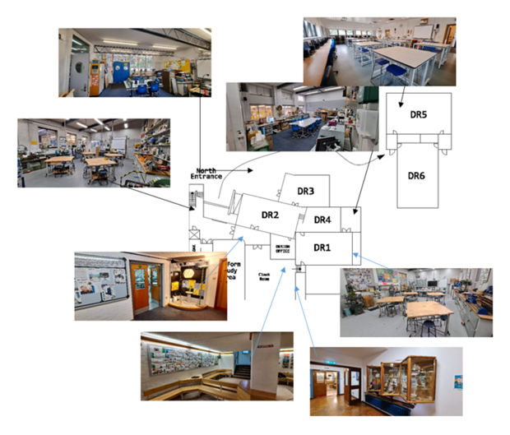

**CURRICULUM**

The ethos of the department is to offer a curriculum where our students can develop skills to be used in any career. We pursue higher order thinking skills, organisational skills and project management. We want our curriculum to be thought provoking, one that improves creativity and develops the students theoretical and applied knowledge.

During the iterative design process our students use a balance of cutting edge manufacturing and traditional manufacturing, and in doing so develop their practical skills and dexterity. As well as developing their individual ideas, we look to develop their hand rendering skills and use of 2D & 3D CAD work.

All pupils study Design & Technology up to year nine, between 45-50 continue onto GCSE and 5-10 study at A level.

**KEY STAGE 3**

At Camp Hill School for Boys, form sizes are approximately 30. Design & Technology is taught in two hours a fortnight (double-staffed) in Year 7 and in three hours a fortnight (2 double-staffed & 1 single staffed) in Years 8 & 9. The first three years aim to give the students a foundation in the expectations for GCSE by increasing their understanding of the following -

* Structures
* Control, Mechanisms & Electronics
* 3D CAD / CAM
* Problem Solving
* Designing for a situation
* Experience of working and finishing Materials

This year we have given the students an experience of food preparation and we are going to develop this aspect in the coming years.

**KEY STAGE 4**

In Years 10 and 11, Design & Technology is taught in option groups. We currently have three groups of 16 students each year.

The students have five, hour-long lessons a fortnight. We follow AQA 8552 Design & Technology course, which is 50% NEA and 50% Terminal Exam.

In 2023, 67% of students in Year 11 achieved grades 7 - 9 in GCSE Design & Technology.

We are currently investigating the additional delivery of GCSE Engineering (AQA 8852).

**A LEVEL**

In year 12 and 13 D&T: Product Design has one group of between 5 to 10 students each year. We also accept students from Camp Hill School for Girls.

The students have nine, hour-long lessons a fortnight. We follow AQA 7552 D&T: Product Design course, which is 50% NEA and 50% Terminal Exam.

In 2022 80% of our students achieved A*/A in D&T: Product Design

**THE POST**

The post is to add an additional full time member of the department. We are seeking a suitably qualified and talented classroom practitioner who can bring the best out of our students, and who is able and willing to make a contribution to the wider life of our school. We are willing to explore a start date of Easter 2024 but this is not essential. A start date of September 2024 will also be acceptable.

A generic job description is available on the website.

**FURTHER INFORMATION**

Candidates are asked to complete the application form and attach a letter of application giving examples of achievements, skills and experience which match those sought in the job description provided by the school. These documents should be sent to me as soon as possible, but by no later than **Tuesday 22nd January**. Interviews are scheduled to take place in the week beginning 29th January, 2024.

Please do not hesitate to contact me if you require any further information. Camp Hill Boys is a happy, flourishing and friendly community as well as an outstandingly successful grammar school. I look forward to receiving your application.

**R W Bowen**

**Headmaster**