St Philip Howard

Catholic Voluntary Academy

Part of the St Ralph Sherwin Catholic Multi Academy Trust

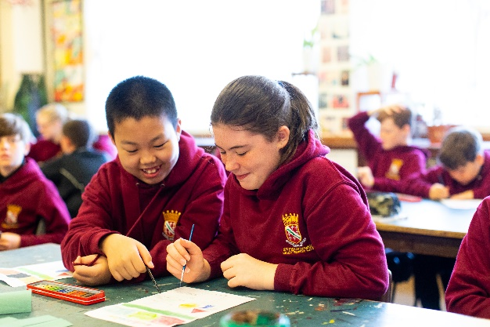
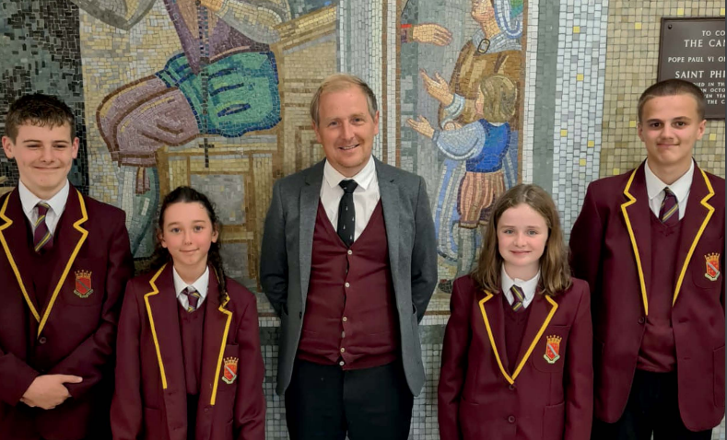
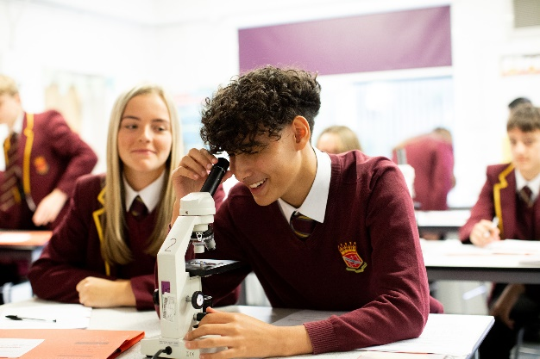

Designated Safeguarding Lead

Start Date: September 2024

Salary: SRS Band 5
Line-manager: Headteacher

Headteacher’s Welcome

Through a three – way partnership between home, school and parish we aim to work as a team to ensure our children achieve their potential. We believe that a happy child is a fulfilled child and therefore our strong pastoral system is of key importance to us. Our Catholic faith underpins everything that we do and ensures that our pupils are well rounded, confident young people with increasingly high aspirations. We are on an exciting journey at SPH and we firmly believe that by working together all our pupils will have a bright future ahead.

St Philip Howard Catholic Voluntary Academy is an exciting place for our students to grow and develop, building an enriching love of learning and a spiritual outlook that they will carry with them through life. We are an oversubscribed smaller than average Catholic Secondary school with 579 pupils located in Glossop, Derbyshire.

The successful applicant for this position will be joining a school where we care about our students and we care about our staff. We are delighted with our recent Ofsted inspection where we secured a ‘good’ judgement in all areas.

If you are excited by the opportunity to be part of #TeamSPH then we would welcome a discussion regarding this important position.

Mr M Kays Headteacher

About this post

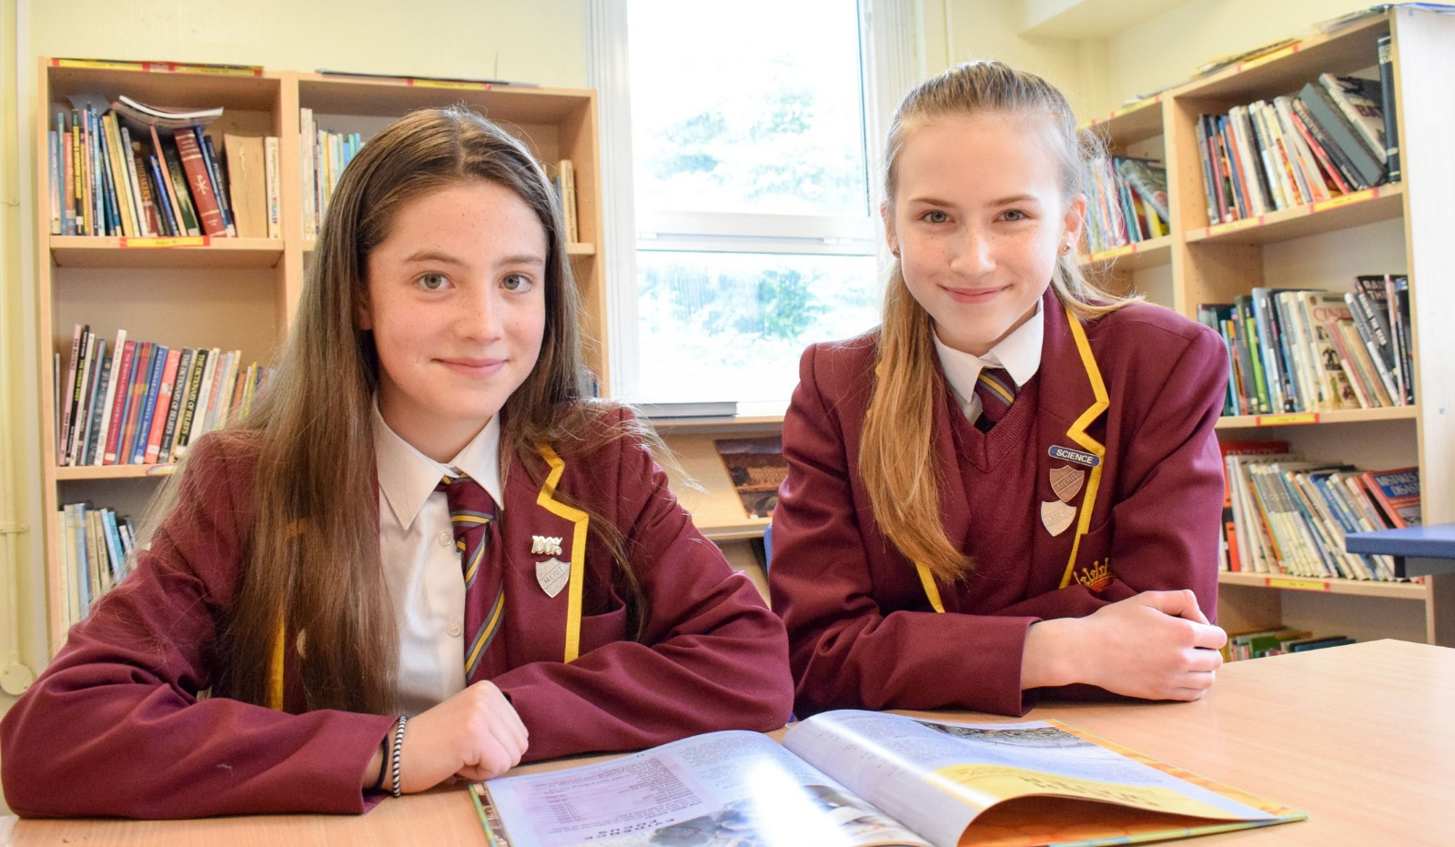
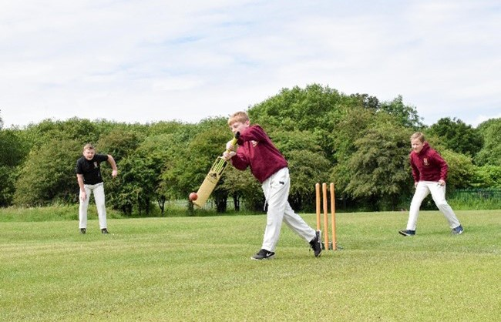

The Post
We are looking for a highly skilled and passionate Designated safeguarding Lead to join our busy, hardworking team from September 2024 at Saint Philip Howard Catholic Voluntary Academy.

The Role
- The successful candidate will be required to take lead responsibility for safeguarding and child protection across the academy (including online safety and understanding the filtering and monitoring systems )

#TeamSPH: Together on the Journey
Together, we will make the SPH journey: safely, respectfully and with kindness as part of a united Catholic family.

God will be at the heart of our journey, supporting us to realise the potential of our God given talents.

Our Gospel Values will guide us on our journey, helping us to make brave choices along the way.

Respect for all will be at the spirit of our journey and we will
embrace the uniqueness of everyone we greet.

Inspiration and passion for learning will lead us all to have a
memorable and successful journey.

Person Specification

criteria | qualities
Qualifications  and training | - GCSE (or equivalent) in English and maths  - Degree
Experience | - Successful leadership and management experience in a school or other relevant organisation  - Experience of managing safeguarding in a school or other relevant organisation, including:  - Building relationships with children and their parents, particularly the most vulnerable  - Working and communicating effectively with relevant agencies  - Implementing and encouraging good safeguarding practice throughout a large team of people  - Demonstrable evidence of developing and implementing strategies to help children and their families  - Experience of handling large amounts of sensitive data and upholding the principles of confidentiality
Skills and knowledge | - Expert knowledge of legislation and guidance on safeguarding and working with young people, including knowledge of the responsibilities of schools and other agencies  - Ability to work with a range of people with the aim of ensuring the safety and welfare of children  - Awareness of local and national agencies that provide support for children and their families  - Excellent record keeping skills and attention to detail, in order to produce reports, take minutes of meetings, and document safeguarding concerns  - Good IT skills, including previous use of safeguarding software e.g. My Concern, CPOMS  - Effective communication and interpersonal skills  - Ability to communicate a vision and inspire others  - Ability to build effective working relationships with staff and other stakeholders
Personal qualities | - Commitment to ensuring the safety and welfare of children  - Commitment to upholding and promoting the ethos and values of the school  - Integrity, honesty and fairness  - Ability to work under pressure and prioritise effectively  - Commitment to always maintaining confidentiality at all times  - Commitment to equality

Notes:
This job description may be amended at any time in consultation with the postholder.

Job Description

Main purpose

The DSL will take lead responsibility for safeguarding and child protection across the school (including online safety and understanding the filtering and monitoring systems in place).
They will take part in strategy discussions and inter-agency meetings and contribute to the assessment of children.
They will advise and support other members of staff on child welfare, safeguarding and child protection matters, and liaise with relevant agencies such as the local authority and police.Some safeguarding activities may be delegated to deputies, but the DSL will retain ultimate lead responsibility for safeguarding and child protection.

Duties and responsibilities

Managing referrals
- Refer cases of suspected abuse and neglect to the local authority children’s social care
- Support staff who make referrals to the local authority children’s social care
- Refer cases to the Channel programme where there is a radicalisation concern
- Support staff who make referrals to the Channel programme
- Refer cases to the Disclosure and Barring Service where a person is dismissed or leaves due to risk or harm to a child
- Refer cases to the police where a crime may have been committed

Working with staff and other agencies
- Act as a source of support, advice and expertise for all staff
- Act as a point of contact with the safeguarding partners
- Inform the headteacher of safeguarding issues, especially ongoing enquiries under section 47 of the Children Act 1989 and police investigations, and the requirement for pupils to have an appropriate adult
- Liaise with the case manager and the local authority designated officer(s) (LADO) for child protection concerns in cases which concern a staff member
- Liaise with staff on matters of safety, safeguarding and welfare (including online and digital safety), and when deciding whether to make a referral by liaising with relevant agencies so that children’s needs are considered holistically
- Liaise with the senior mental health lead and, the family support team, where safeguarding concerns are linked to mental health
- Promote supportive engagement with parents and/or carers in safeguarding and promoting the welfare of children, including where families may be facing challenging circumstances
- Work with the headteacher and relevant strategic leads, taking lead responsibility for promoting educational outcomes by:
- Knowing the welfare, safeguarding and child protection issues that children in need are experiencing, or have experienced
- Identifying the impact that these issues might be having on children’s attendance, engagement and achievement at school

- The above includes:
- Ensuring the school knows which children have or have had a social worker, understanding their academic progress and attainment, and maintaining a culture of high aspirations for this cohort
- Supporting teaching staff to provide additional academic support and/or reasonable adjustments to help these children reach their potential

Managing the child protection file
- Ensure child protection files are kept up to date
- Keep information confidential and store it securely
- Make sure records include:
- A clear and comprehensive summary of the concern
- Details of how the concern was followed up and resolved
- A note of any action taken, decisions reached and the outcome
- Ensure files are only accessed by those who need to see them, and that where a file or content within it is shared, this happens in line with information sharing advice as set out in Keeping Children Safe in Education (KCSIE)
- Where children leave the school (including in-year transfers):
- Ensure their child protection file is securely transferred to the new school as soon as possible, separately from the main pupil file, with a receipt of confirmation, and within the specified time set out in KCSIE
- Consider whether it would be appropriate to share any additional information with the new school before the child leaves, to help it put appropriate support in place

Raising awareness
- Ensure each member of staff has access to, and understands, the school’s child protection policy and procedures, especially new and part-time staff
- Work with the governing board to ensure the child protection policy is reviewed annually (as a minimum) and the procedures and implementation are updated and reviewed regularly
- Ensure the child protection policy is available publicly and parents and carers are aware that referrals about suspected abuse or neglect may be made and the role of the school in this
- Link with the safeguarding partner arrangements to make sure staff are aware of any training opportunities and the latest local policies on local safeguarding arrangements
- Help promote educational outcomes by sharing information with teachers and school leadership staff about the welfare, safeguarding and child protection issues that children who have or have had a social worker are experiencing

Training
- Undergo training (at least every 2 years) to gain the knowledge and skills required to carry out the role and meet the expectations set out in KCSIE, including those outlined in the ‘Training, knowledge and skills’ section of annex C
- Undertake Prevent awareness training
- Refresh knowledge and skills at regular intervals and at least annually

Providing support to staff
- Support and advise staff and help them feel confident on welfare, safeguarding and child protection matters
- Deliver (or facilitate) appropriate safeguarding and child protection training, including online safety, and staff responsibilities in relation to filtering and monitoring
- Support staff during the referrals process
- Support staff to consider how safeguarding, welfare and educational outcomes are linked, including to inform the provision of academic and pastoral support

Understanding the views of children
- Encourage a culture of listening to children and taking account of their wishes and feelings, among all staff, and in any measures the school may put in place to protect them
- Understand the difficulties that children may have in approaching staff about their circumstances and consider how to build trusted relationships which facilitate communication

Holding and sharing information
- Understand the importance of information sharing, both within the school, with other schools and colleges on transfer, and with the safeguarding partners, other agencies, organisations and practitioners
- Understand relevant data protection legislation and regulations, especially the Data Protection Act 2018 and the UK General Data Protection Regulation (UK GDPR)
- Keep detailed, accurate, secure written records of concerns and referrals

Filtering and monitoring
- Understand the filtering and monitoring systems and processes in place in the school, including how to manage them effectively and escalate concerns when identified
- Make sure that the filtering and monitoring systems and processes block harmful and inappropriate content without unreasonably impacting teaching and learning
- Review filtering and monitoring provision at least annually

Other areas of responsibility

The DSL will be required to safeguard and promote the welfare of children and young people, and follow school policies and the staff code of conduct.
During term time, the DSL should always be available during school hours for staff in the school to discuss any safeguarding concerns. Ideally this will be in person, but can also be via phone or video call in exceptional circumstances.
Please note that this list of duties is illustrative of the general nature and level of responsibility of the role. It is not a comprehensive list of all tasks that the DSL will carry out. The postholder may be required to do other duties appropriate to the level of the role.

St Philip Howard CVA, Sunlaws Street, Glossop,
Derbyshire, SK13 8DR.

Email: vparker@sph.srscmat.co.uk

Web: https://www.stphiliphowardglossop.srscmat.co.uk/

Twitter: @StPhilipHoward1 Tel: 01457 853 611

