

Tel: 01202 871243
www.fernup.dorset.sch.uk

Director of Digital and Technical Education | L8-L16
Required for September 2022, an experienced leader of digital technology to take our computing department to the next level and be part of the school’s senior leadership team. We are looking for practitioners who are enthusiastic about preparing our students for the digital age. The role also includes management of our school’s brand-new T Levels curriculum launching this September.
Ferndown is a successful 13-19 Upper School that is a centre of excellence for STEM. We have a strong reputation for supporting and inducting ECTs and experienced teachers. Digital Technology is currently composed of three teachers and three support staff, with plans to expand with up to two teachers over the next few years.
The department is a friendly, collegiate team, who work hard together to achieve high standards and have achieved excellent results. It is a strong faculty with high levels of recruitment and success at A Level, with many going on to take these subjects at University. The department has undergone recent expansion to delivering Digital T Levels and the creation of a new Digital Education building for Autumn 2022.
As a lead STEM school, we have a sophisticated range of STEM enrichment in place, including the EPQ, engineering competitions and extra-curricular clubs.
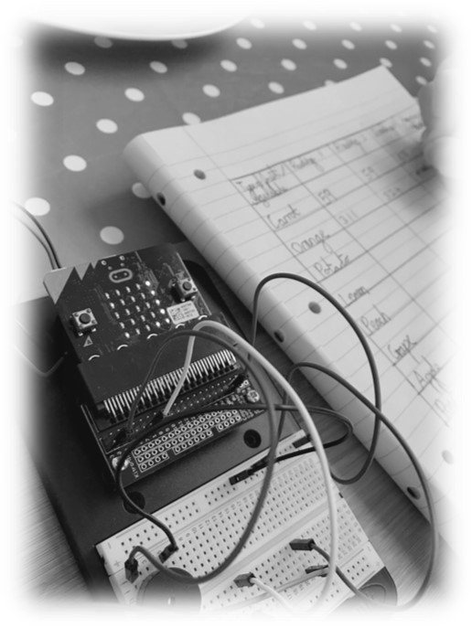
Please see the attached application pack for further information. If you would like to discuss the position in more detail, please contact Sonia Chater, Deputy Headteacher on soniachater@fernup.dorset.sch.uk
An Application Form and Job information Pack are also available on our website https://fernup.dorset.sch.uk/information/job-vacancies/, apply either via the ‘Apply’ button on Dorset For You or on our website .
Completed Application Forms should be uploaded via Dorset For You or sent to andreabaxter@fernup.dorset.sch.uk
Ferndown Upper School is a great place to work, and we look forward to receiving your application.

Closing date: 2nd May 2022 at midnight Via Dorset For You
Or delivered direct to the School Office or email to andreabaxter@fernup.dorset.sch.uk by 9.00 a.m. on Tuesday 3rd May 2022

Interviews: W/C 9thMay 2022
This school is committed to safeguarding and promoting the welfare of children and young people and expects all staff and volunteers to share this commitment. The successful candidate will be required to have an Enhanced Disclosure & Barring Service check (formerly CRB) in line with the Governments safer recruitment guidelines.
Ferndown Upper School values the diversity of our workforce and welcome applications from all sections of the community. This role is UK based and your Right to Work will need to be established as part of the appointment process.

