FALINGE PARK HIGH SCHOOL

Director of English

Date of Taking up Post: Easter or September 2023

Organisation Chart

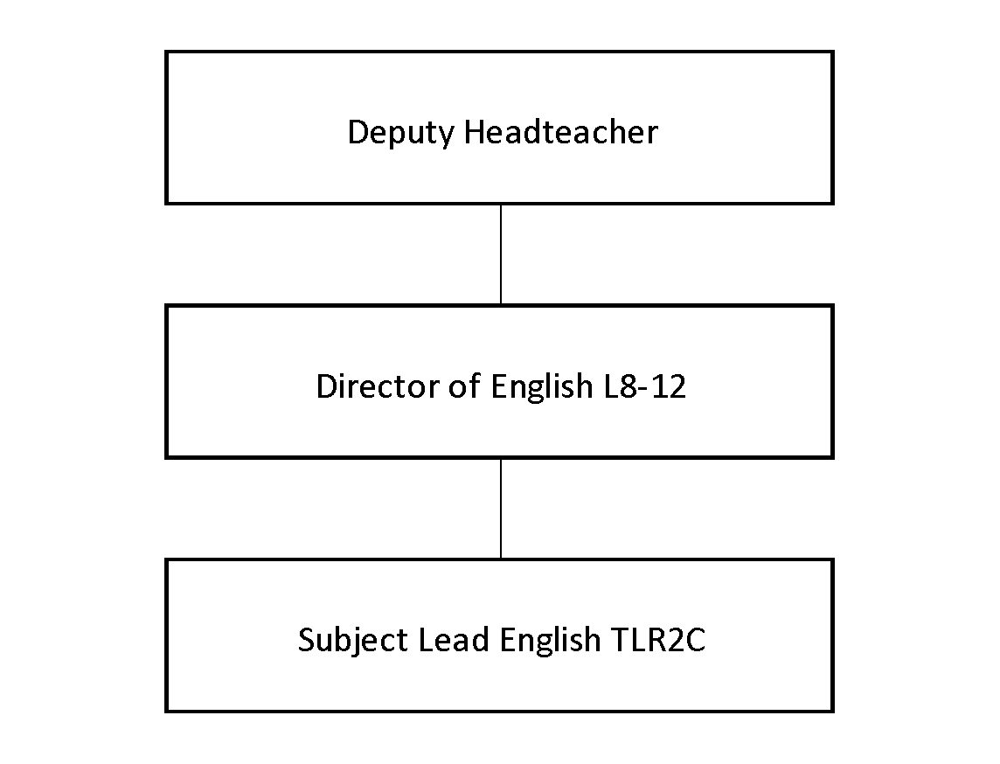

Job role and purpose

- To create a compelling learning experience

- To actively commit to the school strategy of believing in people (professional learning and research) and positive relationships

- To lead English across the school

- To demonstrate compelling leadership as part of the wider leadership team

Principal responsibilities:

- Embody and fulfil the values of Compelling Leadership.
- Work alongside the Senior Leadership Team in maintaining a high presence around the building during unstructured times as expected by those on the Leadership Spine.
- Lead subject leads through coaching and/or mentoring to reframe their curriculum and respond to where pupils have misconceptions.
- Quality assure the work of the subject leads through:
- analysis of data at each whole school Key Assessment point – identifying where pupils are underachieving/ making slow progress/ require more challenge;
- identifying underachieving pupils and sharing this information with Heads of Year so that we can provide intervention for pupils not progressing in English and Maths;
- pinpointing underachieving pupils to subject leads so that they can provide support to the teacher where required;
- triangulating the data that is inputted at whole school level and via teacher reflection sheets with the work that is in pupils’ books, the curriculum and teacher assessments;
- providing support and guidance to the subject leads including best practice in teaching and learning within English and Maths;
- working collaboratively with other directors in order to ensure consistency of impact.
- Quality assure the written reports which are sent to parents.
- Manage the budgets for their subject leads, providing strategic financial plans for each subject area and ensuring that value for money is met.
- Provide commentary on the successes of their areas to external stakeholders as required.
- Provide leadership to the subject leads in their team.
- Prepare reports for the Senior Leadership team which identify the impacts of their actions on pupil outcomes and how they have ensured we are continually improving.
- Be responsible for timetabling for their subject areas.
- Commit to sharing their practice as part of collaborative partnerships across Rochdale and wider.
- Meet regularly with their subject leads for whom they are responsible, providing regular and timely support.
- Undertake Performance Development reviews in line with school policy.

Additional Information
You are employed in the capacity of a teacher subject to, and with the benefits of, the conditions of employment set out, or referred to, in your letter of appointment and statement of particulars.

This Job Description identifies the responsibilities attached to your post. It is subject to the limits on working time set out in the current Teacher’s Pay and Conditions document.

This Job Description is subject to amendment from time to time within the terms of your conditions of employment, as the needs of the school/service may require, but only to an extent consistent with those conditions of employment and only after consultation with you. The agreed Grievance Procedures may be invoked in any dispute arising from this job description or subsequent amendment, in which case teachers are advised to consult their Professional Association.

The school is committed to safeguarding and promoting the welfare of children and young people and expects all staff and volunteers to share this commitment. Successful candidates will undergo an enhanced DBS check, checks of references and employment history.

Signatories:

(Both Headteacher and postholder are asked to sign and date this Job Description following consultation on its contents).

Signed: Date: __
(Post Holder)

Signed: Date: __
(Headteacher)
FALINGE PARK HIGH SCHOOL

Director of English

ATTRIBUTES | ESSENTIAL | DESIRABLE | HOW IDENTIFIED
WORK RELATED EXPERIENCE AND SKILLS | - Evidence of positive impact at Middle Leader Level.  - Evidence of successful leadership which demonstrates positive outcomes for pupils.  - Excellent relationship skills.  - Evidence of successful leadership.  - Evidence of leading whole school initiatives.  - Evidence of working with external partners  - Excellent knowledge of effective curriculum design. | - Knowledge and practice of alternative qualifications including Media, Film, Functional Skills  - Knowledge of evidence based interventions. | Application Form/Letter  Interview  References
QUALIFICATIONS | - Degree  - Qualified Teacher Status  - Evidence of further commitment to professional development i.e. NPQ  - A willingness and commitment to professional development. |  | Application Form  Qualifications
SPECIALIST SKILLS AND KNOWLEDGE | - Understanding of and practical application of effective curriculum and assessment design.  - Understanding of and leadership of teaching and learning within their subject discipline. | - Evidence of leadership across the school. | Application Form/Letter  Interview  References

