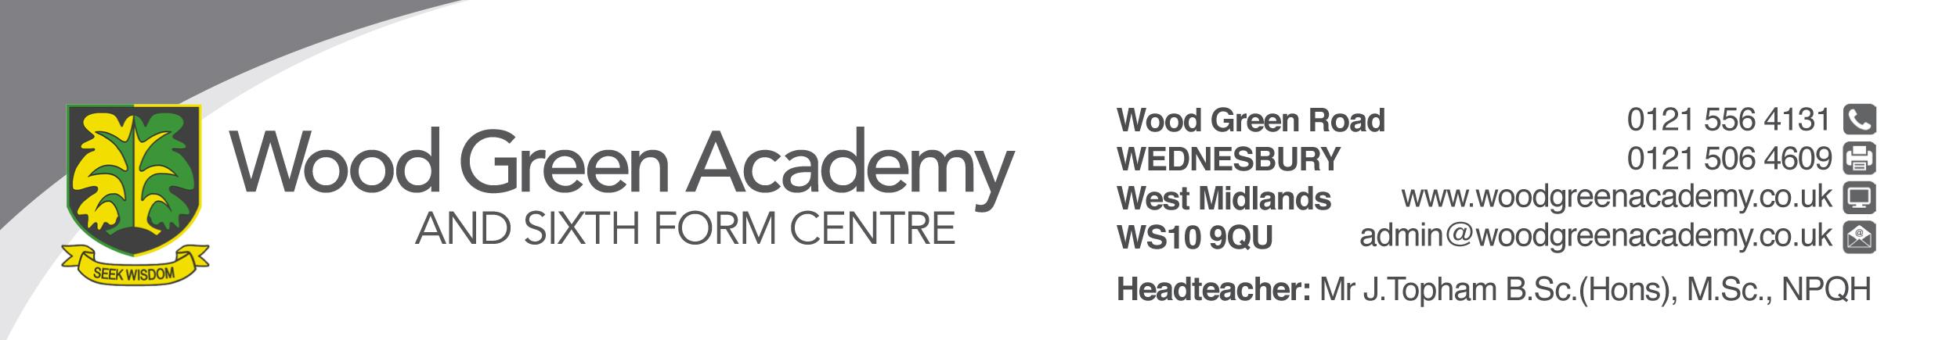
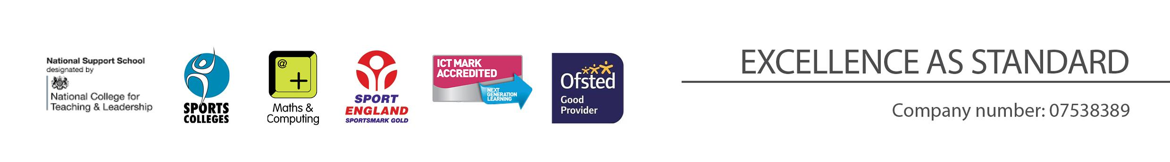
Director of English
Person Specification

REQUIREMENT | ESSENTIAL | DESIRABLE
LEGAL REQUIREMENTS | - Enhanced DBS Clearance including children barred lists
QUALIFICATIONS  Principally assessed through letter and application form | - Completed a course leading to DfE recognised teaching qualification (QTS)  - Qualified to degree level | - NPQSL / NPQML or comparable qualifications  - SLE  - Masters
EXPERIENCE and PROFESSIONAL COMPETENCE  Principally assessed through letter, application form | - Proven to teach outstanding lessons  - Teaching across Key Stages 3-4  - Proven experience and track record in leading raising achievement in English in Key Stage 4 / 5 or both  - Experience of supporting colleagues in developing their practice  - Wide range of learning and teaching skills  - Highly effective lesson planning to meet the needs of all students  - Highly effective classroom management  - Ability to engage and motivate all students  - Experience of involvement in the leadership and development of whole school priorities | - Experience of teaching post 16 students  - Completed action research in teaching and learning  - Effectively led a department  - Experience of developing others (leading CPD, ECT or ITT mentoring)  - Experience of developing partnerships with other schools, ITEs, businesses and the local community
KNOWLEDGE  Principally assessed through letter and interview process | - Up to date subject knowledge  - Use of assessment and achievement data to improve practice and raise standards  - Know how pupils’ learn and strategies to promote student progress  - Excellent understanding of the OFSTED framework and what constitutes outstanding learning and student progress  - Current education initiatives that affect English  - Strategies to ensure good progress for the most able and those requiring support | - Current education initiatives that affect the wider school, beyond English  - School self-evaluation
COMMUNICATIONS  Principally assessed through letter and interview process | - Have excellent written and verbal communication skills  - Interpersonal skills
PERSONAL ATTRIBUTES  Principally assessed through references, letter and interview process | - To be committed to safeguarding and promoting the welfare of children and young people  - Passion for English  - Flexibility and willingness to be involved in the school  - Committed to teaching and a willingness to continue to learn through professional development  - High student expectations  - Work effectively as a member of a team  - Be an effective role model through presentation and personal conduct  - Enthusiasm, energy, vigour, reliability and integrity  - Committed to professionally developing others  - Innovative and creative, willing to try and adapt new ideas and approaches

