Director of Mathematics Recruitment Pack 2022

Letter from the CEO

Dear Colleague

Thank you for your interest in the role of Director of Mathematics at Lincoln Castle Academy, part of the Harbour Learning Trust.

Harbour Learning Trust is an education charity that runs a family of seven primary and two secondary schools in Lincolnshire and North East Lincolnshire. After a period of growth starting in 2018, Harbour Learning Trust now serves over 4,000 children and young people across its nine academies. We are a values-driven organisation with a commitment to integrity, collaboration and excellence.

We are proud to say that all of our academies are happy, safe and inclusive communities. From the first day a child or young person joins Harbour Learning Trust they are fully supported to overcome any barriers so they can learn, develop, thrive and succeed. Education really can change lives for the better and we passionately believe that every child should receive the very best education in order to fully prepare them for the future. We are a caring employer who values all of our staff, providing genuine and exciting opportunities to develop expertise, share best practice and form strong partnerships both within and beyond our Trust.

We are seeking an exceptional individual to lead Mathematics across our secondary academies, forward into the next chapter of its exciting journey.

Lincoln Castle Academy (LCA) is located close to Lincoln’s historical quarters, in the backdrop of Lincoln Castle and Lincoln Cathedral. The school has the capacity for just over 1,000 students, including a sixth-form, and joined Harbour Learning Trust in September 2019. LCA was last inspected in 2016, receiving a Good judgement. However, a decline in standards since the last inspection presents both a challenge and an exciting opportunity to reset the school’s trajectory.

Healing Science Academy is located in the village of Healing, approximately five miles from Grimsby town centre. The school is regularly oversubscribed, and has approximately 1,000 pupils on roll. Healing Science Academy was the founding member of the multi academy trust. The school was last inspected in 2009, receiving an Outstanding judgement. Healing Science Academy consistently performs above the national average in all performance measures.

The successful candidate will benefit from both support and challenge from Harbour Learning Trust’s Executive Team and Trustees as well as the Academy’s Local Academy Council. The Trust provides high-quality training and coaching for all staff, as well as additional induction support and mentoring for those new to the role of Director of Mathematics. The successful candidate will share a commitment to Harbour Learning Trust’s vision and values, have a successful track record of senior leadership in a school serving a similar context, and be able to clearly articulate how they would lead the school on its improvement journey.

If you feel you have the skills, drive and commitment to join us at this pivotal time for Harbour Learning Trust, we very much look forward to receiving your application. Please do contact us via telephone or email to discuss the post in more detail and to arrange a visit to the academy.

Many thanks once again.

Kind regards

Jo Nolan
CEO

Vision & Values

Our Vision

We seek to inspire greatness in every child and to equip them with the academic achievements, life skills and personal attributes to lead happy, safe, successful lives.

Our Values

We are child-centred. We make decisions based on what is right for our children and their life chances.

We are inclusive. We believe that every child can be successful regardless of background or ability.

We are ambitious. We aim for excellence in all that we do.

We act with integrity. We promote respect and trust; we value different points of view and beliefs. We actively reject discrimination, racism, bullying, deceit and dishonesty.

We are collaborative. We work in partnership with all stakeholders including parents, carers and the wider community ensuring a sense of togetherness.

We value our staff. We invest extensively in outstanding training and development opportunities.

Trust and Academy Information
Chief Executive Officer | Ms Jo Nolan
Address | Harbour Learning Trust  Healing School  Low Road  Healing Grimsby  North East Lincolnshire  DN41 7QD
Telephone | 01472 582525
Email | enquiries@harbourlearningtrust.com
Website | www.harbourlearningtrust.com
Twitter | @HarbourLearning
Harbour Learning Trust is an exempt charity and a company limited by guarantee. Registered in England & Wales. Company No. 07345756. Registered Office as shown.

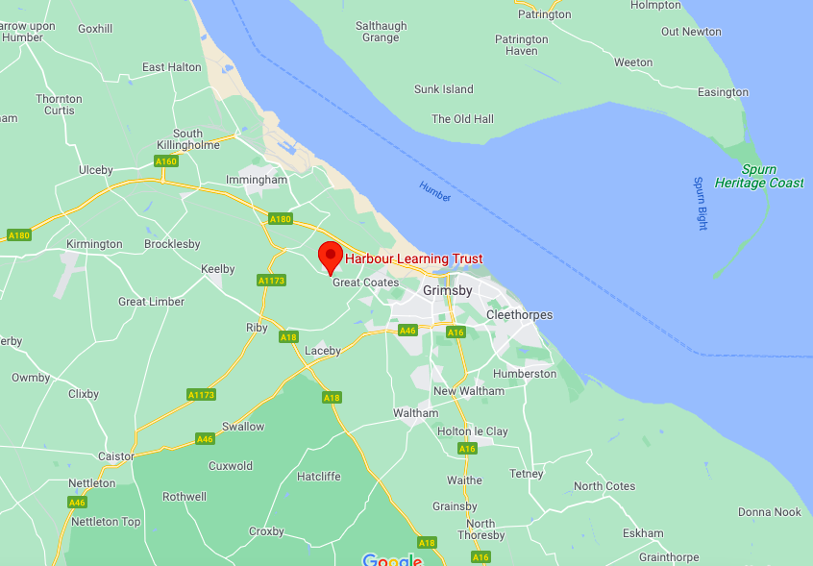
Executive Principal | Ms Jeanette Saw
Age Range | 11-16
School Capacity | 1,020
Number of Pupils | 984
Proportion of Disadvantaged Pupils | 12.6
Address | Healing Science Academy  Low Road  Healing Grimsby  North East Lincolnshire  DN41 7QD
Telephone | 01472 502400
Email | office@healing-school.co.uk
Website | www.healing-school.co.uk

Executive Principal | Ms Jeanette Saw
Age Range | 11-18
School Capacity | 1,041
Number of Pupils | 884
Proportion of Disadvantaged Pupils | 48%
Address | Lincoln Castle Academy  Riseholme Road  Lincoln  LN1 3SP
Telephone | 01472 502400
Email | lcaenquiries@harbourlearningtrust.com
Website | www.lincolncastleacademy.co.uk

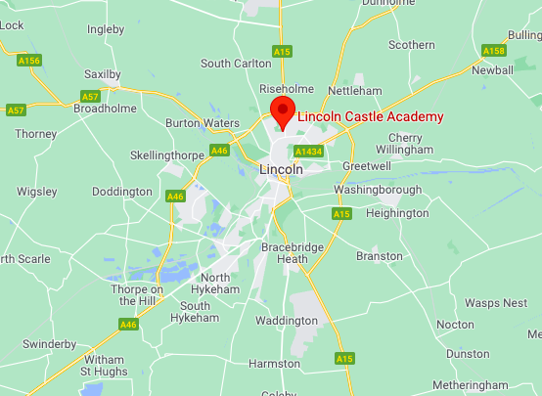

Job Description & Person Specification

Post Title | Director of Mathematics
Contract | Full Time, permanent
Salary | L10 – L14
Reporting to | Executive Principal, Secondary
Work Base | Working across Secondary Phase (Based at Lincoln Castle Academy initially)
Additional Information | Regular travel between academies will be required

Overall Purpose of the Post

Under the reasonable direction of the Executive Principal (Secondary) the post holder will carry out the professional duties of a teacher set out in the current Schools Teachers’ pay and Conditions Document (STPCD). Furthermore, as the leader of a core subject area across the Trust’s academies, expectation of the postholder will be:

- To raise standards of student attainment and achievement within the Trust, the whole curriculum area and to monitor and support student progress
- To be accountable for student progress and development within Mathematics across the Trust
- To develop and enhance the teaching practice of others
- To ensure the provision of an appropriately broad, balanced, relevant and differentiated curriculum for students studying Mathematics, in accordance with the aims of the Trust and curricular policies
- To be accountable for leading, managing and developing Mathematics across the Trust
- To secure high quality student outcomes within the designated curriculum area.
Main Duties & Responsibilities

Teaching
- To undertake an appropriate programme of teaching in accordance with the duties of a standard scale teacher.

Operational / Strategic Planning
- To lead the development of appropriate syllabuses, resources, schemes of work, marking policies, assessment and teaching and learning strategies in Mathematics
- To be responsible for the day-to-day management, control and operation of course provision within Mathematics
- To monitor actively and follow up student progress
- To implement Trust policies and procedures, eg Equal Opportunities, Homework, etc.
- To work with colleagues to formulate aims, objectives and strategic plans for Mathematics which have coherence and relevance to the needs of students and to the aims and objectives of the Trust.
- To ensure that the work in the curriculum area fully reflect the Trust’s distinctive vision and values

Curriculum Provision
- To liaise with the Curriculum Leaders to ensure the delivery of an appropriate, comprehensive, high quality and cost-effective curriculum programme
- To be accountable for the development and delivery of Mathematics

Curriculum Development
- To lead curriculum development for the whole of Mathematics
- To keep up to date with national developments in the subject area and teaching practice and methodology
- To monitor actively and respond to curriculum development and initiatives at national, regional and local levels
- To be responsible for the development of key skills in Mathematics
- Staffing / Staff Development
- To work with the Curriculum Leaders to ensure that staff development needs are identified and that appropriate programmes are designed to meet such needs
- To continue own professional development

Quality Assurance
- To ensure the effective operation of quality control systems
- To establish the process of the setting of targets for teachers and students within Mathematics and to work towards their achievement
- To establish common standards of practice within Mathematics and develop the effectiveness of teaching and learning styles in all relevant subject areas within Mathematics
- To contribute to the Trust procedures for lesson observations and feedback
- To monitor and evaluate Mathematics in line with agreed Trust procedures including evaluation against quality standards and performance criteria
- To seek / implement modification and improvement where required

Management Information
- To ensure the maintenance of accurate and up to date information concerning Mathematics on the management information system
- To make use of analysis and evaluation of performance data for staff and students
- To identify and take appropriate action on issues arising from data, systems and reports; setting deadlines where necessary and reviewing progress on the action taken
- To produce reports within the quality assurance cycle for Mathematics
- To produce reports on examination performance

Pastoral System
- To monitor and support the overall progress and development of students within Mathematics
- To monitor student attendance together with students’ progress and performance in relation to targets set for each individual; ensuing that follow-up procedures are adhered to and that appropriate action is taken where necessary
- To ensure the Behaviour Management system is implemented in Mathematics so that effective learning can take place

Health and Safety
- The post holder has a duty to comply with the requirements of the Health and Safety at work and safe working practices.
- Ability to maintain appropriate levels of security in all working areas.

GDPR
- The post holder is required to comply with the GDPR regulations and maintain awareness of Trust policies and procedures in this area. Attention is specifically drawn to the need for confidentiality in handling personal data and the implications of unauthorised disclosure.

Whilst every effort has been made to explain the main duties and responsibilities of the post, each individual task undertaken may not be identified and the post holder may reasonably be expected to undertake other duties commensurate with the level of responsibility that may be allocated from time to time.

Person Specification
Qualifications & Training | E | D
Qualified teacher status | 
Evidence of continuous professional development and training | 
Experience, Knowledge and Understanding | E | D
Be a Specialist Leader in Education (SLE) within your curriculum area or an outstanding practitioner with at least two years middle of senior leadership experience | 
Proven successful track record of examination success and curriculum leadership in specialist curriculum area |  
Experience of monitoring and evaluating teaching / learning and target setting including the ability to accurately analyse data | 
Experience of effective working with a range of relevant stakeholders | 
Successful sustained experience of teaching in KS3 and KS4 which is at least good | 
Skills and Knowledge | E | D
Good knowledge of the school self-evaluation and planning framework and ability to contribute to implementation | 
Good knowledge of leadership and management styles and when to use them | 
Able to plan personal workload and set priorities | 
Good written and oral communication skills to a range of audiences | 
Ability to work with parents / carers to understand and meet the needs of individual students | 
A team leader who can ensure the involvement and commitment of all team members | 
Persuasive and confident in a range of different environments | 
Has a sound knowledge of strategies to enhance teaching and learning opportunities within academies | 
Understanding and experience of Performance Management and accountability in an academy | 
A profound commitment to the vision and values of the Trust and the maintenance of excellent standards | 
A commitment to equality and diversity | 
High standards of integrity and a positive role model for students, staff, parents and the wider community | 
The post holder will be subject to an Enhanced Disclosure and Barring Service (DBS) check | 
The post holder must be committed to safeguarding the welfare of children and to providing equality of opportunity | 
Personal Skills and Attributes | E | D
A high level of interpersonal skills with the ability to empathise with different points of view and win respect | 
Ability to motivate and inspire others | 
Persuasive and confident in a range of different environments | 
Aware of opportunities for teaching and learning presented by new technologies | 
Full driving licence, or access to mobility support | 
Other Duties - The duties and responsibilities in this job description are not restrictive and the post-holder may be required to undertake any other duties which may be required from time to time. Any such duties should not however substantially change the general character of the post.

