MUSIC AT CHRISTS SCHOOL 2020

There is a strong musical life at Christ’s School, with opportunities abounding for a broad range of music making at all levels. The state-of-the-art facilities were opened by Sir Tim Rice in 2004, and the present Director of Music, Mr. Philip Wilson, has been at Christ’s since 2005, a period which has seen expansion in all areas, the development of new schemes of work, consistently good GCSE results, increasing numbers learning instruments, more extra-curricular opportunities and more music events. With an expanding department within an expanding school, the department now consists of two teachers and two teaching areas: one specialising as a performance space and the other as a technology hub. A level music is offered in our sixth form. Mr. Philip Wilson is assisted by Ms Lorraine Latin in the department.

The Curriculum
Lower School classes: years 7 and 8 have an hour and a half of music every week, year 9 one hour per week; in these lessons musical ideas, techniques and styles are covered in a practically-based course which includes plenty of performance (keyboards, singing, xylophones and percussion) and composition. Students often get to work in groups, perform to the class and have their work recorded onto computer or video. There are also activities which aim to develop the students’ listening skills. The use of music technology is embedded in the lower school curriculum throughout the key stage. Each of the three years has an overarching theme:
Year 7 The Elements of Music
Year 8 Music of Other Cultures
Year 9 The Roots of Modern Popular Music
Most years, the entire Year 7 cohort gets together for a performance in the autumn concert. Past projects have included Flanders’ Captain Noah and His Floating Zoo and Running on Rails; these have included performances in front of pupils from local primary schools.
Every lower school project is designed to focus on all three of the music “attainment targets” – performing, composing and listening/appraising.

GCSE. Students can opt to take GCSE in Year 10 and 11. They have 2.5 hours per week, and be expected to demonstrate a firm commitment to develop as composers and performers, as well as developing a more technical and theoretical knowledge. Listening is structured by the study of set works: these pieces are studied from the point of view of musical elements/techniques such as melody, harmony, texture, timbre, structure etc. etc. The GCSE course is practically based, with plenty of scope for the students to create their own music in a wide variety of styles. For any student wishing to consider study beyond GCSE, the facilities exist for the study of musical theory, and those students will be expected to have achieved Grade 5 theory as well as their GCSE.

Sixth Form. A Level music is a possible pathway for students in our sixth form, using the Edexcel syllabus. Two of our recent A level students have gone on to study music full time at tertiary level. The opening of the sixth form centre about five years ago coincided with the opening of our music technology suite in the lower room of the music centre.

After Christ’s
Advice and mentoring is given on the requirements post-16 and post-18 of various music courses and pathways. Part of our remit within the music department is to ensure that students are fully prepared and briefed for future study; these considerations place Christ’s music department in a strong position to be able to advise students on career possibilities related to music and the arts, university entrance and music college requirements. We are proud of our musical alumni: several of our recent students have gone on to study music and won awards in the field of classical, jazz and popular music. Currently, ex-students of Christ’s including a member of the National Youth Jazz Orchestra and a scholar at the Guildhall School of Music and Drama, a music student at West London University and another at Royal Holloway College, and multiple members of at least two professional rock bands. Many others are also involved in the world of music and the performing arts in a variety of roles.
Music Lessons
Christ’s School music department hires independent tutors offering high-quality one-to-one tuition in the full range of instruments, including voice. Numbers in all areas continue to expand. The department is flexible and will aim to provide tuition in areas not previously covered if there is a need. Tuition is currently offered in piano, guitar (classical/jazz/rock/bass guitar), drums, flute, oboe, clarinet/saxophone, brass, singing, violin/viola and cello/double-bass. A possible future area of development is individual tuition in the field of music technology.
Clarinet/saxophone Ms Stephanie Frankland
Oboe Mr. Mark Radcliffe
Violin/viola Mr. John Haworth
Cello Ms Amy Sims
Double Bass Mr. Enrique Galassi
Drums/percussion Mr. Alex Maxted
Guitar (all styles) Mr. Elliot Frost; Mr. Enrique Galassi
Flute Ms Lorraine Latin
Piano Mr. Gamal Khamis; Mr. Mark Radcliffe; Mr. Gianni Boscarino
Singing Mr. Philip Wilson
Brass Mr. Chris Guy

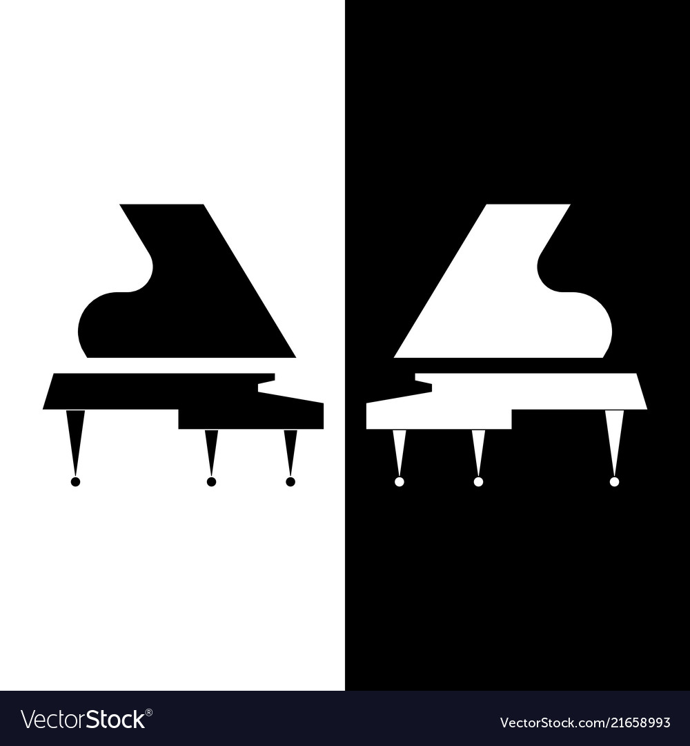

Extra-curricular music
Plenty of opportunities exist at Christ’s for extra-curricular music. We generally host two major concerts each year, which give the chance for singers and instrumentalists to exercise their skills on the public stage. In recent years there has been considerable investment in sound and lighting equipment by the school. In addition, Christ’s music department hosts about six informal concerts (our “At Home” series) each year; these are smaller in scale and give students the opportunity to perform solos in a friendly setting; this is often a stepping stone to performing in the main concerts. Performances are also a regular part of our school assemblies, PTA events, the school’s Awards Evening and on the annual jazz band primary schools tour.
The department has established a schedule which results in a major music/drama production alternating with a choral and orchestral concert in the summer term. In the summer of 2019 the Christ’s School and Community choir and orchestra performed Carl Orff’s Carmina Burana, along with trombone and cello concertos plus orchestral compositions by two of our best young composers. Please email Mr. Wilson, Director of Music, if you would like to hear and view a high quality recording of this concert, and he will send you a link. In the Spring, the department hosted a young composers’ workshop in collaboration with the Nonesuch Orchestra, one of the foremost amateur London orchestras. Other recent productions have been the world premiere schools’ production of Gypsy Kings’ and John Cameron’s Zorro the Musical, Oliver and (in Summer 2014) Bugsy Malone. In the summer of 2015 the school performed Sir Karl Jenkins’ iconic Adiemus – Songs of Sanctuary, which directly resulted in an invitation to perform the piece in the presence of Sir Karl in the Carnegie Hall, New York in January 2016. In summer 2017, we performed Faure’s Requiem, and this concert was also the third in which we have given our most advanced musicians the opportunity to play a concerto movement with a professional orchestra. Christ’s Jazz Band, which is rapidly gaining a local reputation and has established an annual primary schools tour, our string ensemble, run by Mr. Robin Wedderburn and Christ’s dectet, containing our most advanced instrumentalists, are three of our main regular ensembles, and our school orchestra is always a part of events such as our annual carol service. Flute and recorder ensembles also rehearse on a regular basis.
The department has an open-door policy at lunchtimes and after school, where students can come in and practise/rehearse. Typically during most lunchtimes all available spaces in the department are being used by students, if they are not in use by visiting teachers and the department is indeed a vibrant place.
Musically gifted pupils will be strongly encouraged to join external youth music organizations to supplement what can be achieved in school. A number of students have joined local youth orchestras (such as Ealing, Thames or Stoneleigh Youth Orchestras and the London Schools Symphony Orchestra) and have been encouraged to attend the junior departments of the main London music colleges such as the Royal College of Music and the Guildhall.
This academic year and Covid-19
Like all educational institutions, the current pandemic is currently clipping our wings in terms of performance and musical events. As the year begins, for example, we are currently unable to run any ensembles for students using students from more than one year group. Generally, we regard this diversity as a strength of the department, but now it is bringing in restrictions which hit us particularly hard. However, we are always looking for new opportunities; for example, in the lockdown earlier in the summer the department produced three virtual concerts, which are available for listening on the school website. Our autumn concert will also be a virtual event, but this will be more ambitious with a number of our ensembles recording at home and being stitched together in software. We are hoping for our carol service this year to be recorded with live ensembles in Holy Trinity church, but without a congregation. In addition, our young composers’ workshop with the Nonesuch orchestra will be going ahead in some format or other. We have a second composition project planned with a young professional music ensemble called the Hermes Experiment. We have high hopes that we will be able to run our major choral and orchestral concert this summer, but decisions about that will obviously come further down the line. In addition, some new music ensembles involving single year groups are currently being set up. We will continue to use our ingenuity to keep the flame of music alive at the school!

Music Technology
This has taken a quantum leap forward recently, with our state of the art Apple Mac suite of computers equipped with Logic Pro X and Sibelius software. We also have a good selection of high quality microphones for various purposes. It has a hard disc recorder, other recording hardware and a PA system in the school hall for productions/concerts.
Music Technology has been fully integrated into the Lower School curriculum, is a major feature of GCSE work and there is also a Music Technology after school club. Students often use the equipment in the lunch hour and after school, learning to record their own music, as well as using the technology as a tool for composition. Through taking responsibility for sound, lighting and stage management for musical and other events at school, pupils can, under the guidance of the Director of Music, develop invaluable skills in the technical side of productions.
Recent events have included:
- 2012 - 2016. World schools premiere of the Gipsy Kings’ and John Cameron’s Zorro the Musical. Other music drama productions have included Bugsy Malone, Oliver and Arabian Nights.
- Choral and Orchestral concert 2015, featuring Sir Karl Jenkins’ Adiemus – Songs of Sanctuary; this concert led directly to an invitiaton for our choir to sing the work at the Carnegie Hall in New York in January 2016.
- March 2020 Annual Jazz Band mini-tour of local primary schools. We were very fortunate to get our annual tour in just before the lockdown!
- Choral and Orchestral concert July 2017 with a performance of Faure’s Requiem in the church of St. John the Divine, Richmond. Concerto movements by Mozart, Haydn and Hoffmeister by our advanced students accompanied by a professional orchestra also featured in the concert.
- July 2018. Major summer popular concert featuring choir (joined by our community choir), dectet, jazz band and numerous soloists and ensembles
- March 2019 and 2020. Nonesuch Orchestra young composers’ workshop project. One of our students participating in this project, Jacob Cavendish, also entered his piece “River” for the presitigious BBC Young Composer 2020 competition and received a “highly commended” award. This project was completed shortly before the lockdown.
- July 2019. Choral and Orchestral concert featuring Carl Orff’s Carmina Burana performed by Christ’s School and Community choir and orchestra. This concert also featured two student compositions for orchestra and two concerto performances by two of our most advanced players.
Every year we also have:
- a major autumn concert,
- a large-scale Carol Service in our local church featuring choirs, orchestra, brass group and dectet.
- a series of around six “At Homes” – informal concerts giving students the opportunity to perform in front of a small audience in the friendly setting of the Christ’s Music Centre.
- Either a major summer concert or a music drama production
- Once or twice a year, we now host a visit to the school by the ABRSM for those wishing to take instrumental or vocal graded exams.

……… A GRAND PIANO FOR CHRIST’S SCHOOL

In the summer of 2018 the department formed the ambition to raise money to buy a high quality new grand piano. Six months later we had managed to raise around £13,000 with the help of parents and friends of the school; local businesses; ex-students, local charities and other generous donations including a very generous contribution from our very active PTA and a gift of £500 from Sir Tim Rice, who opened our music centre in 2004. We are now the proud owners of a new six-foot Yamaha grand piano, which has already given pleasure and inspiration to our many pianists in the school, and been the focus of several concerts.

