

APPLICATION PACK

Post: Director of Operations and Finance

Department: Business Support

Salary: Scale Points 10-14 (£76,416-£86,766)

Contract: Full-time and permanent

Location: Spa Education Trust
(based initially at Spa Camberwell School, Southampton Way, London, SE5 7EW, with regular travel to Spa Bermondsey School)

Reports to: Executive Headteacher

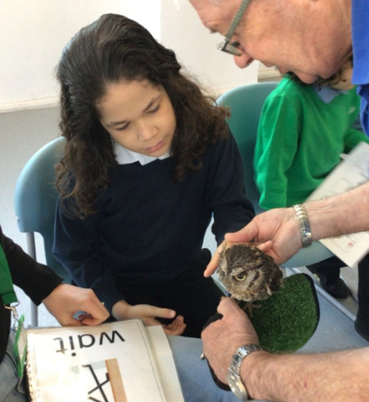

March 2026

Dear Applicant

Director of Operations and Finance (DOF)

The world of special education will change rapidly because of the government’s white paper – Every Child Achieving and Thriving. At Spa Education Trust we are determined to help mould that change for the benefit of the children and young people in our schools.

Our multi-academy trust is currently made up of two special schools (Spa Bermondsey and Spa Camberwell) located in the London Borough of Southwark. We are privileged to educate autistic children and young people, collaborating closely with supportive families from Southwark and nearby boroughs. At Spa Bermondsey, we teach pupils aged 11 to 19 (116 on roll), while Spa Camberwell serves pupils aged 4 to 16 (113 on roll).

To support the development of our trust at this exciting time, we are looking for an outstanding colleague, with leadership experience in finance and wider business operations in education.

This newly created post will lead all aspects of our work to support educational provision; the DOF will lead and develop further the small team of business professionals to facilitate the delivery of high-quality education for young people by providing effective services for teaching and educational support staff. Reporting directly to me as Executive Headteacher, the DOF will bring expertise in financial planning and management, the leadership of business support functions, and will support the Board of Trustees in fulfilling its statutory functions. As a small trust, there will be a clear need for the postholder to operate both at a strategic level, but also to carry out a range of day-to-day functions; however, we see clear potential for this to develop in the coming years. We are particularly keen to meet with colleagues with a successful track record of change management as we look to improve and develop our business support systems and functions.

You can find out more about our trust through our website. To discuss this post, please contact our leadership consultant, Gordon Smith, at gordon.smith@education-leadership.co.uk.

I would be delighted to receive an application from you if, upon consideration, you feel that this role and Spa Education Trust may be right for you. To apply, please complete the application form, including where requested a statement of no more than two sides of A4, identifying how you meet the criteria in the person specification that are tested by Application Form (A) or Supporting Statement (S). Completed applications should be sent to gordon.smith@education-leadership.co.uk by 9am on Monday 23rd March; we are working to a tight schedule and hope to interview shortlisted candidates on Thursday 26th March. I look forward to hearing from you.

Yours sincerely

Steph Lea
Executive Headteacher

Job Description

Reporting to: Executive Headteacher
Location: Spa Education Trust (Spa Camberwell School)

Salary: Scale Points 10-14 (£76,416-£86,766)

Main Purpose of the Role
The Director of Operations and Finance will play a pivotal role in ensuring the smooth and effective running of the Trust’s business functions, supporting the provision of high-quality education for autistic children and young people. The postholder will lead and develop the small team of business professionals, providing strategic oversight and operational leadership in finance, estates, health and safety, compliance, HR, IT, and administration across the Trust’s schools. The role will ensure that robust systems and processes underpin the Trust’s educational mission, enabling teaching and education support staff to focus on pupil outcomes.

Key Responsibilities
- Provide strategic leadership and management for all operational and financial activities across the Trust, ensuring compliance with statutory and regulatory requirements.
- Lead the Trust’s financial planning, budgeting, reporting and audit processes, working closely with the Executive Headteacher and Trustees to ensure sustainability and value for money.
- Through the Premises Manager, oversee the management and development of Trust facilities, including premises management, health and safety, capital projects, and site security.
- Through the HR Manager, oversee the management and development of the HR service, including the development of HR policies and practice that make the Spa Education Trust an employer of choice.
- Ensure the effective management of support services, including HR, IT, procurement, contracts, and administration.
- Advise the Executive Headteacher and Trustees on all operational and financial matters, providing timely and accurate reports to inform decision-making.
- Identify opportunities to maximise the Trust’s resources and take advantage of its location, including seeking new funding streams and developing partnerships.
- Lead, motivate, and develop the business support team, fostering a culture of continuous improvement and high performance.
- Ensure robust risk management procedures are in place and maintained for all operational areas.
- Promote and uphold the values and ethos of the Spa Education Trust in all aspects of the role.

Relationships
- Work as a key member of the Trust’s central team, contributing to overall strategy and development.
- Liaise with external agencies, suppliers, local authorities, and other stakeholders to support Trust operations.
- Support and advise school leaders and staff in relation to operational and financial matters.
Person Specification

Qualifications | 1 | General education at least to Level 4 (graduate level desirable), with successful higher levels of professional study specific to the role | A
2 |  | Accounting qualification (e.g., ACCA, CIMA) | A
Experience | 3 | Significant previous role in financial, and HR or facilities management, with clear understanding of all areas | A/S
4 |  | Successful leadership of multi-disciplinary teams | A/S
5 |  | Effective delivery of complex and integrated work programmes | S/I
6 |  | Working within a school / trust governance structure or similar commercial / third sector set up | A/S
7 |  | Effective delivery to deadline of complex projects and change management | S/I
Knowledge | 9 | Safeguarding requirements in schools | S/I
10 |  | Funding and audit mechanisms in education | S/I
11 |  | Organisational tools and systems to manage complex day-to-day and strategic planning | S/I
12 |  | Best value tendering and procurement processes | I
13 |  | HR requirements and systems | S/I
14 |  | H&S requirements and systems | S/I
Understanding | 15 | The wider educational policy environment | I
16 |  | The demands of the Department for Education | I
Qualities | 17 | Evaluative skills to assess the quality of a team’s work | I
 | 18 | Innovative and creative problem-solver | I
19 |  | High-level oral and written communication skills | S/I
20 |  | Clear commercial acumen | I
21 |  | Emotionally intelligent | I
22 |  | Exemplary role model | I
23 |  | Committed to high-quality special education | I

Each criterion will be tested as follows:
A Application Form
S Supporting Statement
I Interview
Should you be invited to interview, your named referees will be asked to comment in particular on those points of experience, knowledge and qualities outlined above.

The Spa Education Trust is committed to safeguarding and promoting the welfare of children and young people, and an enhanced DBS check will be required for the successful applicant.

Organisational Structure

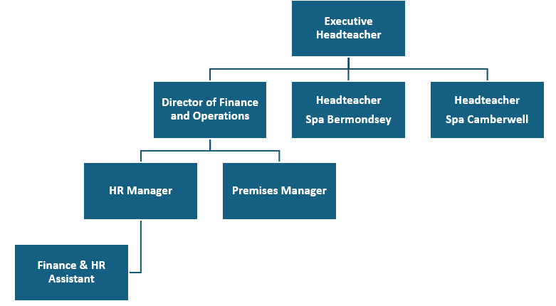

The Executive Headteacher leads all aspects of the Trust’s work and is accountable to the Board of Trustees; she is also the Accounting Officer of the Trust. In 2025/26, the Executive Headteacher holds the role of Headteacher at Spa Camberwell School.
Information on Application and Safeguarding Procedures

Application
Applications will only be accepted from candidates completing the required application form in full. CVs will not be accepted as a substitute for completed application forms in the absence of a good reason.

Safeguarding Children
Candidates should be aware that all posts in the school involve some degree of responsibility for safeguarding children, although the extent of that responsibility will vary according to the nature of the post. Please see the job description for the post.

Accordingly, this post is exempt from the Rehabilitation of Offenders Act 1974 and therefore all convictions and cautions, including those normally regarded as ‘spent’ must be declared. The successful applicant’s appointment is conditional upon satisfactory clearance by the Disclosure and Barring Service (DBS). Any convictions or cautions disclosed by this process will be treated in the strictest confidence and certain types of conviction or caution need not necessarily prevent you from working with us - especially if they were a long time ago. Your current employer will be asked about disciplinary offences, including disciplinary offences relating to children or young persons (whether the disciplinary sanction is current or time expired), and whether you have been the subject of any child protection allegations or concerns and if so the outcome of any enquiry or disciplinary procedure.

You should be aware that provision of false information is an offence and could result in the application being rejected. If appointed on the basis of false information you could be summarily dismissed for acquiring your post by deception and a possible referral to the police and/or the National College for Teaching and Leadership could also follow. You will be aware if you are barred from working with children that it is a criminal offence to apply for this post and a criminal offence for the school to employ you.

Equality Monitoring
The school has a duty to monitor the workforce to ensure race equality, gender equality, and disability equality. We would be grateful if you could complete the accompanying equality monitoring form and return it with your completed application form. The information you provide will only be used for monitoring purposes and it will not influence the recruitment decision. The paper form will be retained confidentially and will be destroyed securely after the monitoring data has been recorded and the recruitment decision is made.

Invitation to Interview
If you are invited to interview this will be conducted in person and the areas which it will explore will include suitability to work with children. If you are disabled and need special arrangements to access the selection process, please tell us on the application form what we can do to adapt our processes so that you are able you to compete with others on an even footing. All candidates invited to interview must bring original documents confirming any educational and professional qualifications that are relevant to the post (e.g. the original copy of certificates, diplomas, etc.). Where original copies are not available for the successful candidate, written confirmation of the relevant qualifications must be obtained from the awarding body.

All candidates invited to interview must also bring with them:

- Proof of identity such as a current passport or photo card driving licence
- Birth certificate
- Utility bill or financial statement showing candidate’s current name and address.
- Where appropriate, any documentation evidencing a change of name, e.g. marriage certificate, change of name by deed poll.
- Other documentary evidence showing your eligibility to work in the UK. If you do not have a UK passport the UK Borders Agency website has up to date publications on the prevention of illegal working and this lists the acceptable documents to demonstrate the right to work in the UK.
- If you are registered with the DBS update service, please still bring your DBS certificate with you.

Please note that originals of the above are necessary, photocopies or certified copies are not sufficient.

Conditional Offer of Appointment
Any conditional offer will be subject to the following:

- Receipt of at least two satisfactory references (if these have not already been received)
- Verification of identity, qualifications and eligibility to work.
- A satisfactory DBS Disclosure with a check of the DBS lists of people who are barred from working with children.
- Where the successful candidate has worked or been resident overseas in the previous five years, such checks and confirmations as the school may require in accordance with statutory guidance.
- Medical clearance and clarification of any adaptations that may be necessary if you are disabled. Confirmation that the health risks associated with the post have been considered and do not pose a particular risk to you in the light of previous illness/pain.
- Consideration of your absence record from your previous employer. If this is higher than acceptable under our absence management procedure, we will call you / meet with you to discuss the reasons for the absences before making a final decision.

WARNING
Where a candidate is:
- found to be on a DBS list of people who are barred from working with children or the DBS disclosure shows s/he has been disqualified from working with children by a court, or,
- found to have provided false information in, or in support of, this application, or
- the subject of serious expressions of concern as to his/her suitability to work with children,
these facts will be reported to the Police and/or the DBS.

