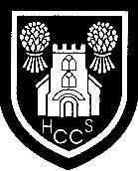
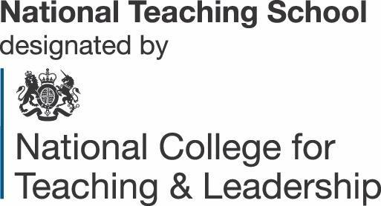
Director of SEND
L7 to L9 + SEND allowance (if qualified SEND Co)
Start date January 2022

We are looking to appoint an exceptional individual to fulfil the role of Director of SEND with responsibility for whole school SEND including the strategic leadership and management of the Resource Provision.

As part of our strong and successful SEND faculty, Holmes Chapel Comprehensive School and Sixth Form College are excited to be opening an SEND Resource Provision in Autumn 2022 supporting pupils with Social, Emotional and Mental Health needs.

This is a new and exciting leadership role and an excellent opportunity for a motivated and innovative individual with the desire to shape the future in establishing outstanding SEND practice across the organisation as well as planning, launching and establishing our new Resource Provision.

The main responsibilities of the role will be:

- Determine the strategic development of special education needs and disability (SEND) policy and provision across the organisation ensuring effective implementation of the SEND code of practice
- Lead all aspects of the new SEMH resource provision
- Ensure that SEND provision and practice across the organisation is consistently outstanding

We are looking for someone who is passionate, enthusiastic and innovative about ensuring the best outcomes for all pupils, particularly those with SEND and have the determination and resilience to embed change across the organisation. Candidates will have a strong background in Special Educational Needs as well as being an excellent teacher and leader. They will have the capacity to build on the success of the organisation and the continuing commitment to providing high quality education for pupils and improving standards of learning and achievement.

This unique leadership role represents a new direction for our school and provides an excellent opportunity for someone who is ambitious and keen to make a significant investment in their career.
To arrange an informal discussion or to visit the school please contact Sarah Bradney
HR Manager.
Holmes Chapel Comprehensive School & Sixth Form College is an equal opportunities employer and the Academy is strongly committed to the safety and welfare of children and young people. The successful candidate is required to comply with our safeguarding procedures.
For further details please visit our website: www.hccs1978.co.uk.
N.B. Applications will only be accepted on the TES application form.
Closing date: Friday 15th October 2021
Interviews/Assessment Centre to be held on Wednesday 20th October 2021 and Thursday 21st October 2021

Executive Head Teacher: Nigel Bielby
Tel: 01477- 410500
Web Site: www.hccs1978.co.uk NOR: 1308 including 209 in the Sixth Form)

