16 June 2022

Dear Applicant

Thank you for your interest in the post of a self employed Drum Teacher, which offers the successful candidate the opportunity to work in this outstanding school.

To assist with your application, we have enclosed a person specification and further information about the school. You may also want to visit the school website at www.sghs.org.uk

We look forward to receiving your completed application form.

Please send the completed application form to recruitment@nsat.org.uk or the above address as soon as possible, and to arrive no later than 9am on Friday 1 July 2022.

Once again, thank you for your interest in the post; we look forward to hearing from you.

Yours sincerely

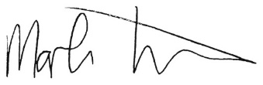
Mr Mark Turner
Headteacher

