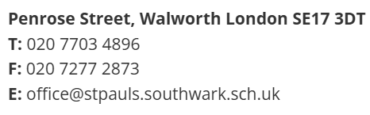


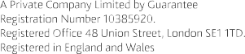

Job Advert – DSL, Family Support & Attendance Officer

St Paul's is looking for an enthusiastic DSL, Family Support and Attendance Officer to join our dedicated team.

Start date: | ASAP
Closing date: | 5pm on Sunday 30th August 2026
Interview date: | Thursday 3rd September 2026
Salary: | Southwark Grade 7a – Points 20 (£38,637 FTE) to 25 (£41,637 FTE)  Actual pro-rata £37,090 to £39,970
Hours: | 40 hours term time

At St Paul’s Church of England Primary, we are proud of our diverse and inclusive school where in all we do we aim high, encourage and have faith. The post holder will act as the Designated Safeguarding Lead (DSL) for the School and will oversee all aspects of attendance and will play a lead in supporting our families.

As DSL you will take lead responsibility for safeguarding and child protection across the school and will take part in strategy discussions and inter-agency meetings, and contribute to the assessment of children. You will advise and support other members of staff on child welfare, safeguarding and child protection matters, and liaise with relevant agencies such as the local authority and police.

At St Paul’s:

- We are committed to high quality teaching and to excellent professional development opportunities for all our staff
- We have a resilient staff team from a wide range of backgrounds and experiences who work closely together to secure the best outcomes for our children

The successful applicant will:

- Be committed to the development and welfare of all children in our inclusive church school
- Have the resilience and drive to work to secure the very best outcomes for all our children
- Work with our dedicated staff team to ensure the education, well-being, behaviour and personal development of children enhances their futures

If interested in joining our hard-working team, we can offer you:

- A well-resourced school set in extensive grounds
- Support and development from the SDBE MAT including a generous staff benefits scheme
- A school committed to wider education including a full extra-curricular programme
- Coaching and bespoke CPD opportunities

Thank you for your interest in this vacancy. We would be delighted to hear from you, arrange a visit to show you around our school, or simply have an informal discussion.
Applicants are expected to be sympathetic to the Christian ethos of the school.
St Pauls’s is committed to safeguarding and promoting the welfare of children and expects all staff and
volunteers to share this commitment.
All appointments are subject to a satisfactory enhanced DBS check and references.

